Harder equations
Solve $\cos{3x=-\frac{1}{2}}$ in the interval $0≤x≤360°$.

Solve $\sin{(2x+30°)=\frac{1}{\sqrt{2}}}$ in the interval $0≤x≤360°$.

Solve $\sin{x}=2\cos{x}$ in the interval $0≤x<300°$

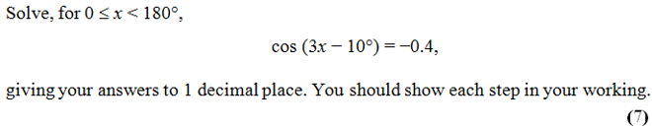

Exercise 10E Pg 218/219

AD Page 11

