10A Roots within Intervals

- The diagram shows a sketch of the curve $y=f\left(x\right),$ where $f\left(x\right)=x^{3}-{4x}^{2}+3x+1$

- Explain how the graph shows that $f(x)$ has a root between $x=2$ and $x=3$.
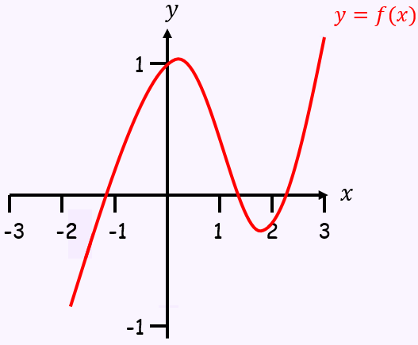

- Show that $f(x)$ has a root between $x=1.4$ and $x=1.5$

- The graph of the function
$f\left(x\right)=54x^{3}-225x^{2}+309x-140$
is shown in the diagram.
A student observes that $f(1.1)$ and $f(1.6)$ are both negative and states that $f\left(x\right)$ has no roots in the interval $\left[1.1,1.6\right]$

- Explain, referring to the diagram, why the student is incorrect
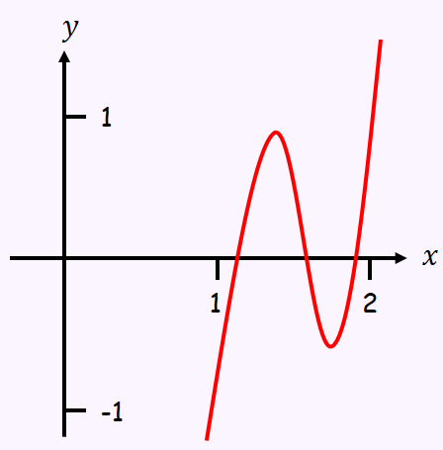

- Calculate $f(1.3)$, $f(1.5)$ and $f(1.7)$ and use your answer to explain why there are at least 3 roots in the interval $1.1<x<1.7$.

- Using the same axes, sketch the graphs of $y=lnx$ and $y=\frac{1}{x}$. Explain how your diagram shows that the function $f\left(x\right)=lnx-\frac{1}{x}$ has only one root

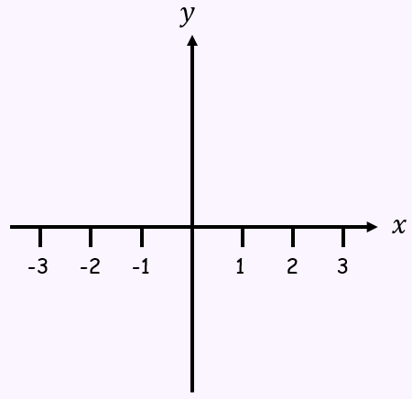

- Show that this root lies in the interval $1.7<x<1.8$

- Given that the root of $f\left(x\right)=α$, show that $α=1.763$ correct to 3 decimal places

