10A Roots within Intervals

- The diagram shows a sketch of the curve $y=f\left(x\right),$ where $f\left(x\right)=x^{3}-{4x}^{2}+3x+1$

- Explain how the graph shows that $f(x)$ has a root between $x=2$ and $x=3$.
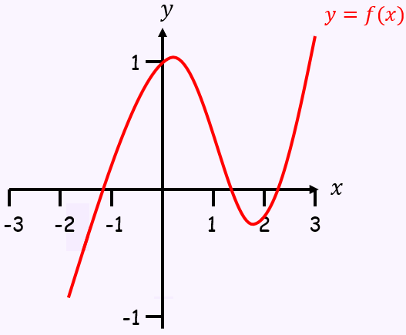

- Show that $f(x)$ has a root between $x=1.4$ and $x=1.5$

- The graph of the function
$f\left(x\right)=54x^{3}-225x^{2}+309x-140$
is shown in the diagram.
A student observes that $f(1.1)$ and $f(1.6)$ are both negative and states that $f\left(x\right)$ has no roots in the interval $\left[1.1,1.6\right]$

- Explain, referring to the diagram, why the student is incorrect
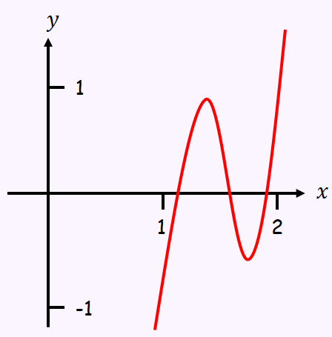

- Calculate $f(1.3)$, $f(1.5)$ and $f(1.7)$ and use your answer to explain why there are at least 3 roots in the interval $1.1<x<1.7$.

- Using the same axes, sketch the graphs of $y=lnx$ and $y=\frac{1}{x}$. Explain how your diagram shows that the function $f\left(x\right)=lnx-\frac{1}{x}$ has only one root

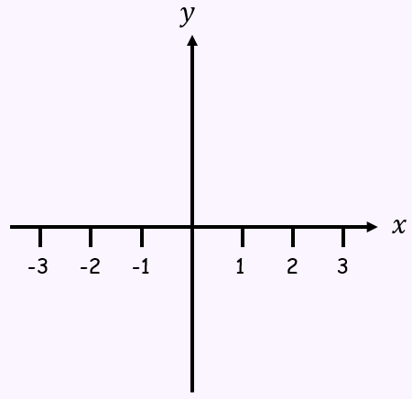

- Show that this root lies in the interval $1.7<x<1.8$

- Given that the root of $f\left(x\right)=α$, show that $α=1.763$ correct to 3 decimal places

10B Iterations

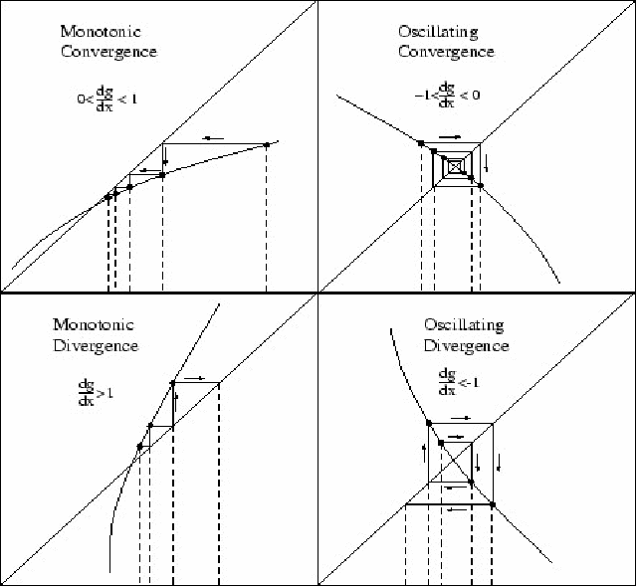
- Given that $f\left(x\right)=x^{2}-4x+1$
- Show that the equation $f\left(x\right)=0$ can be written as $x=4-\frac{1}{x}$, $x≠0$.

The equation $f(x)$ has a root, $α$, in the interval $3<x<4$.
- Use the iterative formula
$x_{n+1}=4-\frac{1}{x_{n}}$, with $x_{0}=3$ to find the value of $x_{1}$, $x_{2}$ and $x_{3}$.

$$f\left(x\right)=x^{3}-{3x}^{2}-2x+5$$
- Show that the equation $f\left(x\right)=0$ has a root in the interval $3<x<4$

- Use the iterative formula:
$$x_{n+1}=\sqrt{\frac{x_{n}^{3}-{2x}_{n}+5}{3}}$$
To calculate the values of $x_{1}$, $x_{2}$ and $x_{3}$, giving answers to 4 decimal places, when:
i) $x_{0}=1.5$ ii) $x_{0}=4$

10C Newton Raphson

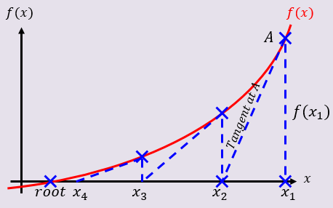

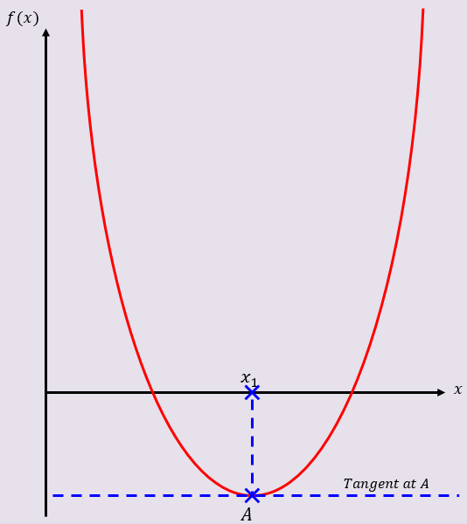

- The diagram shows part of the curve with equation $y=f(x)$, where $f\left(x\right)=x^{3}+2x^{2}-5x-4$.
The point $A$, with x-coordinate $p$, is a stationary point on the curve.
The equation f(x)=0 has a root, $α$, in the interval $1.8<α<1.9$.
- Explain why $x_{0}=p$ is not suitable to use as a first approximation to $α$ when applying the Newton-Raphson method to $f(x)$

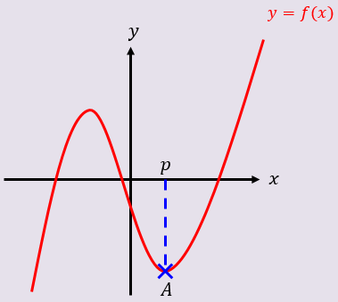

- Using $x_{0}=2$ as a first approximation to $α$, apply the Newton-Raphson method procedure twice to find a new approximation for $α$, to 3dp.

- By considering the change of sign in $f(x)$ over an appropriate interval, show that your answer to part b is accurate to 3 decimal places

10D Application of Numerical methods in context

- The price of a car in £s, x years after purchase, is modelled by the function:
$f\left(x\right)=15000{\left(0.85\right)}^{x}-1000sinx$, $x>0$

- Use the model to find the value of the car 10 years after purchase

- Show that $f(x)$ has a root between 19 and 20

- Find $f'(x)$

- Taking 19.5 as a first approximation, apply the Newton-Raphson method once to find a second approximation for the time when the value of the car is zero. Give your answer to 3dp

- Criticise this model with respect to the value of the car as it gets older

