4A Moments Introduction

- Find the Moment about C
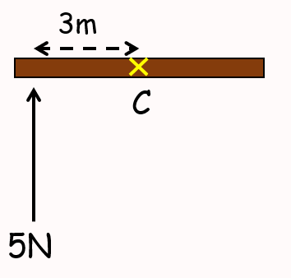

- Calculate the moment of the force about point F
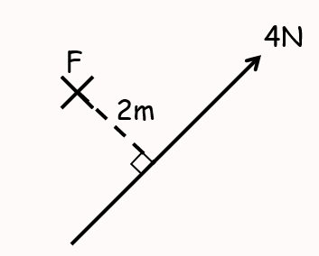

- Calculate the moment of the force about point A
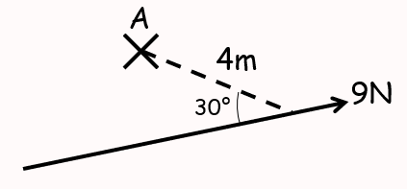

4B Multiple Moments

- Calculate the sum of the moments acting about the point P
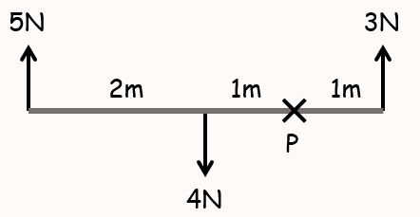

- Calculate the sum of the moments acting about the point P
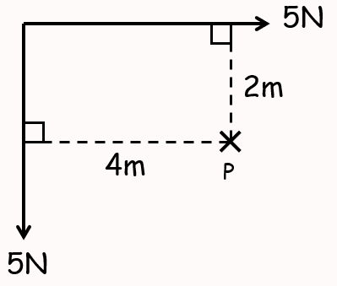

- The diagram to the right shows 3 forces acting on a light rod.
Find the resultant moment about point P
(ie – if the rod were fixed at point P, how would it rotate?)
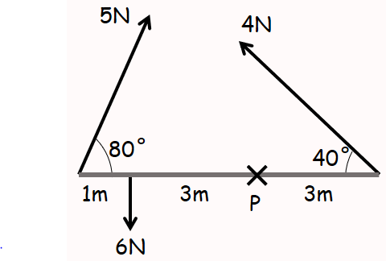

4C Uniform Rods

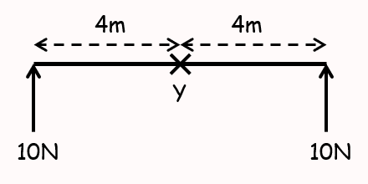

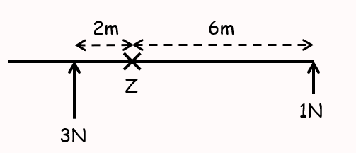

- The diagram shows a uniform rod of length 3m and weight 20N resting horizontally on supports at A and C, where AC = 2m.
Calculate the magnitude of the normal reaction at both of the supports
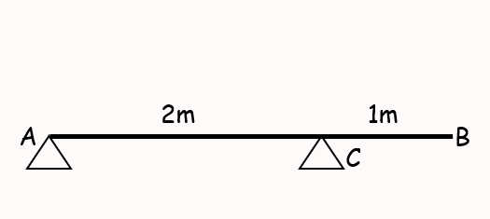

- A uniform beam, AB, of mass 40kg and length 5m, rests horizontally on supports at C and D where AC = DB = 1m.
When a man of mass 80kg stands on the beam at E, the magnitude of the reaction at D is double the reaction at C.
By modelling the beam as a rod and the man as a particle, find the distance AE

- A uniform rod $PQ$ is hinged at the point $P$, and is held in equilibrium at an angle of 50˚ to the horizontal by a force of magnitude F acting perpendicular to the rod at $Q$. Given that the rod has a length of 3m and a mass of 8kg, find the value of $F$.
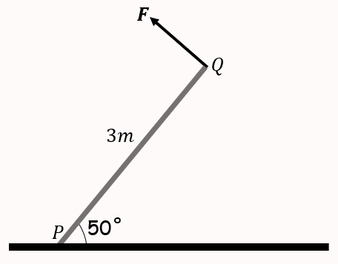

4D Non-Uniform Rods

- Sam and Tamsin are sitting on a non-uniform plank AB of mass 25kg and length 4m.
The plank is pivoted at M, the midpoint of AB, and the centre of mass is at C where AC = 1.8m.
Tamsin has mass 25kg and sits at A. Sam has mass 35kg. How far should Sam sit from A to balance the plank?

- A rod AB is 3m long and has weight 20N. It is in a horizontal position resting on supports at points C and D, where AC = 1m and AD = 2.5m.
The magnitude of the reaction at C is three times the magnitude of the reaction at D.
Find the distance of the centre of mass of the rod from A.

4E Tipping Point

- A uniform rod of length 4m and mass 12kg is resting in a horizontal position on supports at C and D, with AC = DB = 0.5m
When a particle of mass mkg is placed on the rod at point B, the rod is on the point of turning about D.
Find the value of m.

- A non-uniform rod $AB$, of length 10m and weight 40N, is suspended from a pair of light cables attached to $C$ and $D$ where $AC=3m$ and $BD=2m$.
When a weight of 25N is hung from point $A$ the rod is on the point of rotation.
Find the distance of the centre of mass of the rod from point $A$.

7D Hinges
- A Plank AB of mass M and length 2a, rests with its end A against a rough vertical wall. The plank is held in a horizontal position by a rope. One end of the rope is attached to the plank and the other end is attached to the wall at the point C, which is vertically above A.

A small block of mass 3M is placed on the plank at the point P, where AP = x. The plank is in equilibrium in a vertical plane which is perpendicular to the wall. The angle between the rope and the plank is $α$, where tan$\left(α\right)=\frac{3}{4}$, as shown.

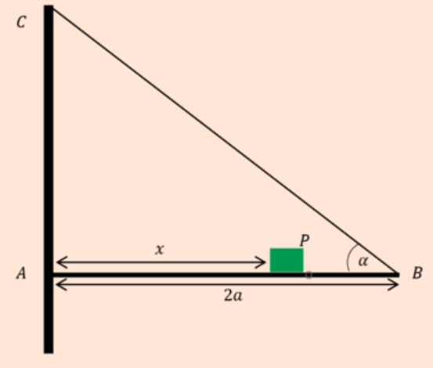

The plank is modelled as a uniform rod, the block is modelled at a particle and the rope is modelled as a light inextensible string.

- Using the model, show that the tension in the rope is

$$\frac{5Mg(3x+a)}{6a}$$

The magnitude of the horizontal component of the force exerted on the plane AB by the wall is 2Mg.
- Find x in terms of a

The forces exerted on the plank by the wall acts in a direction which makes an angle $β$ with the horizontal.
- Find the value of tan $β$

The rope will break if the tension in it exceeds 5Mg.
- Explain how this will restrict the possible values of P

5B (old Spec) Hinges
- A uniform rod AB, of mass 6kg and length 4m, is smoothly hinged at A. A light inextensible string is attached to the rod at a point C where AC = 3m, and the point D, which is vertically above point A. If the string is keeping the rod in equilibrium in a horizontal position and the angle between the string and the rod is 40°, calculate:
- The tension in the string

- The magnitude and direction of the reaction at the hinge.

7D Ladders

- A uniform rod AB of mass 40kg and length 10m rests with the end A on rough horizontal ground. The rod rests against a smooth peg C where AC = 8m. The rod is in limiting equilibrium at an angle of 15° to the horizontal. Find:
- The magnitude of the reaction at C

- The coefficient of friction between the rod and the ground

- A ladder, AB, of mass m and length 3a, has one end A resting on rough horizontal ground. The other end, B, rests against a smooth vertical wall. A load of mass 2m is fixed on the ladder at point C, where AC = a. The ladder is modelled as a uniform rod and the load is modelled as a particle. The ladder rests in limiting equilibrium at an angle of 60° with the ground.
Find the coefficient of friction between the ladder and the ground.

