Upper 6 Chapter 2

Functions and Graphs

Chapter Overview

1. The Modulus Function

2. Mappings vs Functions, Domain and Range

3. Composite Functions

4. Inverse Functions

5. Transformations of the form $y=|f\left(x\right)|$ or $y=f\left(\left|x\right|\right)$. Combined transformations and transforming the modulus function.

6. Solving modulus problems







The Modulus Function

Example:

1. If , find



$f(5)$

$f(-2)$

$f(1)$

Modulus Graphs

|  |  |  |  |  |  |
| --- | --- | --- | --- | --- | --- |
| $$x$$ | -2 | -1 | 0 | 1 | 2 |
| $$y$$ |  |  |  |  |  |

$y=|x|$

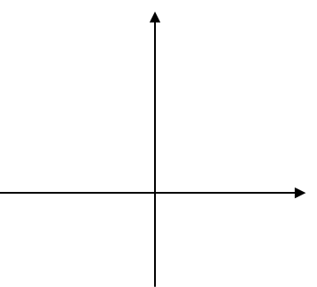Examples

1. Sketch

2. Solve



3. Solve

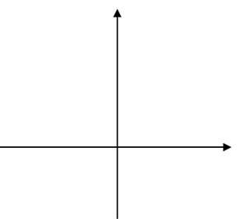

Test Your Understanding

1. Solve



2. Solve



Ex 2a page 18

Mappings

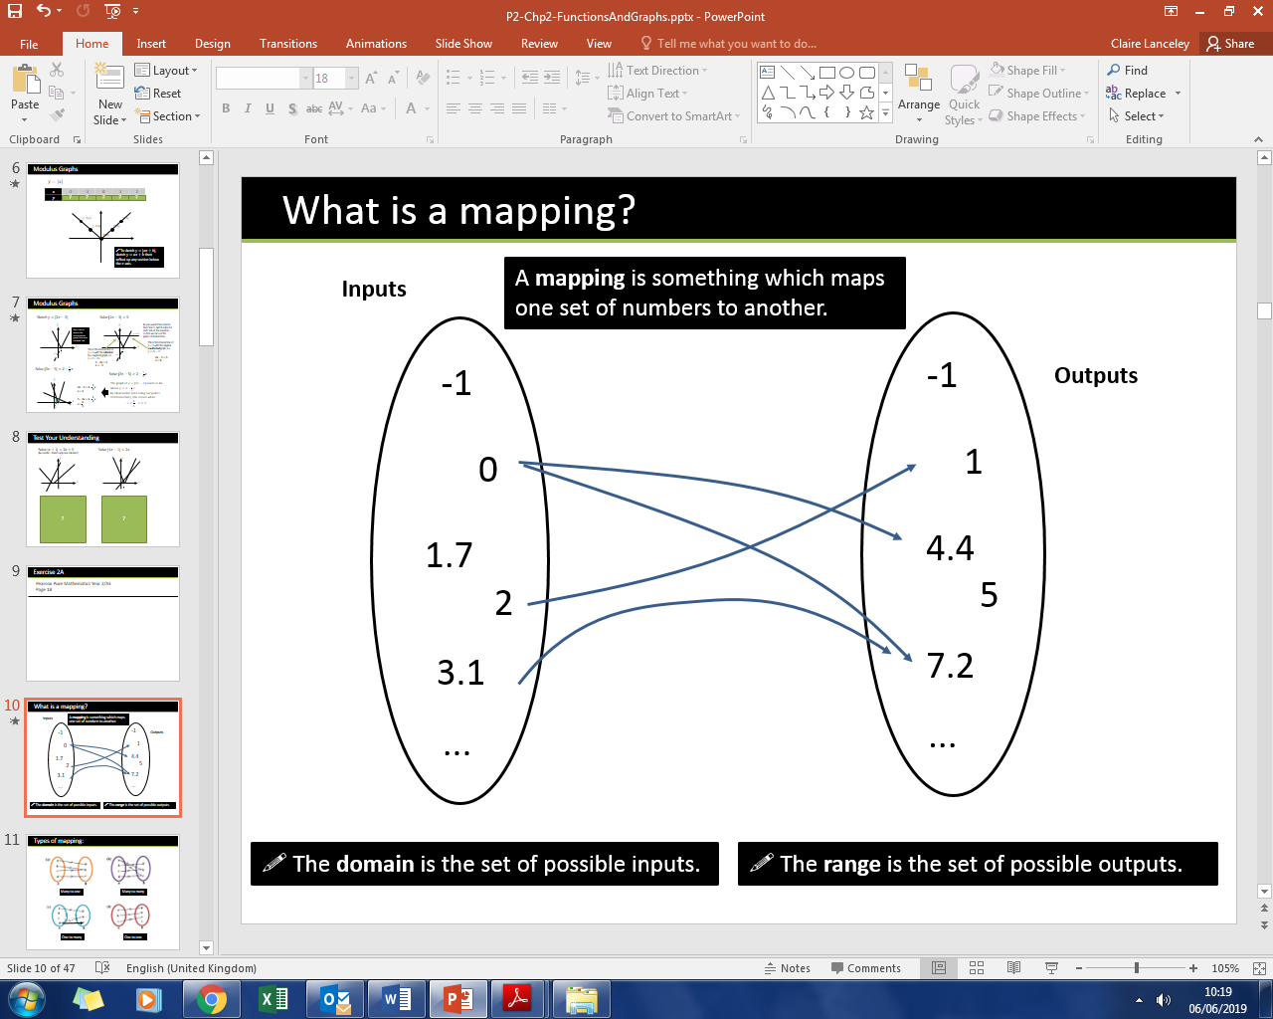

Types of Mappings

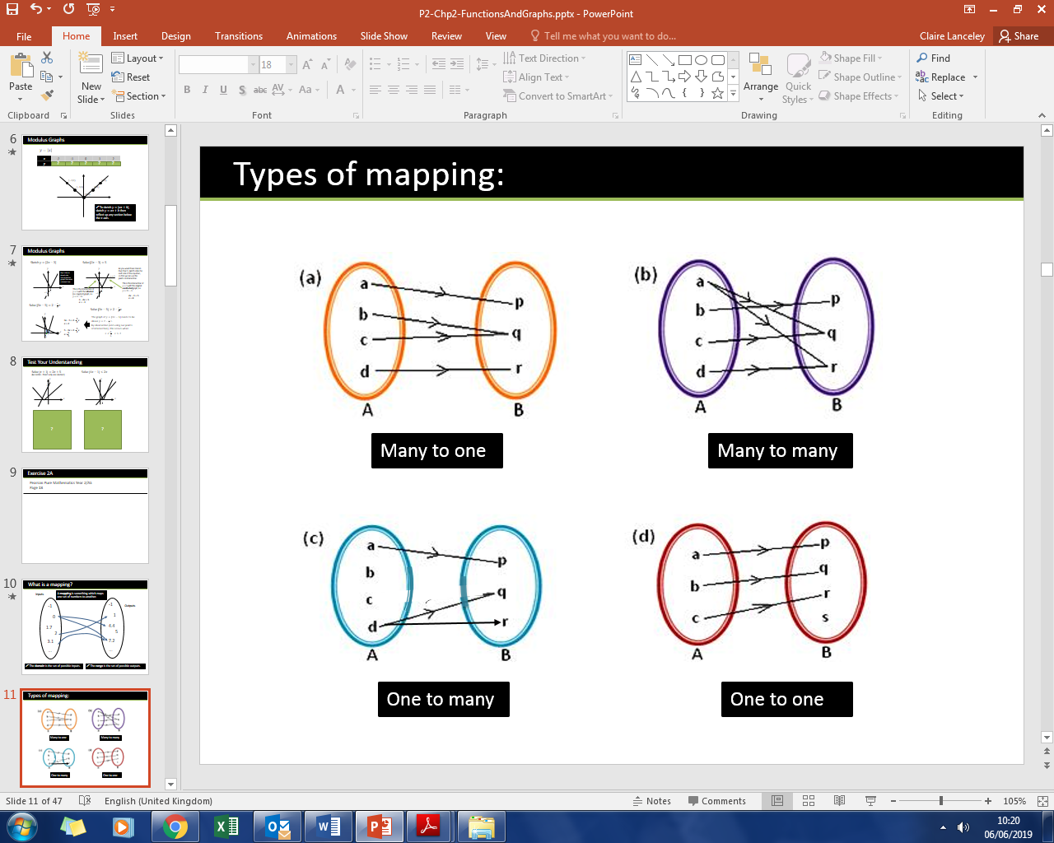

Functions

|  |  |  |
| --- | --- | --- |
| Type | Description | Example |
| Many-to-one Function |  |  |
| One-to-one Function |  |  |

Which of these are functions?

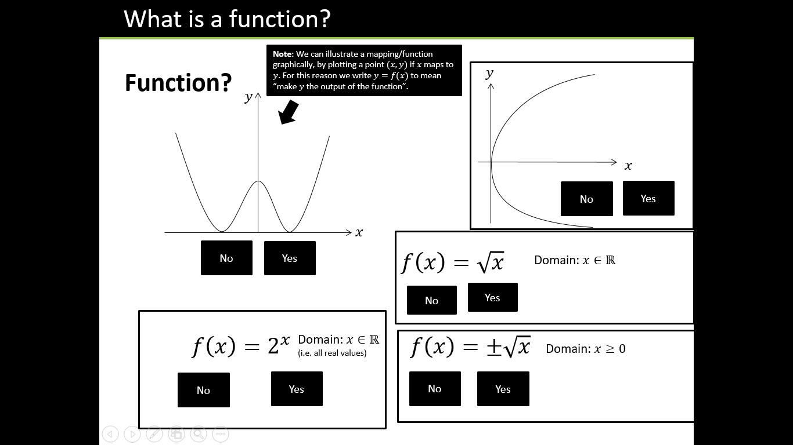

Domain and Range

Remember:

The **domain** is ……………………………………………………………………………………………………

The **range** is ……………………………………………………………………………………………………..

Using a sketch, try to identify the range of the following functions.

$f\left(x\right)=x^{2}, x∈R$

$f\left(x\right)=\frac{1}{x}, x∈R, x≠0$

$f\left(x\right)=\ln{x}, x∈R, x>0$

$f\left(x\right)=e^{x}, x∈R,$

$f\left(x\right)=x^{2}+2x+9, x∈R$

$f\left(x\right)=x^{2}, x∈R, -1≤x≤4$

Further Example

Find the range of each of the following functions.

1. $f\left(x\right)=3x-2$, domain $\{1,2,3,4\}$
2. $g\left(x\right)=x^{2}$, domain $\left\{x∈R, -5≤x≤5\right\}$
3. $h\left(x\right)=\frac{1}{x}$, domain $\{x∈R, 0<x≤3$}

State if the functions are one-to-one or many-to-one.

Piecewise Functions

Examples

1. The function $f(x)$ is defined by
$$f:x→\left\{\begin{aligned}5-2x, x<1 \\ x^{2}+3, x≥1\end{aligned}\right.$$

2. Sketch $y=f\left(x\right)$, and state the range of $f\left(x\right)$.
3. Solve $f\left(x\right)=19$

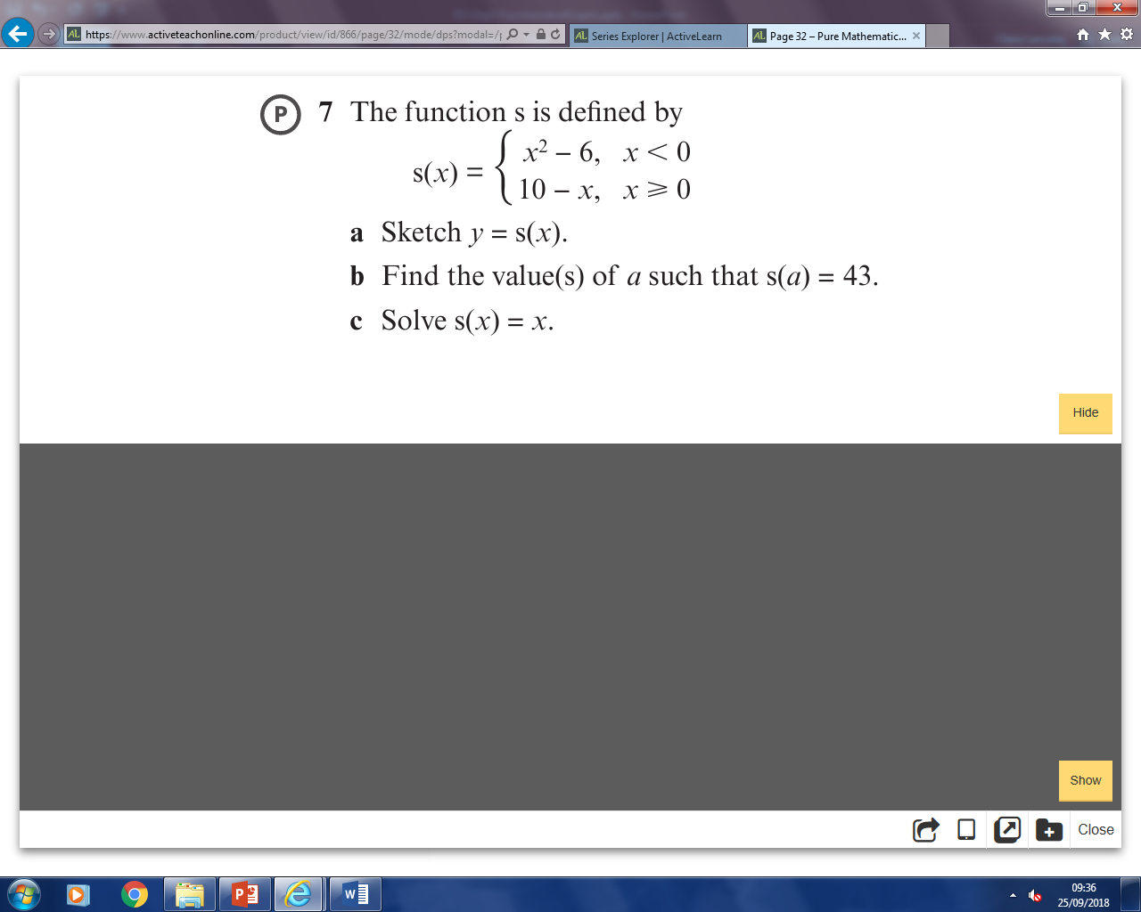

Test Your Understanding

1. The function $f$ is defined by

$$f:x→e^{x}+2, x∈R$$

State the range of $f$.

1. The function $g$ is defined by

$$g:x→x^{2}-4x+1, x∈R, 0≤x≤5$$

Find the range of $g$.

Ex 2B Pg 30

Composite Functions

Examples

1. Let $f\left(x\right)=x^{2}+1$, and $g\left(x\right)=4x-2$. Find

$a) fg(2)$ $b) fg(x)$

$c) gf(x)$ ${d) f}^{2}\left(x\right)$

Solve $gf\left(x\right)=38$

1. The functions $f$ and $g$ are defined by

$$f:x→\left|2x-8\right|g:x→\frac{x+1}{2}$$

a) Find $fg\left(3\right)$ b) Solve $fg\left(x\right)=x$

Test your understanding

1. The functions and $f$ and $g$ are defined by
$$f:x→2\left|x\right|+3, x∈R$$

$$g:x→3-4x, x∈R$$

2. Find $fg\left(1\right)$
3. Solve the equation
$$gg\left(x\right)+{\left[g\left(x\right)\right]}^{2}=0$$

4. The functions $f$ and $g$ are defined by
$$f:x→e^{x}+2, x∈Rg:x→\ln{x}, x>0$$

5. Find $fg\left(x\right)$, giving your answer in its simplest form.

Extension

[MAT 2014 1F]

The functions $S$ and $T$ are defined for real numbers by $S\left(x\right)=x+1$ and $T\left(x\right)=-x$.

The function $S$ is applied $s$ times and the function $T$ is applied $t$ times, in some order, to produce the function

$$F\left(x\right)=8-x$$

It is possible to deduce that:

1. $s=8$ and $t=1$
2. $s$ is odd and $t$ is even.
3. $s$ is even and $t$ is odd.
4. $s$ and $t$ are powers of 2.
5. none of the above.

Ex 2C Pg 34

[MAT 2012 Q2]

Let $f\left(x\right)=x+1$ and $g\left(x\right)=2x$.

i) Show that $f^{2}g\left(x\right)=gf\left(x\right)$

ii) Note that $gf^{2}g\left(x\right)=4x+4$

Find all the other ways of combining $f$ and $g$ that result in the function $4x+4$.

iii) Let $i,j,k≥0$ be integers. Determine the function

$$f^{i}gf^{j}gf^{k}(x)$$

iv) Let $m≥0$ be an integer. How many different ways of combining the functions $f$ and $g$ are there that result in the function $4x+4m$?

Inverse Functions

Why must the function be one-to-one for an inverse function to exist?

How do we find an inverse function?

Example Steps

1. If $f\left(x\right)=3-4x$, find $f^{-1}(x)$
2. If $f\left(x\right)=\frac{x+2}{2x-1}$, $x≠\frac{1}{2}$, determine $f^{-1}\left(x\right)$

Graphing an Inverse Function

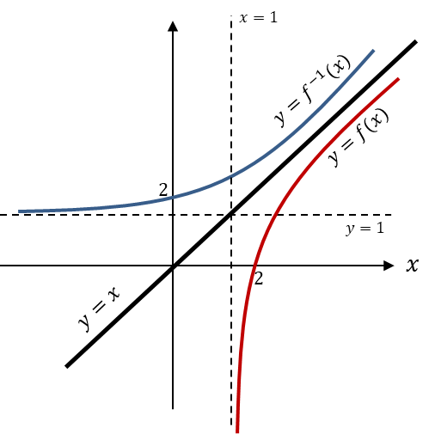

The domain of $f\left(x\right)$ is the range of $f^{-1}\left(x\right)$ and vice versa.

Example

If $g(x)$ is defined as $g\left(x\right)=\sqrt{x-2} \left\{x∈R,x≥2\right\}$

1. Find the range of $g\left(x\right)$.
2. Calculate $g^{-1}\left(x\right)$
3. Sketch the graphs of both functions.
4. State the domain and range of $g^{-1}\left(x\right)$.

Test your understanding

The function $f$ is defined by

$f:x→e^{x}+2$, $x∈R$

(a) Find $f^{-1}$, the inverse function of $f$, stating its domain.

(b) On the same axe sketch the curves with equation $y=f\left(x\right)$ and $y=f^{-1}\left(x\right)$, giving the coordinates of all the points where the curves cross the axes.

Ex 2D Pg 38

Sketching $y=|f\left(x\right)|$ and $y=f\left(\left|x\right|\right)$

It is important to understand the difference between $y=|f\left(x\right)|$ and $y=f\left(\left|x\right|\right)$ and to be able to graph each of these.

The graph below shows $y=f(x)$ where $f\left(x\right)=(x-3)(x+1)$. Sketch $y=|f\left(x\right)|$ and

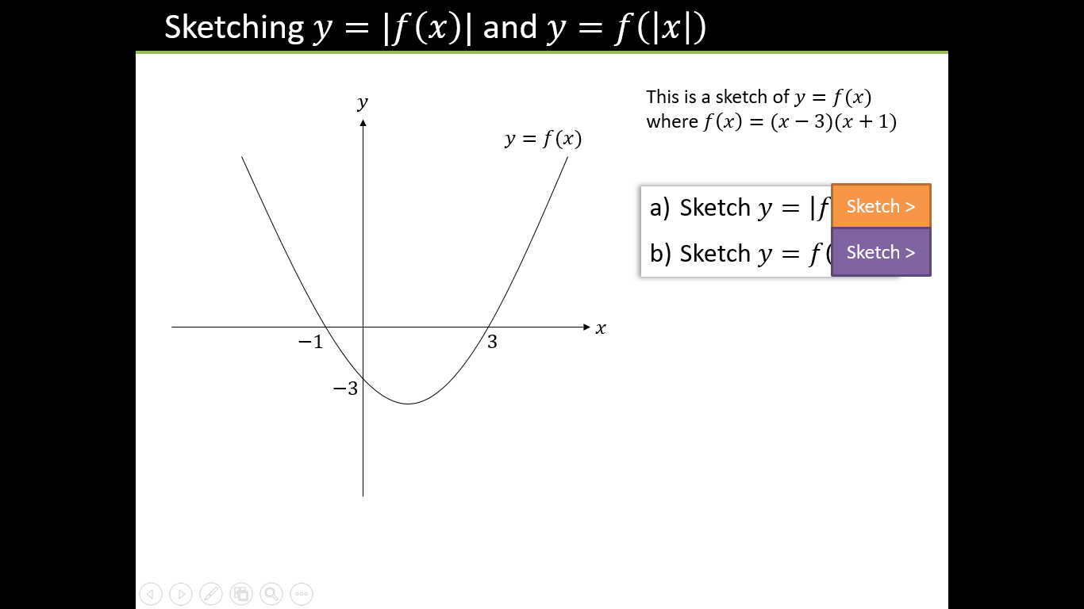





Test your understanding

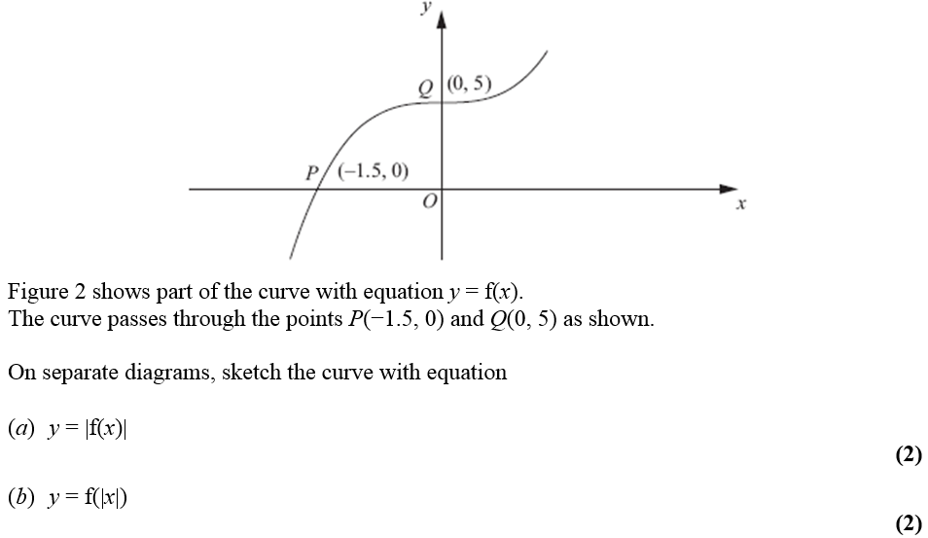

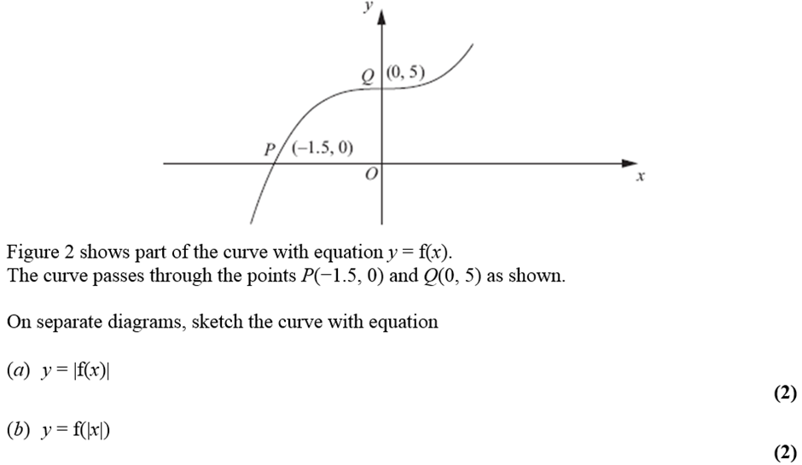



Test your understanding

Sketch for $-2π≤x≤2π$:

a) $y=\left|\sin\left(x\right)\right|$  
b) $y=sin⁡(\left|x\right|)$

Extension

Ex 2E Pg 42

[SMC 2008 Q25] What is the area of the polygon forms by all the points $(x,y)$

in the plane satisfying the inequality $\left|\left|x\right|-2\right|+\left|\left|y\right|-2\right|≤4$?  
A 24 B 32 C 64 D 96 E 112

Combining Transformations

|  |  |  |
| --- | --- | --- |
|  | Affects what axis? | What we expect or opposite? |
| Change inside f( ) |  |  |
| Change outside f( ) |  |  |

In L6 we studied transformations. Here we are asked to combine more than one transformation to a function.

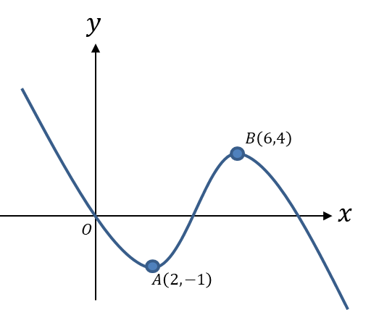

Examples

1. Here is a graph of $y=f(x)$.

Sketch the graph of:

a)

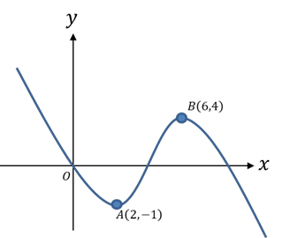

1. )

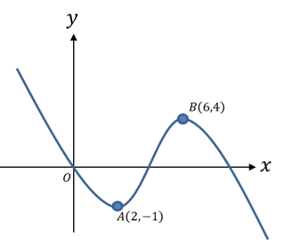

1. 

Test Your Understanding

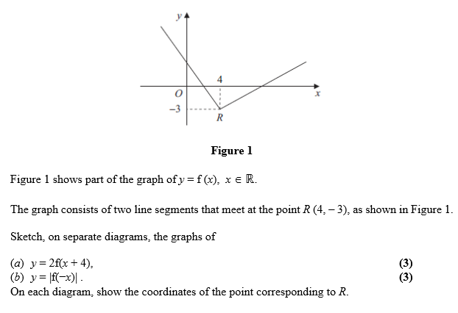  

Ex2F Pg 47

Solving Modulus Problems

Modulus questions are very common in exams. It is important that you are confident with all aspects of questions including sketching graphs, finding the range ad domain and solving equations.

Examples

1. Given the function $f\left(x\right)=3\left|x-1\right|-2, x∈R$,
2. Sketch the graph of $y=f\left(x\right)$
3. State the range of $f$.
4. Solve the equation $f\left(x\right)=\frac{1}{2}x+3$

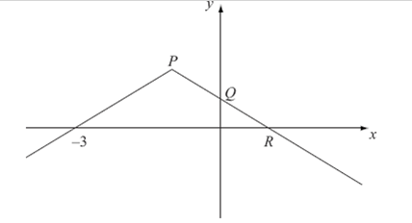Test Your Understanding

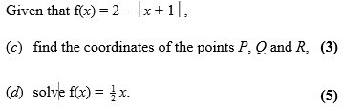

Extension

Ex 2G Pg 51

*[MAT 2006 1I]*

The equation $\left|x\right|+\left|x-1\right|=0$ has how many solutions?