Upper 6 Chapter 10
Numerical Methods
Chapter Overview
1. Locating Roots
2. Iteration
3. The Newton-Raphson Method
4. Applications to Modelling

LOCATING ROOTS

Finding the root of a function $f\left(x\right)$ is to solve the equation $f\left(x\right)=0$

However, for some functions, the ‘exact’ root is complicated and difficult to calculate …

For example:
$$x^{3}+2x^{2}-3x+4=0$$
has the solution:
$$x=\frac{1}{3}\left(-2-\frac{13}{\sqrt[3]{89-6\sqrt{159}}}-\sqrt[3]{89-6\sqrt{159}}\right)$$

… or there is no ‘algebraic’ expression at all. (involving roots, logs, sin, cos, etc.)

For example:
$$x-\cos\left(x\right)=0$$

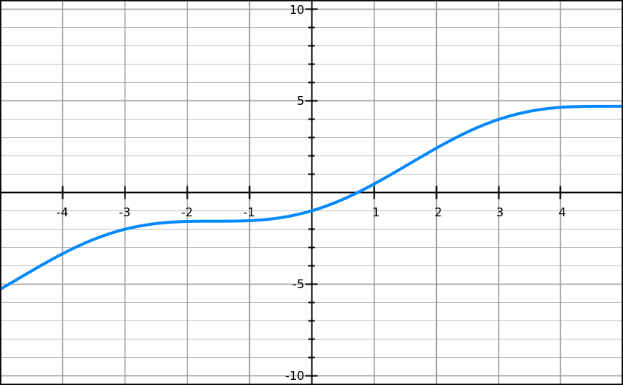

has a root here

To show that a root exists in a given interval, show that $f\left(x\right)$ changes sign

Example 1
Show that ${f\left(x\right)=e}^{x}+2x-3$ has a root between $x=0.5$ and $x=0.6$

STEP 1: Find $f\left(x\right)$ for the two values given in the question

STEP 2: Write a concluding statement referring to the change in sign and the fact that $f\left(x\right)$ is a continuous function

Note on functions that are NOT continuous:
If the function is not continuous, the sign change may be due to an asymptote rather than a root.
For example:
When $f\left(x\right)=\frac{1}{x}$, then $f\left(-1\right)=-1$ and $f\left(1\right)=1$.
However, although there is a sign change, a root does not exist between $x=-1$ and $x=1$

Note on continuous functions:
A continuous function could simply have an even number of roots in a given interval rather than no roots.
For example:
Here $f\left(a\right)$ is negative and $f\left(b\right)$ is also negative
However, although there are two roots, a sign change does not occur.
a
b

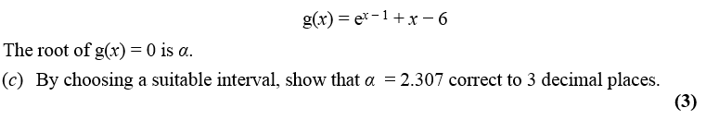
Example 2
Edexcel C3 Jan 2013

Example 3
(a) Using the same axes, sketch the graphs of $y=\ln{x}$ and $y=\frac{1}{x}$. Explain how your diagrams shows that the function $y=\ln\left(x\right)-\frac{1}{x}$ has only one root.
(b) Show that this root lies in the interval $1.7<x<1.8$
(c) Given that the root of $f\left(x\right)$ is $α$, show that $α=1.763$ correct to 3 decimal places.

Exercise 10A Page 276

ITERATION
To solve $f\left(x\right)=0$ by an iterative method, rearrange into a form $x=g\left(x\right)$ and use the iterative formula $x_{n+1}=g\left(x_{n}\right)$
Example 1
Edexcel C3 Jan 2013
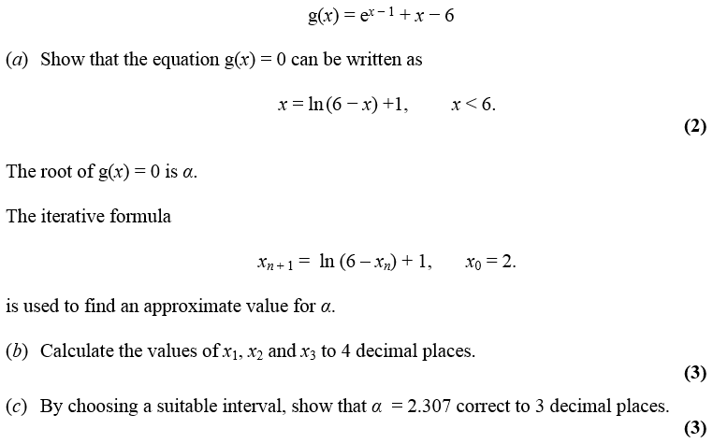

a)

b) $x_{1}$, $x_{2}$, $x_{3}$ represent successively better approximations of the root
Initially type $x_{0}$ (i.e. 2) onto your calculator.
Now just type: $\ln\left(6-ANS\right)+1$
And then press your $=$ key to get successive iterations.

c)

The starting value $x_{0}$matters.
- If there are a multiple roots, the iteration might converge to (i.e. approach) a different root.
- The iteration not converge to a root at all and diverges (i.e. approach infinity).

Example 2
$$f\left(x\right)=x^{3}-3x^{2}-2x+5$$
- Show that the equation $f\left(x\right)=0$ has a root in the interval $3<x<4$.
- Use the iterative formula $x_{n+1}=\sqrt{\frac{x_{n}^{3}-2x_{n}+5}{3}}$ to calculate the values of $x_{1}$, $x_{2}$ and $x_{3}$, giving your answers to 4 decimal places, and taking:
(i) $x_{0}=1.5$ (ii) $x_{0}=4$

Staircase and cobweb diagrams

Example 3
$$f\left(x\right)=x^{2}-8x+4$$
- Show that the root of the equation $f\left(x\right)=0$ can be written as $x=\sqrt{8x-4}$
- Using the iterative formula $x_{n+1}=\sqrt{8x_{n}-4}$, and starting with $x_{0}=1$, draw a staircase diagram, indicating $x_{0},x_{1}, x_{2}$ on your $x$-axis, as well as the root $α$.

Exercise 10B Page 280

THE NEWTON-RAPHSON METHOD

The Newton- Raphson method can be used to find numerical solutions to equations of the form $f\left(x\right)=0$. You need to be able to differentiate $f\left(x\right)$ in order to use this method.
The Newton- Raphson formula is:
$$x_{n+1}=x_{n}-\frac{f\left(x_{n}\right)}{f^{'}\left(x_{n}\right)}$$

Example 1
Recall that in lesson 1 we saw that the function $f\left(x\right)=x-\cos\left(x\right)$ has a root, $α$, in the interval $0<α<1$.
Using $x_{0}=0.5$ as a first approximation to$α$, apply the Newton-Raphson procedure three times to find a better approximation to $α$ which, in this case, will be accurate to 7 decimal places.

To perform iterations quickly, do the following on your calculator:
[0.5] [=]
[ANS] – (ANS – cos(ANS))/(1 + sin(ANS))
Then press [=].

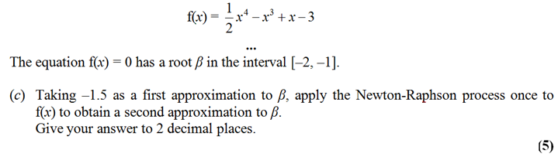
Example 2
Edexcel FP1 June 2013(R) Q3c

Edexcel FP1 Jan 2010 Q2c
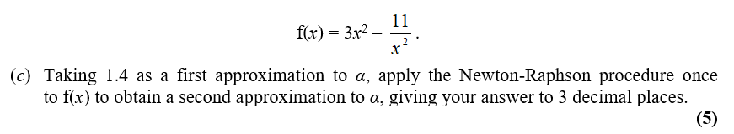
Example 3

When does Newton-Raphson fail?

$$x$$
$$y$$
$$x_{0}$$
tangent

$$x_{n+1}=x_{n}-\frac{f\left(x_{n}\right)}{f^{'}\left(x_{n}\right)}$$

If the starting value $x_{0}$ was the stationary point, then $f^{'}\left(x_{0}\right)=0$, resulting in a division by 0 in the above formula.
Graphically, it is because the tangent will never reach the $x$-axis.

$$x$$
$$y$$
$$y=\frac{x}{\sqrt{1+x^{2}}}$$
$$x_{0}$$
$$x_{1}$$
$$x_{2}$$
Newton-Raphson also suffers from the same drawbacks as solving by iteration, in that it is possible for the values of $x_{i}$ to diverge.
In this example, the $x_{i}$ oscillate either side of 0, but get gradually further away from $α=0$.

Exercise 10C Page 284

APPLICATIONS TO MODELLING

Example 4
The price of a car in £s, $x$ years after purchase, is modelled by the function
$$f\left(x\right)=15 000 {\left(0.85\right)}^{x}-1000\sin{x}, x>0$$
- Use the model to find the value, to the nearest hundred £s, of the car 10 years after purchase.
- Show that $f\left(x\right)$ has a root between 19 and 20.
- Find $f^{'}\left(x\right)$
- Taking 19.5 as a first approximation, apply the Newton-Raphson method once to $f(x)$ to obtain a second approximation for the time when the value of the car is zero. Give your answer to 3 decimal places.
- Criticise this model with respect to the value of the car as it gets older.

Exercise 10D Page 287

