The Large Data Set
All A Level exam boards are obligated to provide a ‘large data set’. Data in exam questions will often be from this set, and you are encouraged to explore this data (which is publicly available) in Microsoft Excel.
It is important to note that you are expected to be familiar with this data set before you go into your exam, including some basic geographic knowledge!

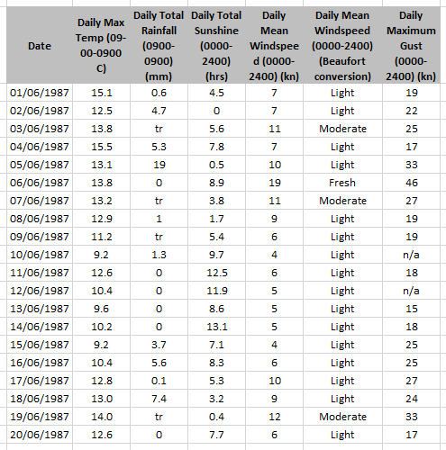
Example.
- Describe the type of data represented by daily total rainfall.

Alison is investigating daily maximum gust. She wants to select a sample of size 5 from the first 20 days in Hurn in June 1987. She uses the first two digits of the date as a sampling frame and generates five random numbers between 1 and 20.
- State the type of sample selected by Alison.

- Explain why Alison’s process might not generate a sample of size 5.
Exercise 1E Page 13
