Daily Mean Temperature (0900-0900) (°C) | Time series graph UK
 | Time series graph UK Overseas
 | Box and Whisker plot UK
 | Box and Whisker plot Overseas
 | Histogram UK
 | Histogram Overseas
Daily Total Rainfall (0900-0900) (mm) | Box and Whisker plot UK
 | Box and Whisker plot overseas
 | Histograms UK
 | Histograms Overseas
 | Time series graph UK
 | Time series graph UK Overseas
Daily Total Sunshine (0000-2400) (hrs) | Time series graph UK
 | Histograms UK
 | Box and Whisker plot UK
Daily Mean Windspeed (0000-2400) (kn) | Box and Whisker plot UK
 | Box and Whisker plot Overseas
 | Histograms UK
 | Histograms Overseas
Daily Mean Windspeed (0000-2400) (kn) against Daily Maximum Gust (kn) | Scatter graph UK
Daily Mean Windspeed (0000-2400) (Beaufort conversion) | Bar chart UK
 | Bar chart Overseas
Daily Maximum Gust (0000-2400) (kn) | Histograms UK
 | Box and Whisker plot UK
Daily Maximum Relative Humidity % | Box and Whisker plot UK
 | Time series graphs UK
 | Histograms UK
Daily Mean Total Cloud (oktas) | Bar chart UK
Daily Mean Total Cloud (oktas) against Daily total Sunshine (hrs) | Scatter graph UK
Daily Mean Total Cloud (oktas) against Daily total Rainfall (mm) | Scatter graph UK
Daily Mean Visibility (Dm) | Box and Whisker plot UK
 | Histograms UK
 | Time series graphs UK
Daily Mean Pressure (hPa) | Box and Whisker plot UK
 | Box and Whisker plot Overseas
 | Histograms UK
 | Histograms Overseas
 | Time series graphs UK
 | Time series graph UK Overseas
Daily Mean Pressure (hPa) against Daily Maximum Gust (kn) | Scatter graph UK
Daily Mean Wind Direction (o) | Bar chart UK
Daily Mean Wind Direction Cardinal Direction | Bar chart UK
Daily Max Gust Corresponding Direction (o) | Bar chart UK
Daily Max Gust Corresponding Direction Cardinal Direction | Bar chart UK

Daily Mean Temperature (0900-0900) (°C) Back to the Index

Daily Mean Temperature (0900-0900) (°C) Back to the Index

Daily Mean Temperature (0900-0900) (°C) Back to the Index

Daily Mean Temperature (0900-0900) (°C) Back to the Index

Daily Mean Temperature (0900-0900) (°C) Back to the Index
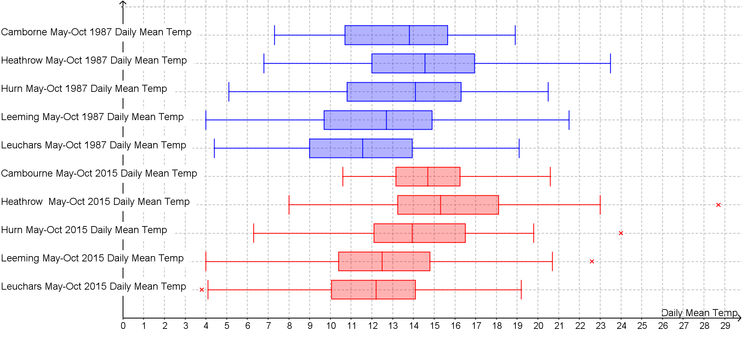

Daily Mean Temperature (0900-0900) (°C) Back to the Index

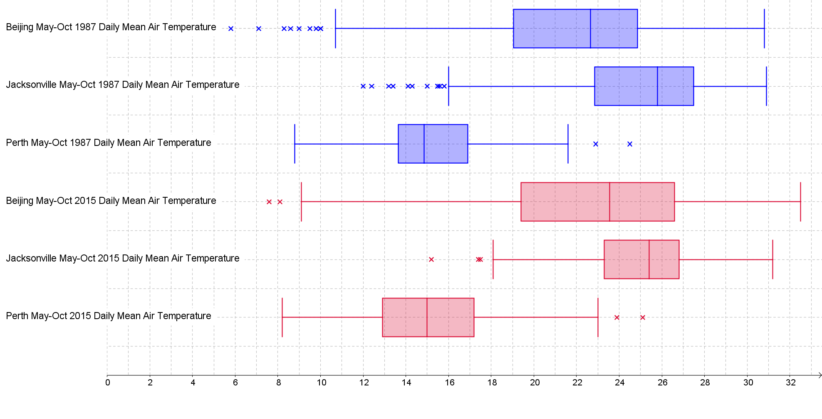

Daily Mean Temperature (0900-0900) (°C) Back to the Index
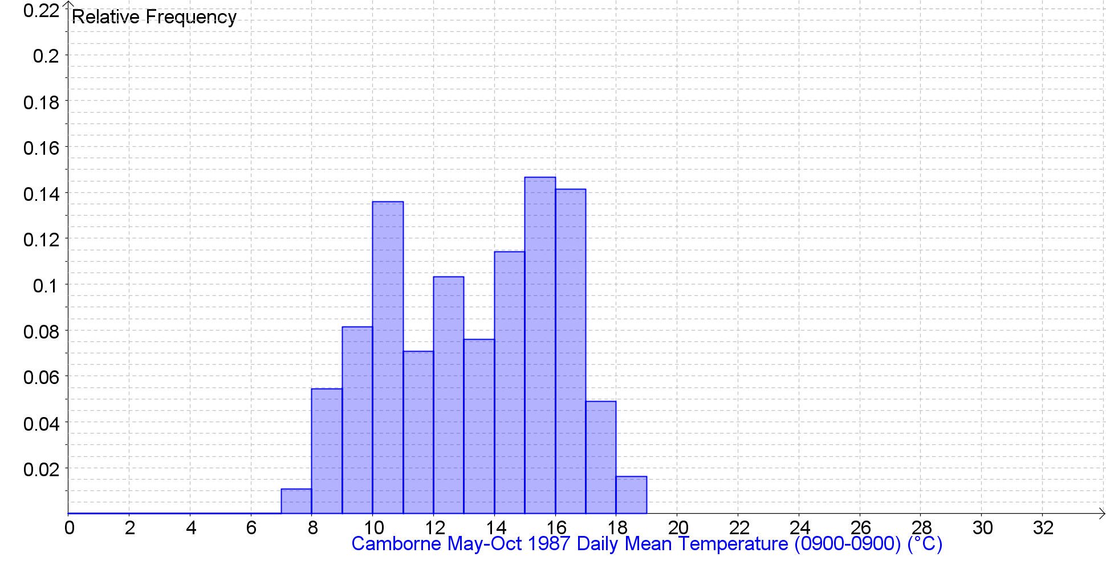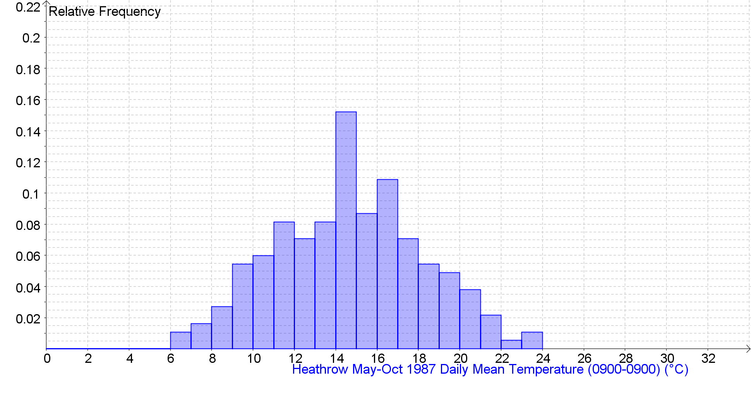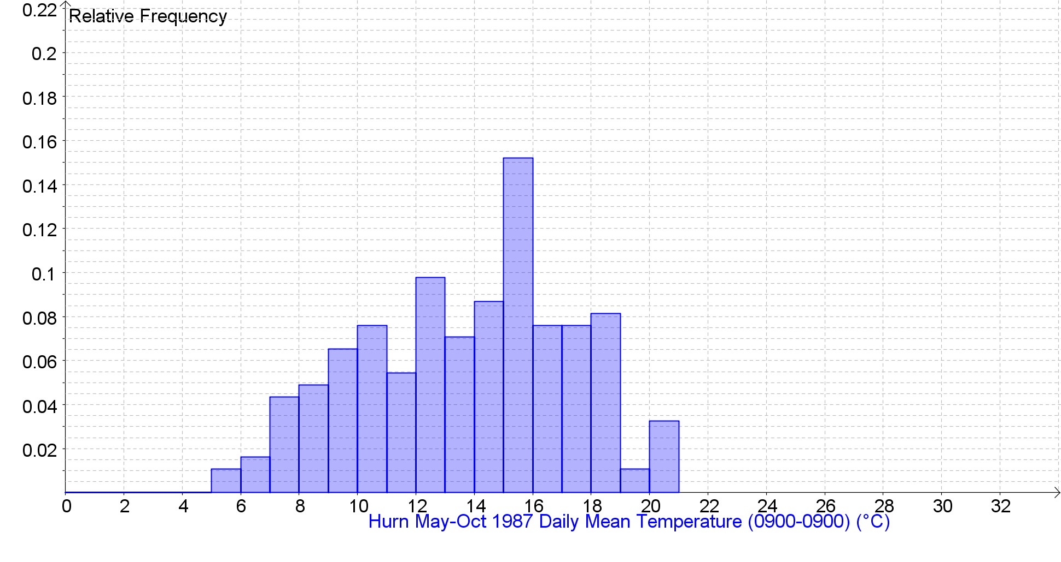

Daily Mean Temperature (0900-0900) (°C) Back to the Index
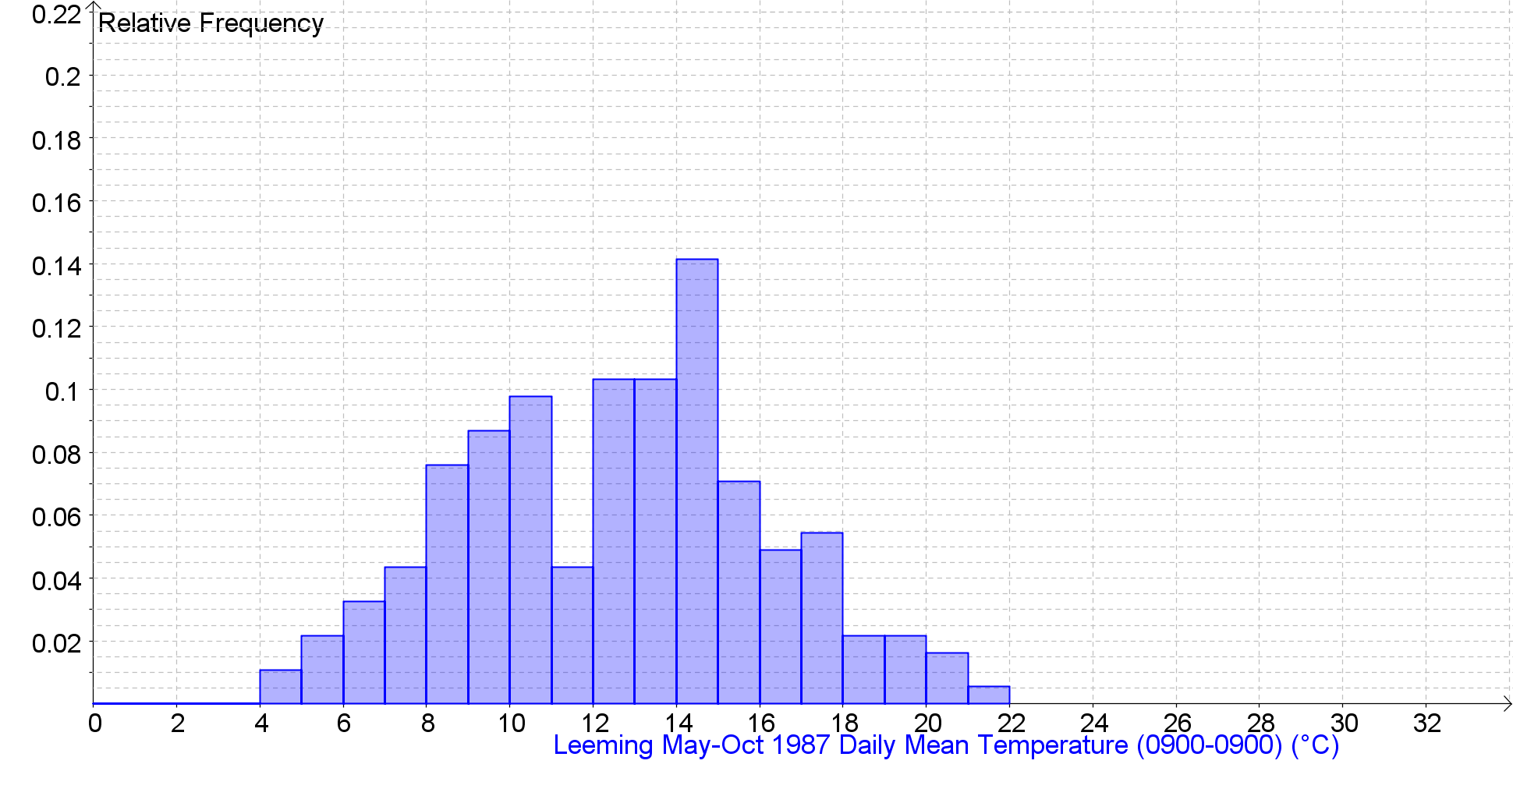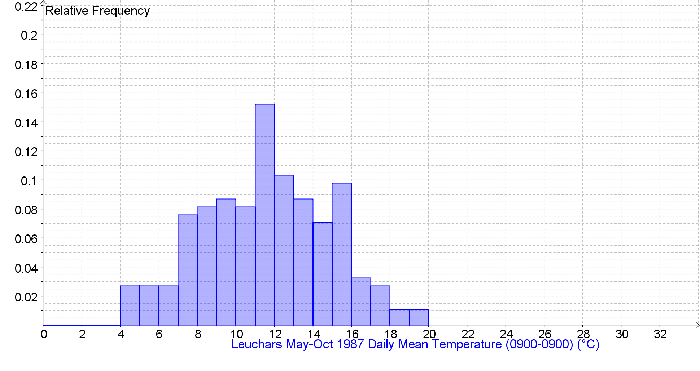

Daily Mean Temperature (0900-0900) (°C) Back to the Index
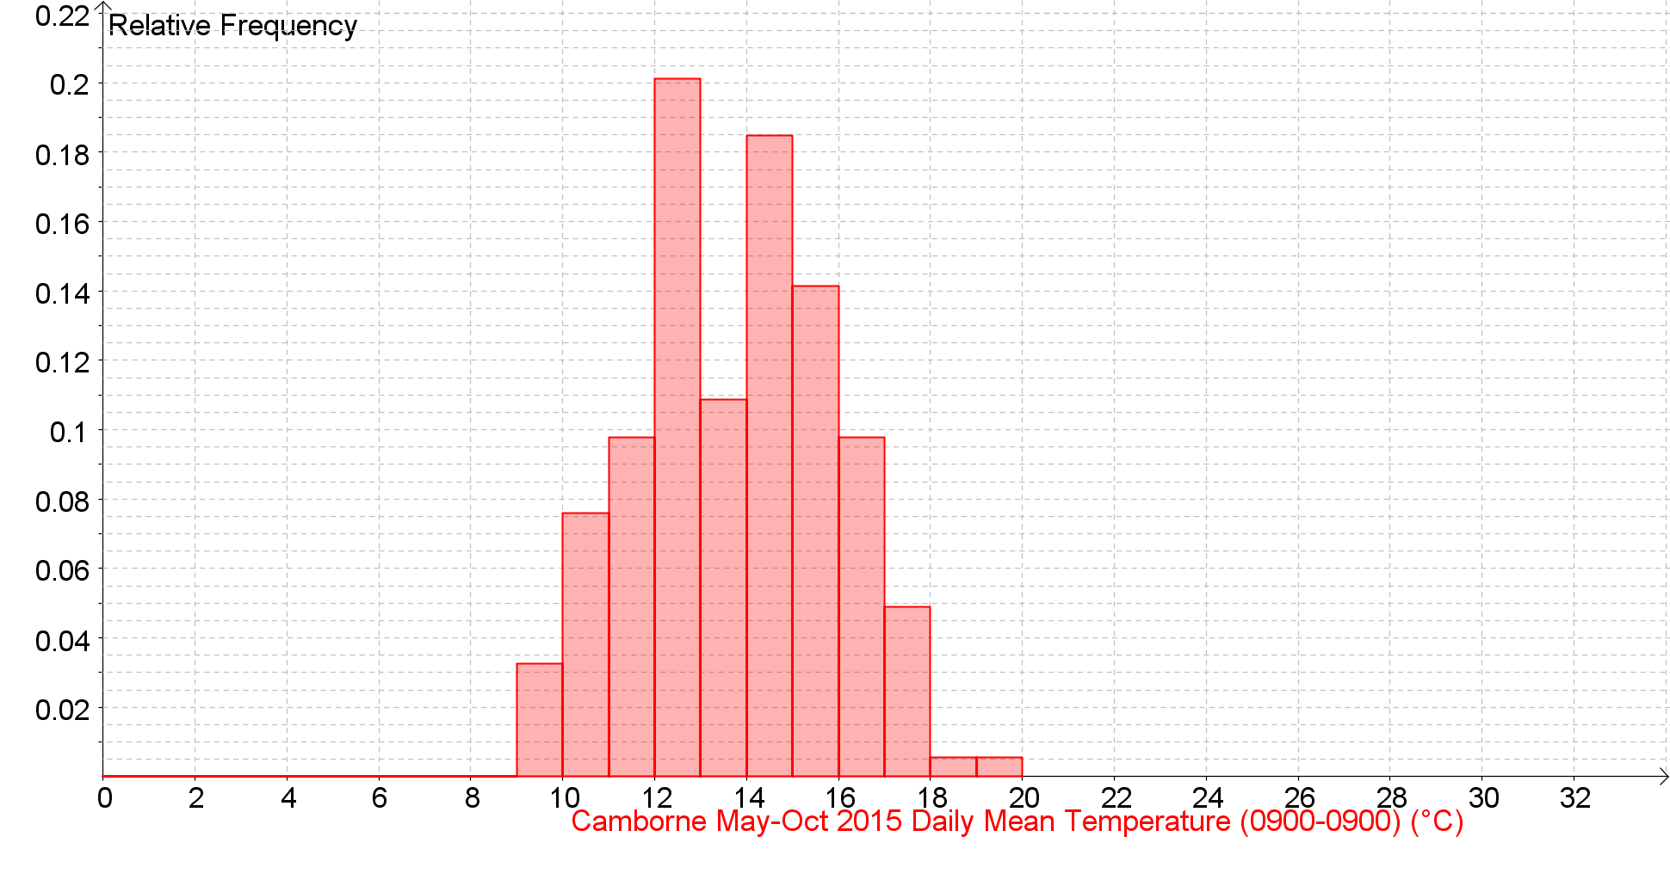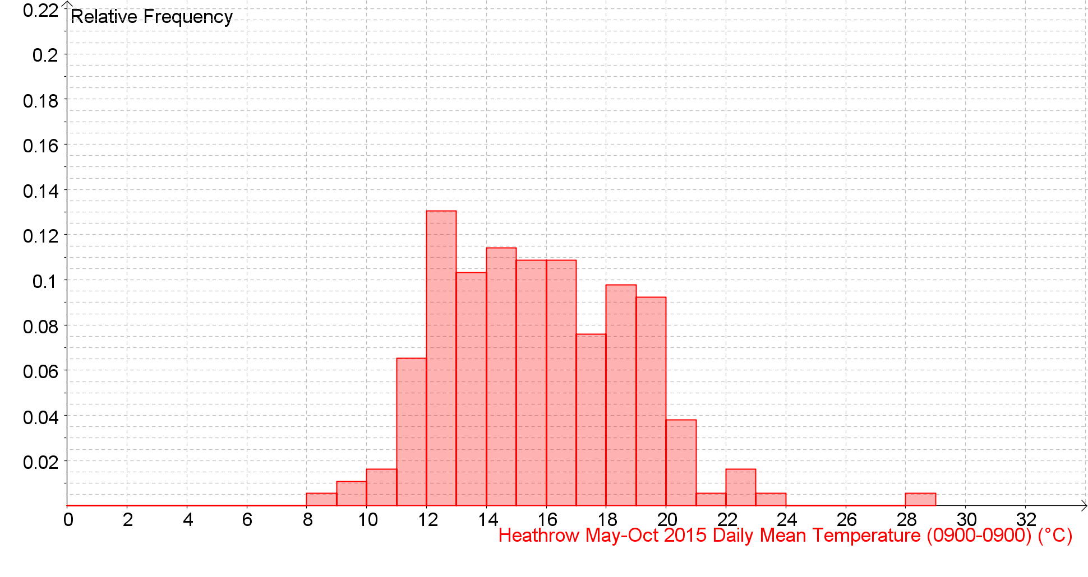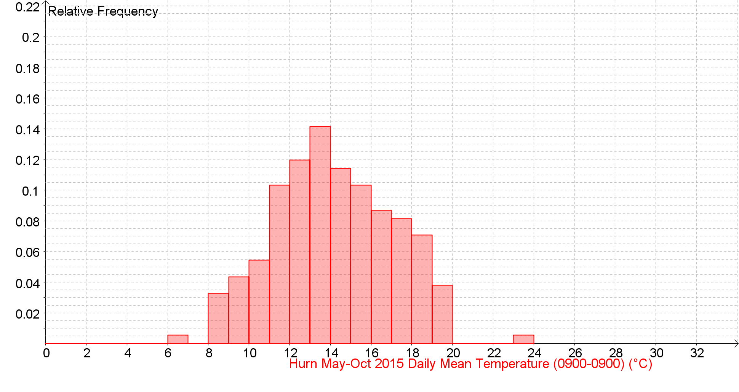
Daily Mean Temperature (0900-0900) (°C) Back to the Index
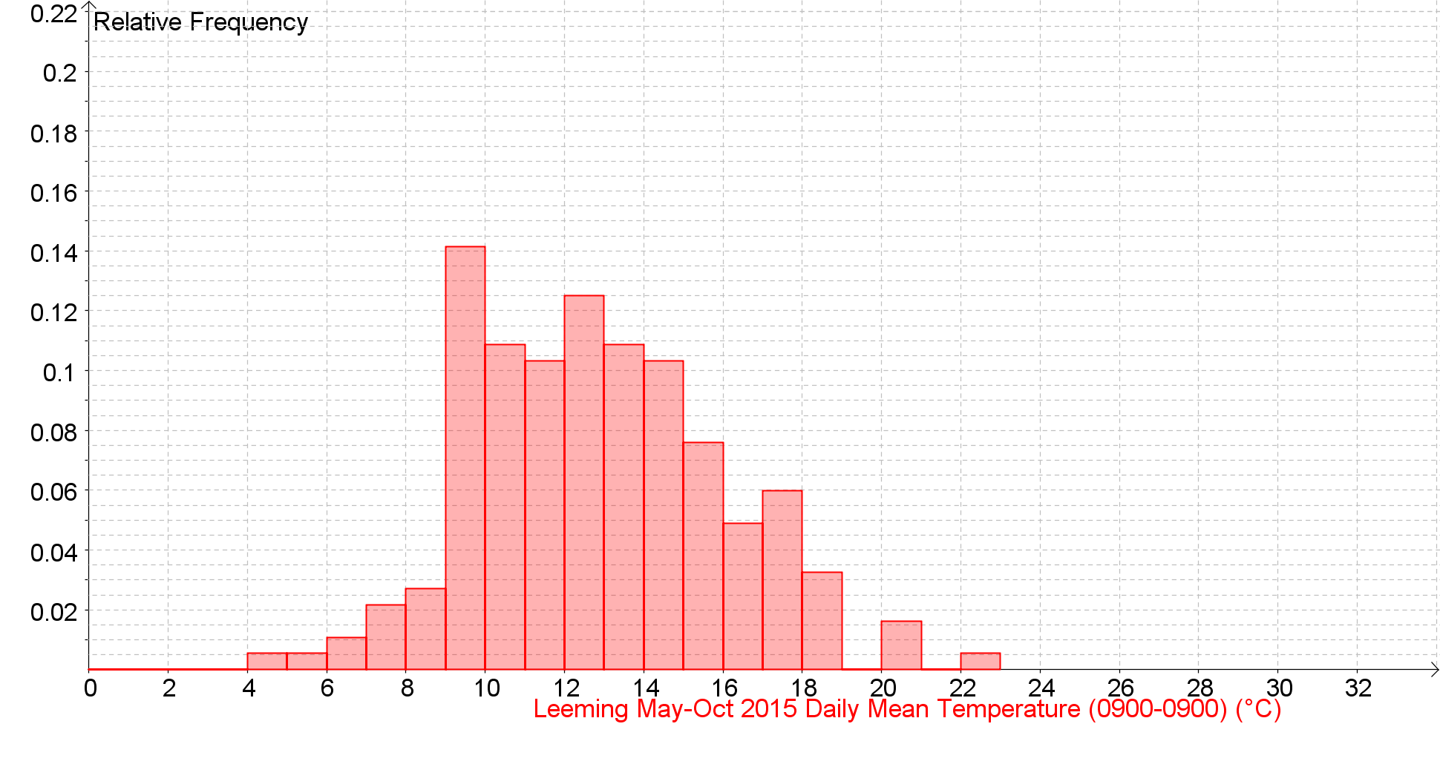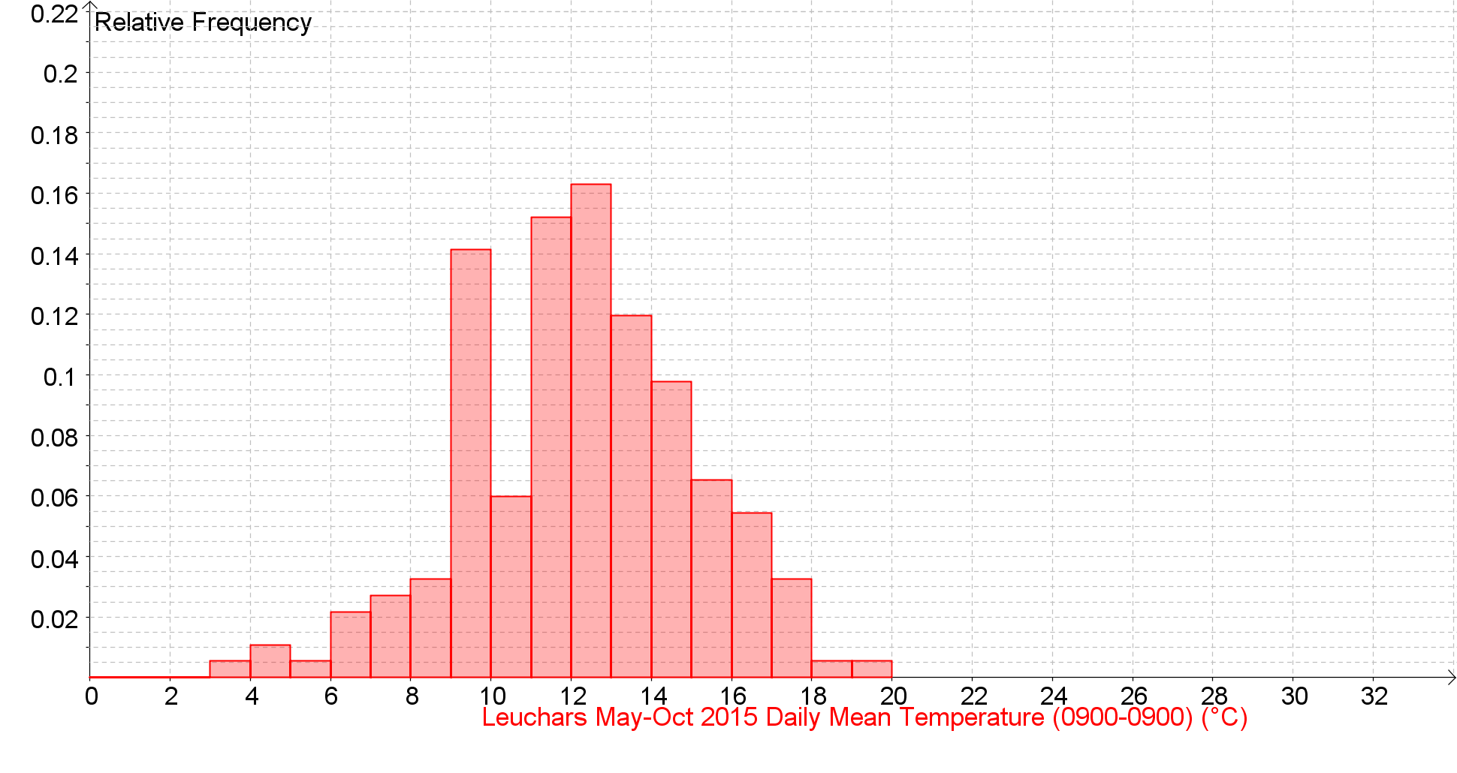

Daily Mean Temperature (0900-0900) (°C) Back to the Index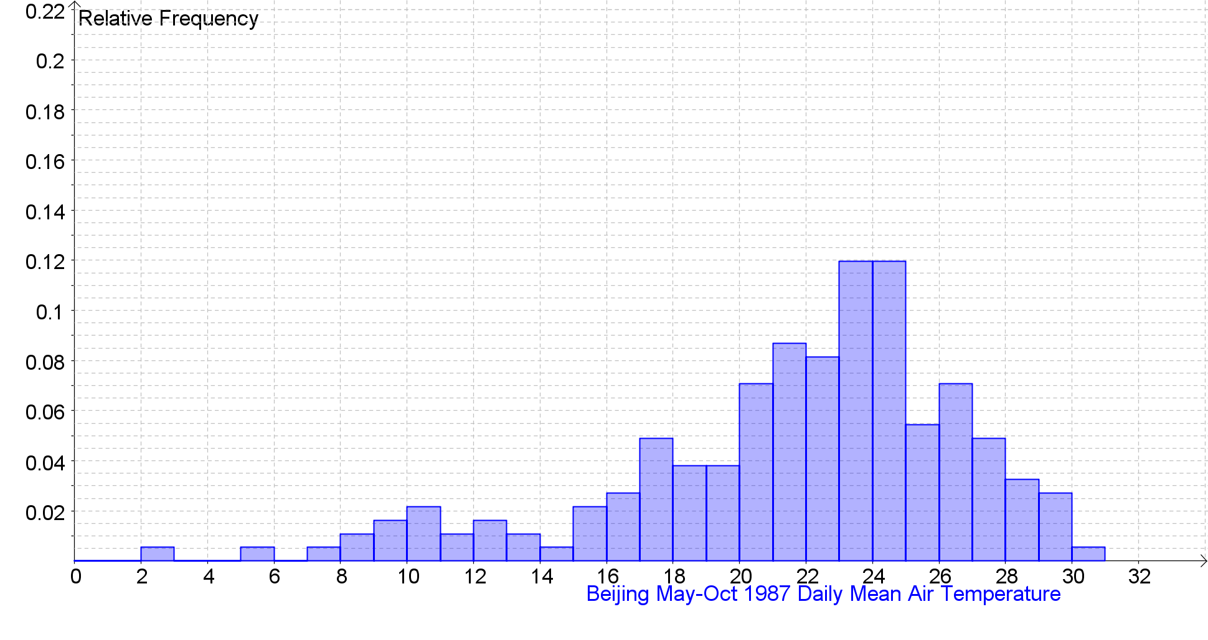 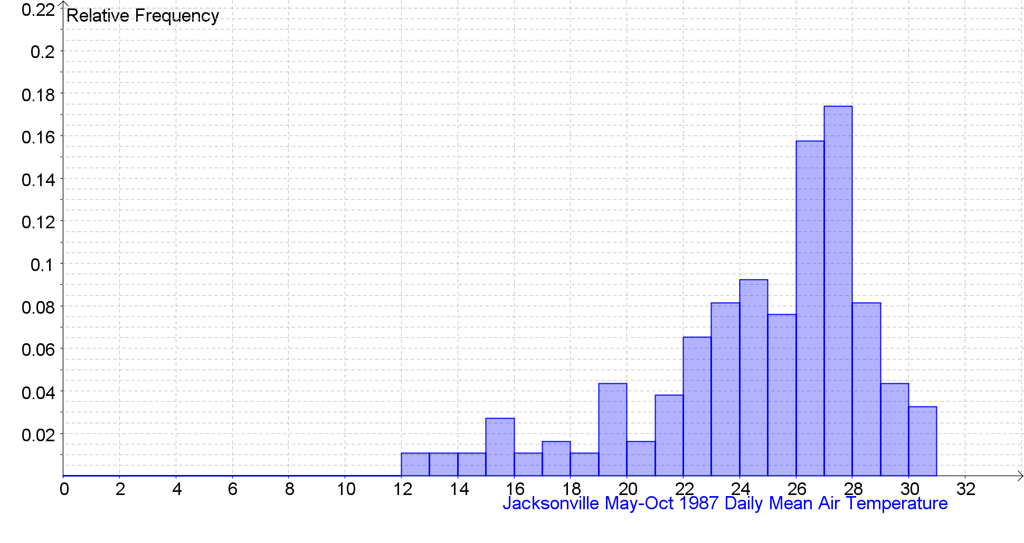 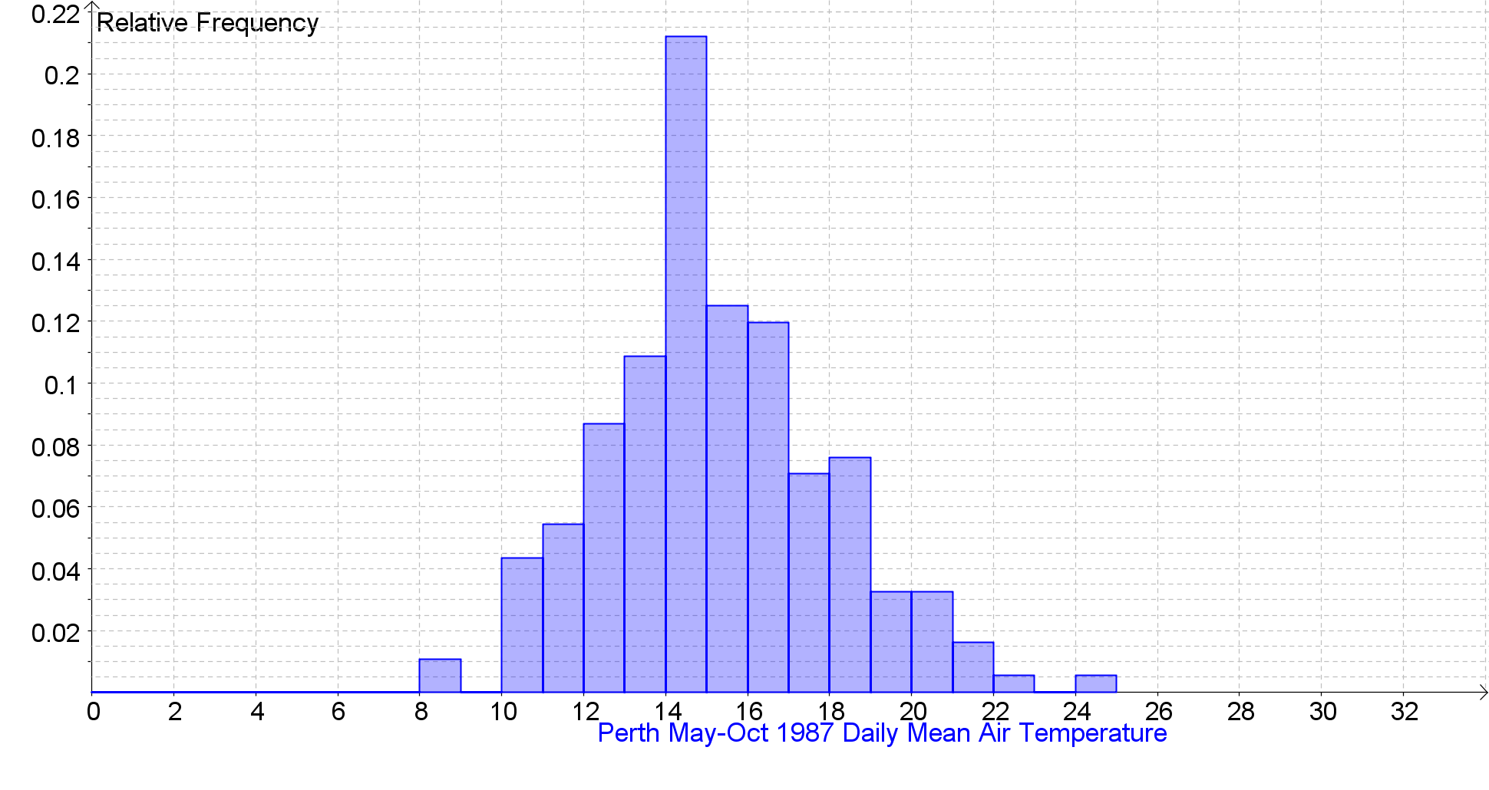

Daily Mean Temperature (0900-0900) (°C) Back to the Index
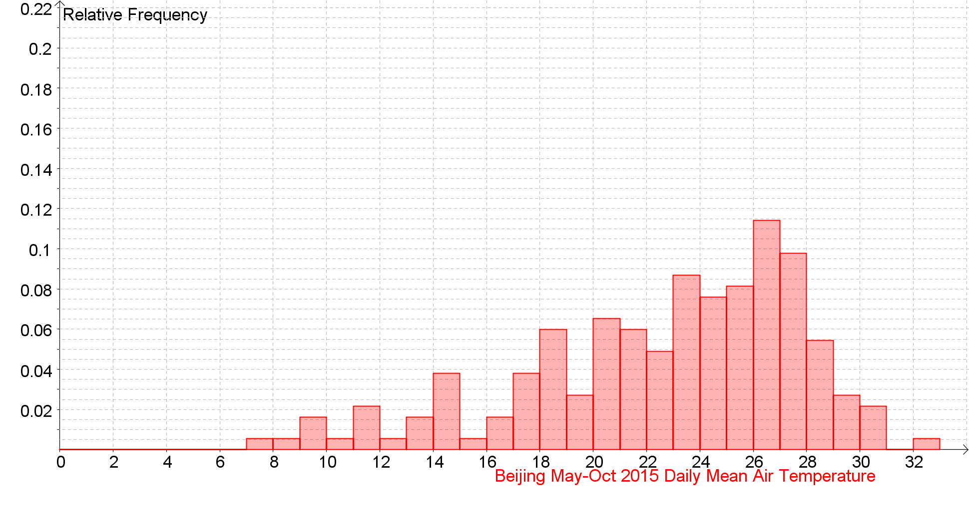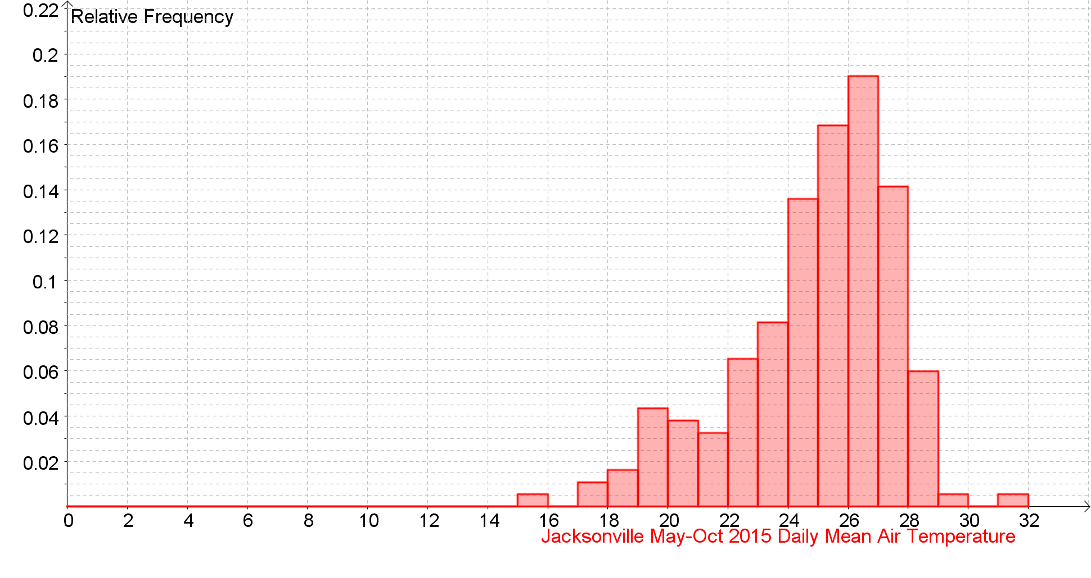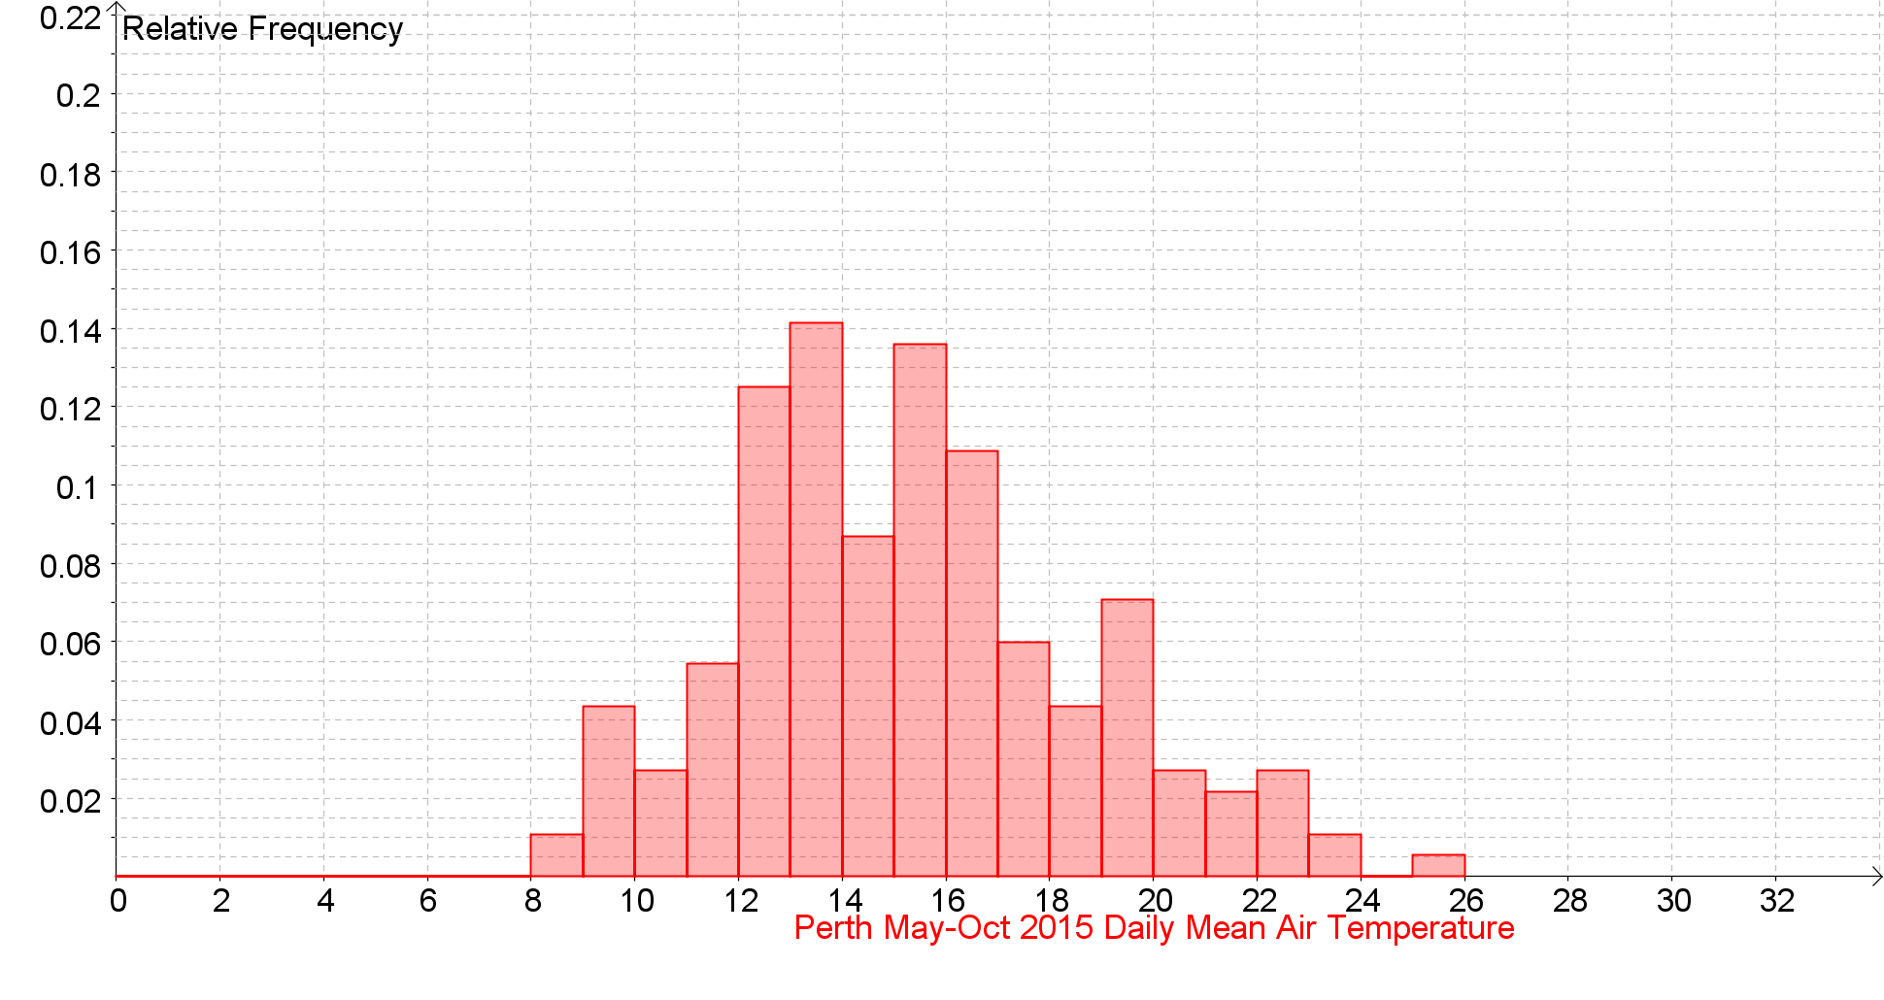

Daily Total Rainfall (0900-0900) (mm) Back to the Index
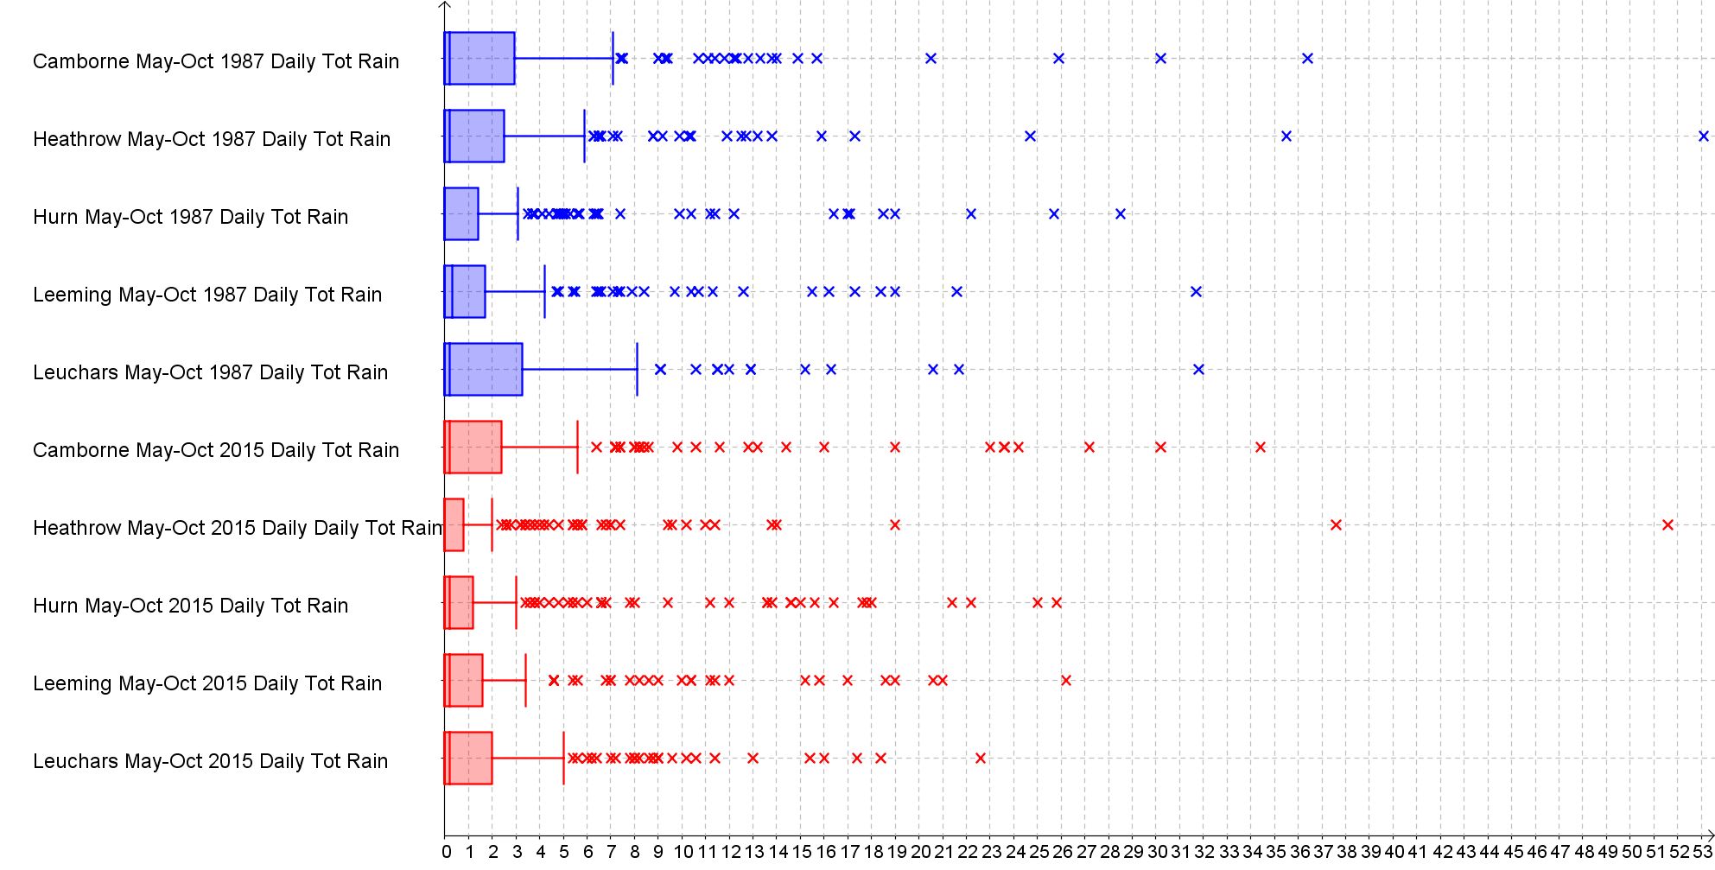

Daily Total Rainfall (0900-0900) (mm) Back to the Index
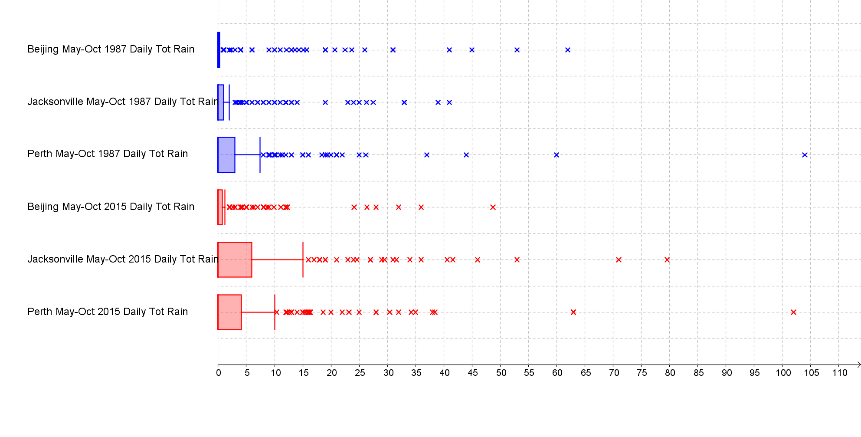
Daily Total Rainfall (0900-0900) (mm) Back to the Index
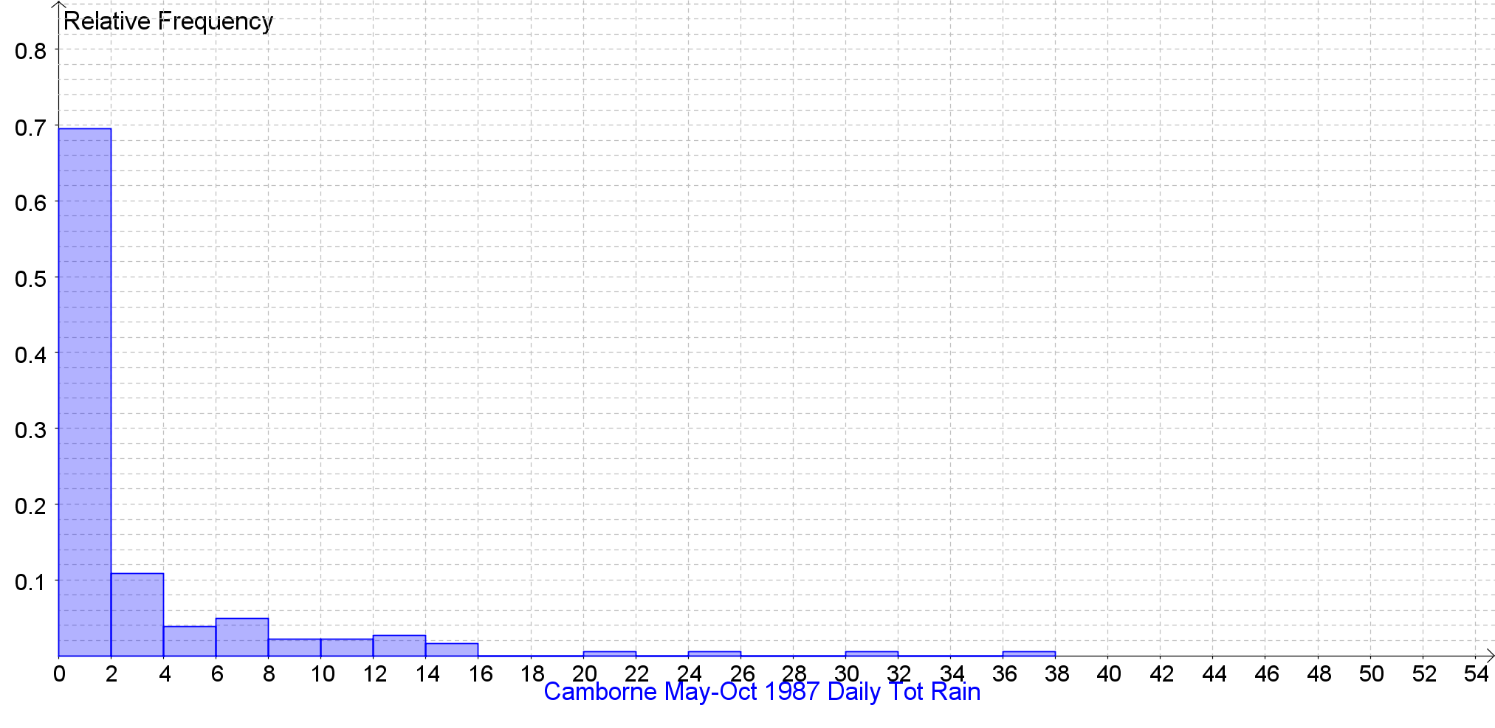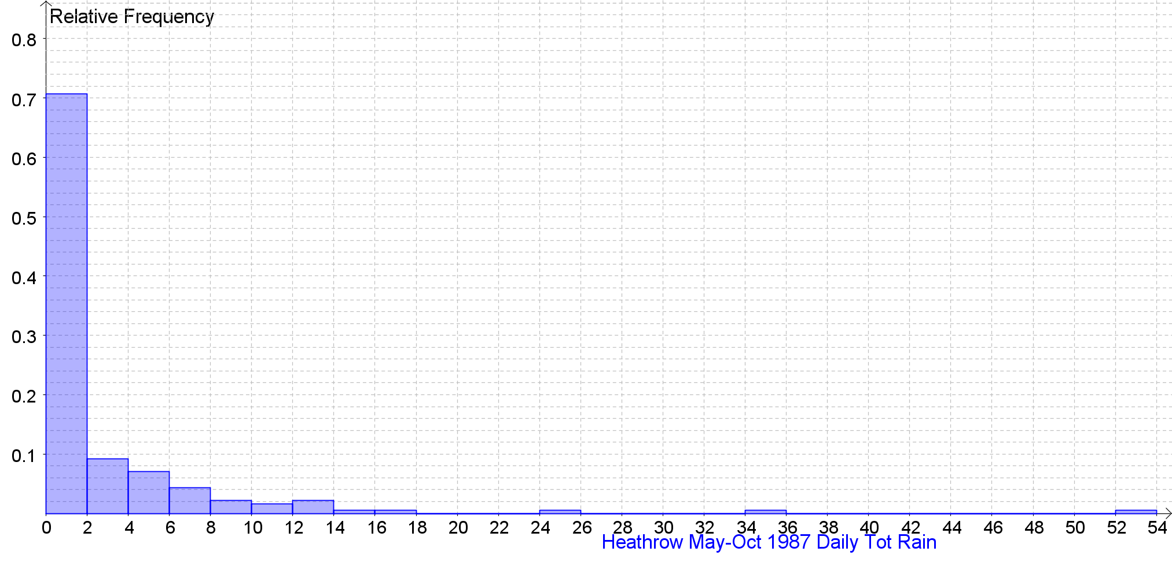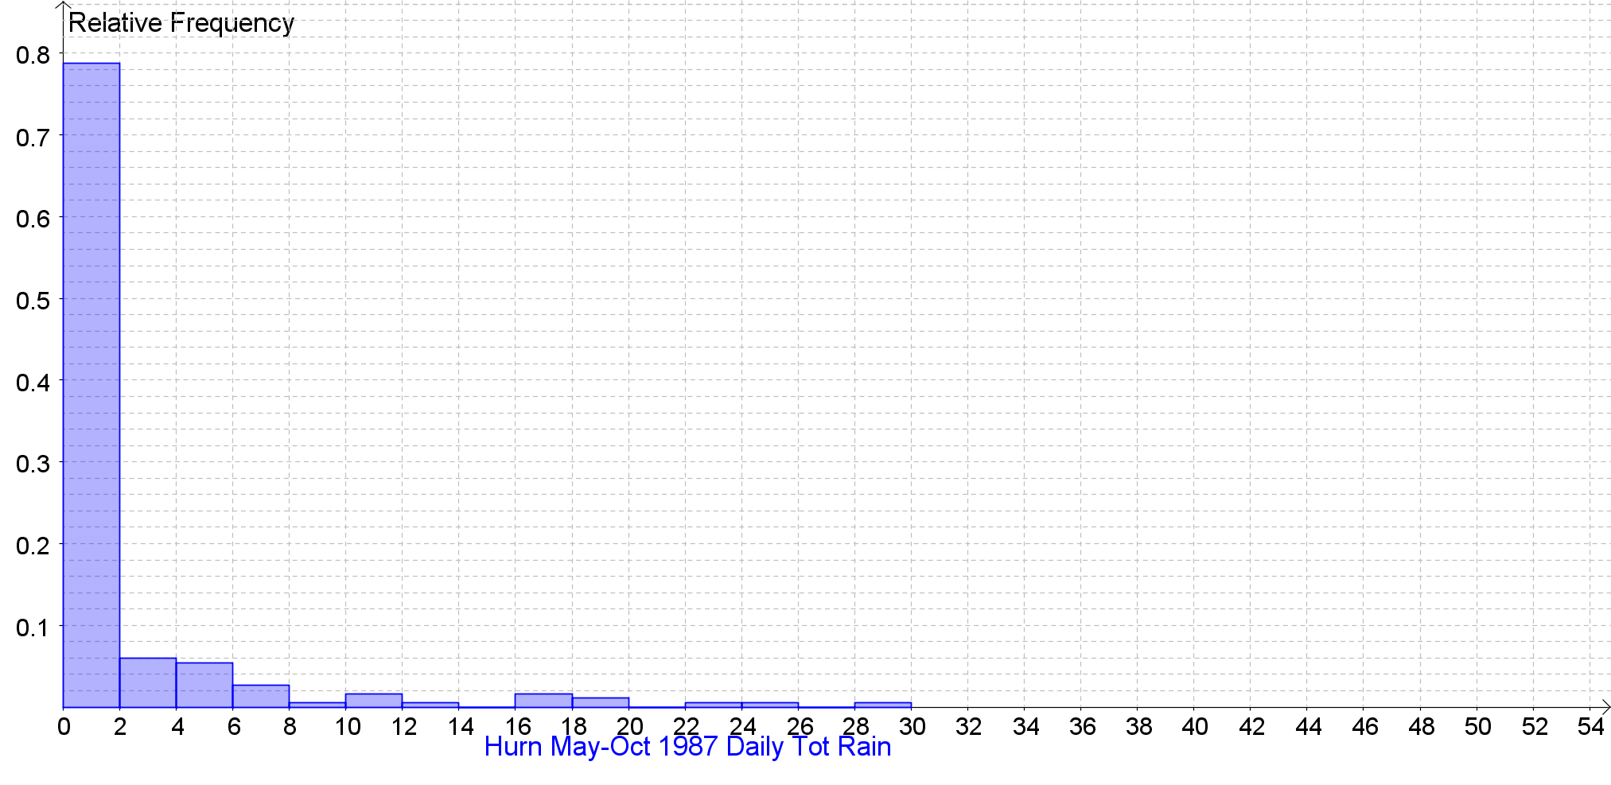

Daily Total Rainfall (0900-0900) (mm) Back to the Index
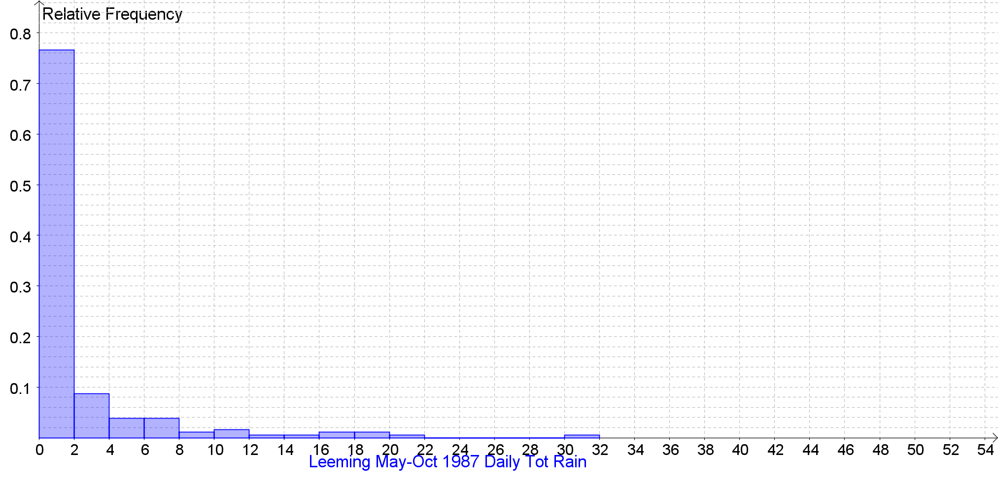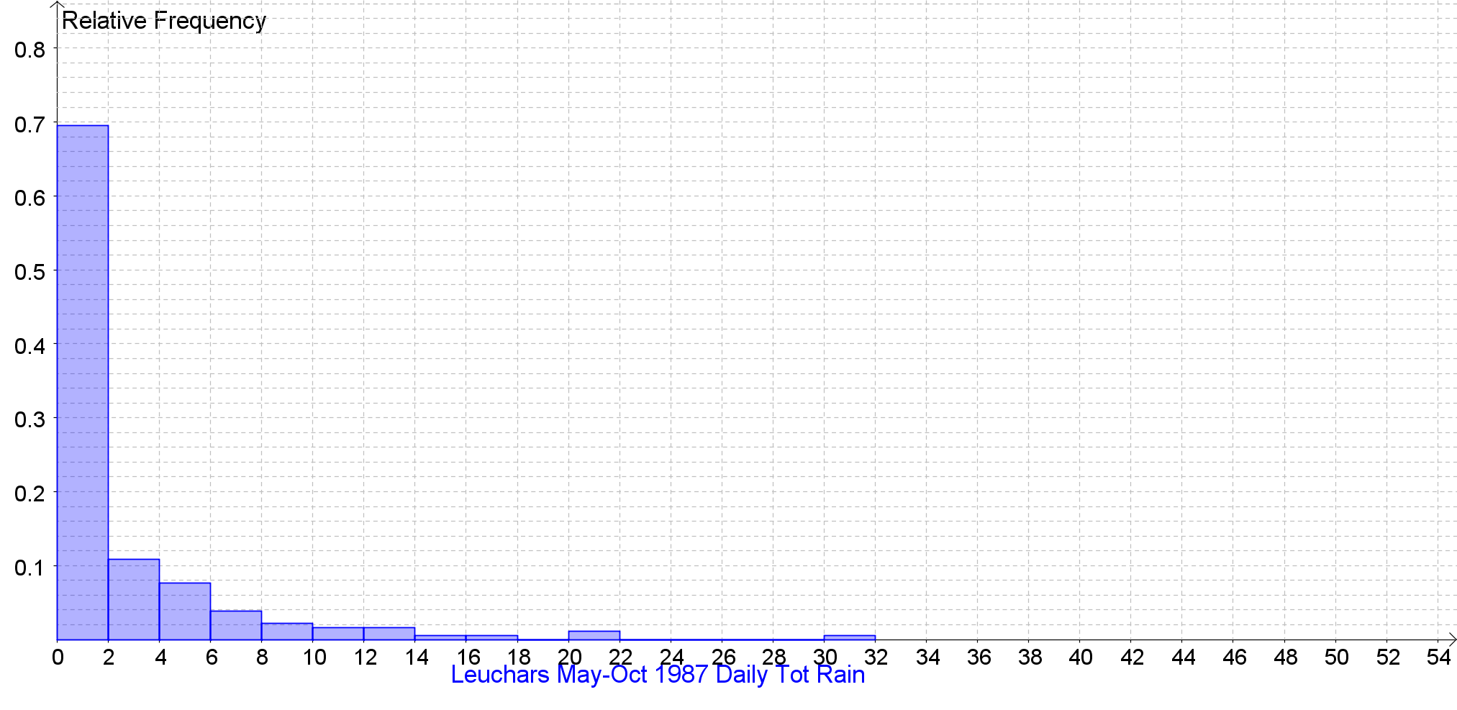

Daily Total Rainfall (0900-0900) (mm) Back to the Index
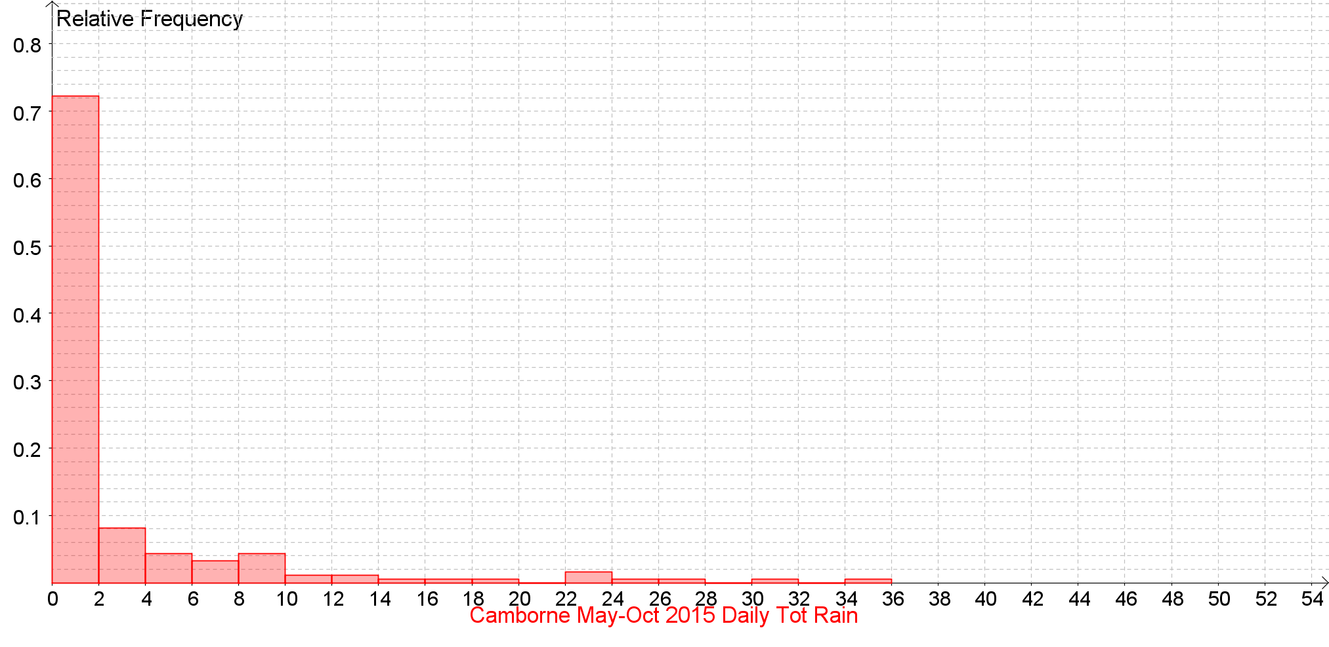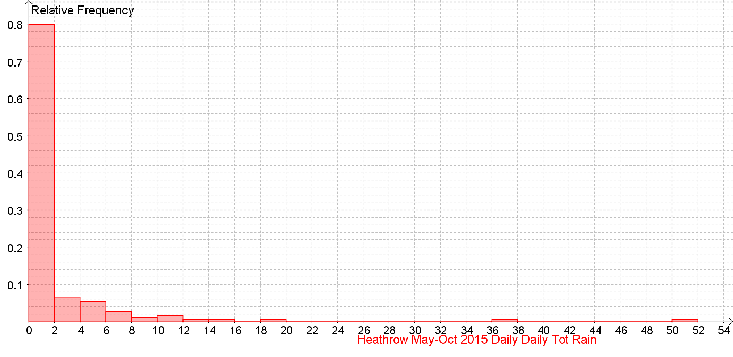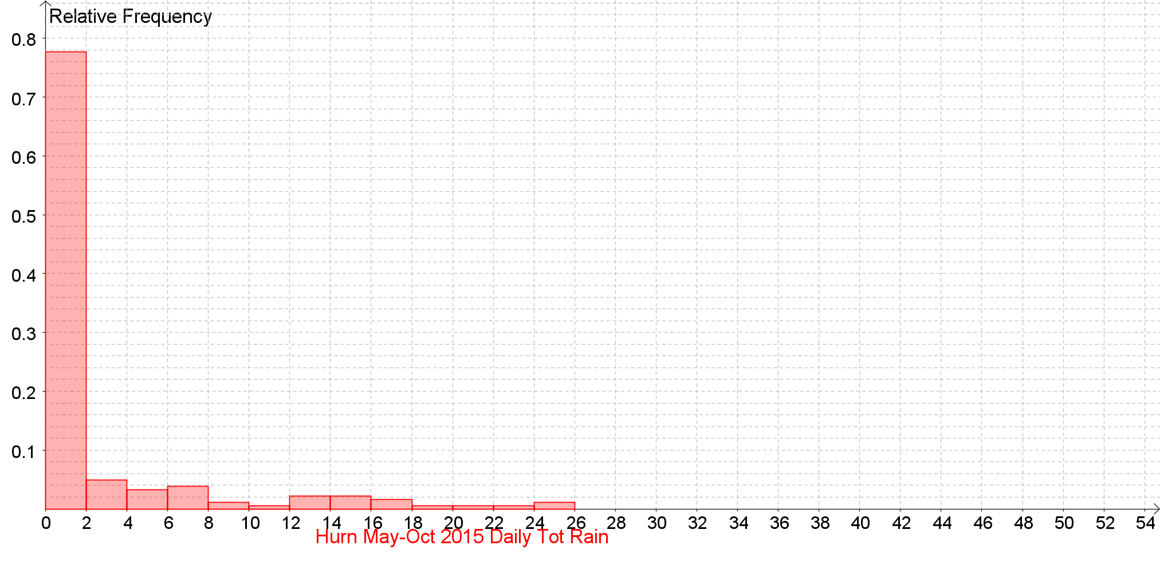
Daily Total Rainfall (0900-0900) (mm) Back to the Index
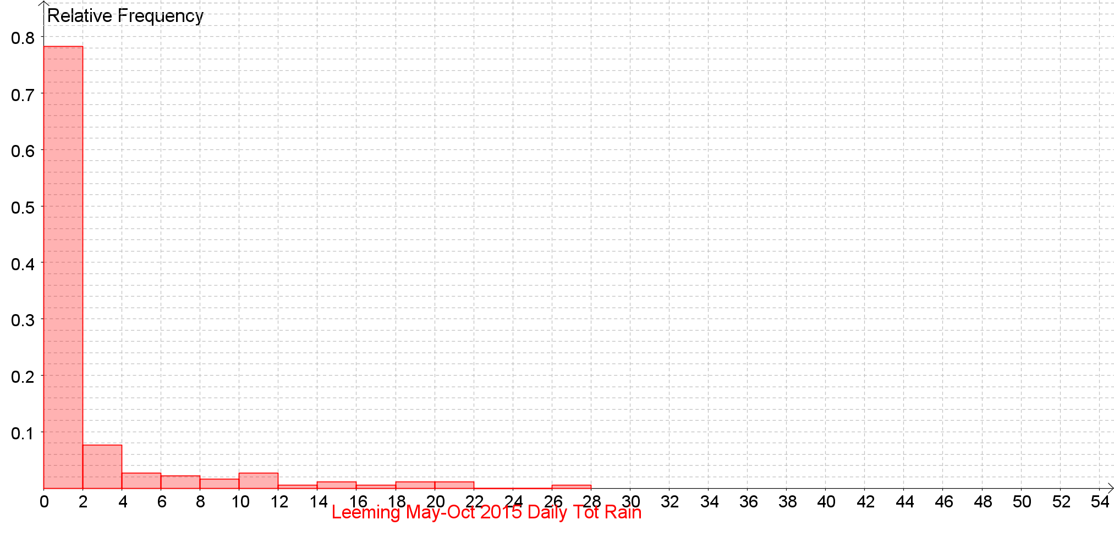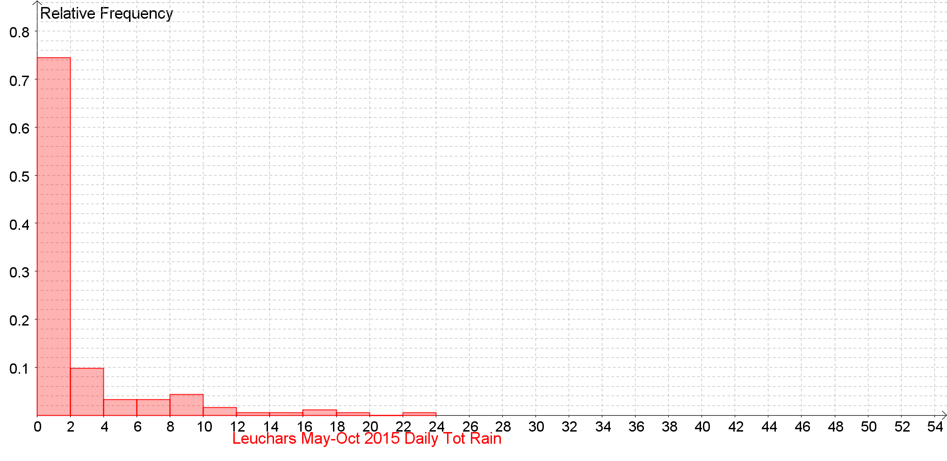
Daily Total Rainfall (0900-0900) (mm) Back to the Index
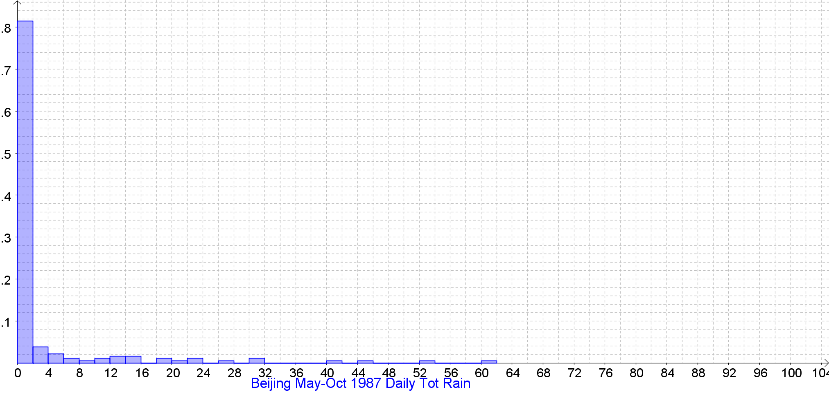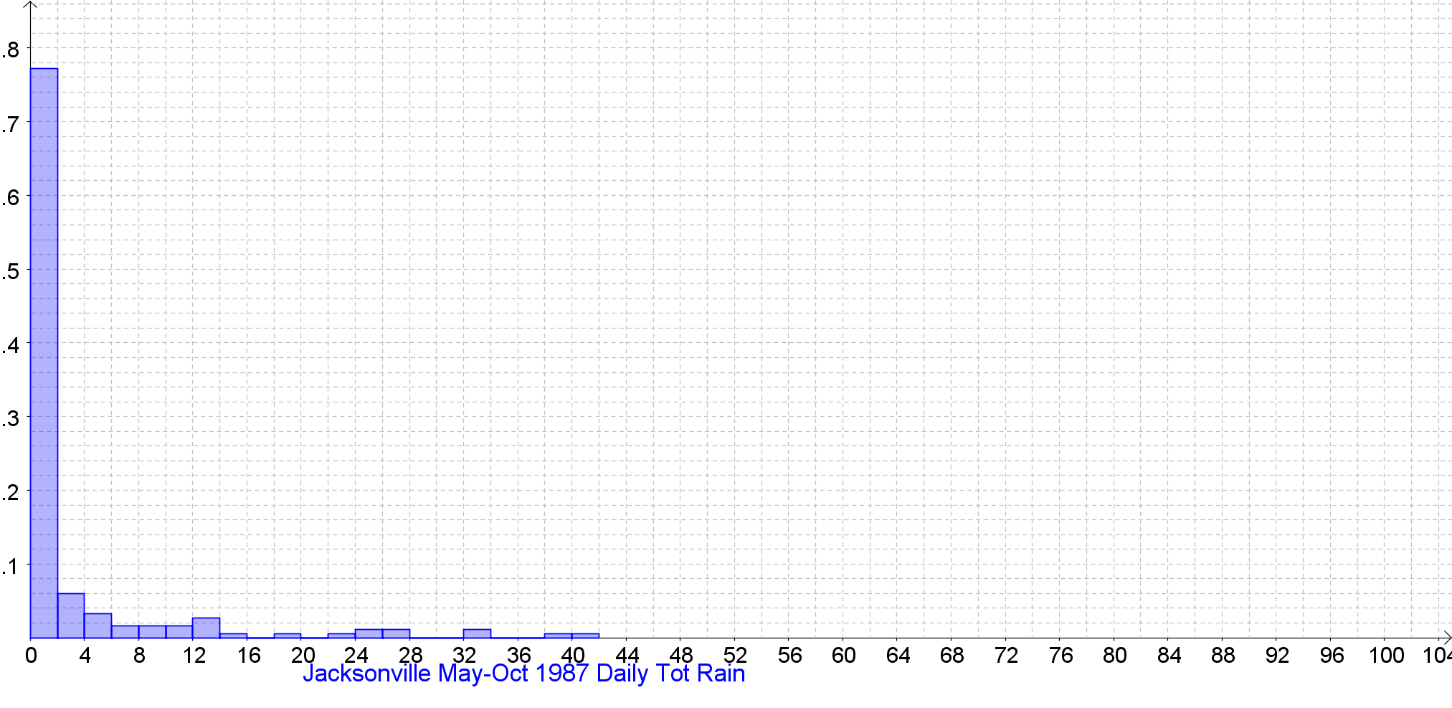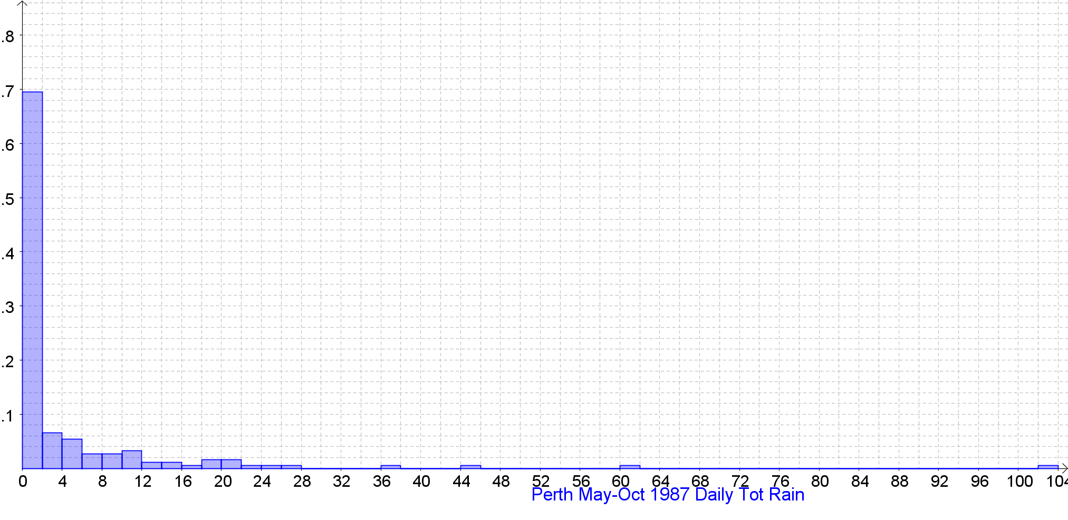

Daily Total Rainfall (0900-0900) (mm) Back to the Index
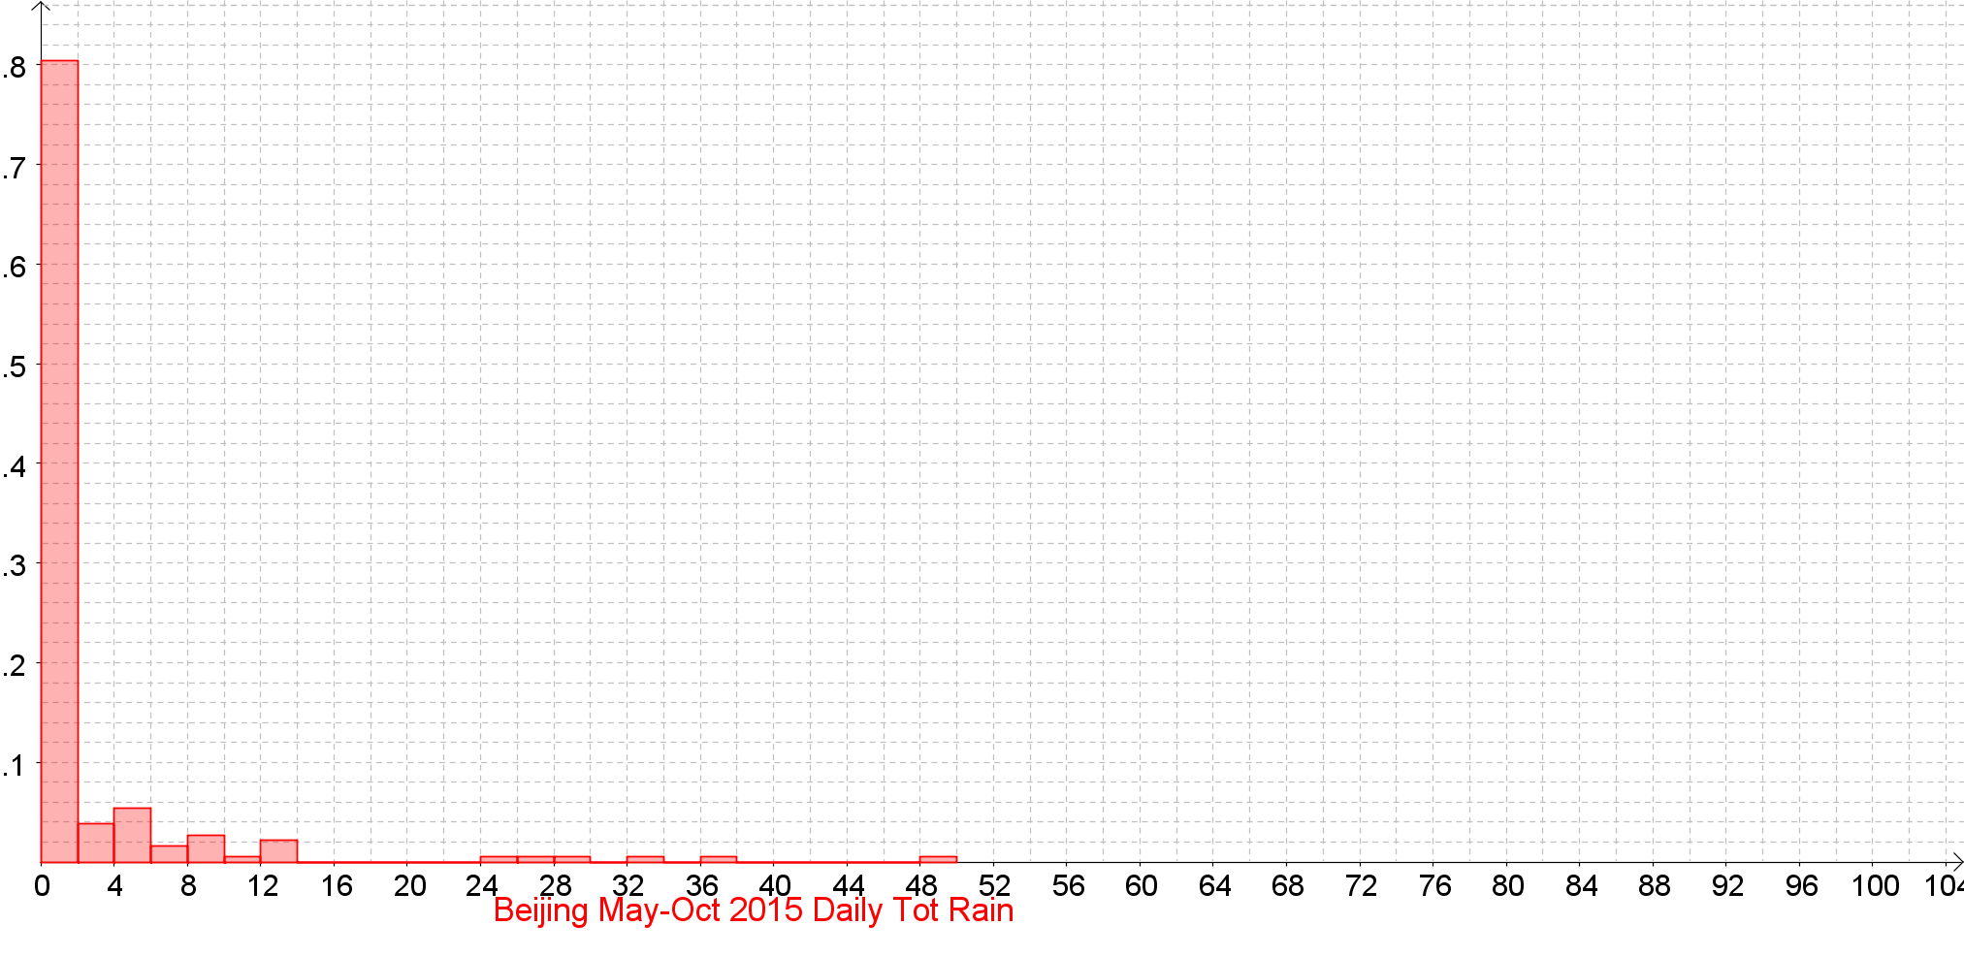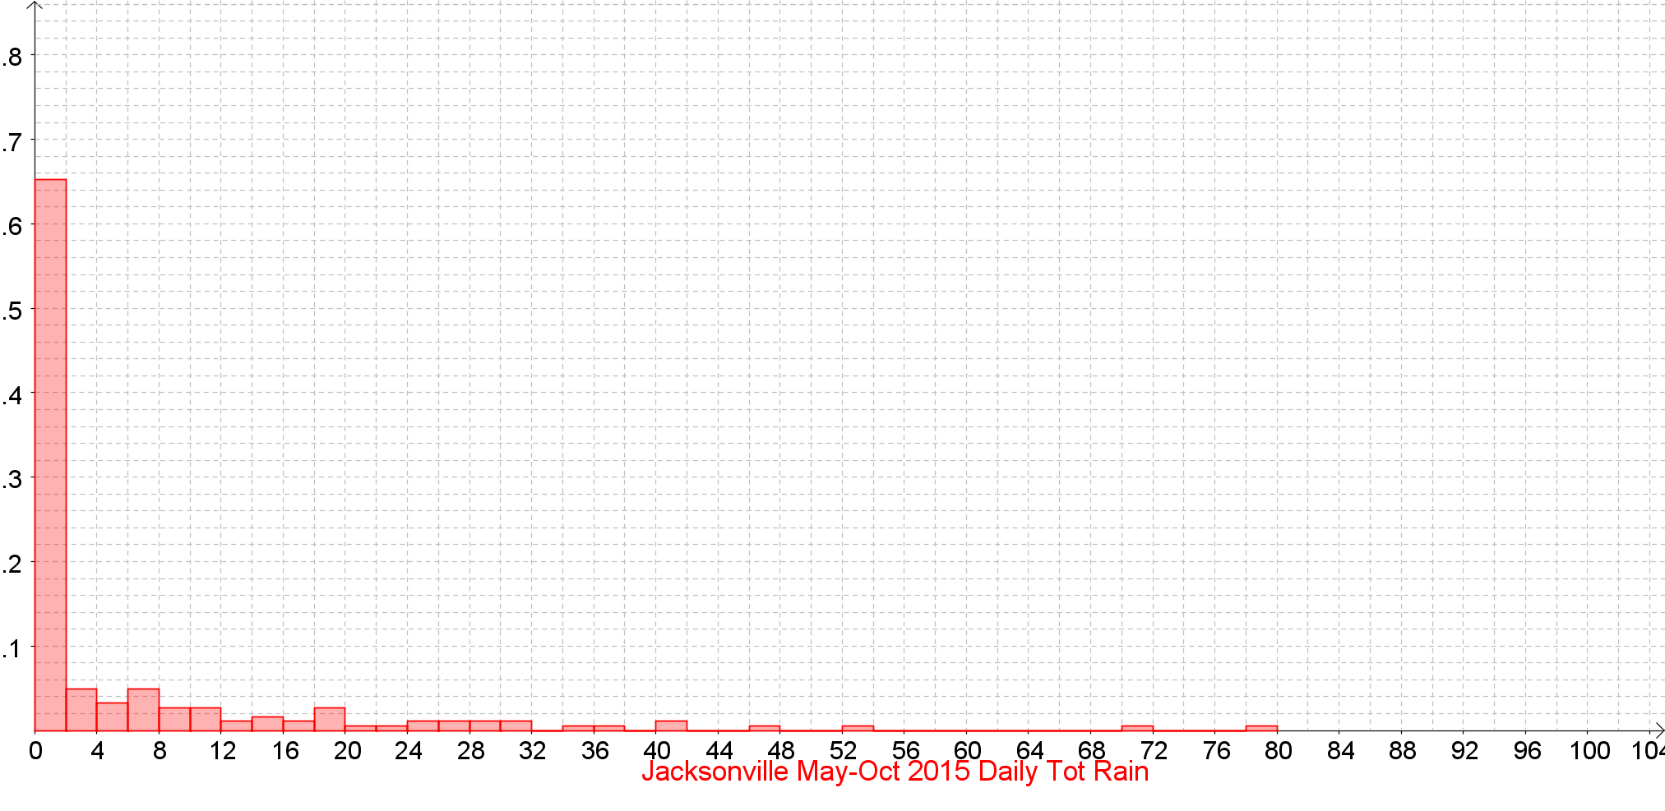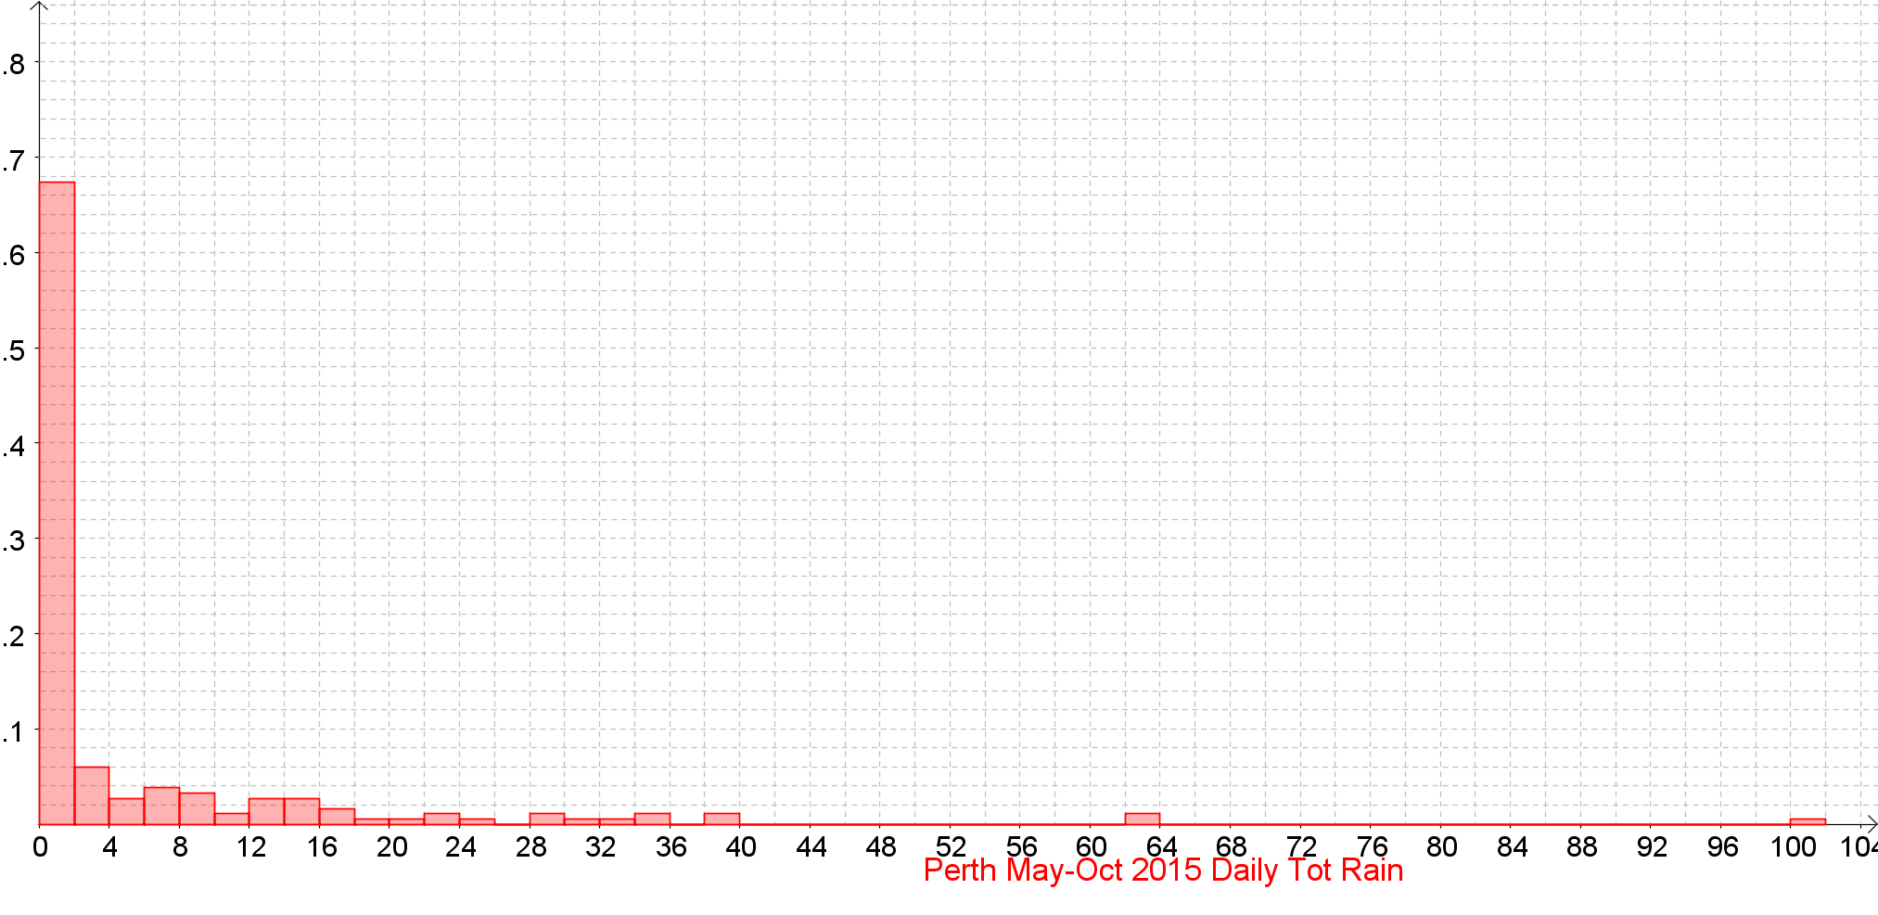

Daily Total Rainfall (0900-0900) (mm) Back to the Index

Daily Total Rainfall (0900-0900) (mm) Back to the Index

Daily Total Rainfall (0900-0900) (mm) Back to the Index

Daily Total Rainfall (0900-0900) (mm) Back to the Index

Daily Total Rainfall (0900-0900) (mm) Back to the Index

Daily Total Rainfall (0900-0900) (mm) Back to the Index

Daily Total Sunshine (0000-2400) (hrs) Back to the Index

Daily Total Sunshine (0000-2400) (hrs) Back to the Index

Daily Total Sunshine (0000-2400) (hrs) Back to the Index

Daily Total Sunshine (0000-2400) (hrs) Back to the Index

Daily Total Sunshine (0000-2400) (hrs) Back to the Index
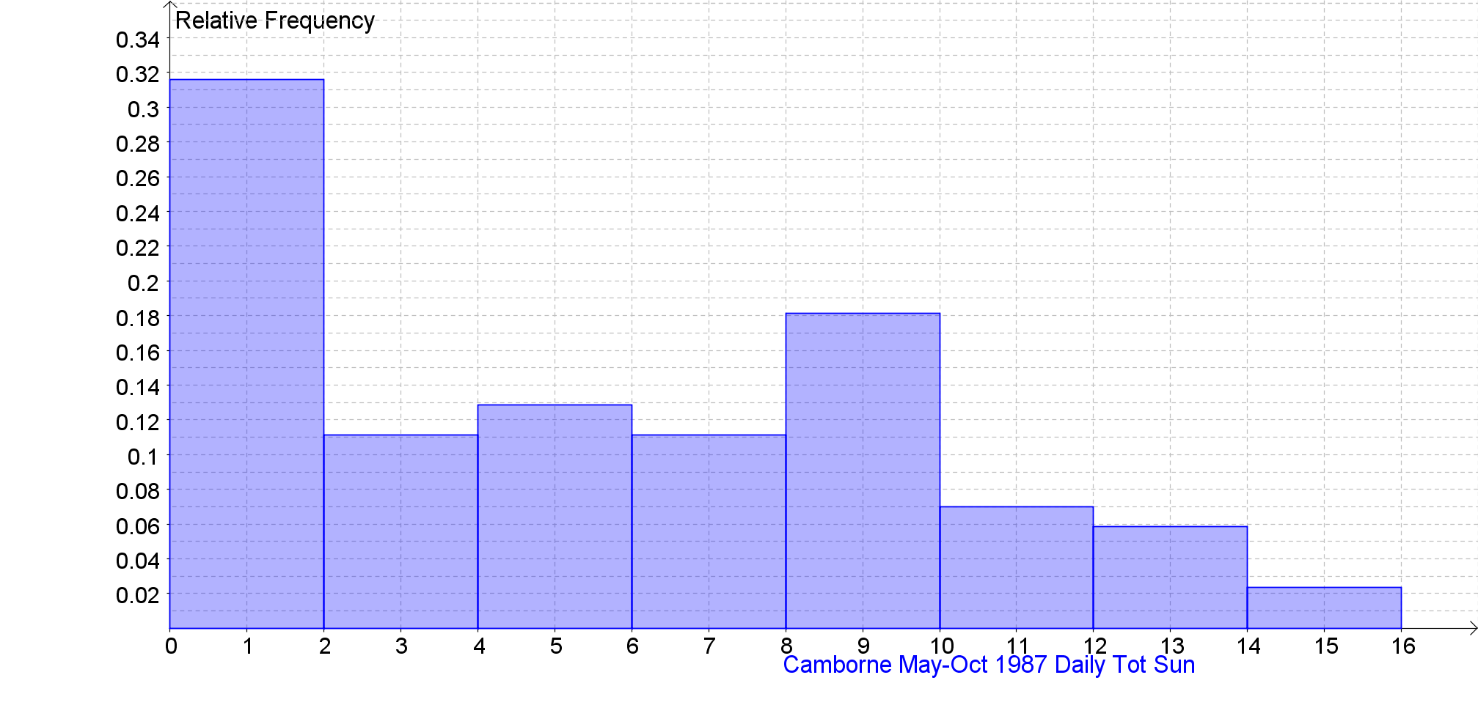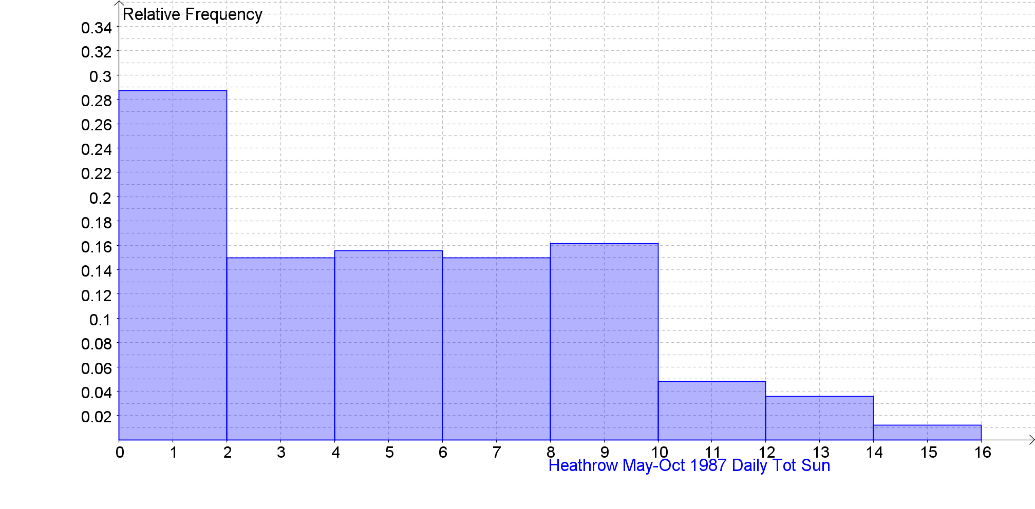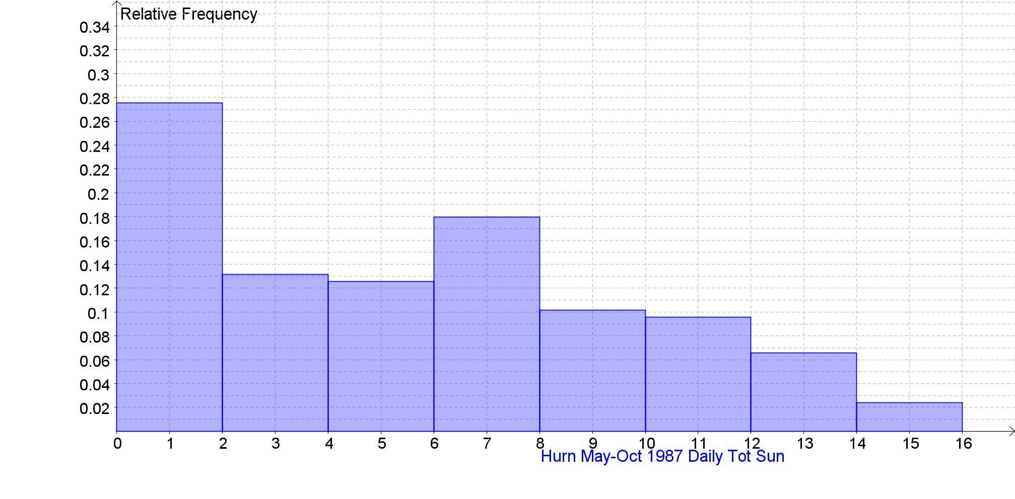

Daily Total Sunshine (0000-2400) (hrs) Back to the Index
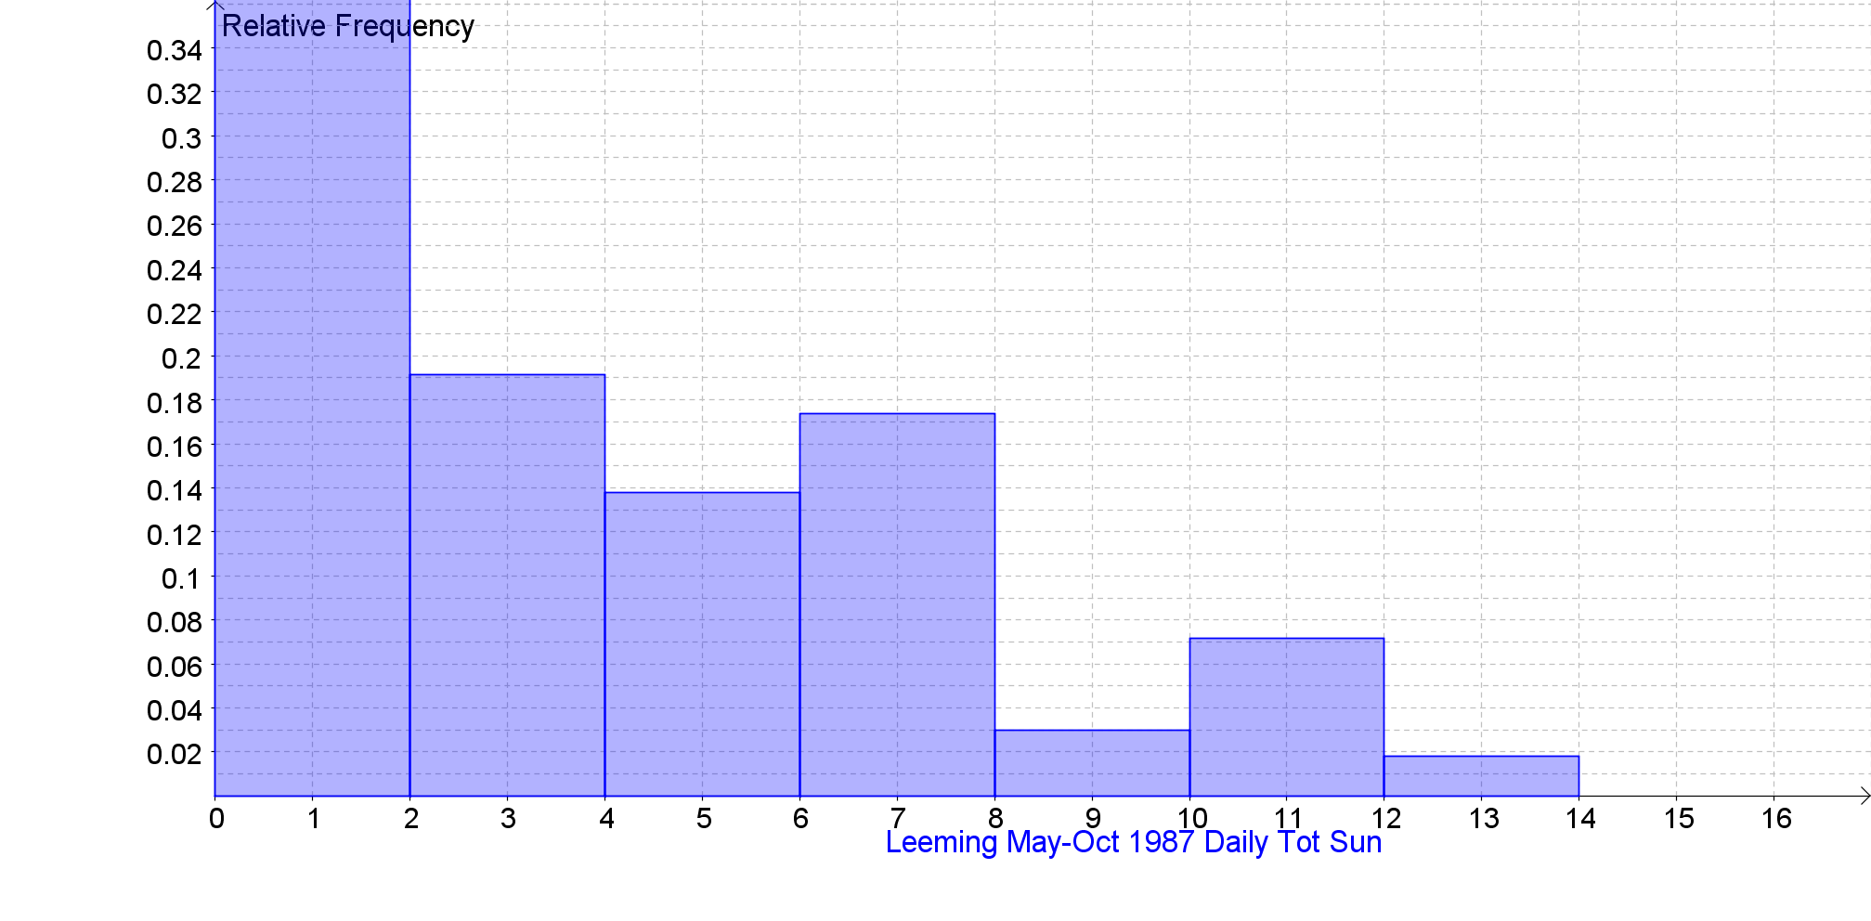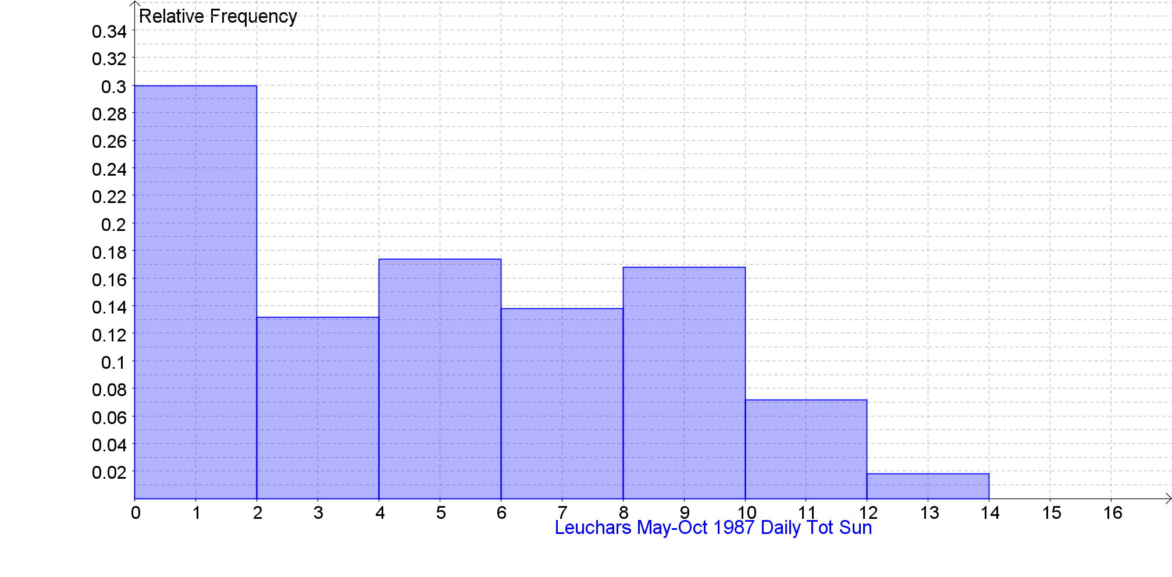

Daily Total Sunshine (0000-2400) (hrs) Back to the Index
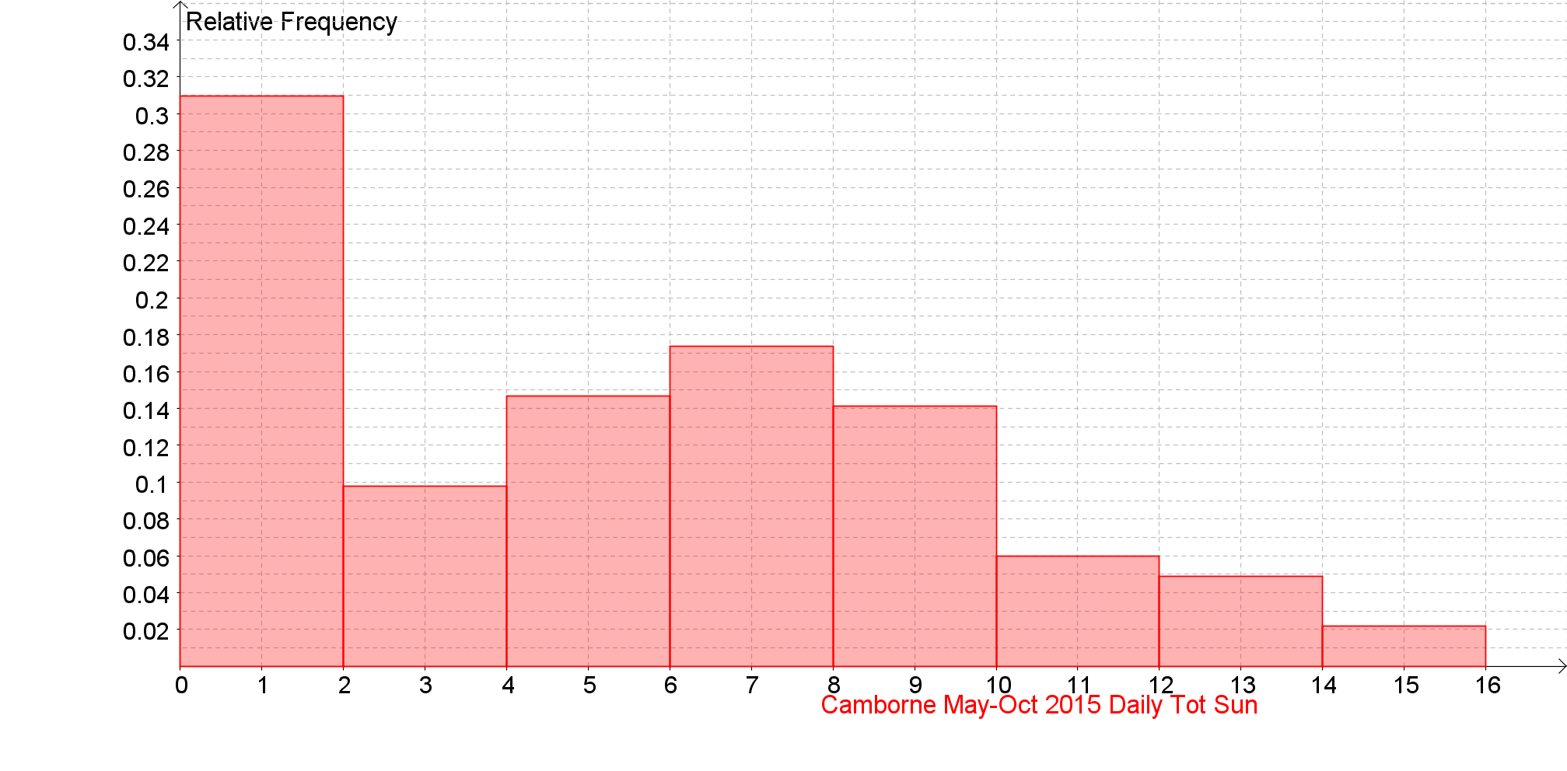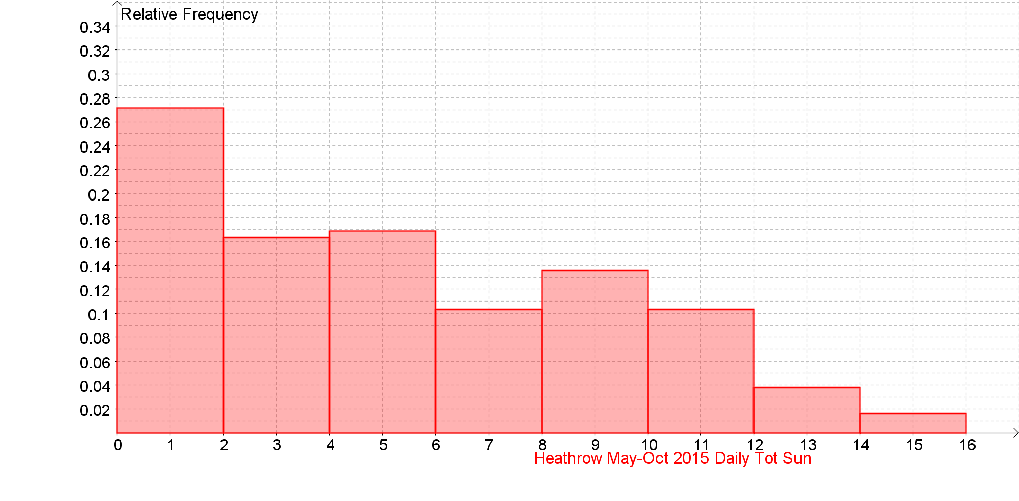
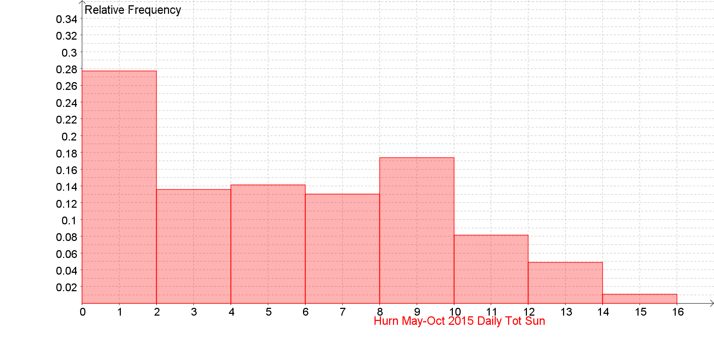

Daily Total Sunshine (0000-2400) (hrs) Back to the Index
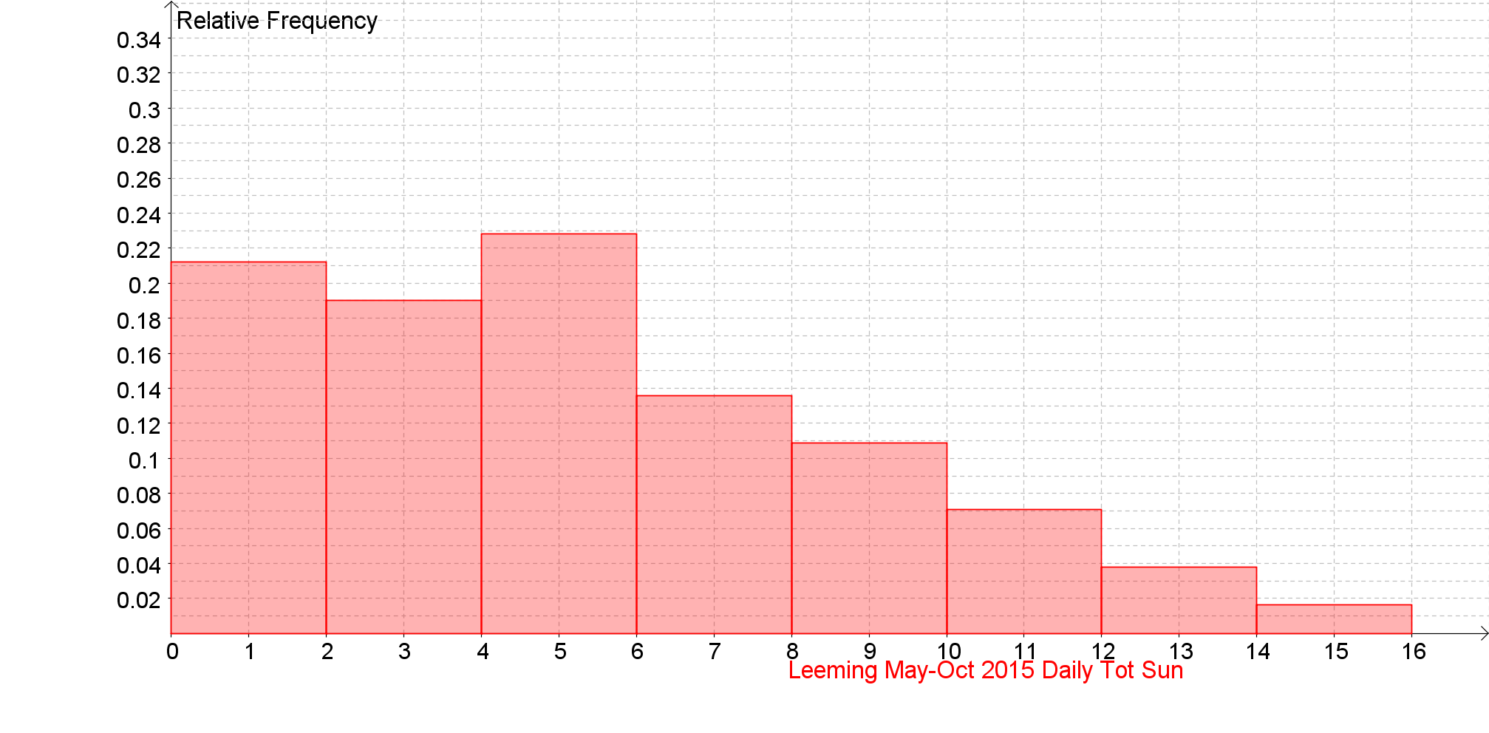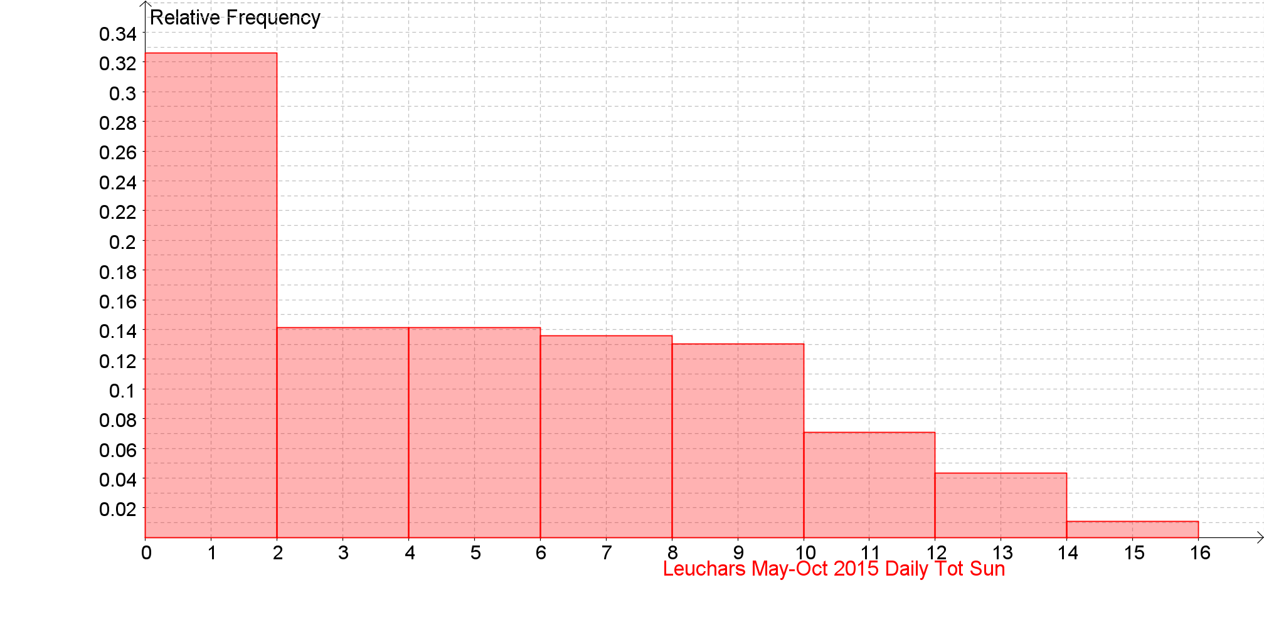
Daily Total Sunshine (0000-2400) (hrs) Back to the Index

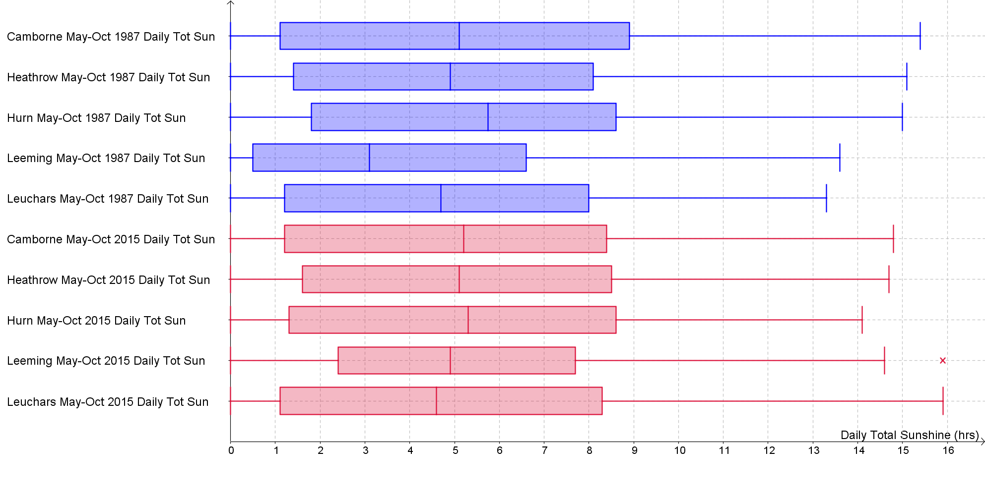

Daily Mean Windspeed (0000-2400) (kn) Back to the Index

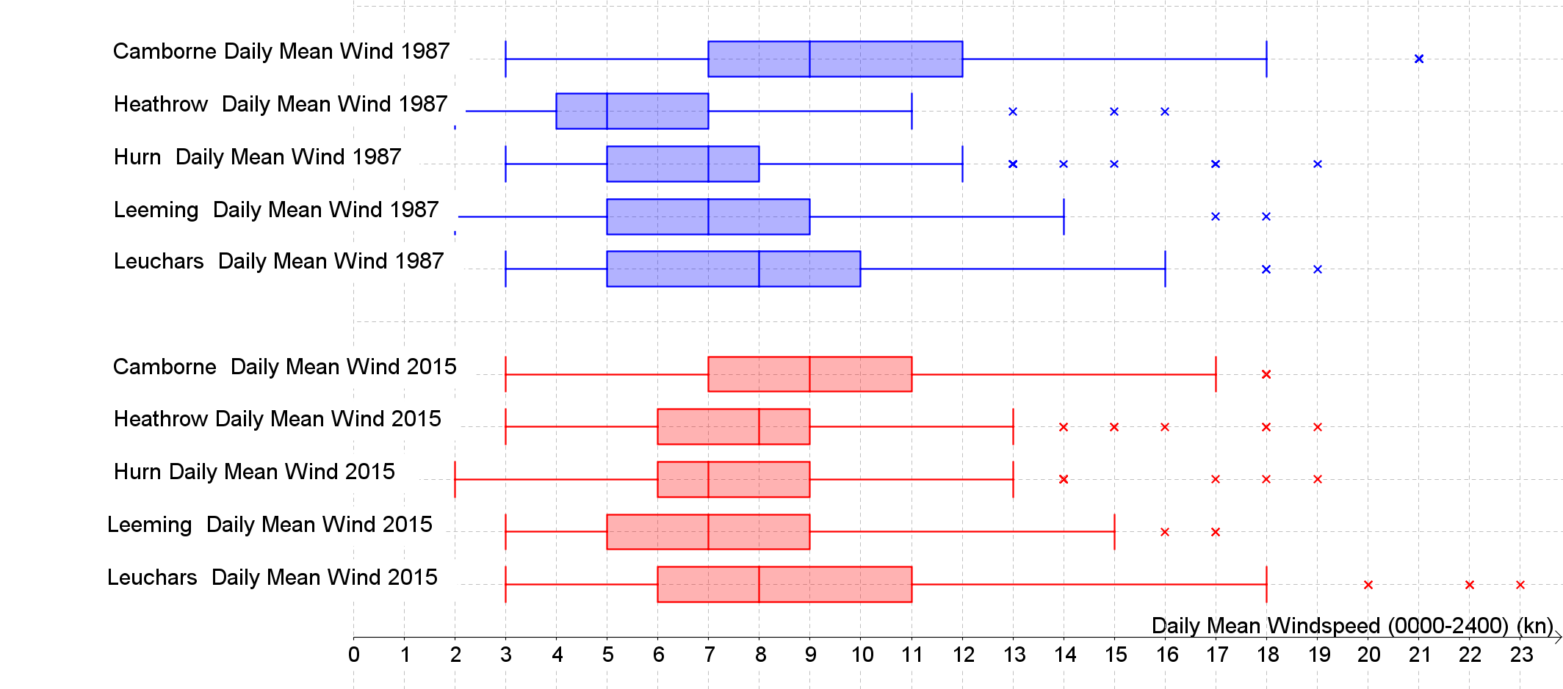

Daily Mean Windspeed (0000-2400) (kn) Back to the Index
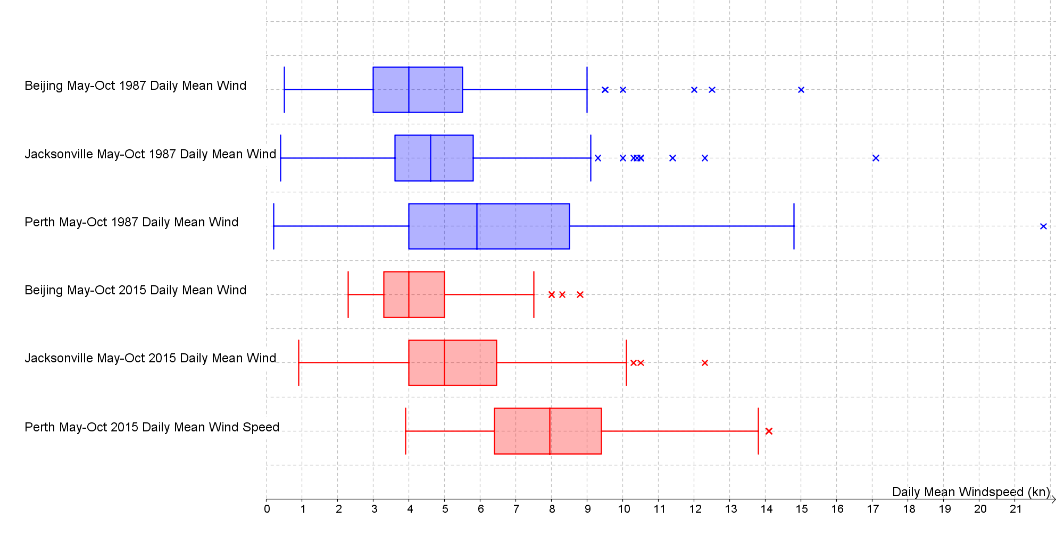

Daily Mean Windspeed (0000-2400) (kn) Back to the Index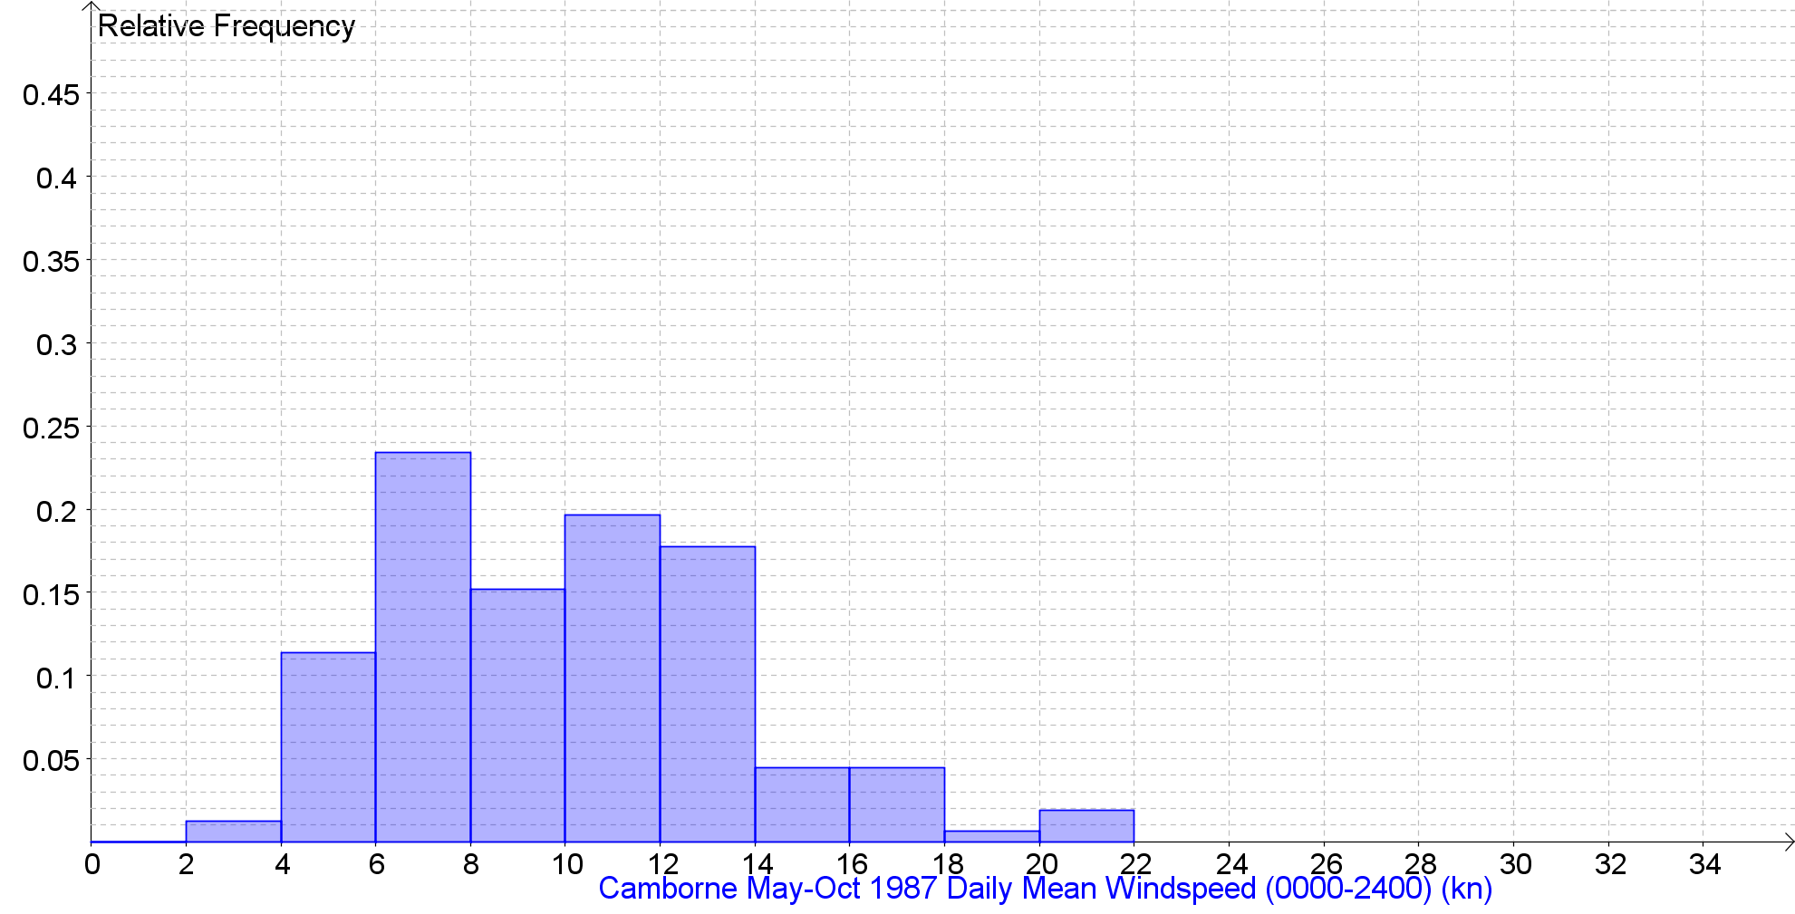 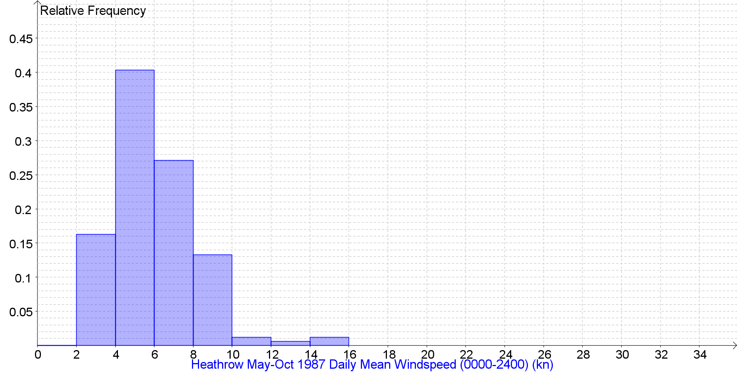 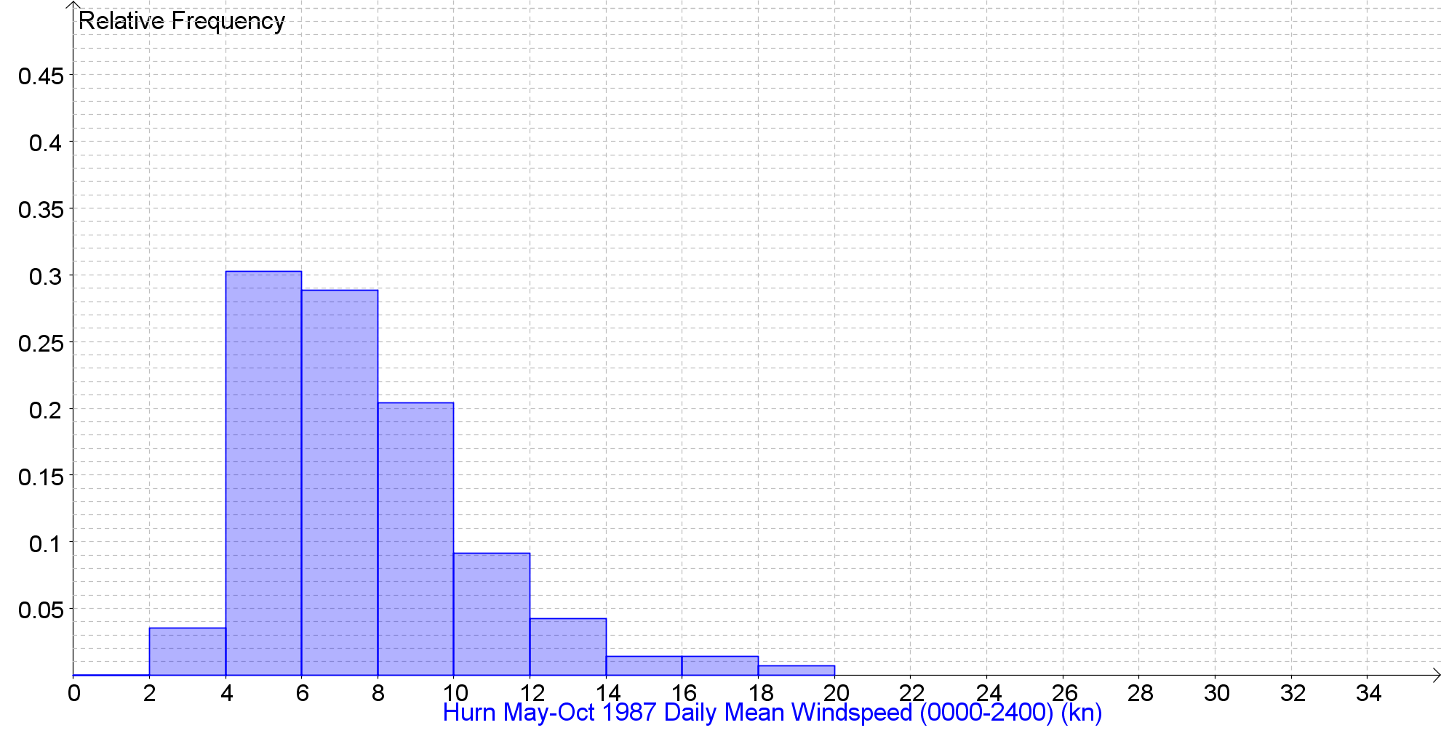
Daily Mean Windspeed (0000-2400) (kn) Back to the Index

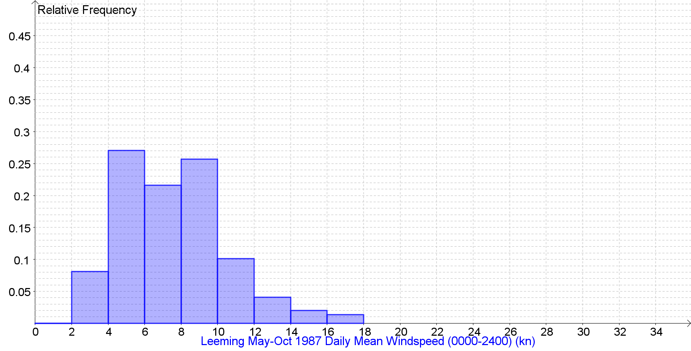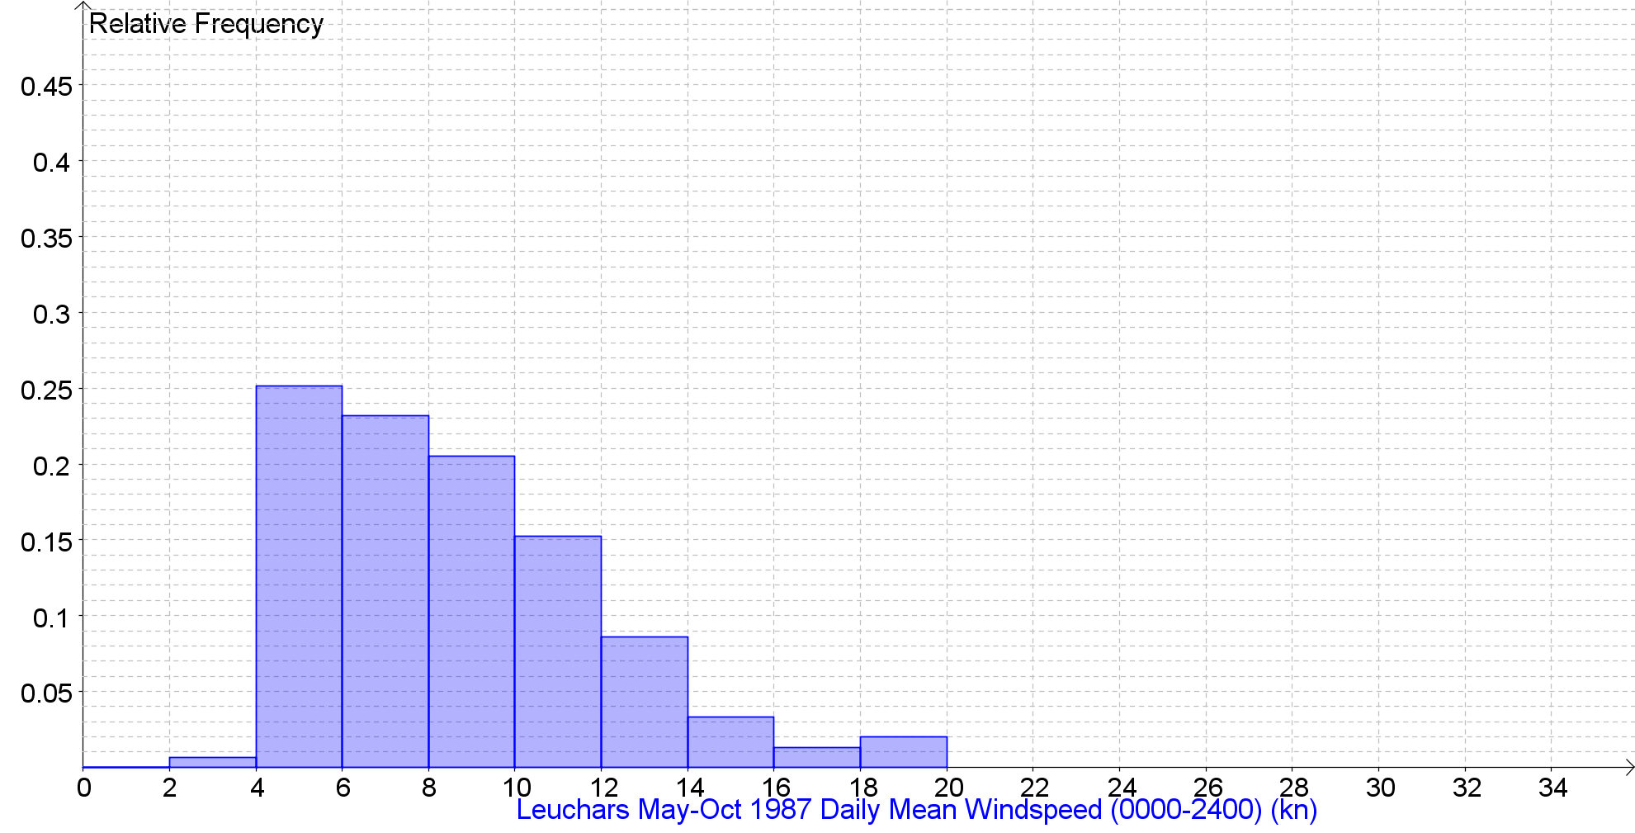
Daily Mean Windspeed (0000-2400) (kn) Back to the Index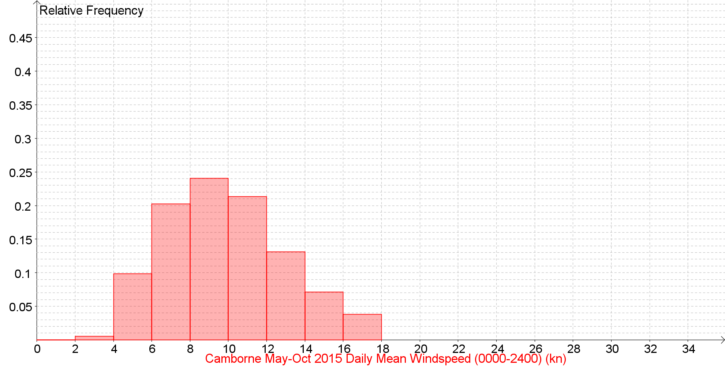 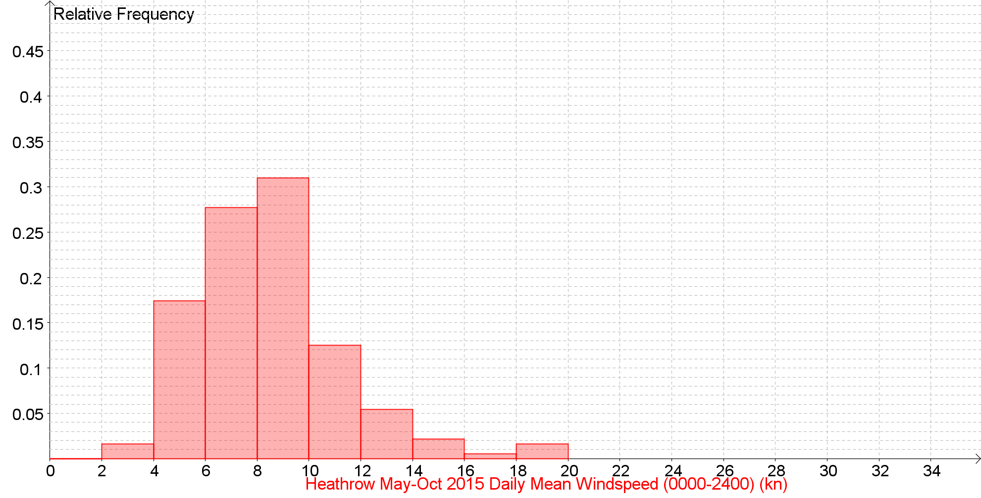 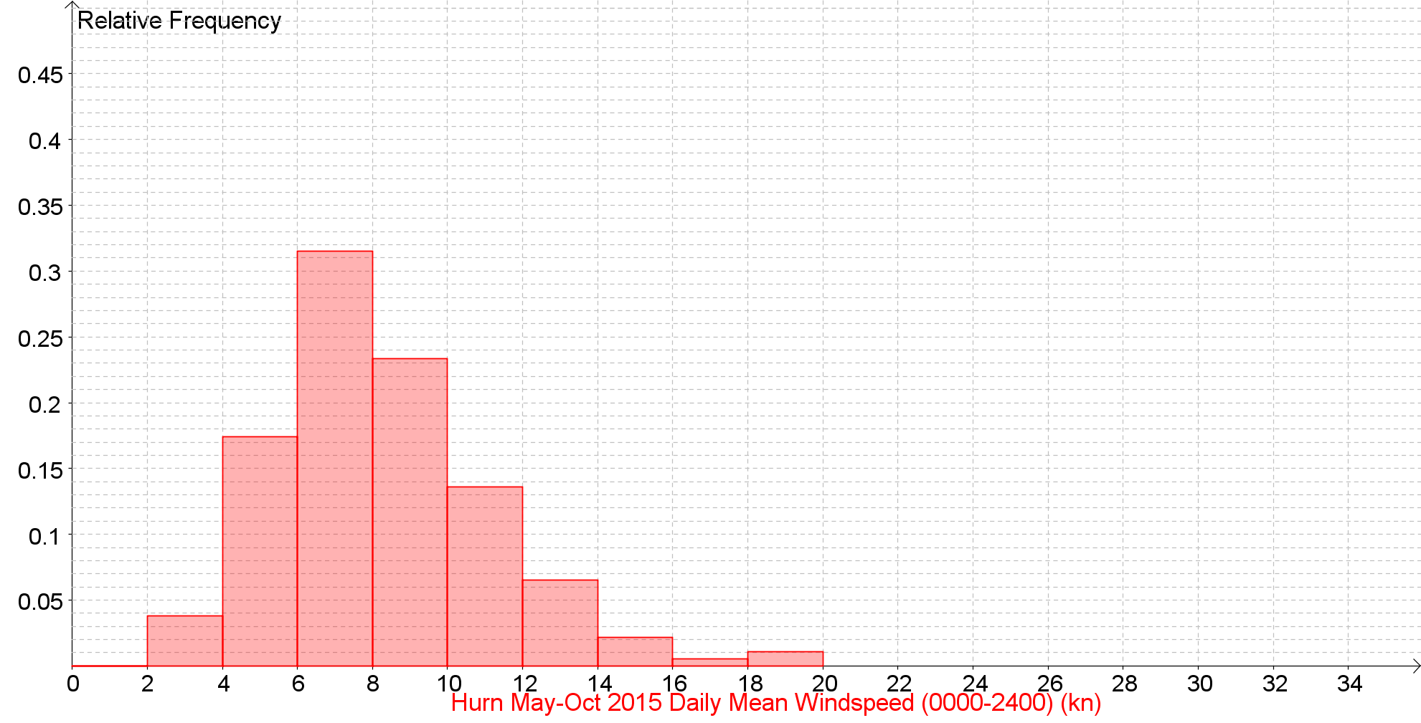
Daily Mean Windspeed (0000-2400) (kn) Back to the Index
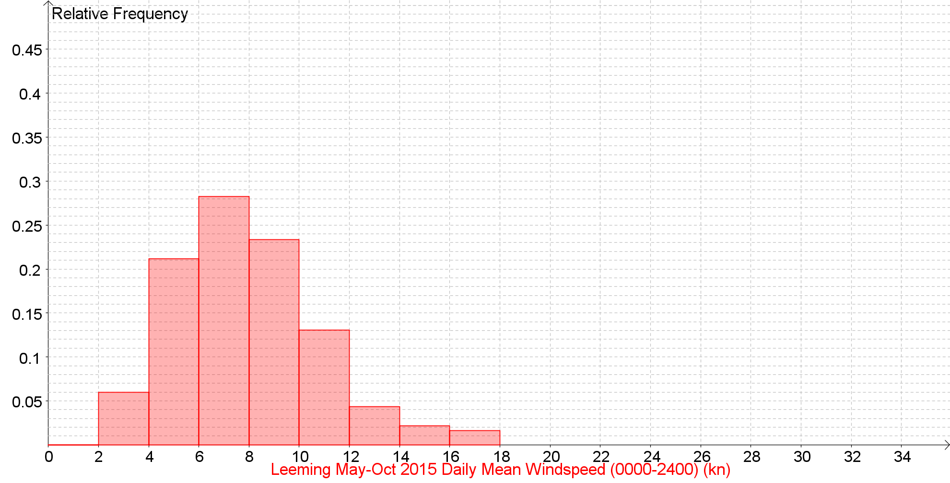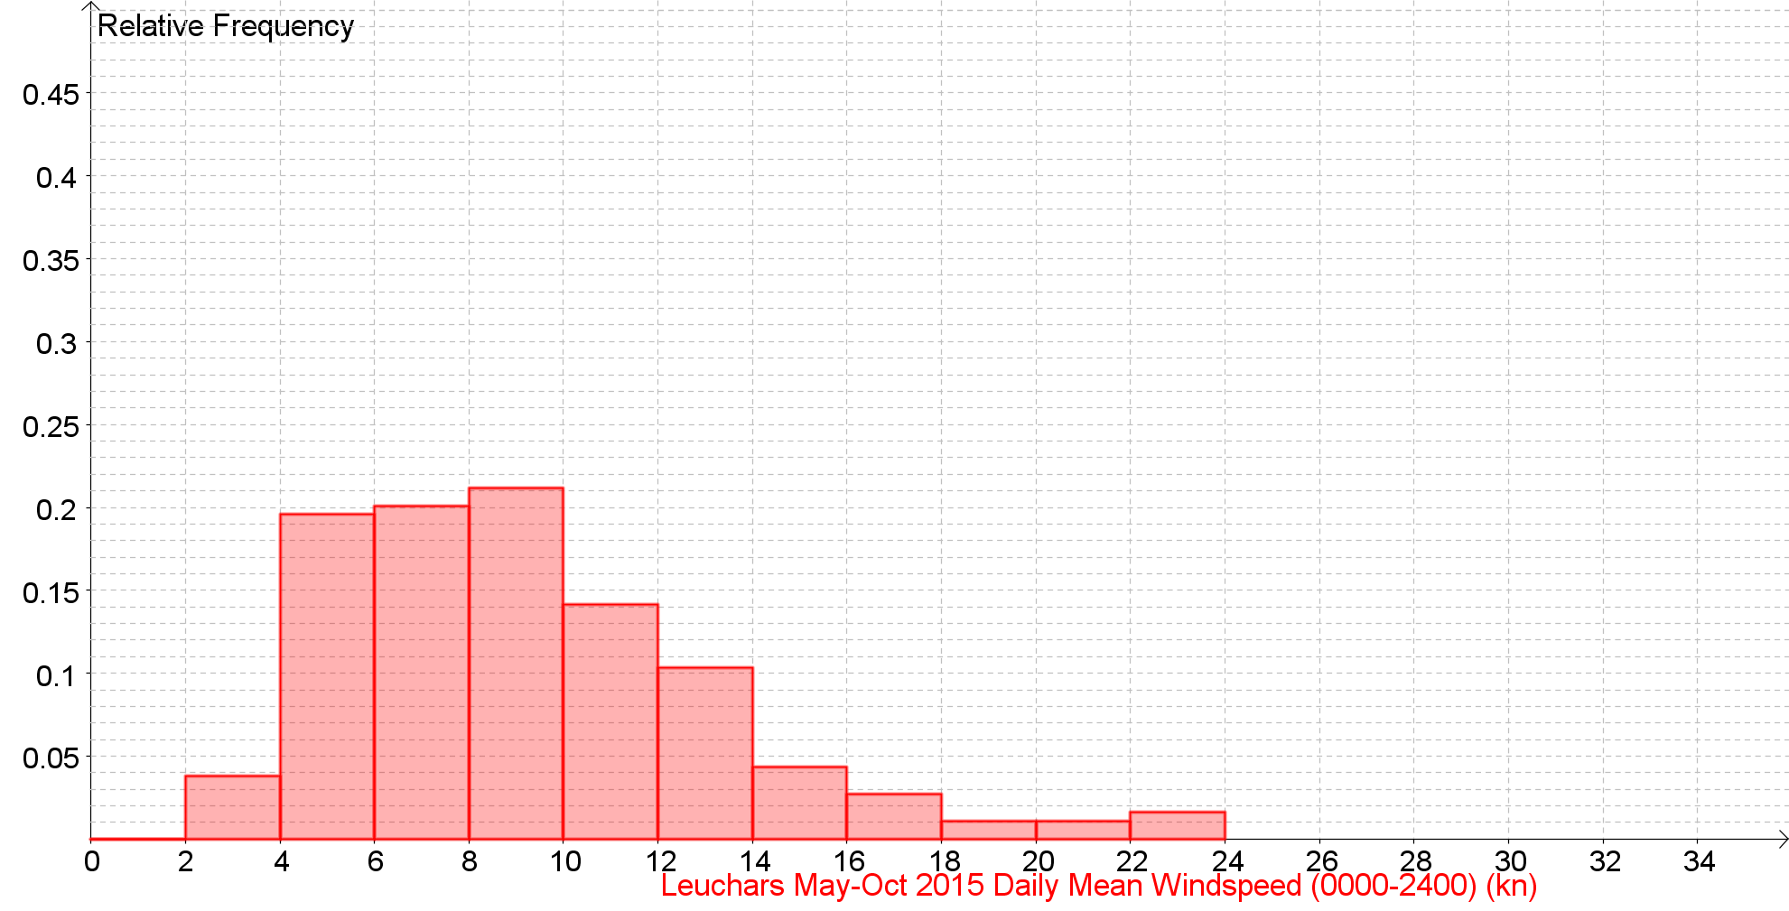

Daily Mean Windspeed (0000-2400) (kn) Back to the Index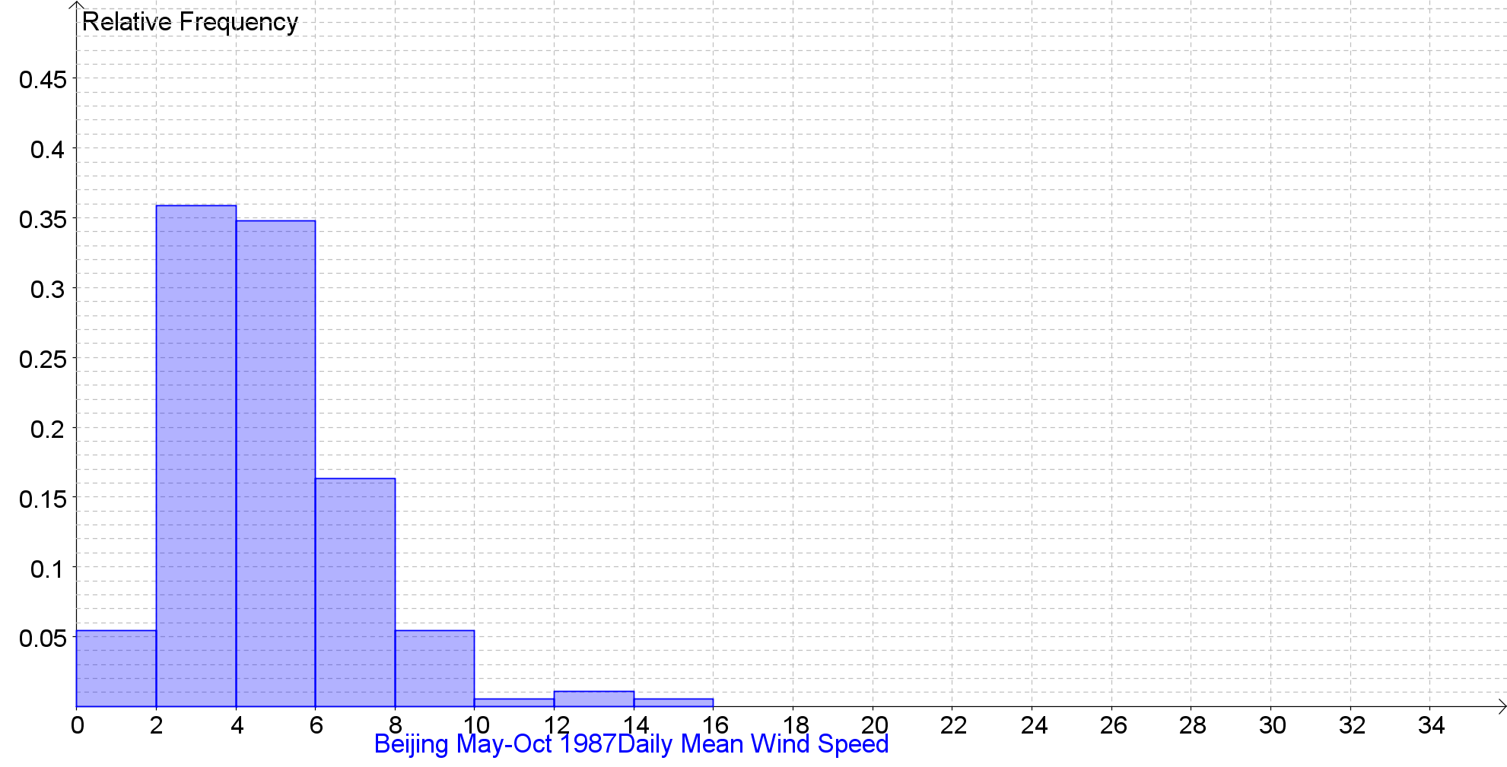 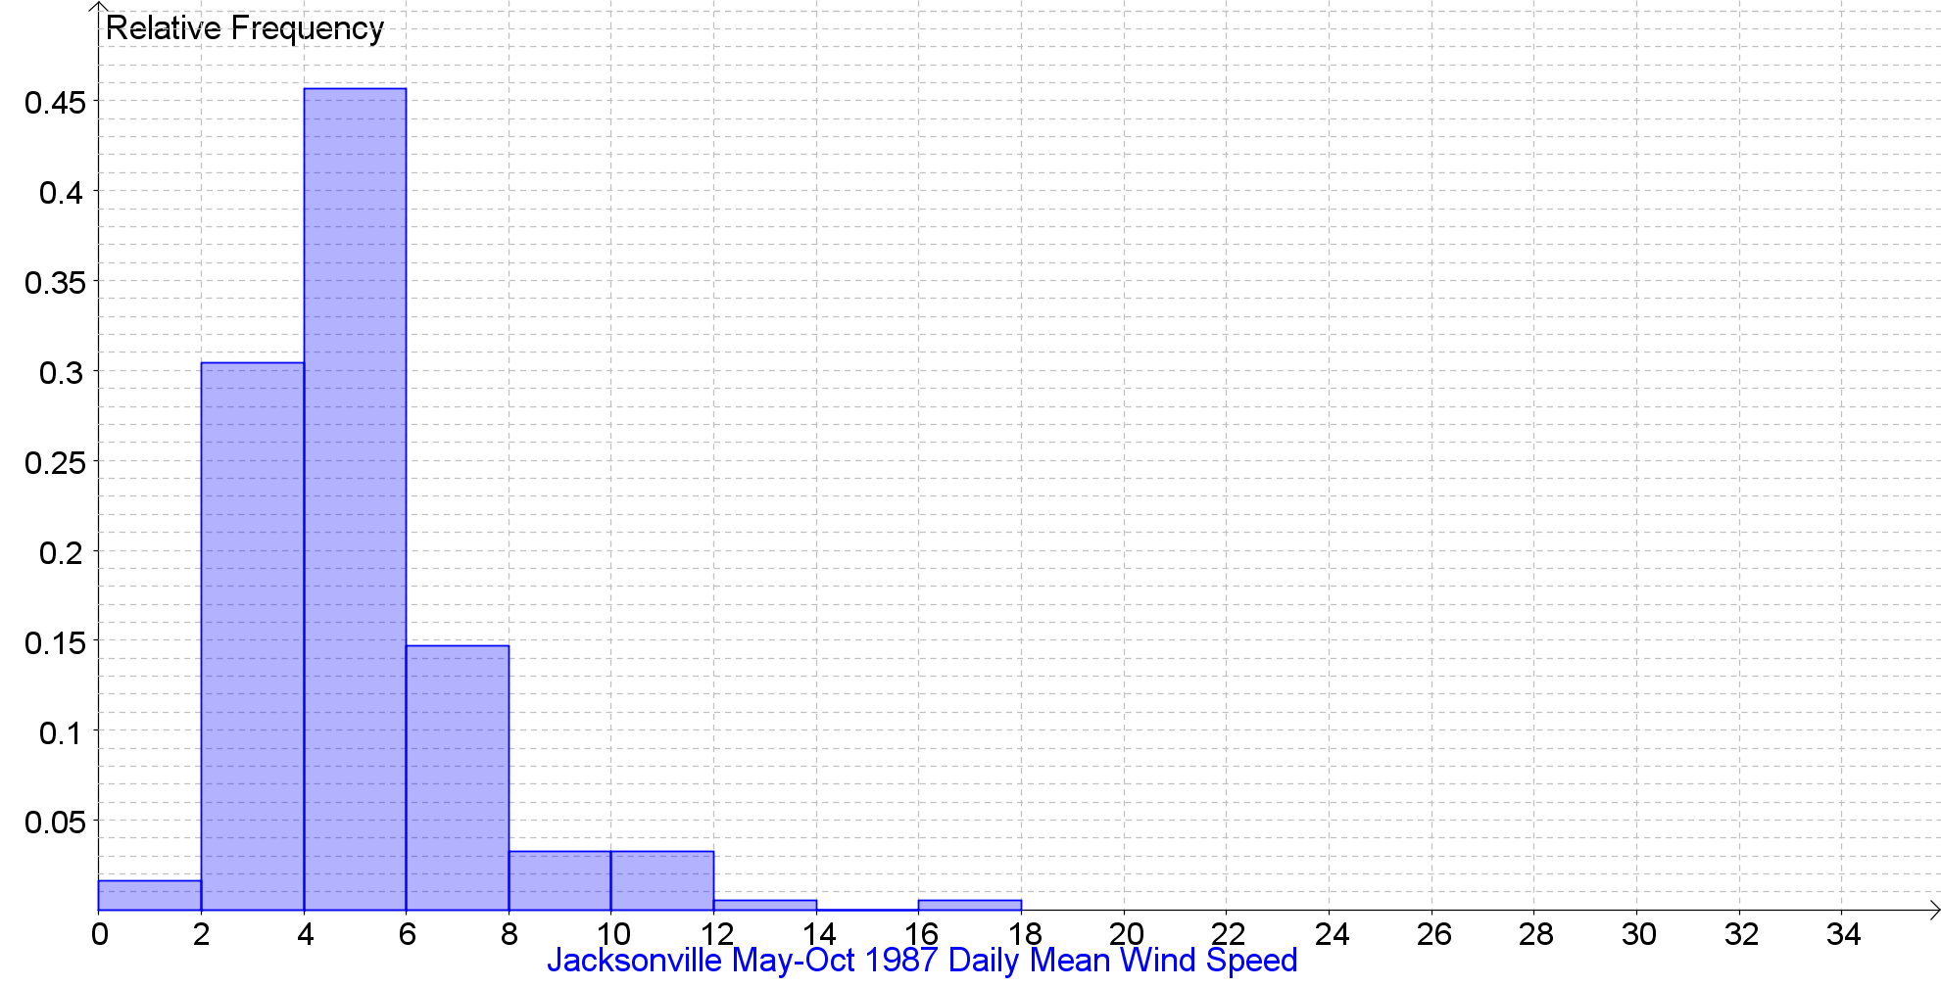 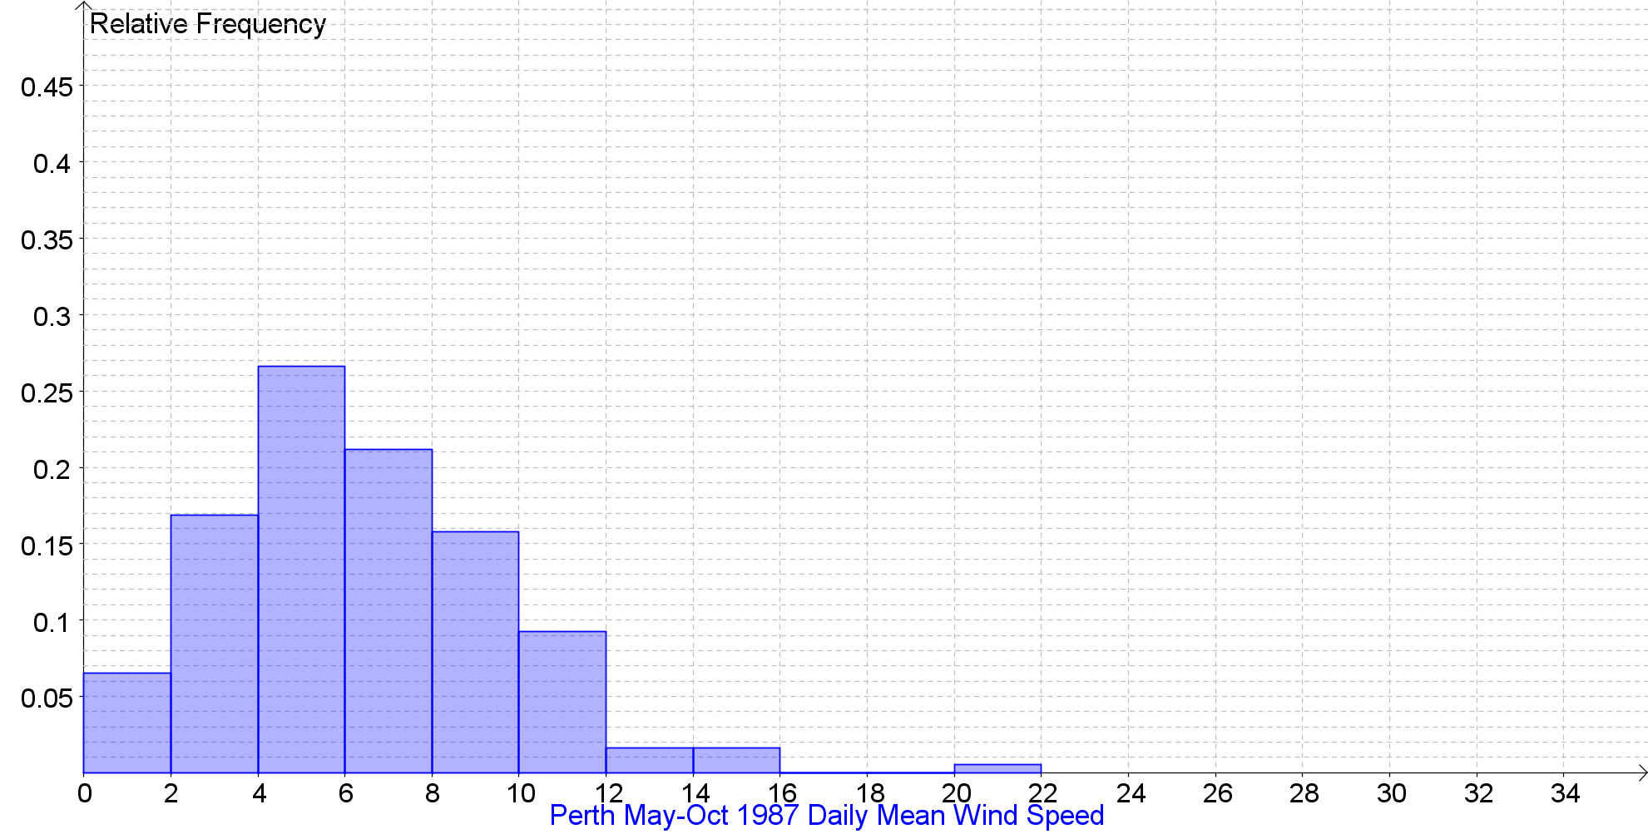
Daily Mean Windspeed (0000-2400) (kn) Back to the Index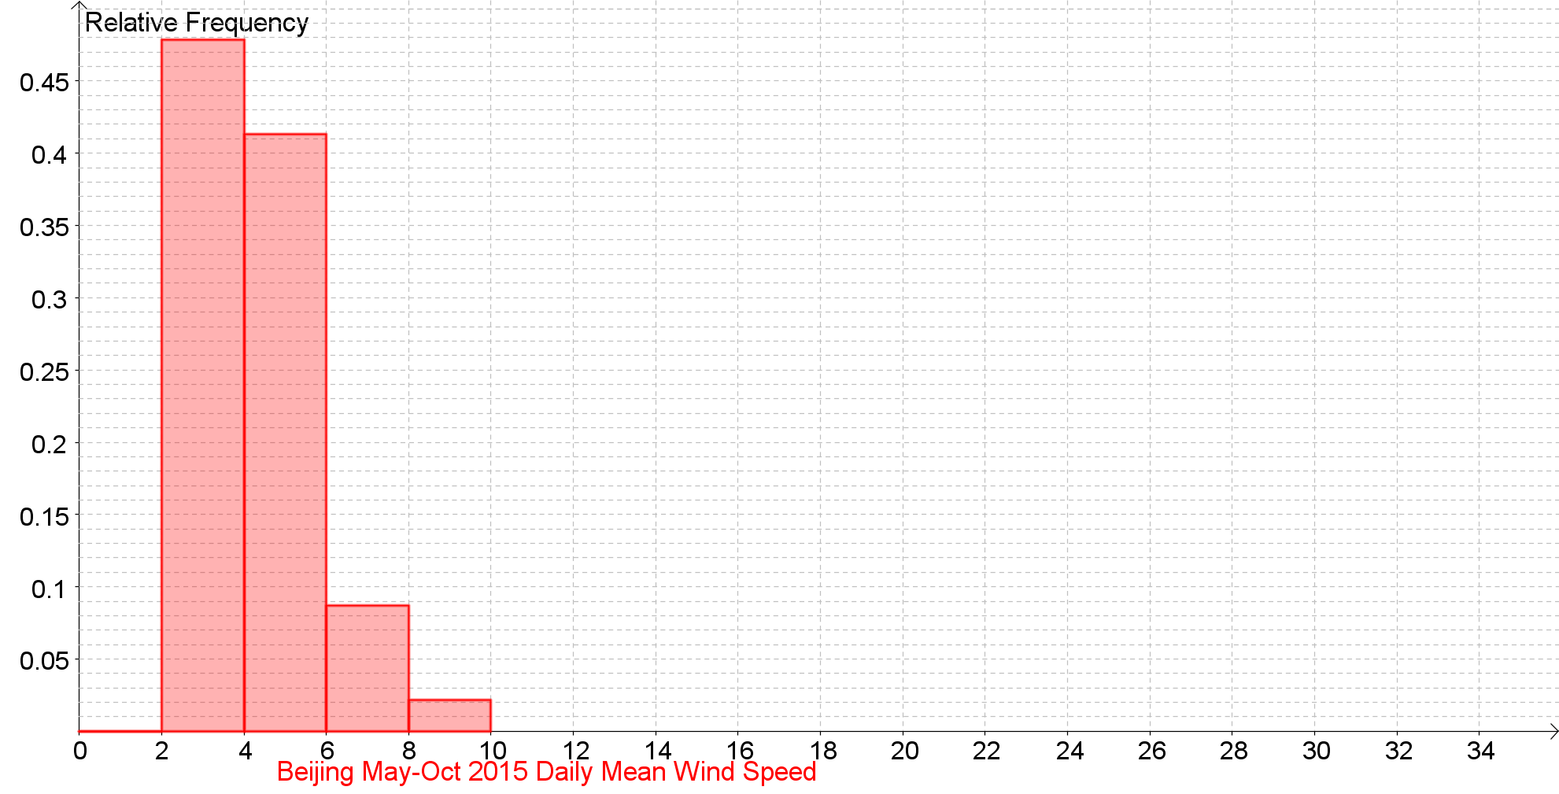 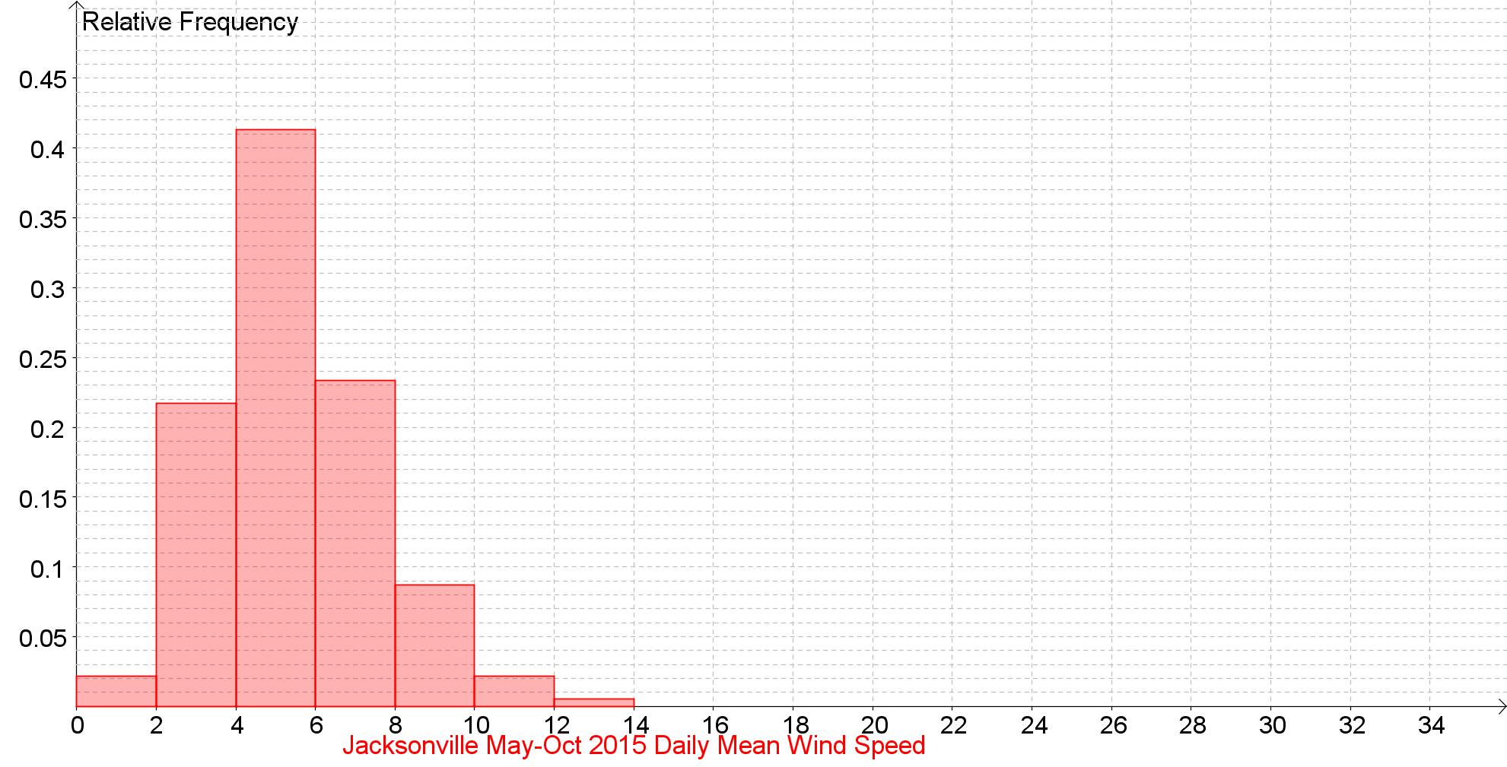 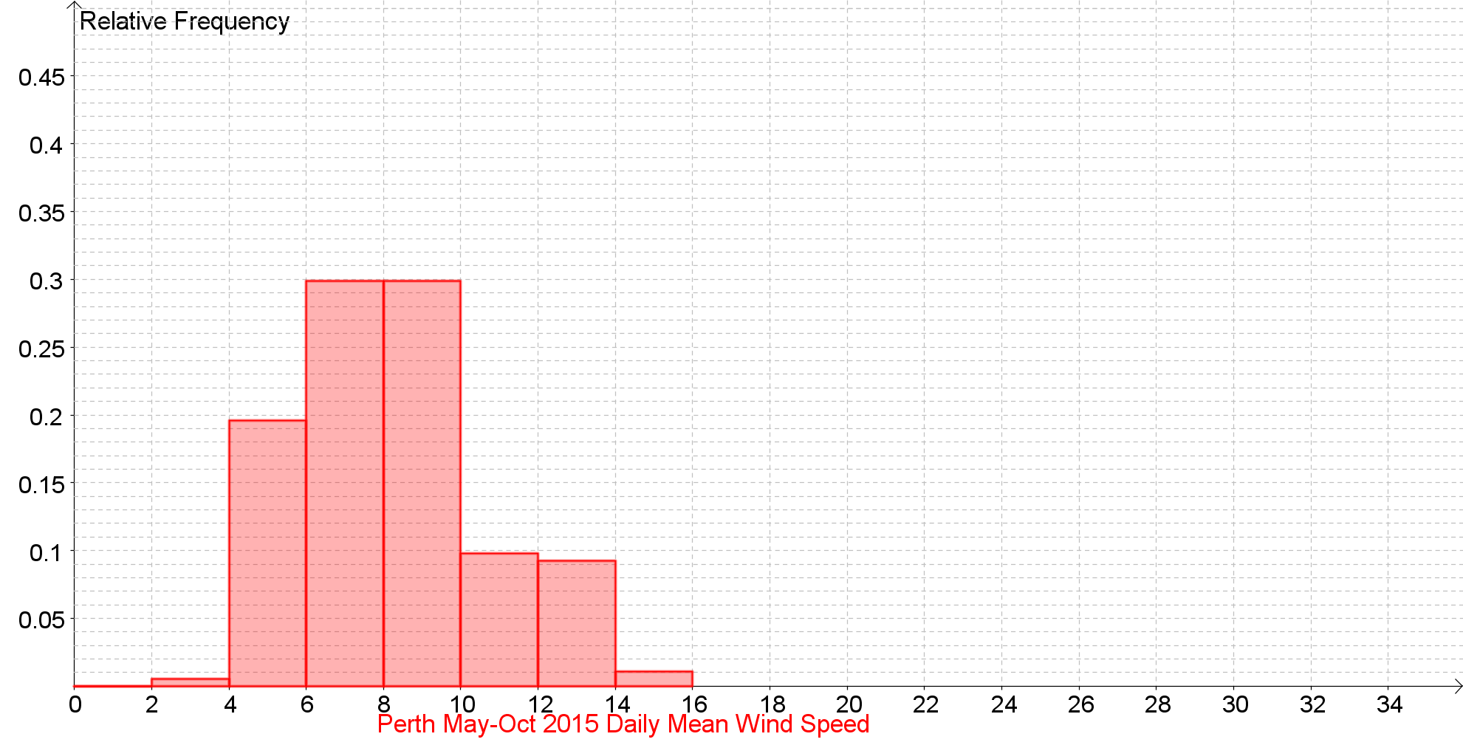

Daily Mean Windspeed (0000-2400) (kn) against Daily Maximum Gust (kn) Back to the Index

Daily Mean Windspeed (0000-2400) (kn) against Daily Maximum Gust (kn) Back to the Index

Daily Mean Windspeed (0000-2400) (kn) against Daily Maximum Gust (kn) Back to the Index

Daily Mean Windspeed (0000-2400) (kn) against Daily Maximum Gust (kn) Back to the Index

Daily Mean Windspeed (0000-2400) (Beaufort conversion) Back to the Index

Daily Mean Windspeed (0000-2400) (Beaufort conversion) Back to the Index

Daily Mean Windspeed (0000-2400) (Beaufort conversion) Back to the Index

Daily Mean Windspeed (0000-2400) (Beaufort conversion) Back to the Index

Daily Mean Windspeed (0000-2400) (Beaufort conversion) Back to the Index

Daily Mean Windspeed (0000-2400) (Beaufort conversion) Back to the Index

Daily Maximum Gust (0000-2400) (kn) Back to the Index
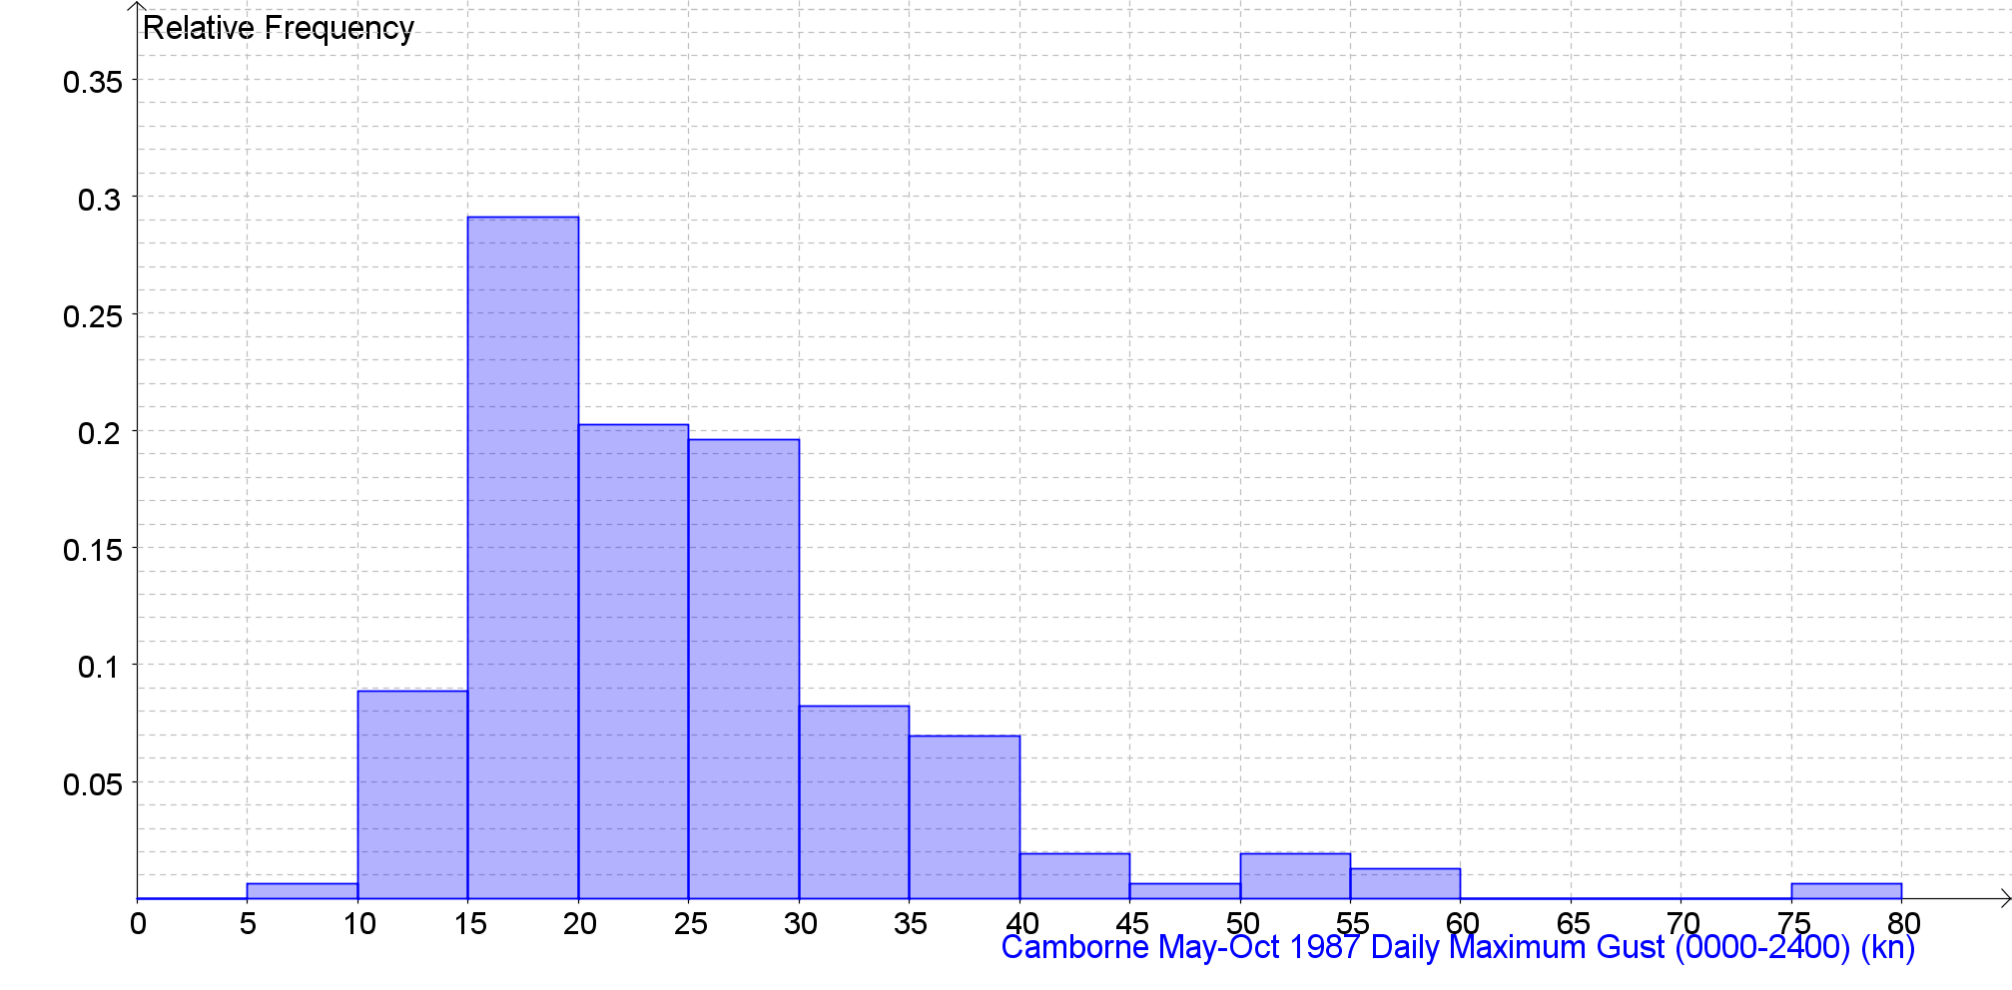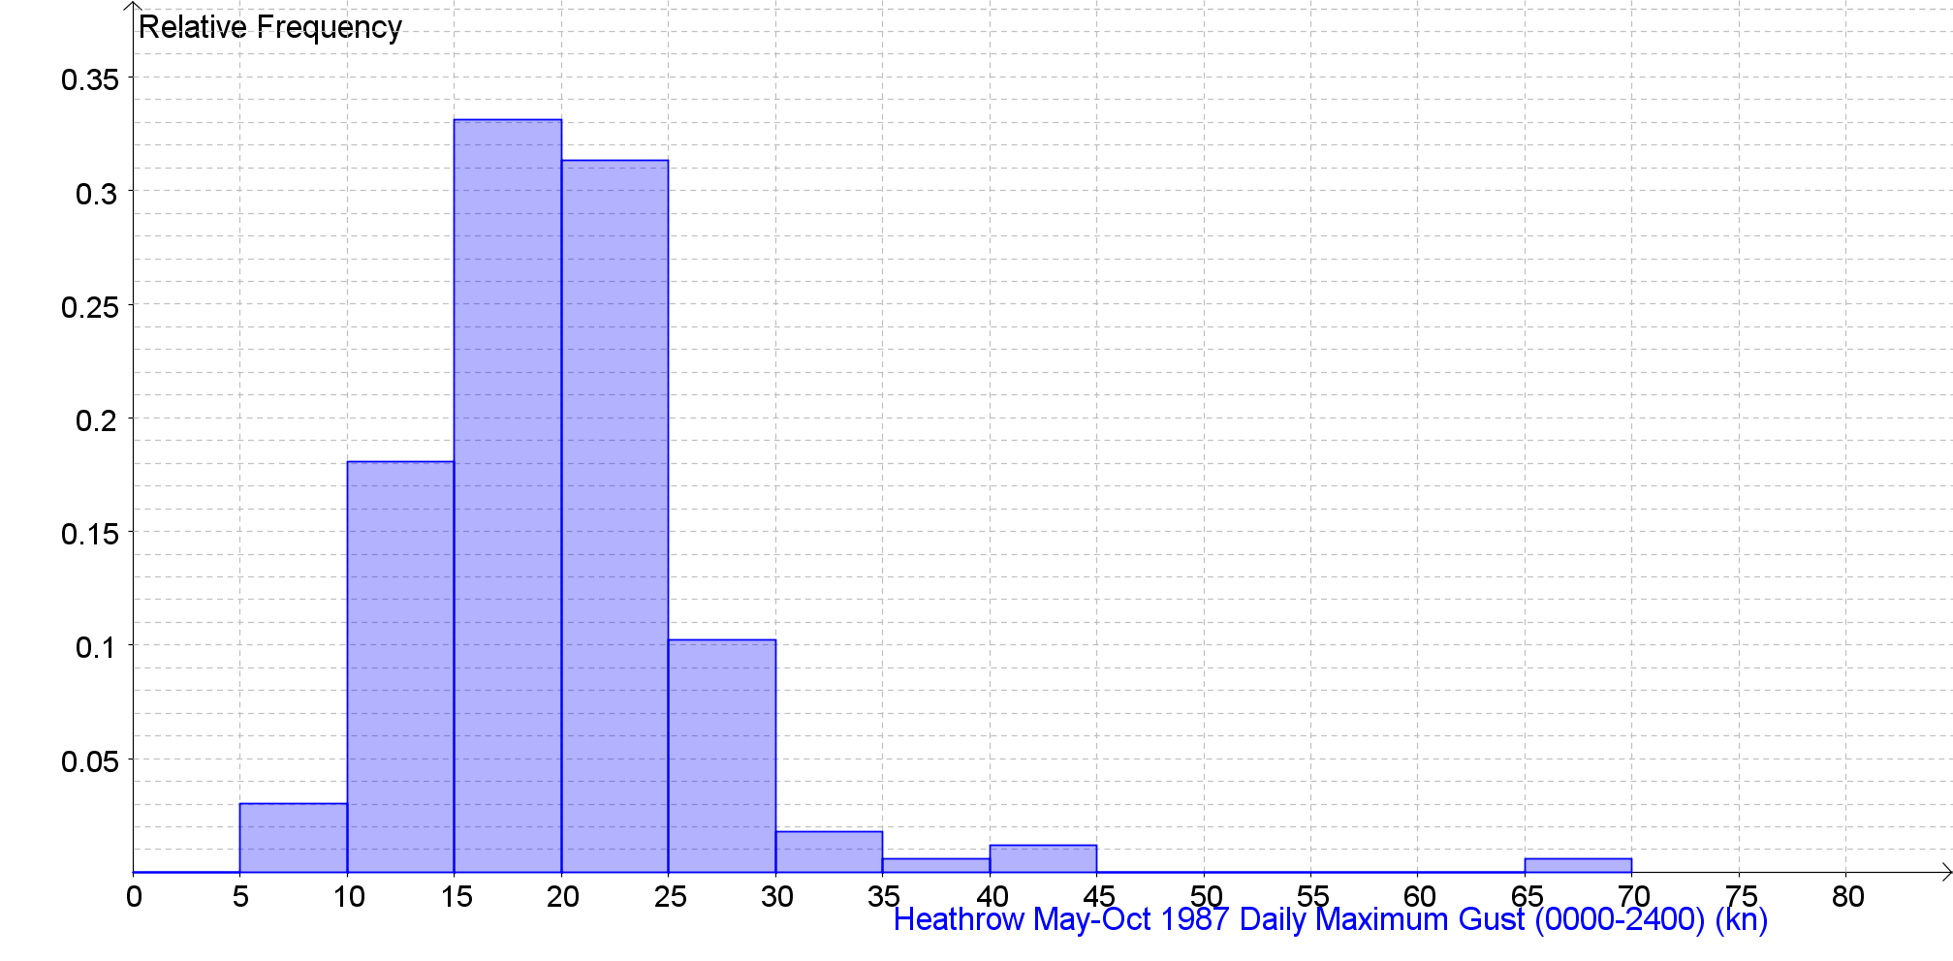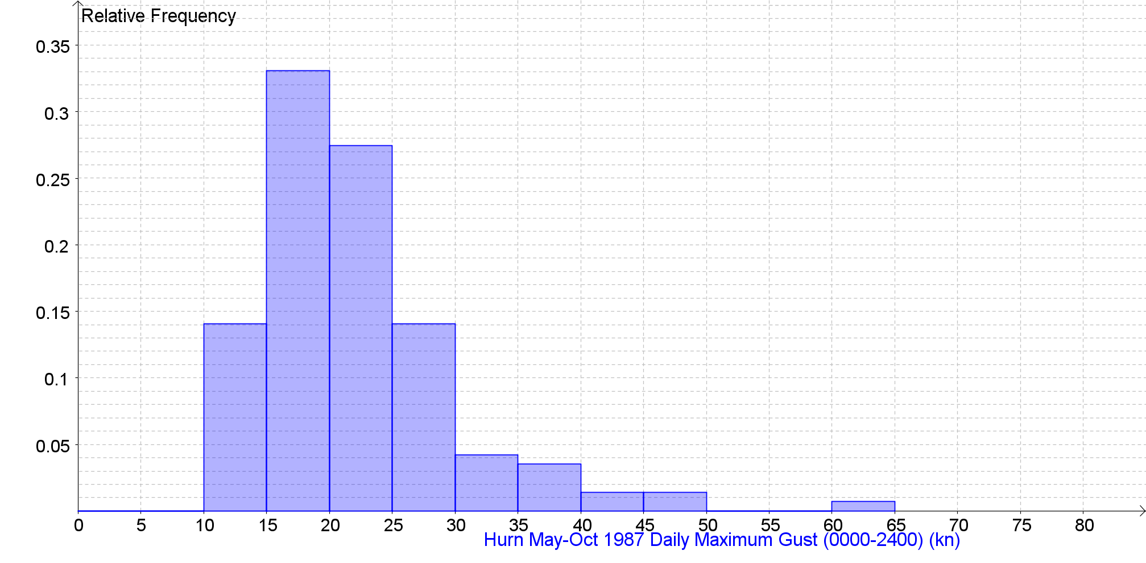
Daily Maximum Gust (0000-2400) (kn) Back to the Index
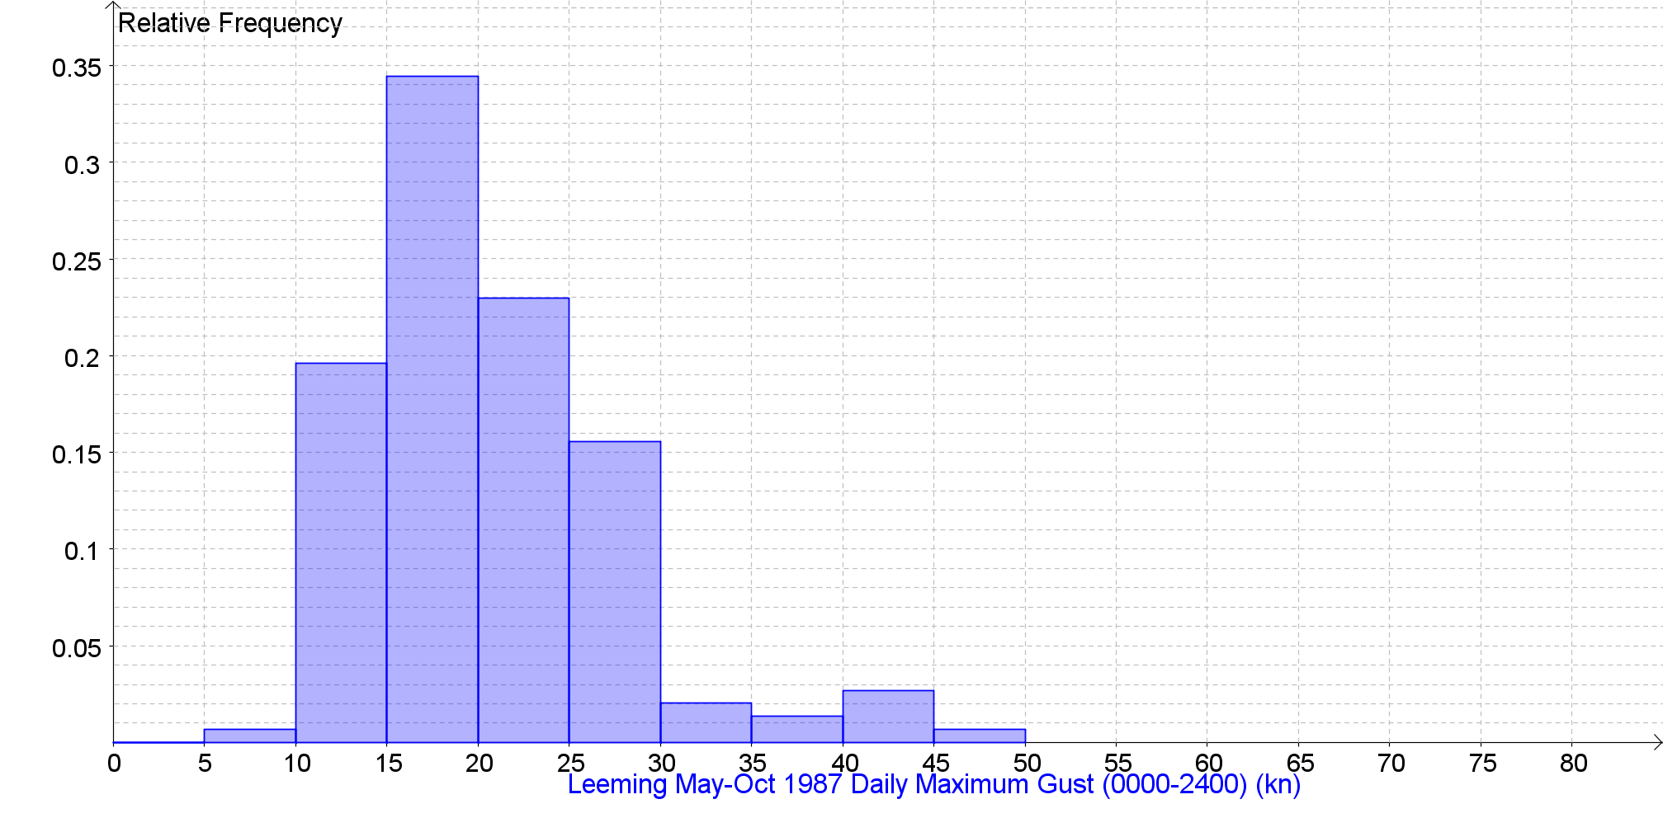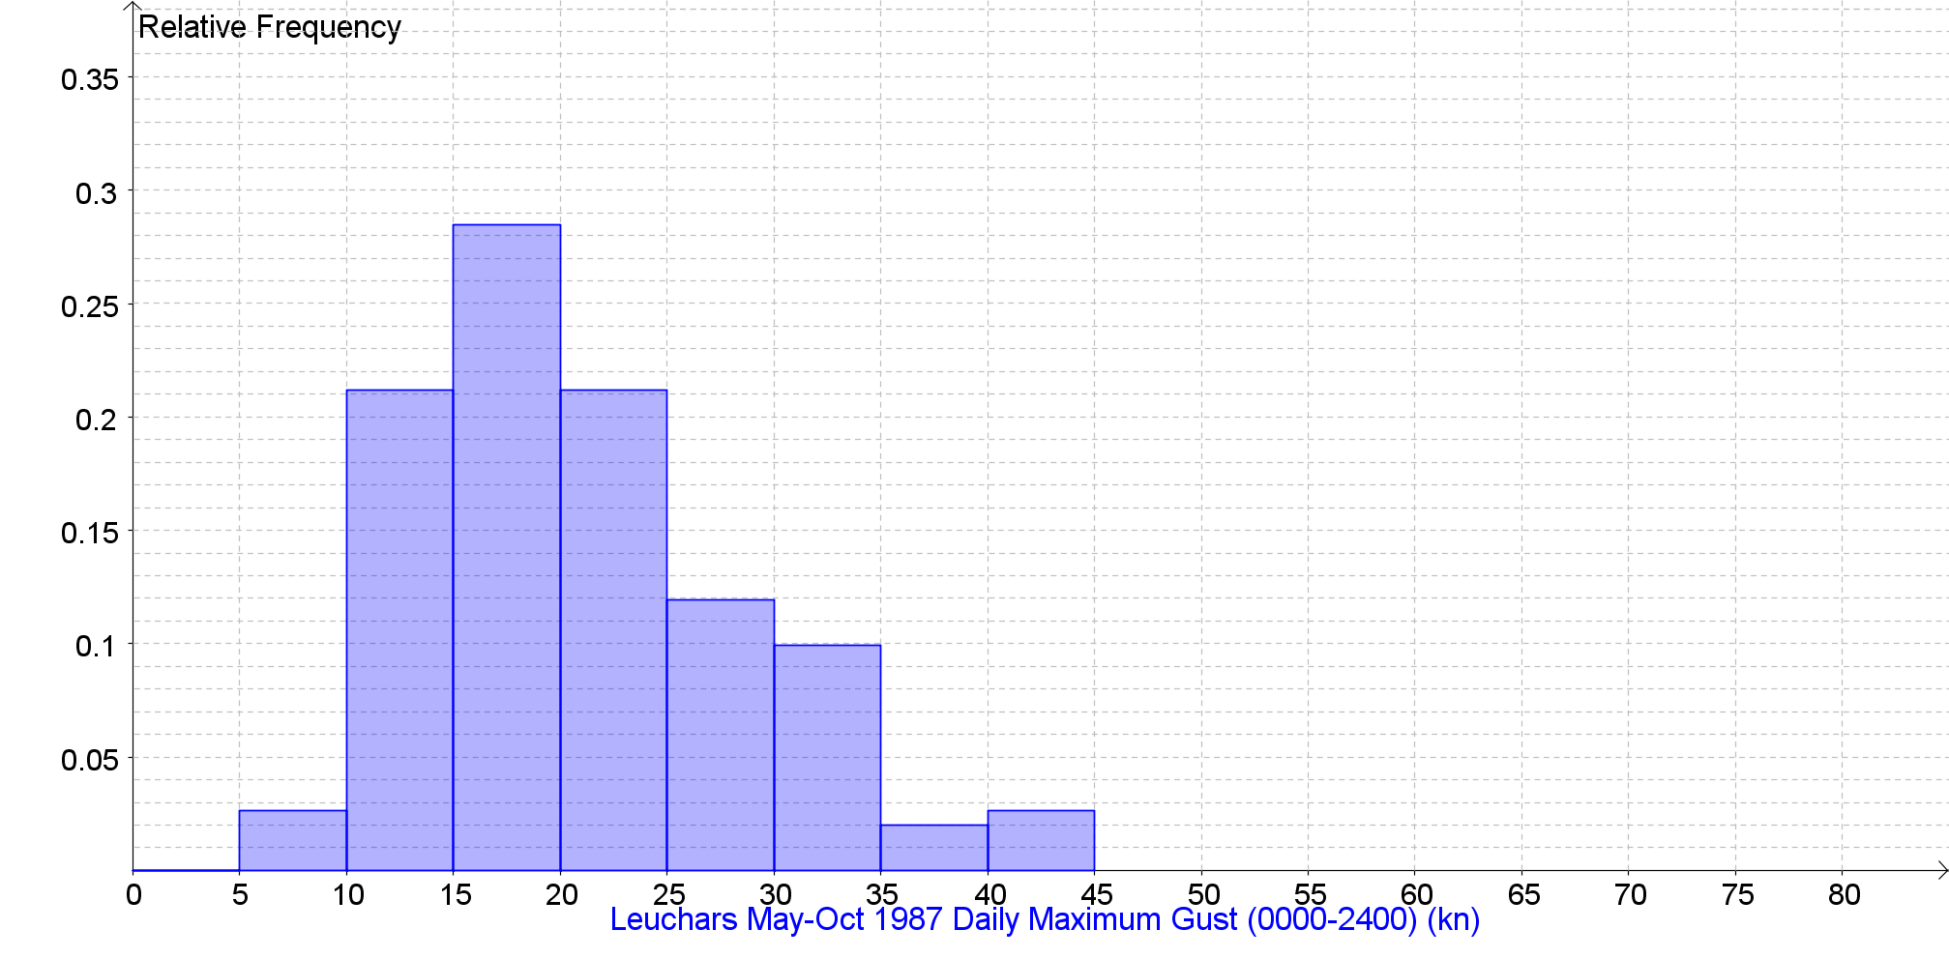

Daily Maximum Gust (0000-2400) (kn) Back to the Index
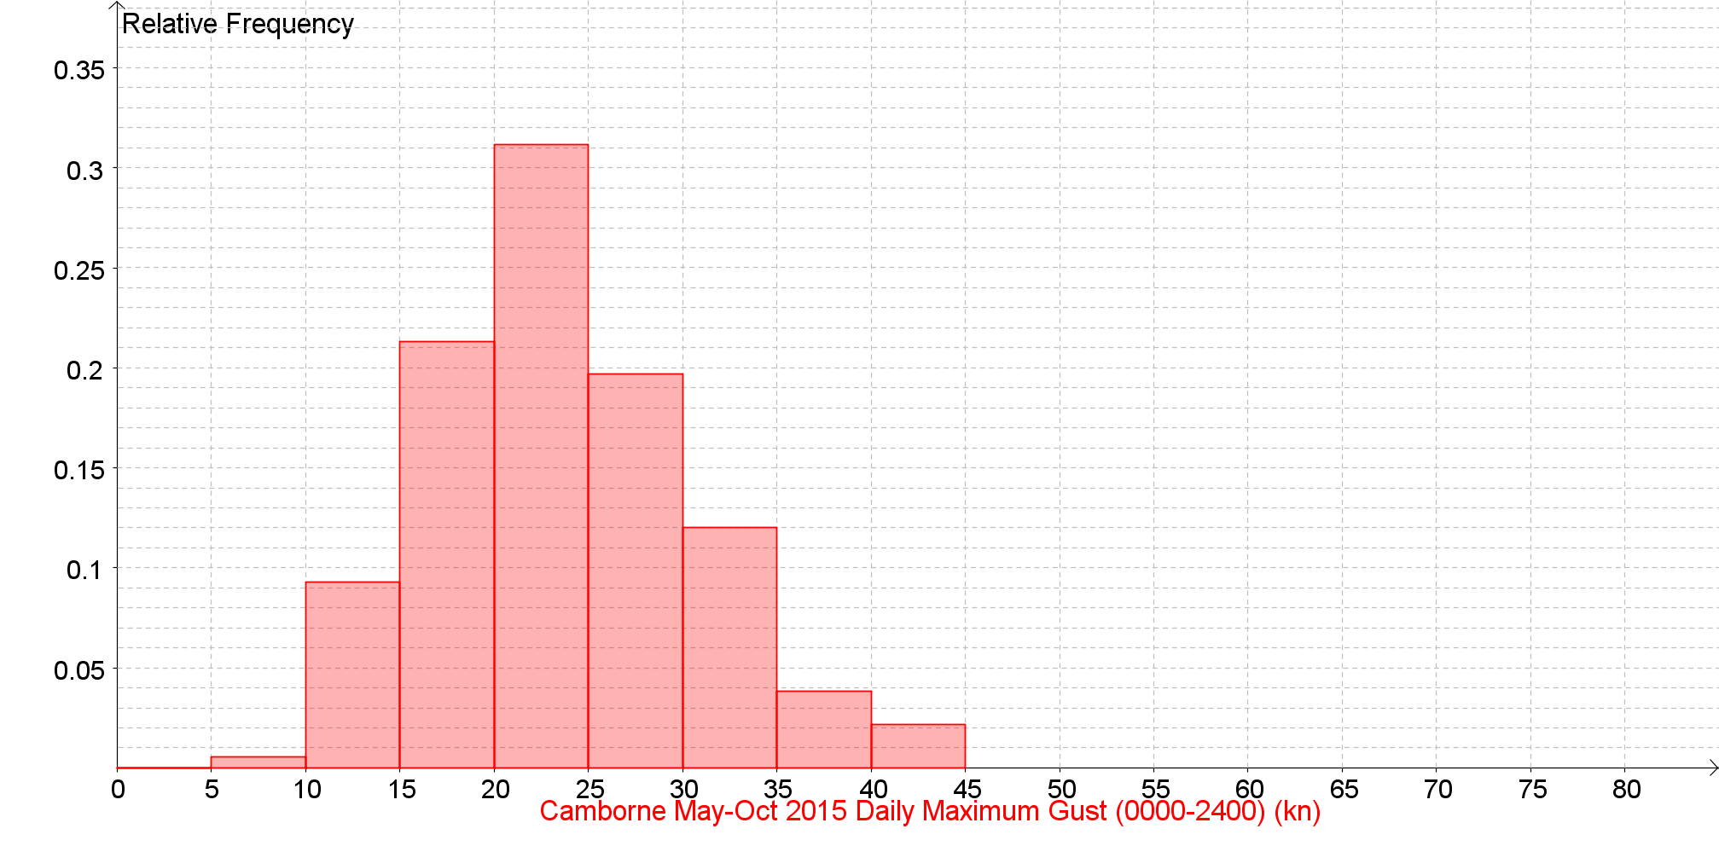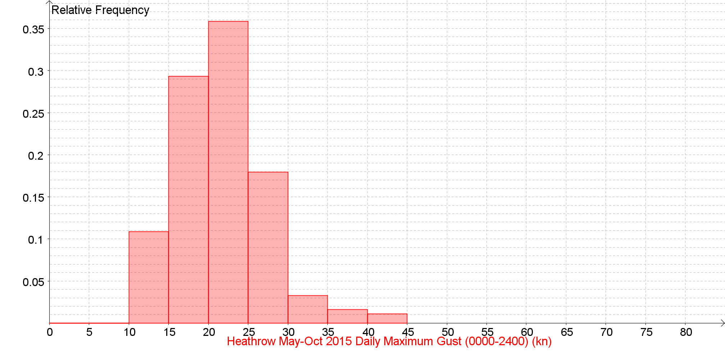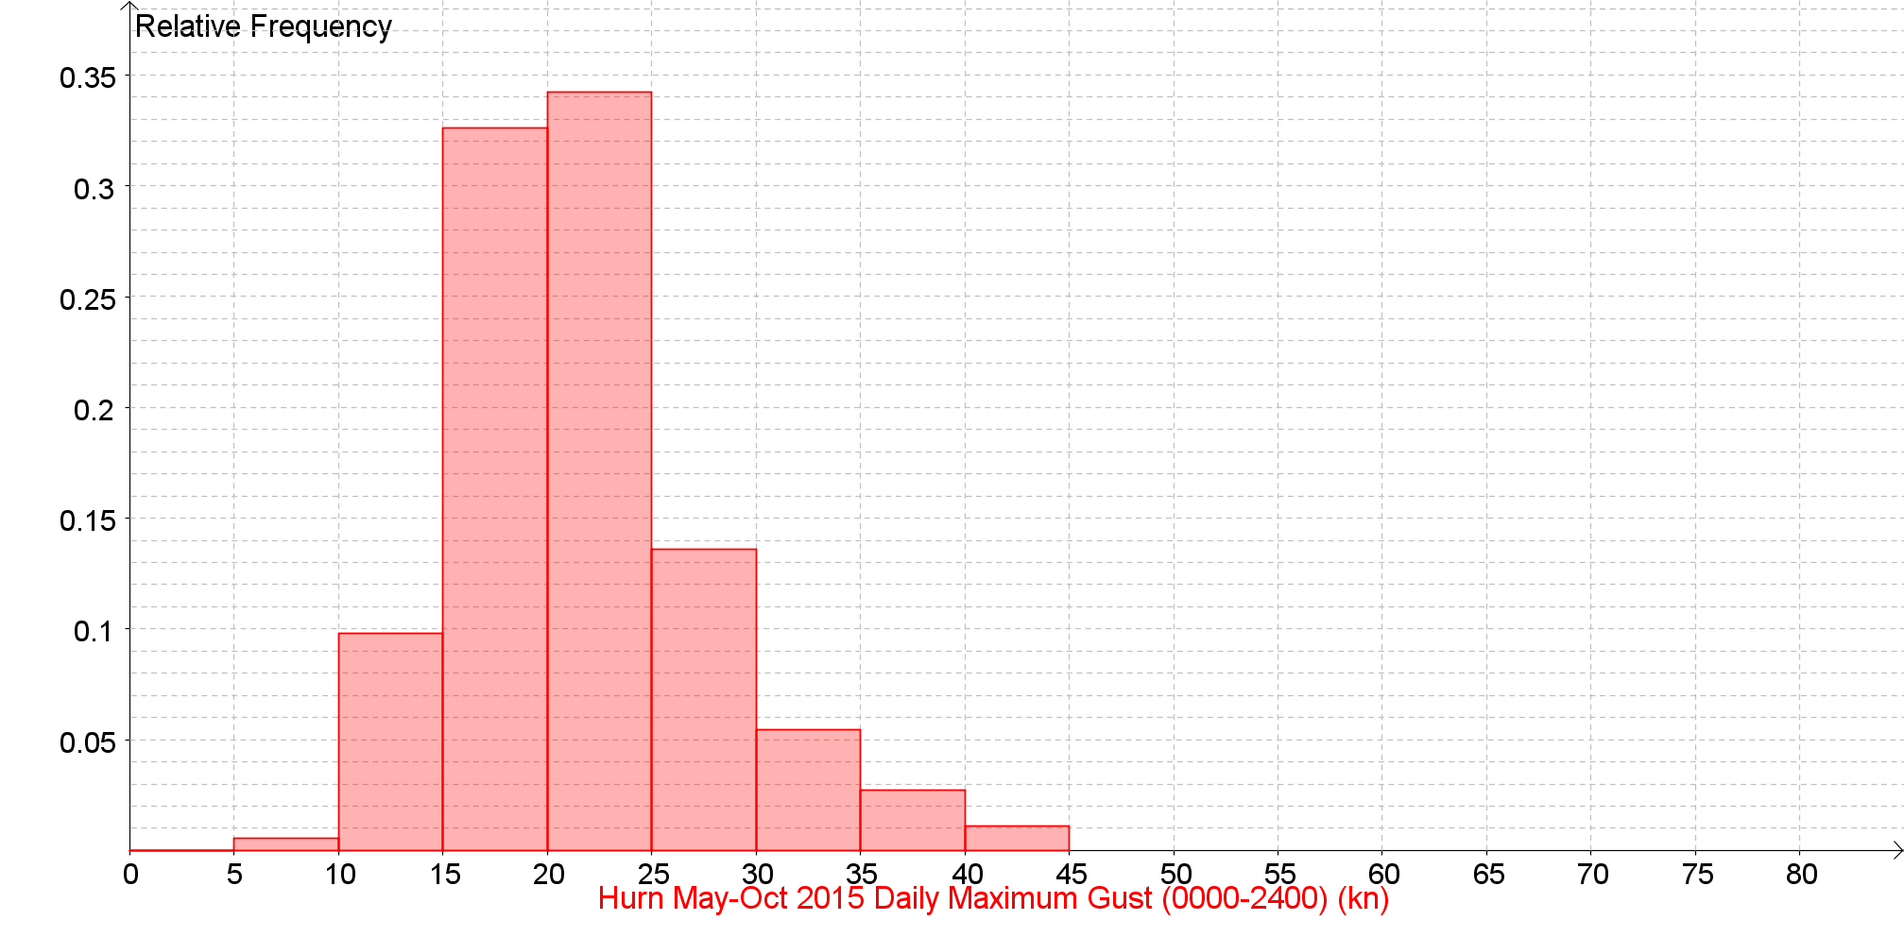
Daily Maximum Gust (0000-2400) (kn) Back to the Index
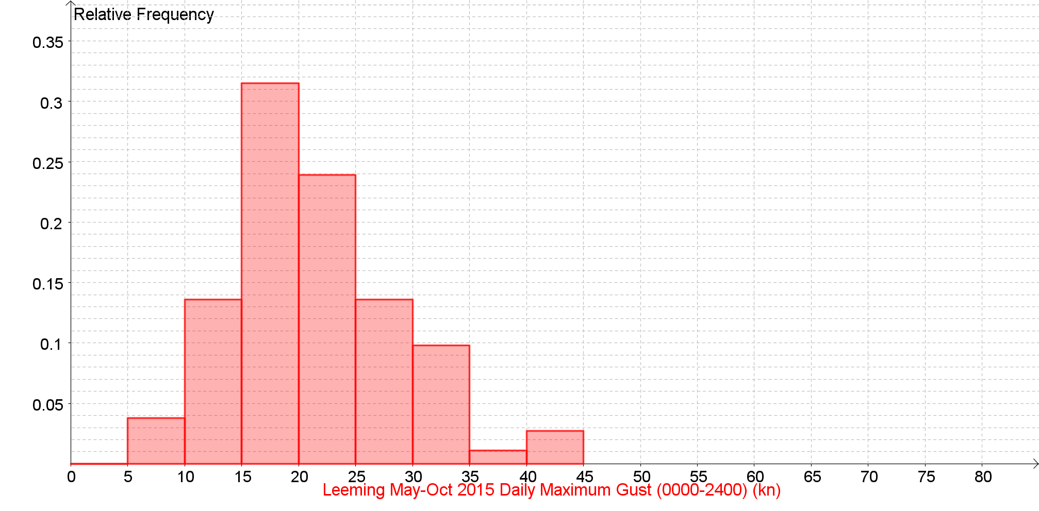
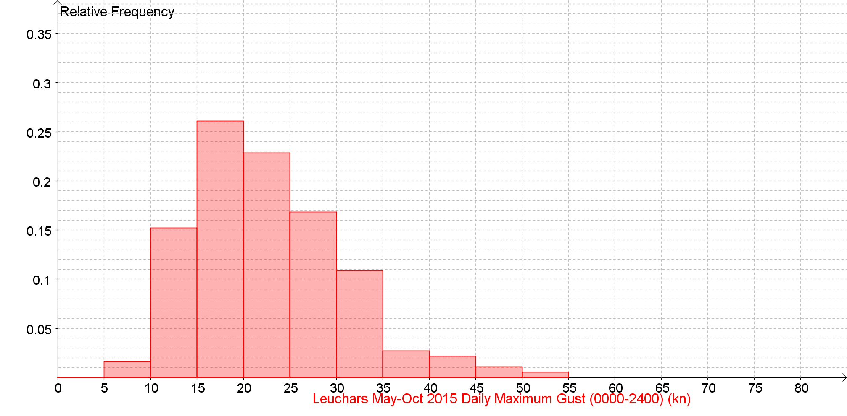

Daily Maximum Gust (0000-2400) (kn) Back to the Index
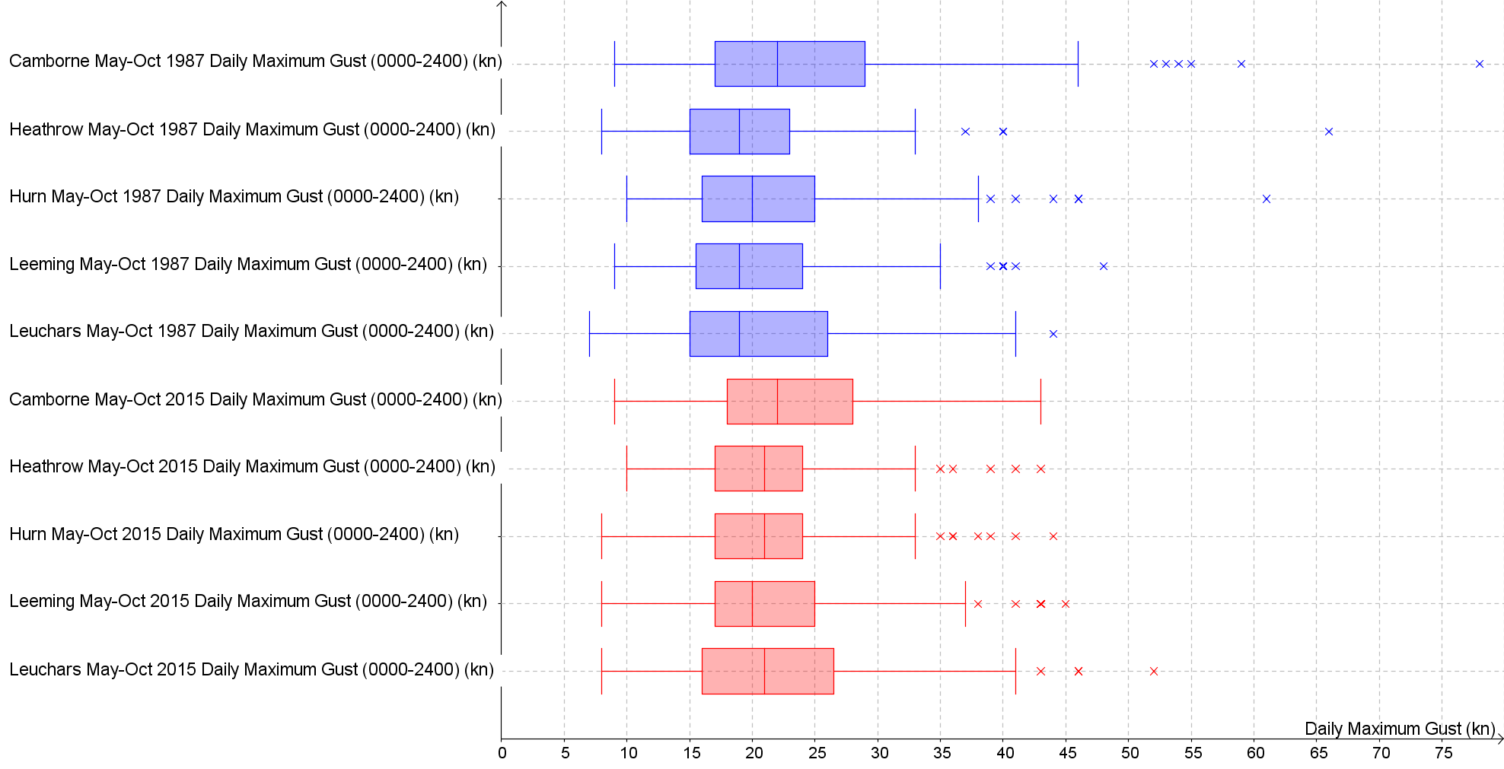

Daily Maximum Relative Humidity % Back to the Index

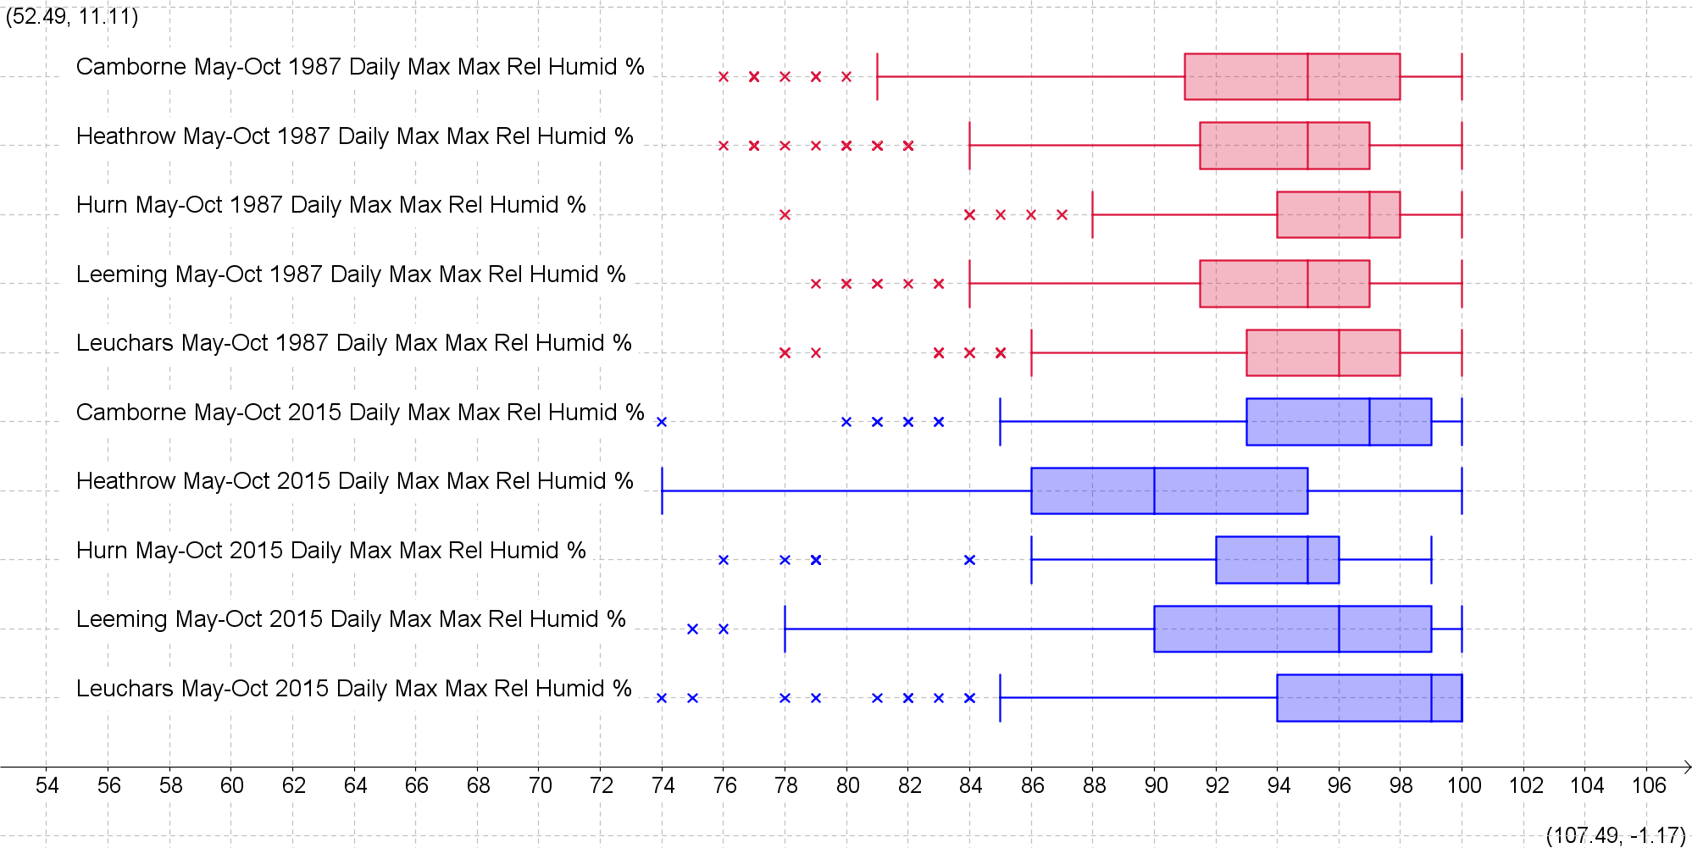

Daily Maximum Relative Humidity Back to the Index
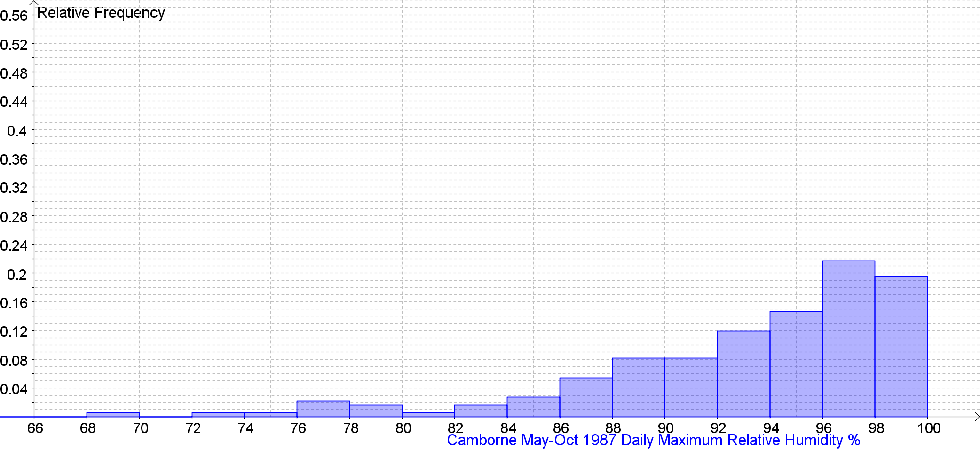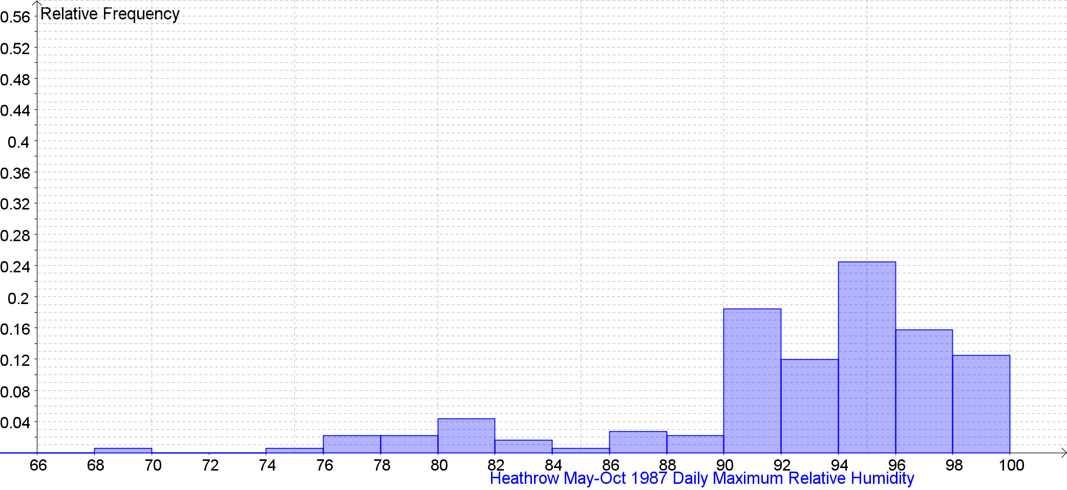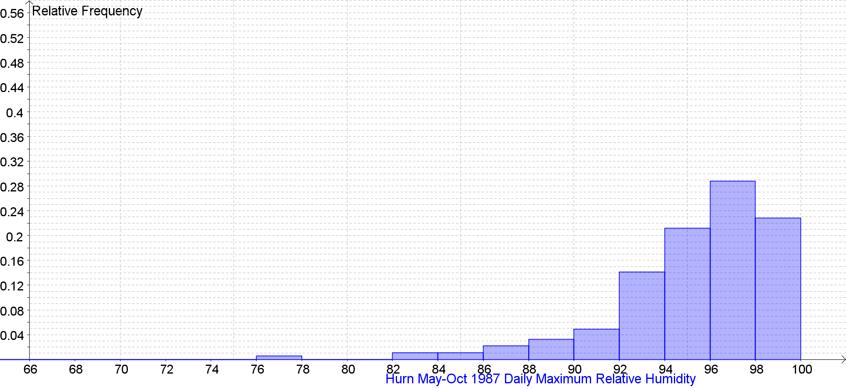

Daily Maximum Relative Humidity Back to the Index
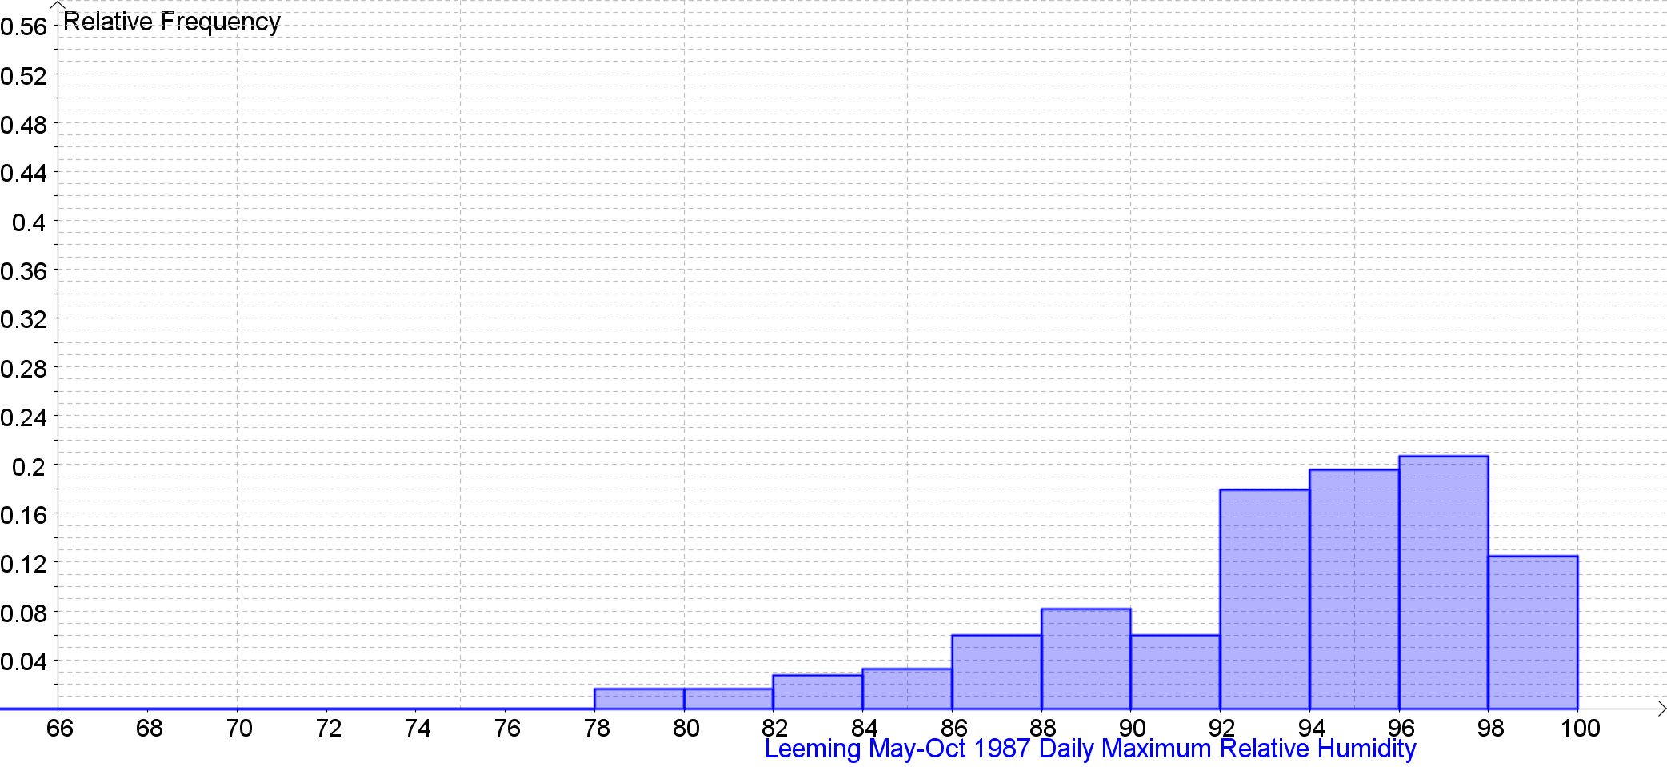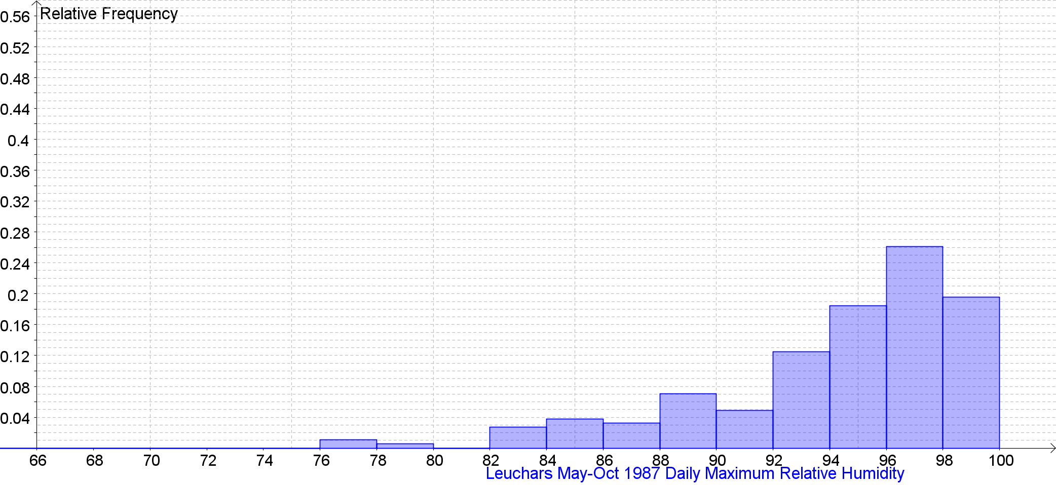

Daily Maximum Relative Humidity Back to the Index
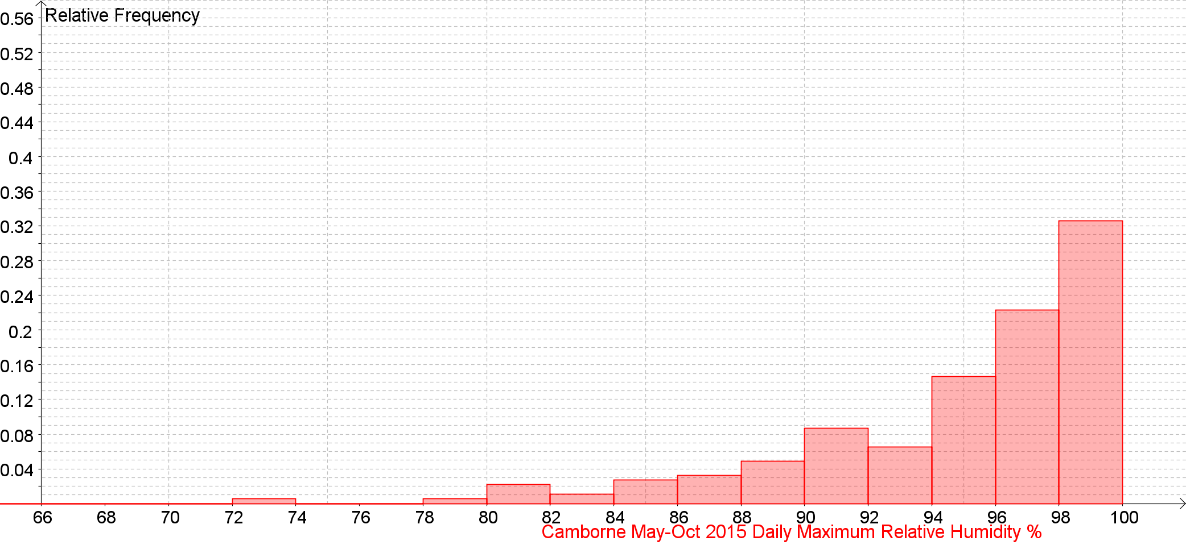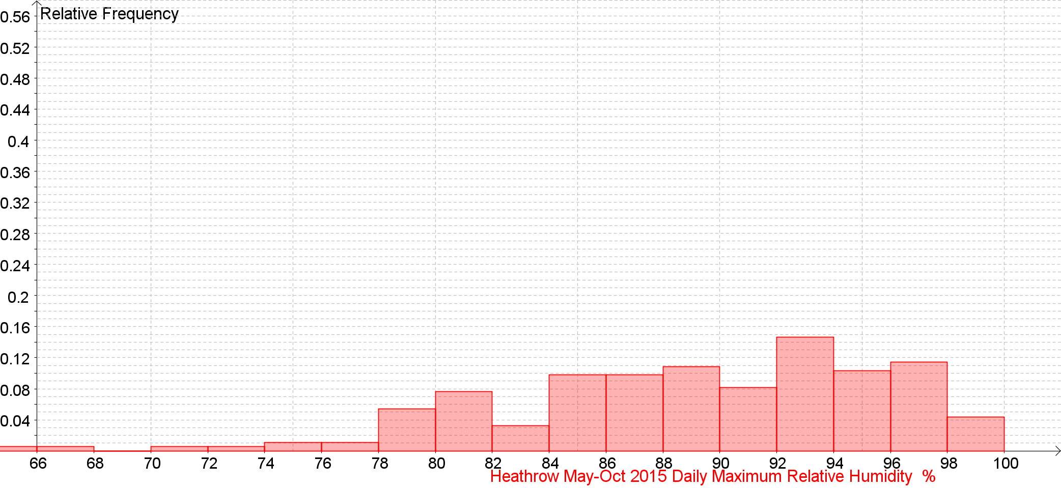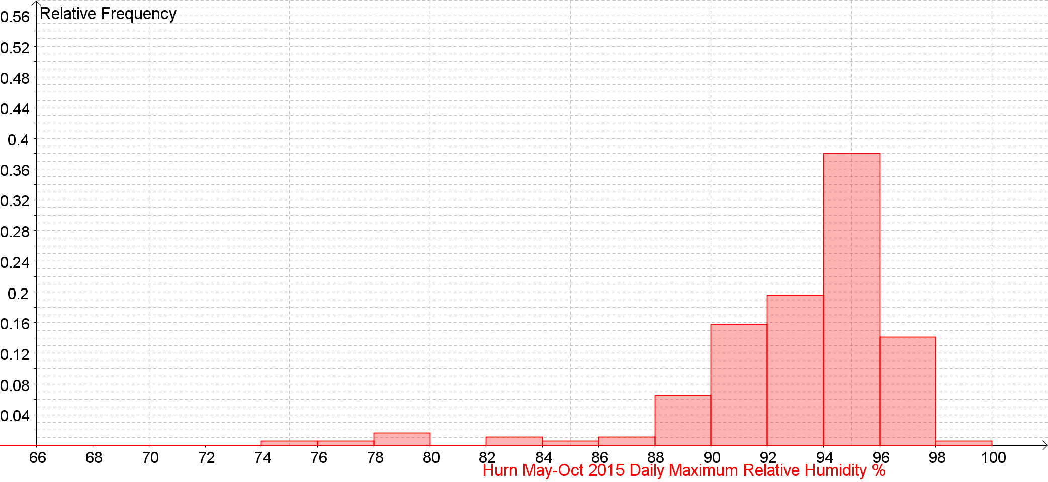

Daily Maximum Relative Humidity Back to the Index
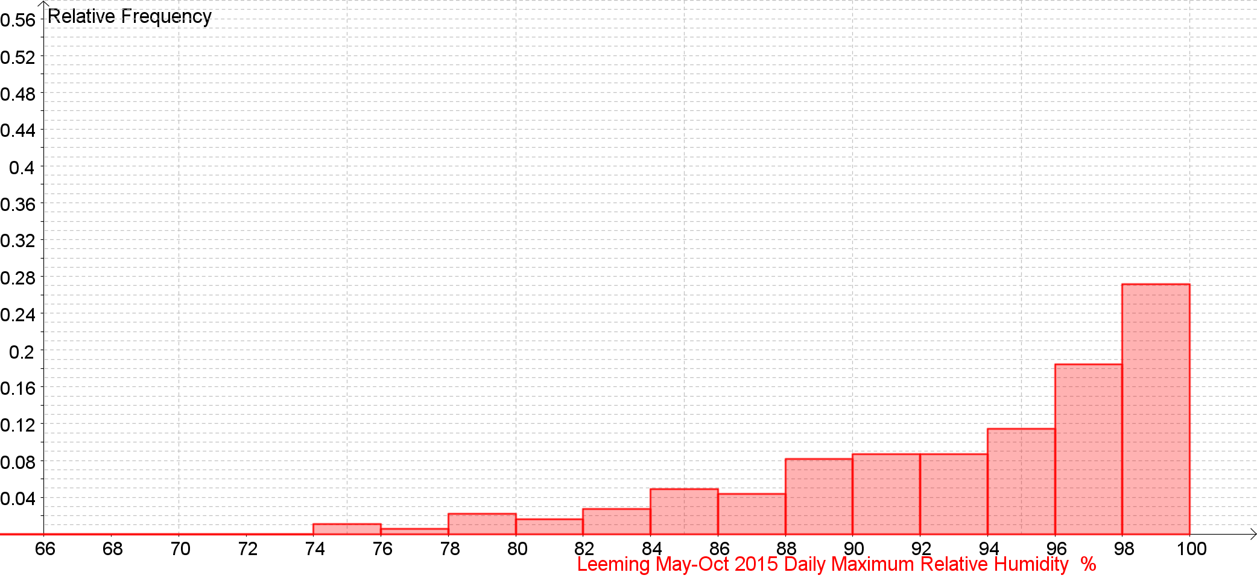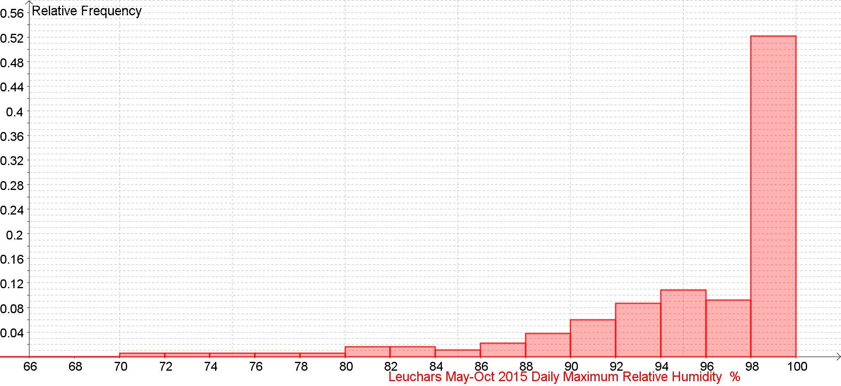
Daily Maximum Relative Humidity % Back to the Index

Daily Maximum Relative Humidity % Back to the Index

Daily Maximum Relative Humidity % Back to the Index

Daily Maximum Relative Humidity % Back to the Index

Daily Maximum Relative Humidity % Back to the Index

Daily Mean Total Cloud (oktas) Back to the Index

Daily Mean Total Cloud (oktas) Back to the Index

Daily Mean Total Cloud (oktas) Back to the Index

Daily Mean Total Cloud (oktas) Back to the Index

Daily Mean Total Cloud (oktas) against Daily total Sunshine (hrs) Back to the Index

Daily Mean Total Cloud (oktas) against Daily total Sunshine (hrs) Back to the Index

Daily Mean Total Cloud (oktas) against Daily total Sunshine (hrs) Back to the Index

Daily Mean Total Cloud (oktas) against Daily total Sunshine (hrs) Back to the Index

Daily Mean Total Cloud (oktas) against Daily Total Rainfall (mm) Back to the Index

Daily Mean Total Cloud (oktas) against Daily Total Rainfall (mm) Back to the Index

Daily Mean Total Cloud (oktas) against Daily Total Rainfall (mm) Back to the Index

Daily Mean Total Cloud (oktas) against Daily Total Rainfall (mm) Back to the Index

Daily Mean Visibility Back to the Index
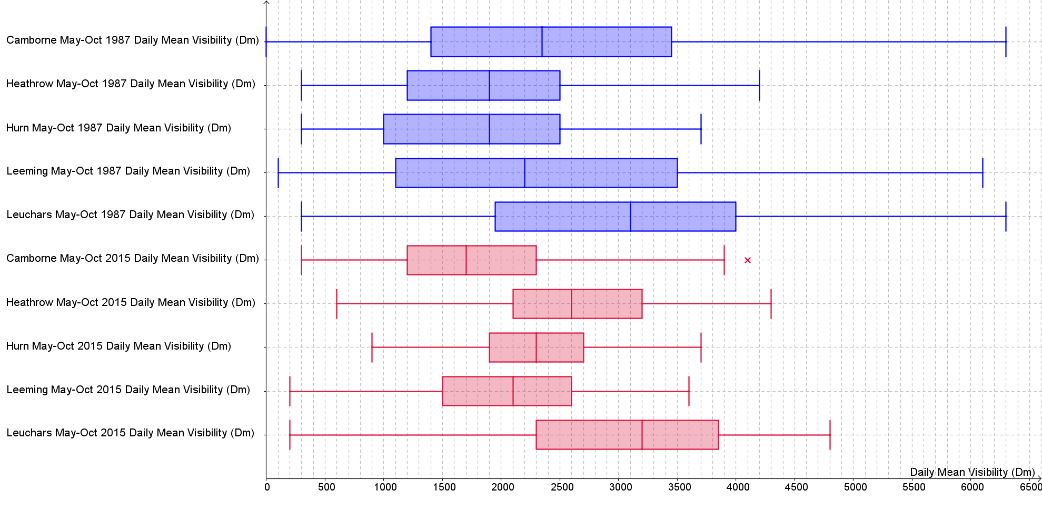

Daily Mean Visibility (Dm) Back to the Index
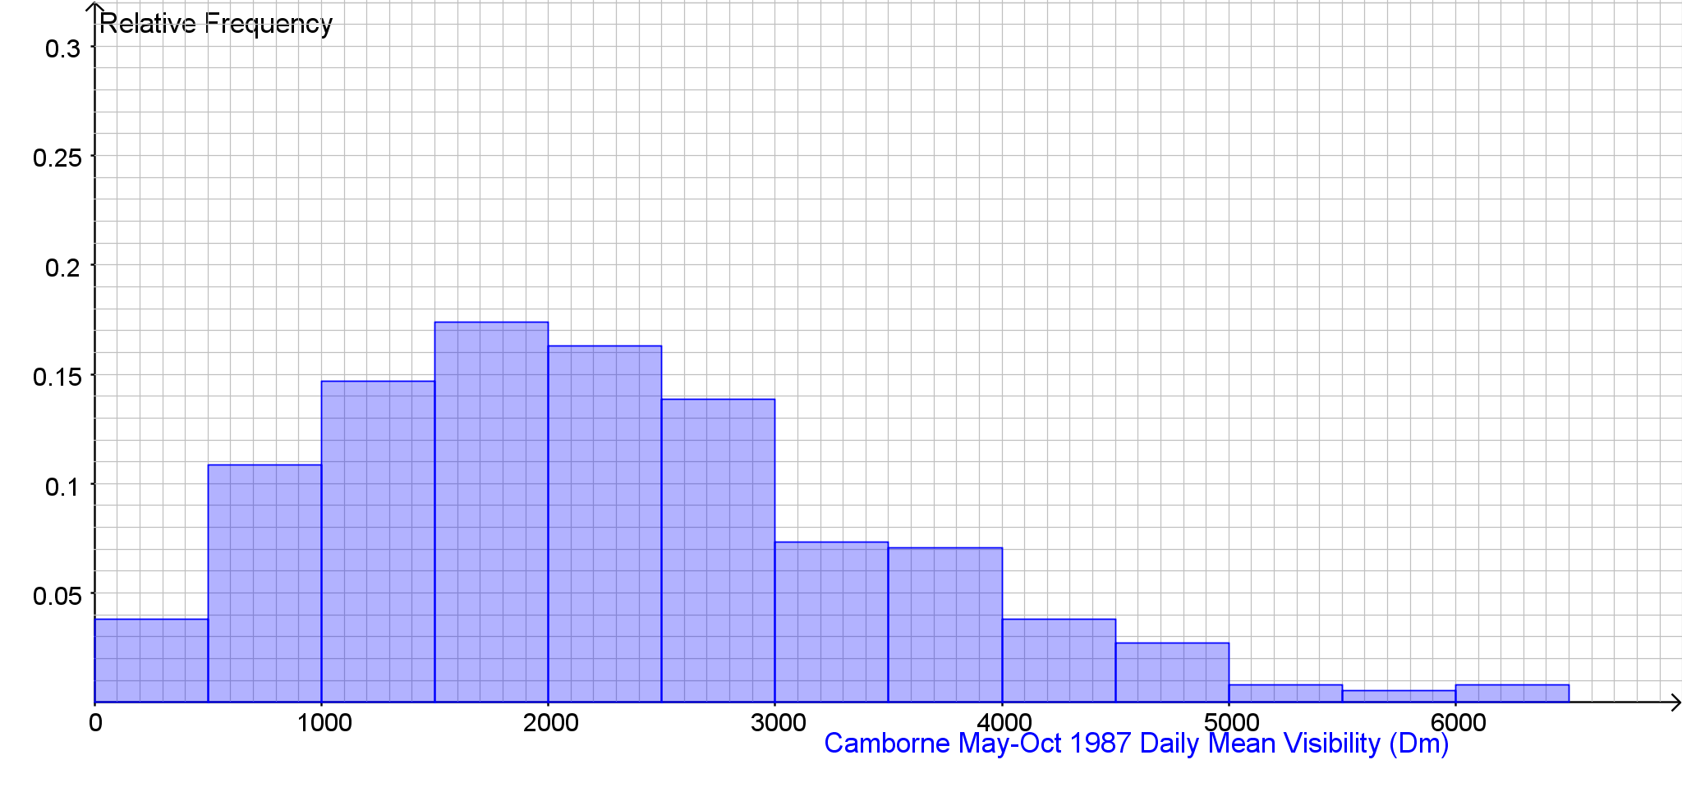

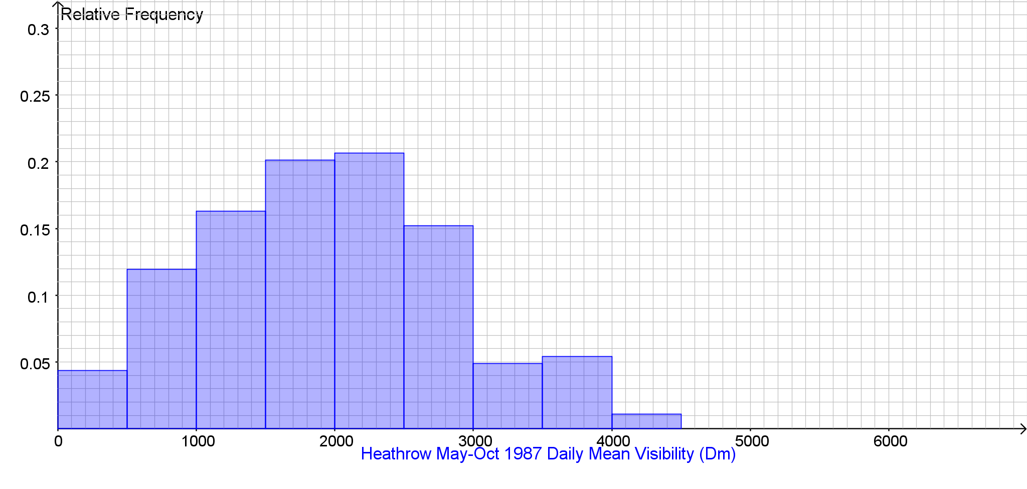

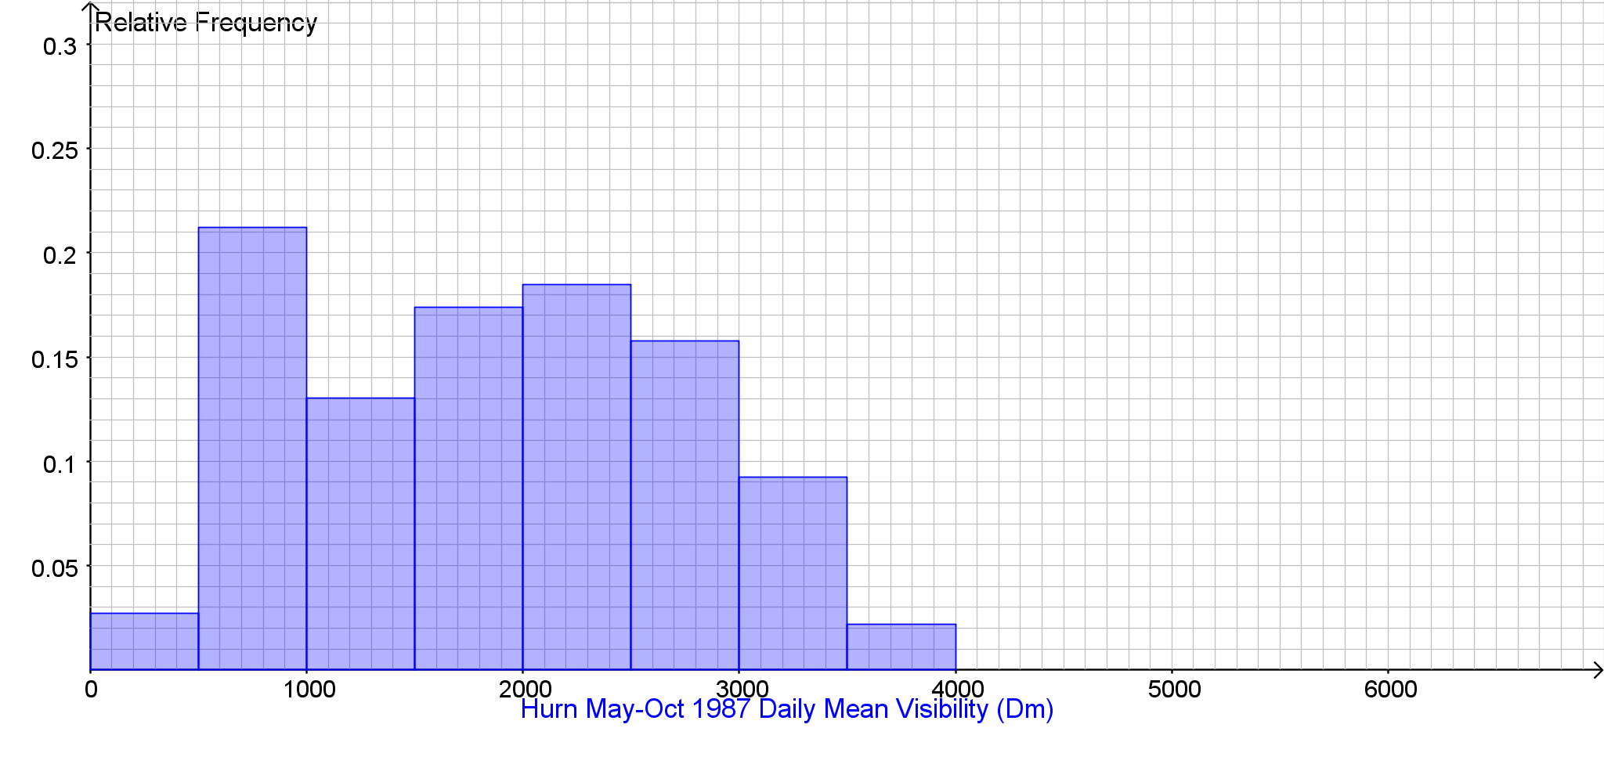
Daily Mean Visibility (Dm) Back to the Index
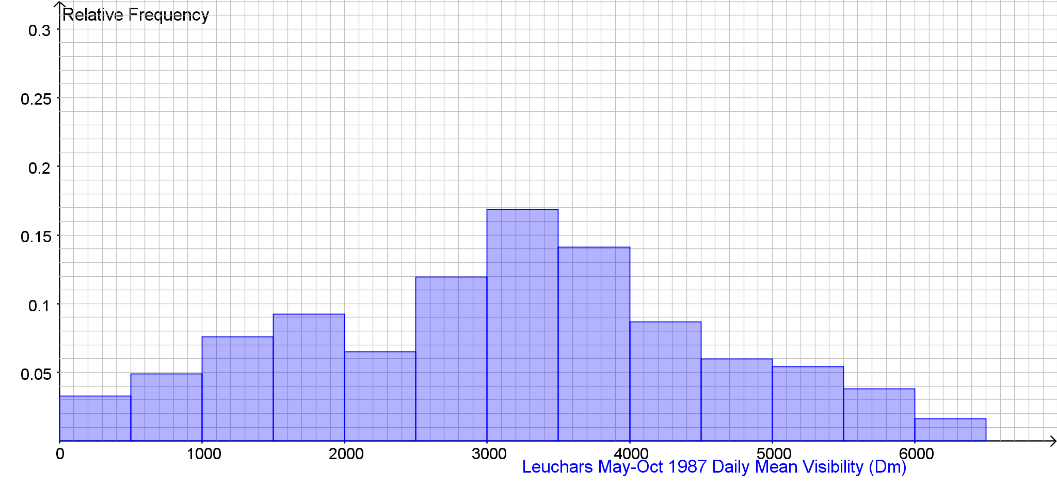
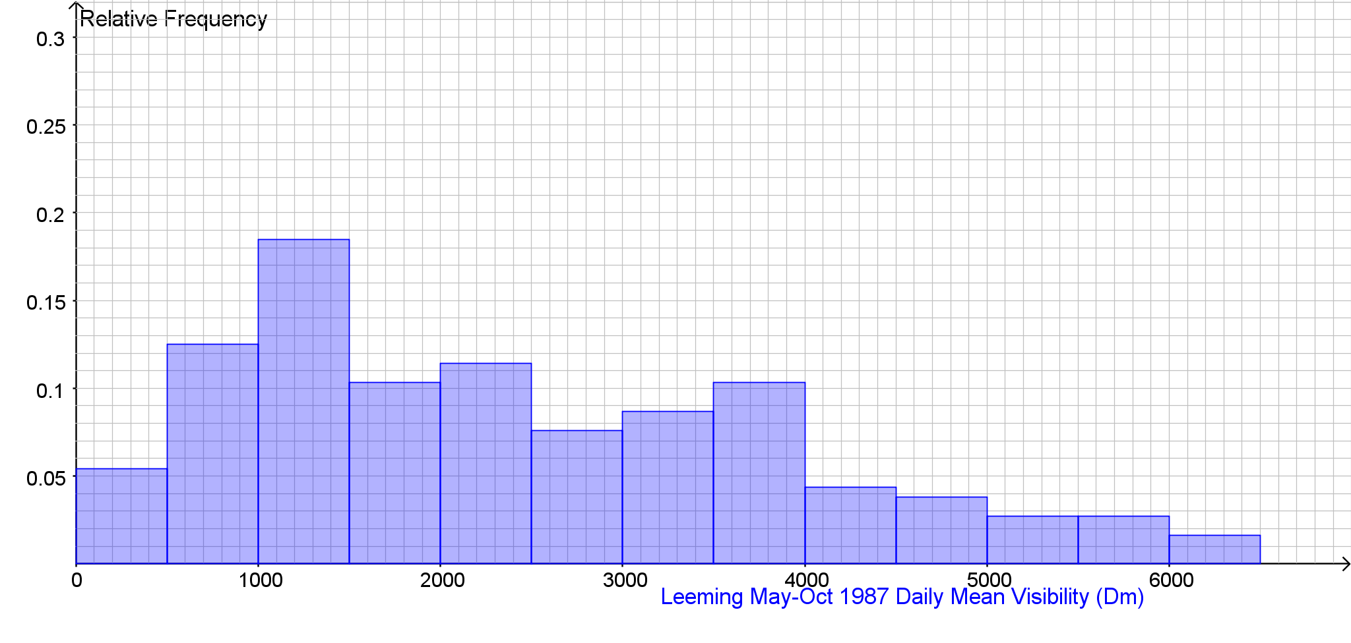
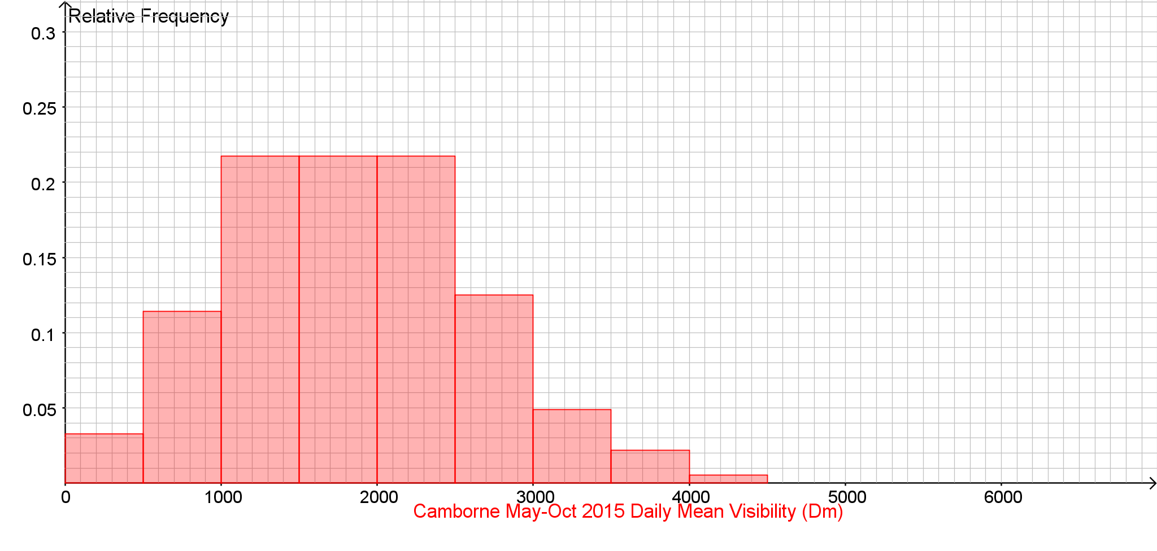
Daily Mean Visibility (Dm) Back to the Index

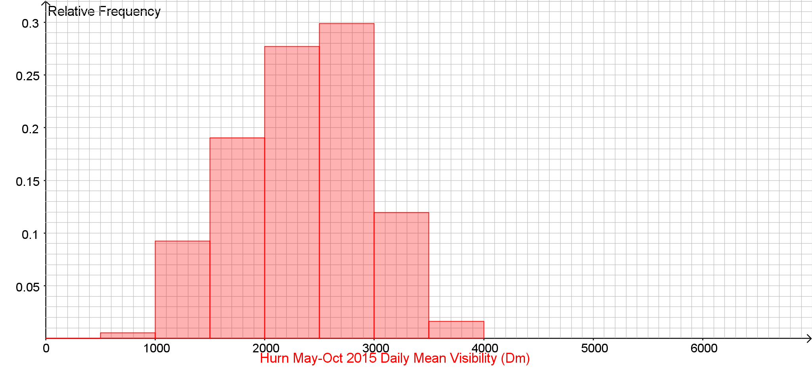
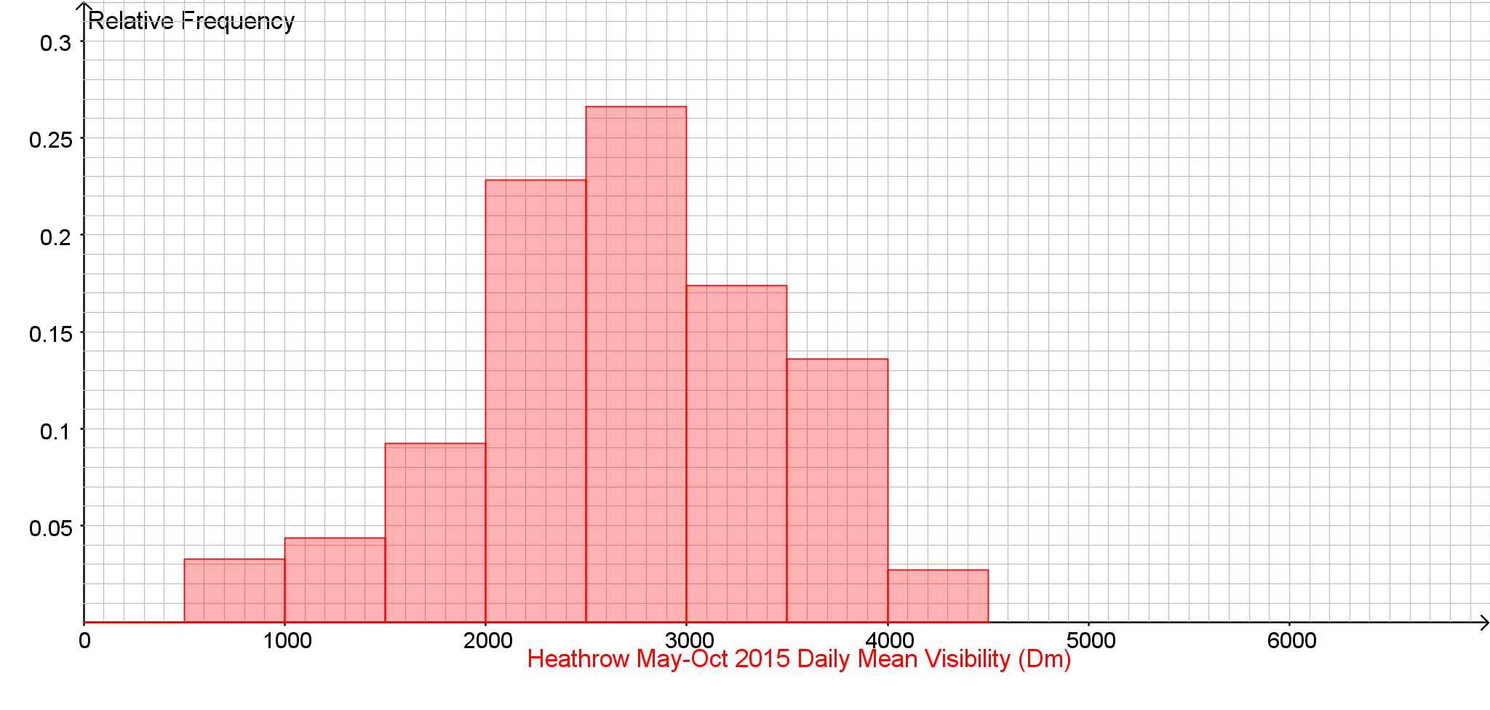
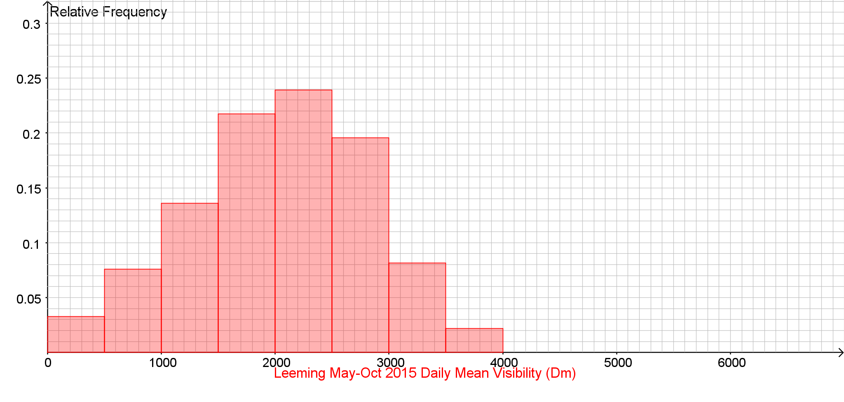
Daily Mean Visibility (Dm) Back to the Index

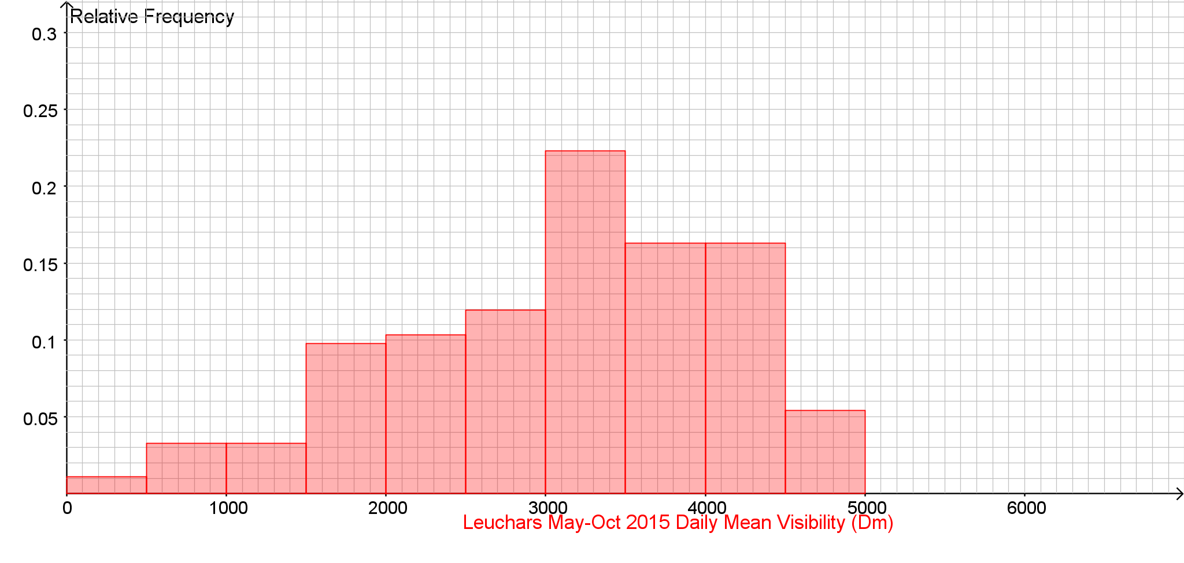
Daily Mean Visibility (Dm) Back to the Index

Daily Mean Visibility (Dm) Back to the Index

Daily Mean Visibility (Dm) Back to the Index

Daily Mean Visibility (Dm) Back to the Index

Daily Mean Pressure (hPa) Back to the Index
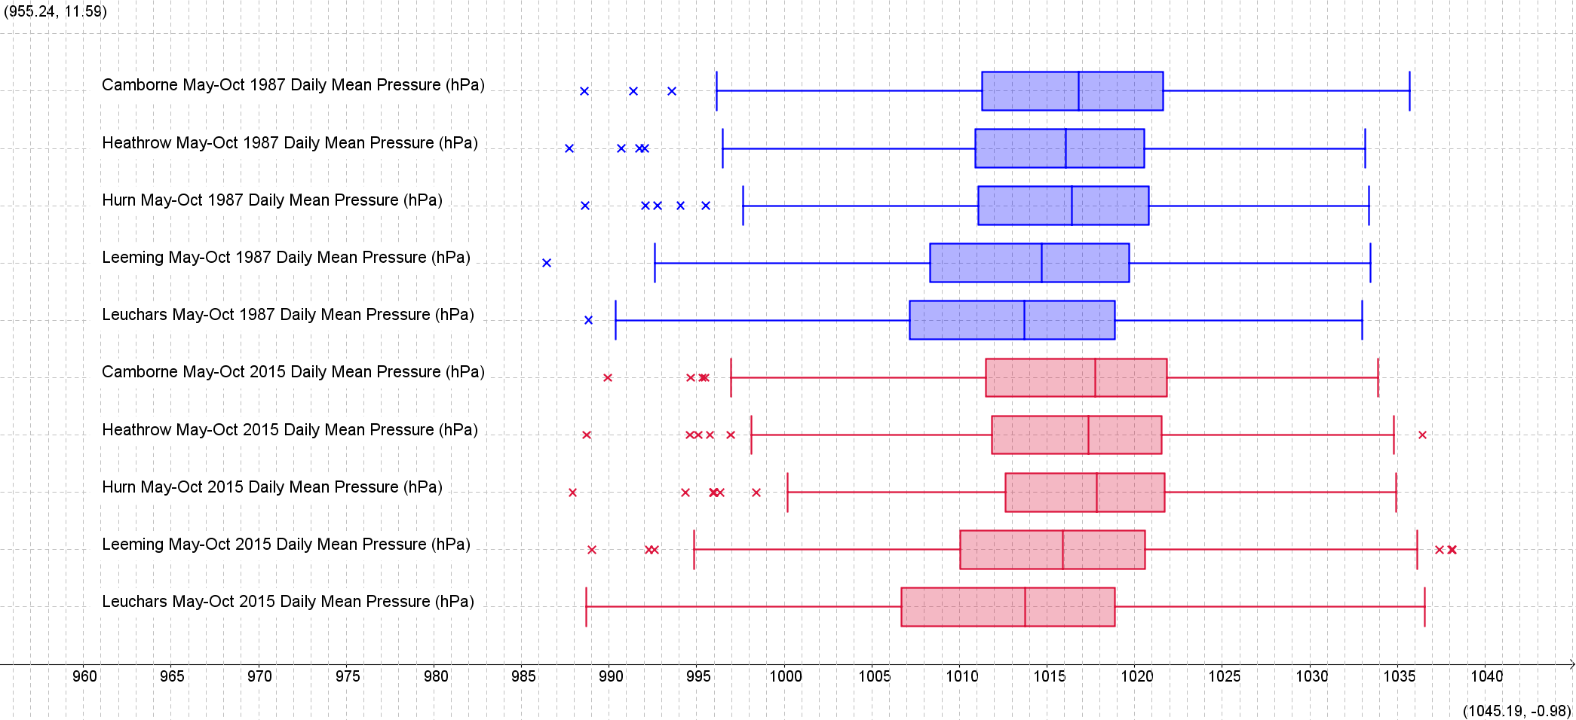

Daily Mean Pressure (hPa) Back to the Index

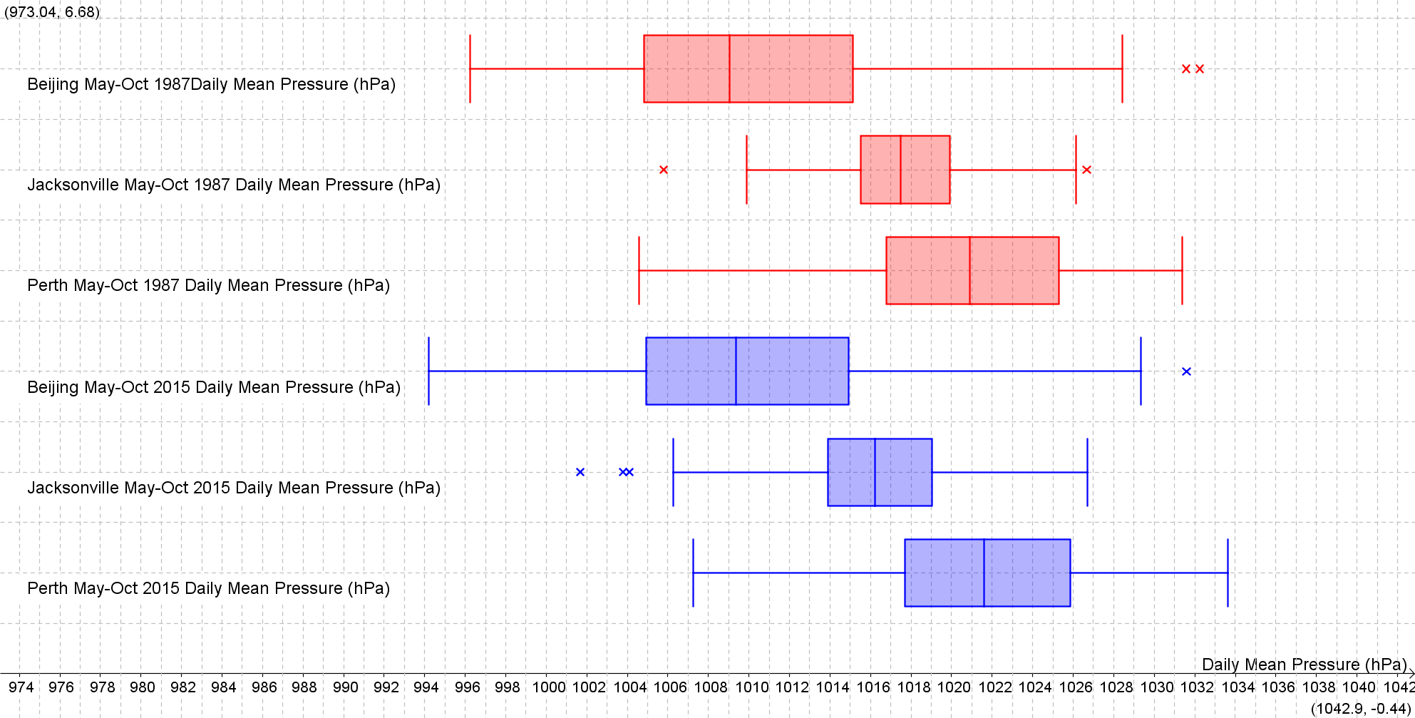

Daily Mean Pressure (hPa) Back to the Index

Daily Mean Pressure (hPa) Back to the Index

Daily Mean Pressure (hPa) Back to the Index
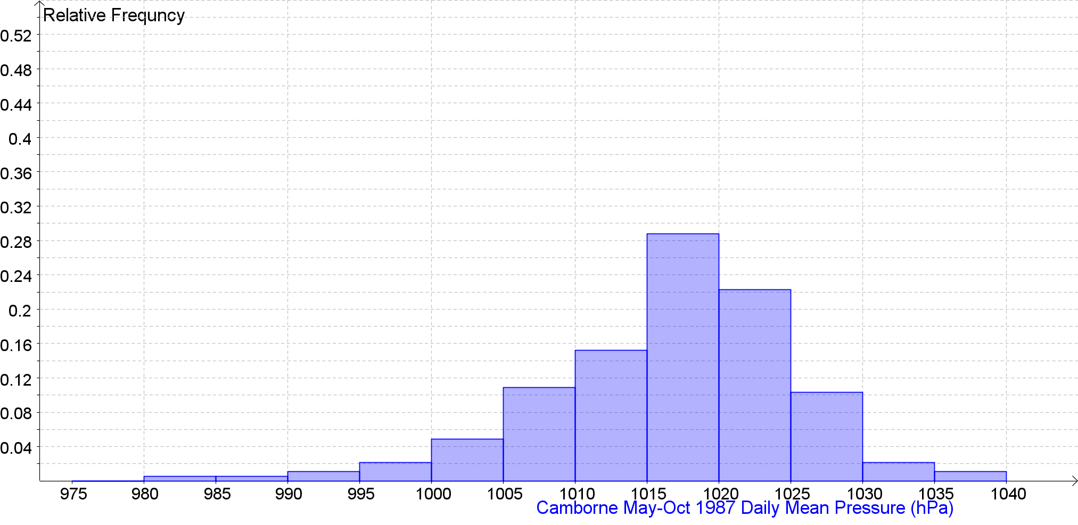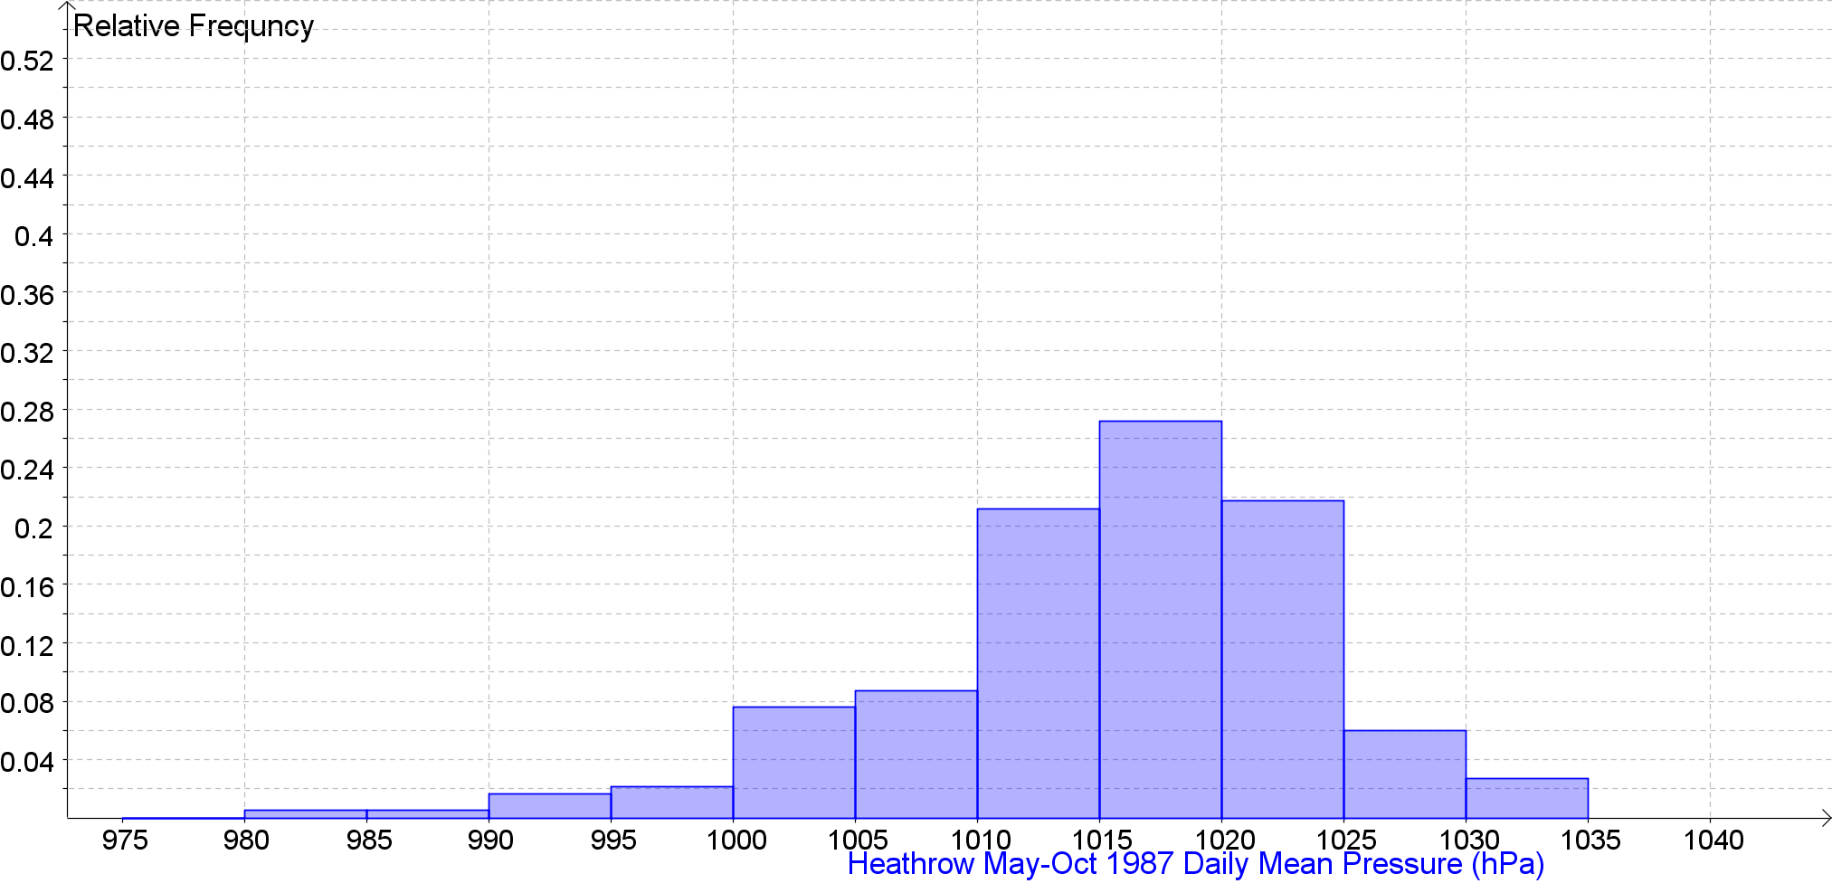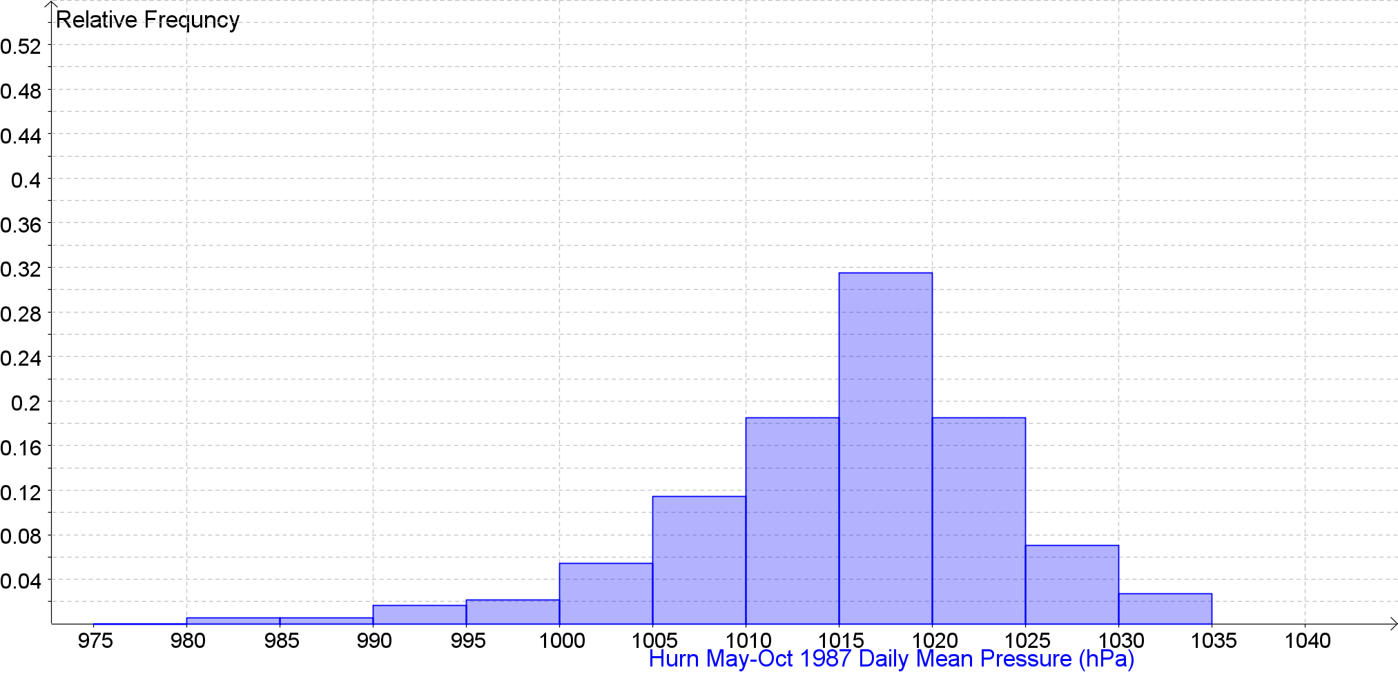
Daily Mean Pressure (hPa) Back to the Index
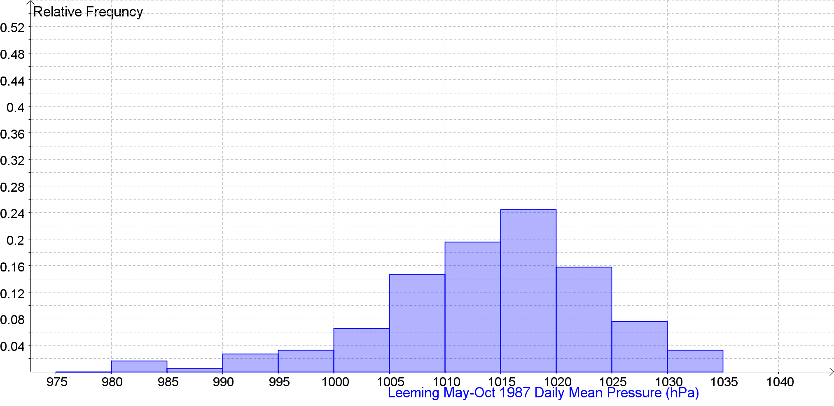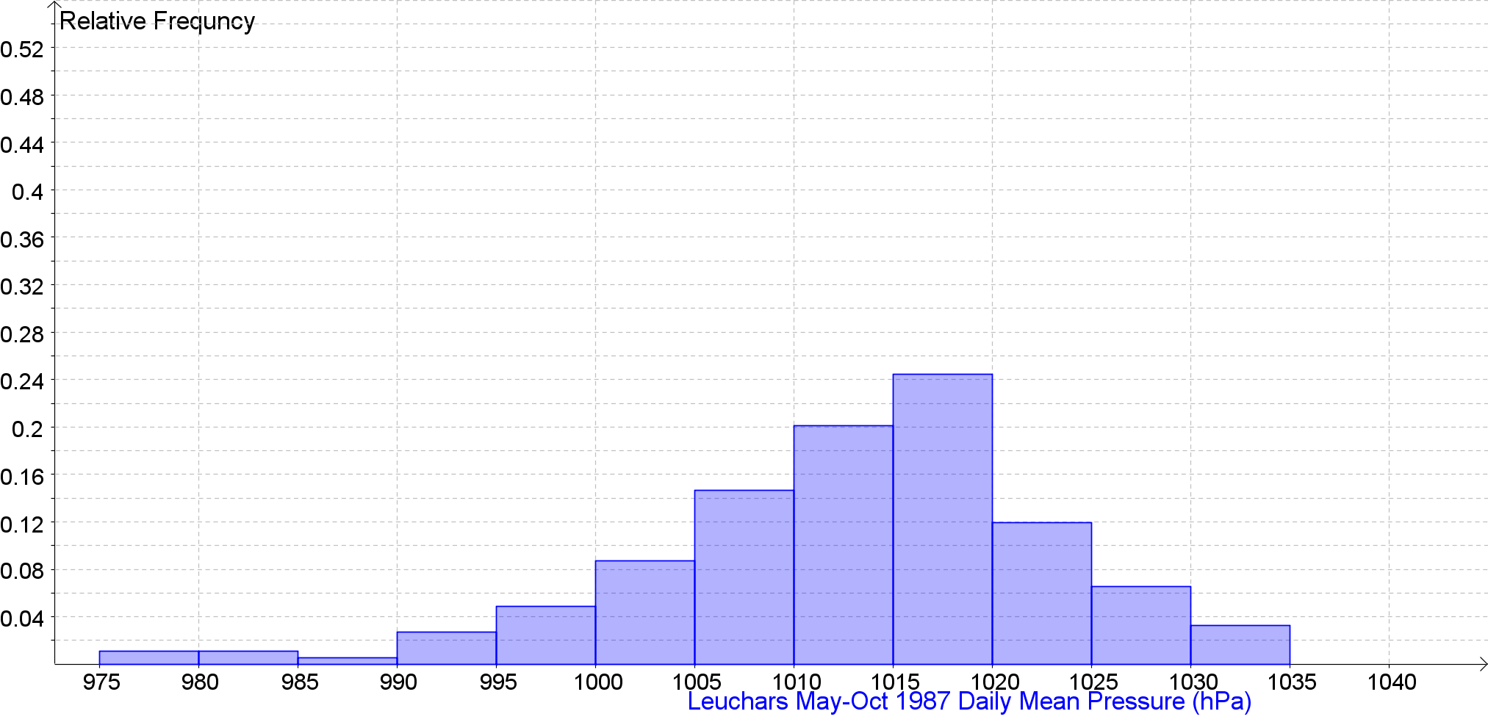

Daily Mean Pressure (hPa) Back to the Index
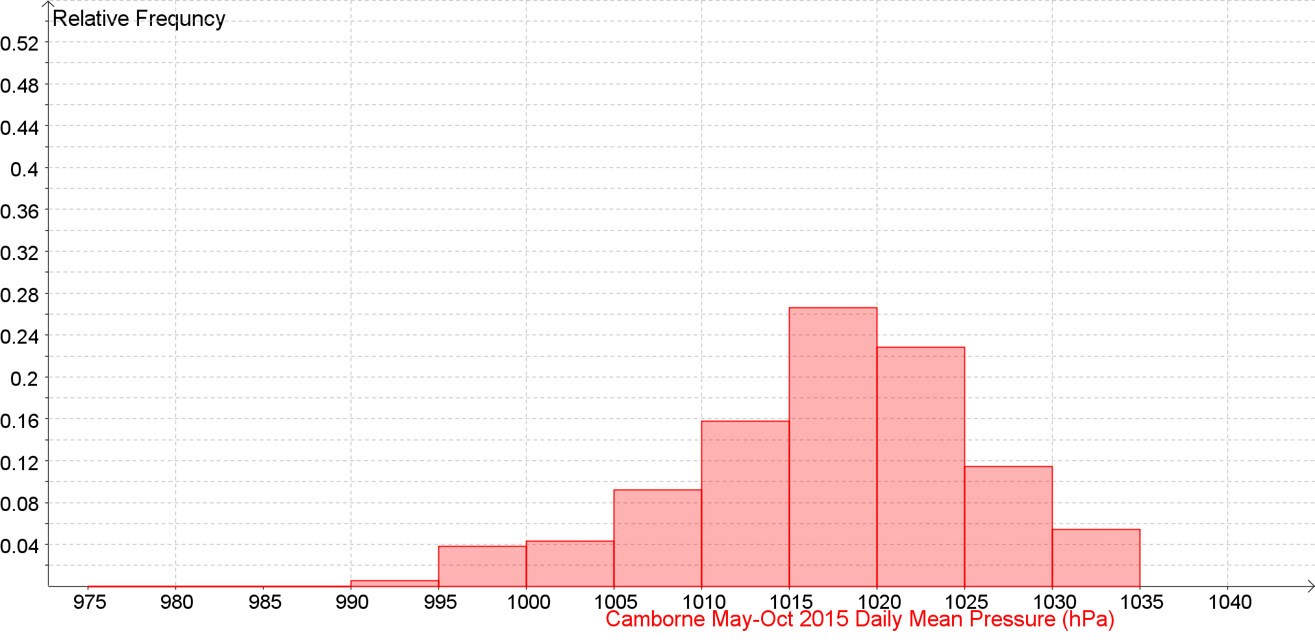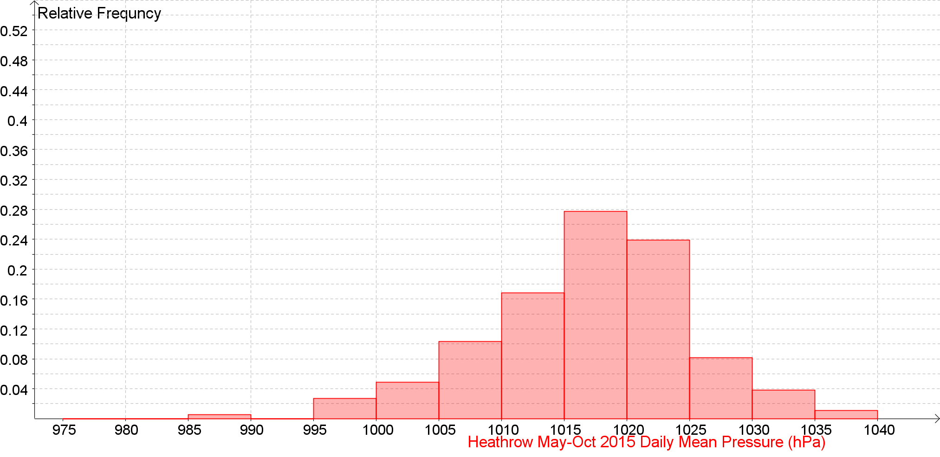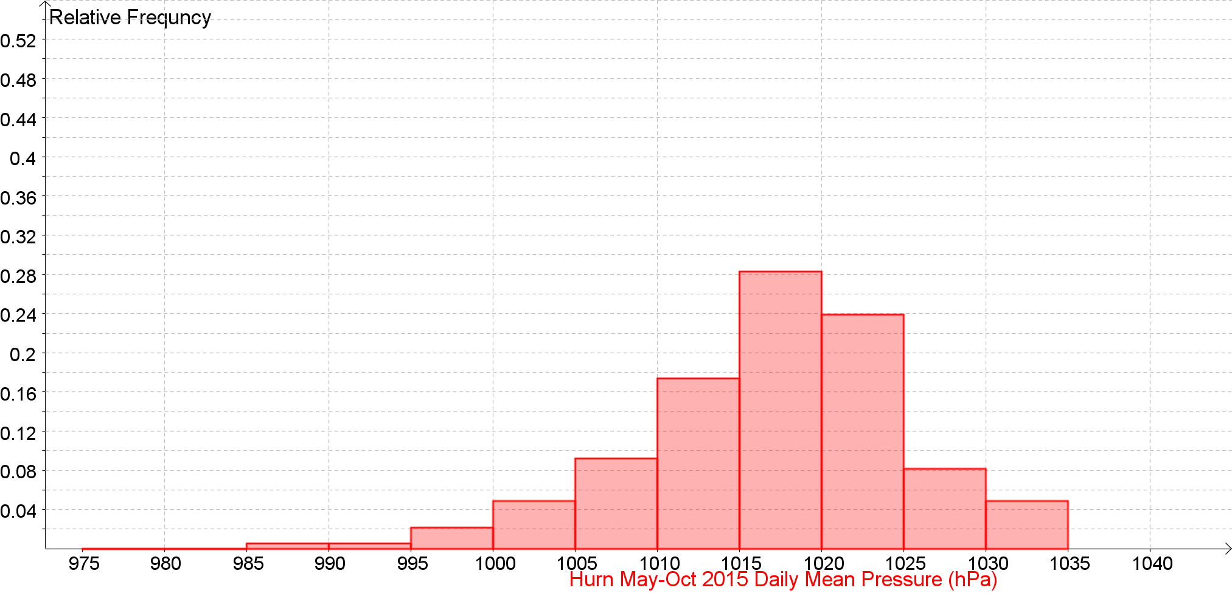
Daily Mean Pressure (hPa) Back to the Index
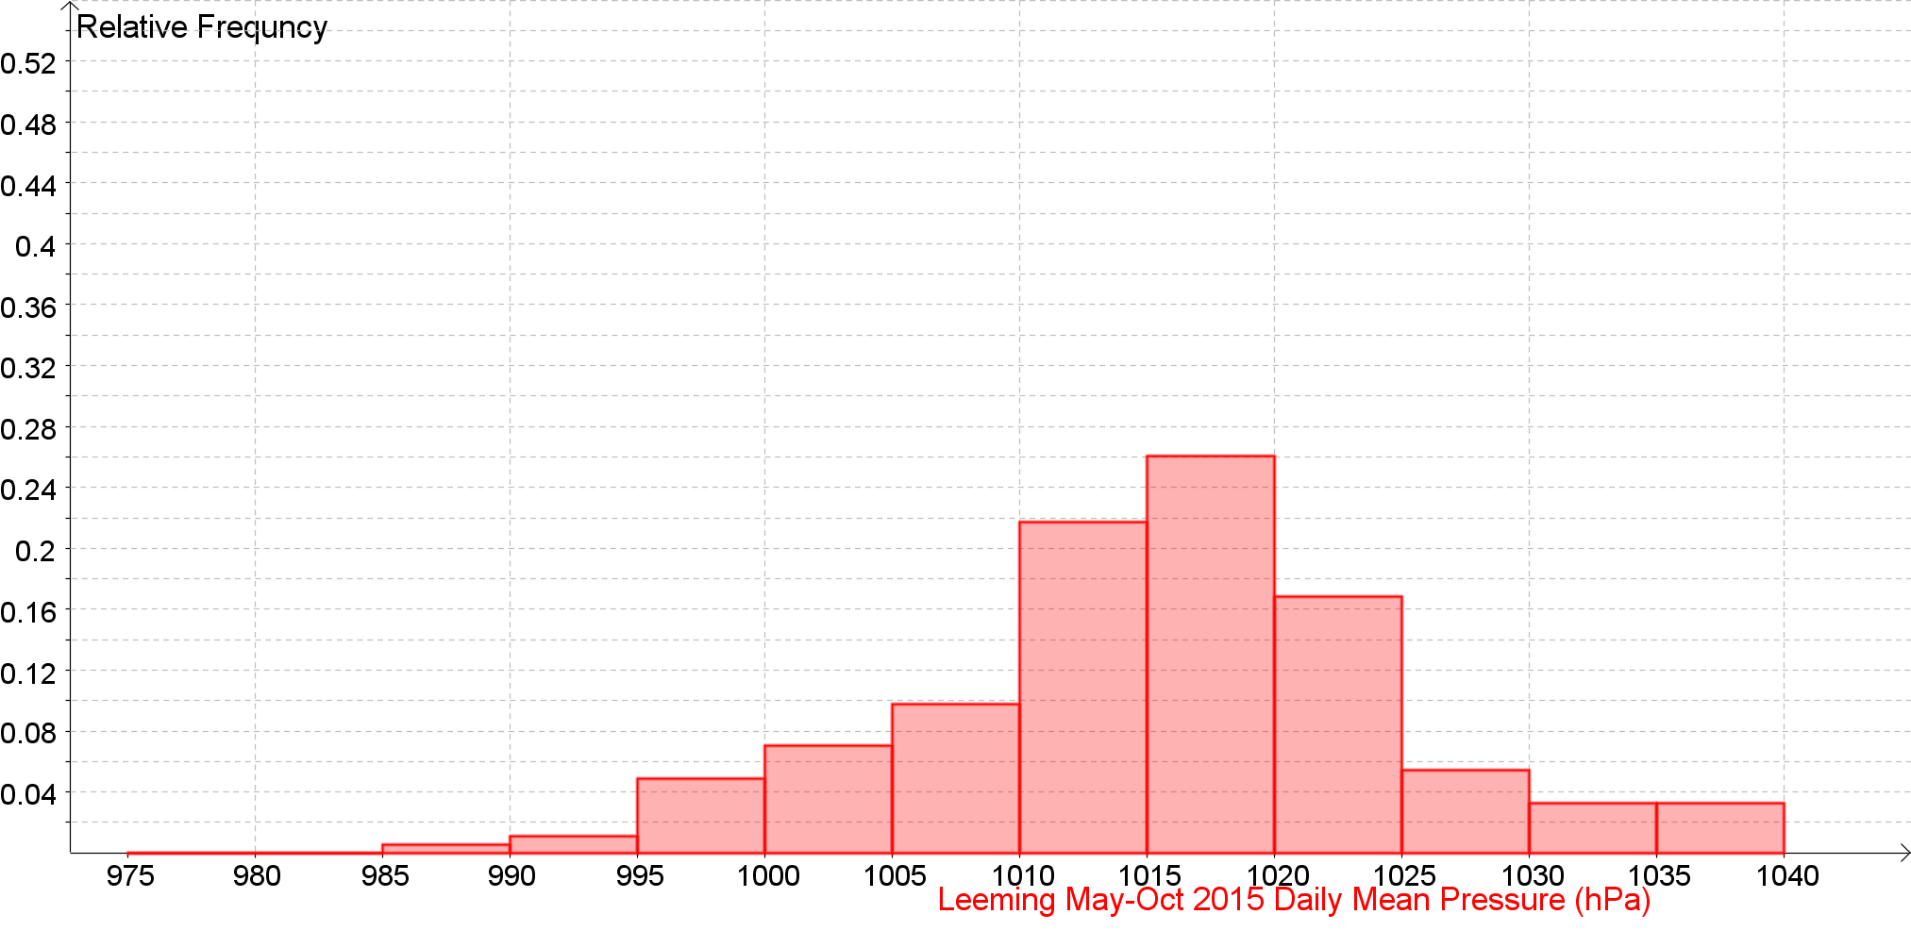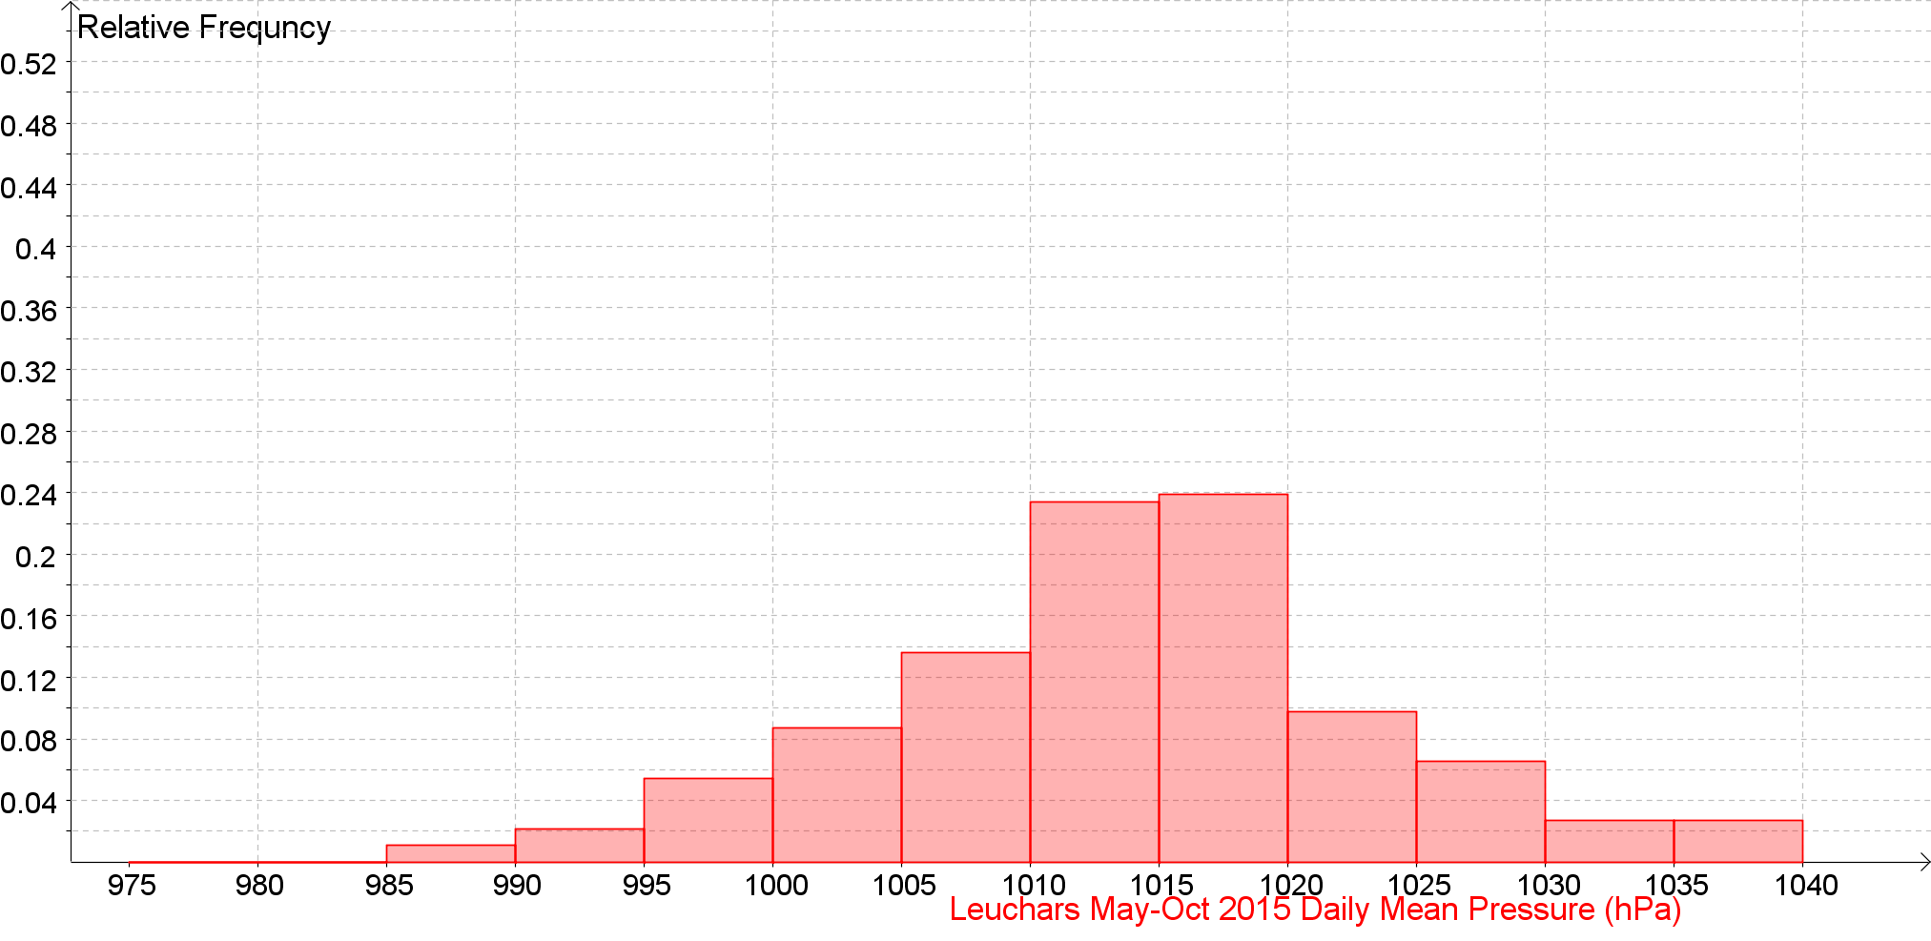

Daily Mean Pressure (hPa) Back to the Index
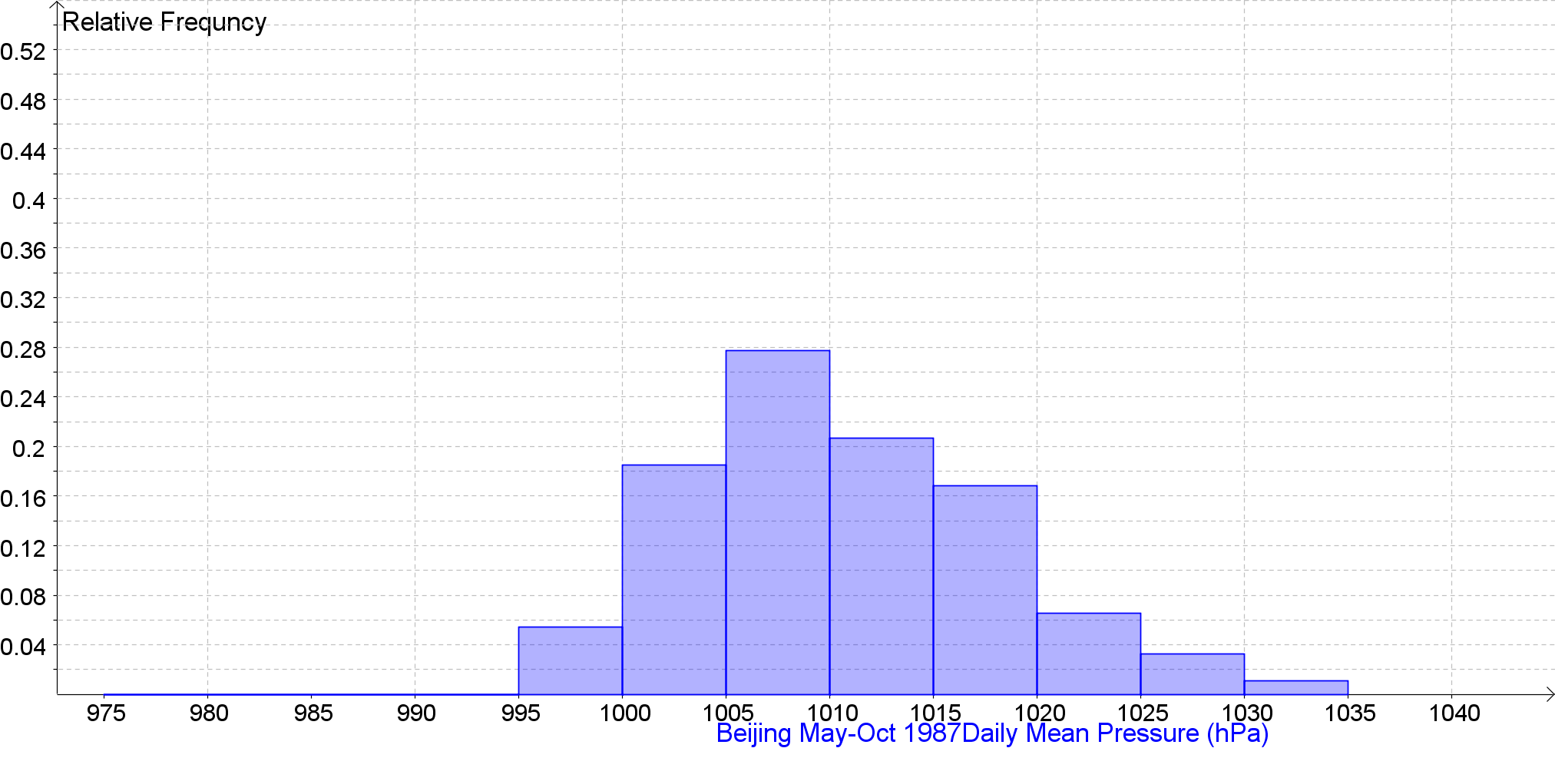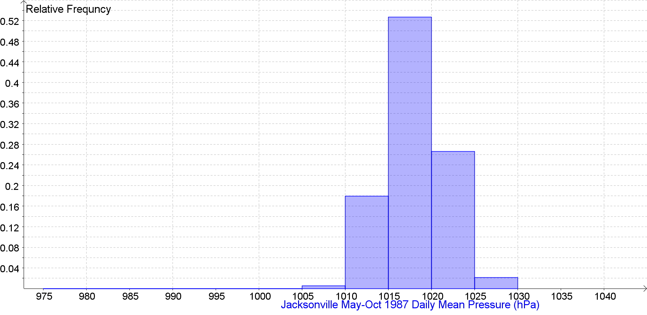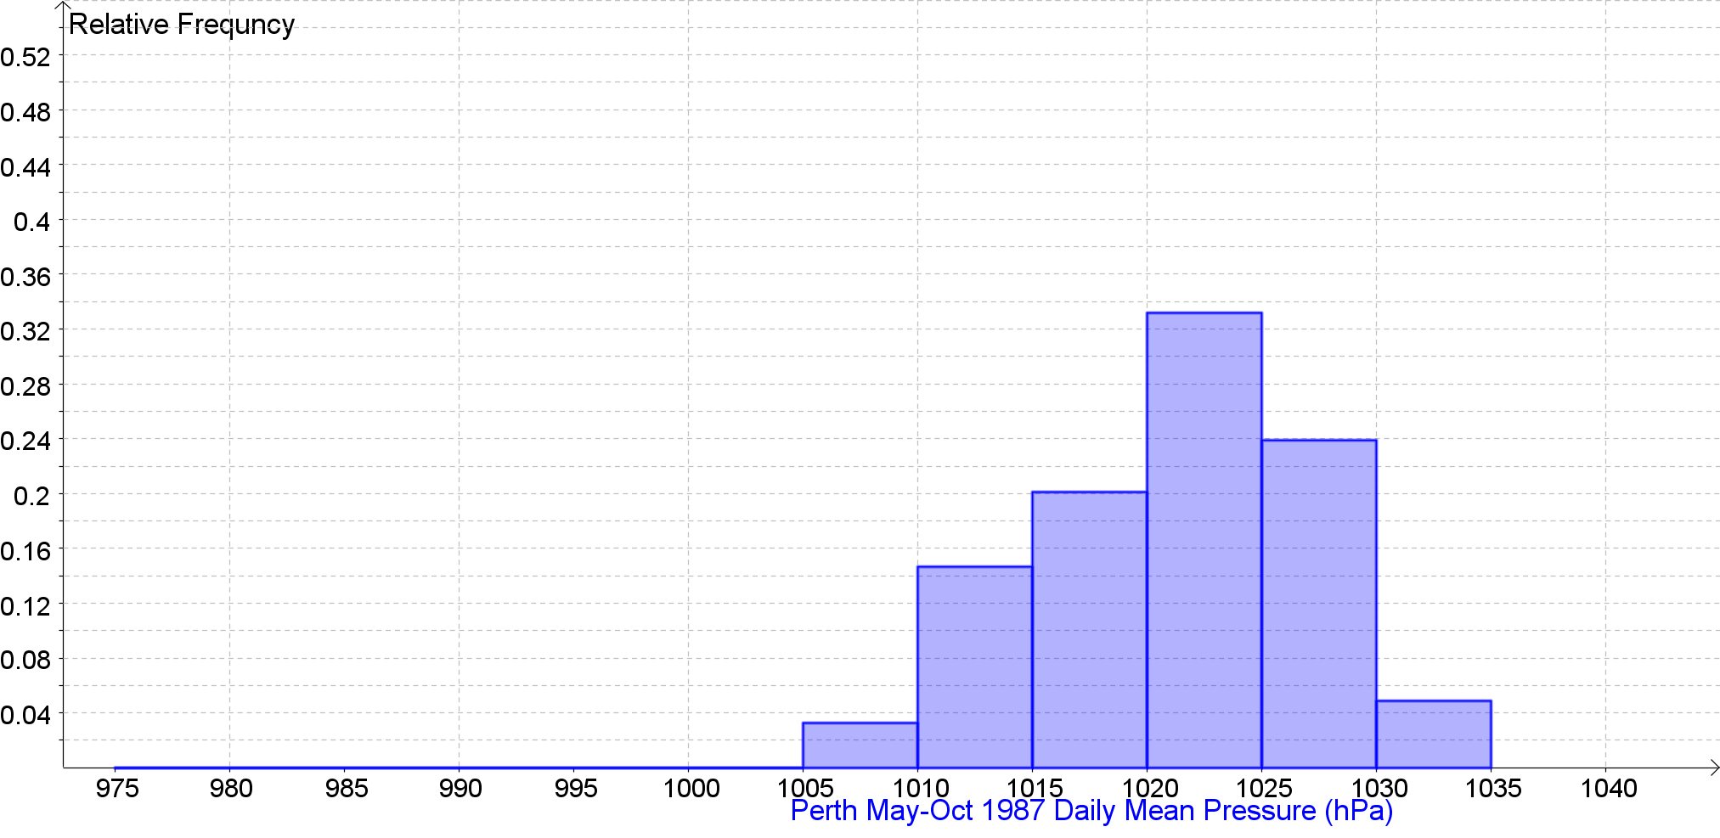
Daily Mean Pressure (hPa) Back to the Index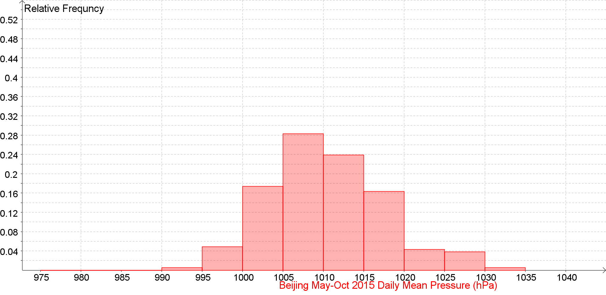 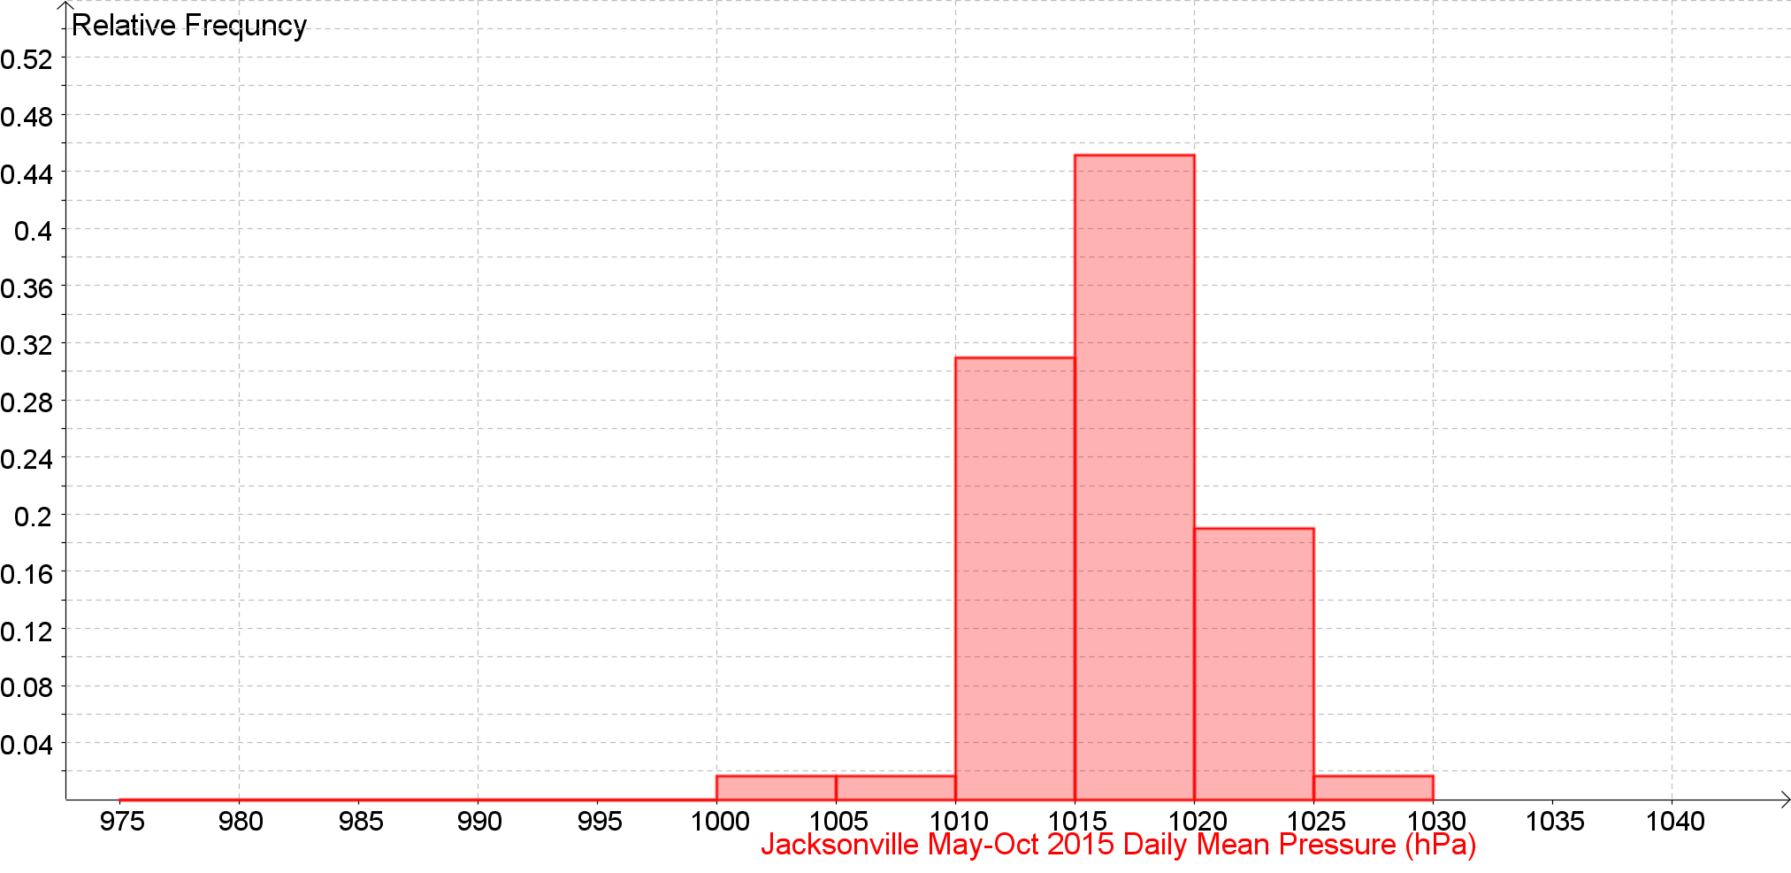 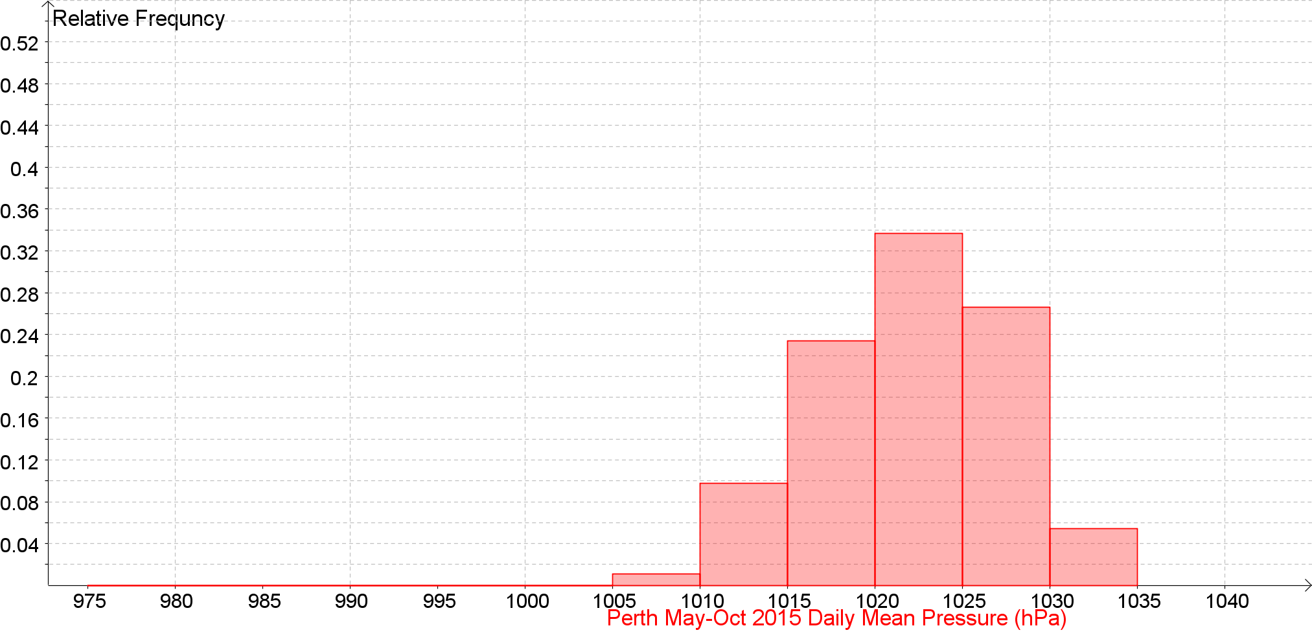
Daily Mean Pressure (hPa) Back to the Index

Daily Mean Pressure (hPa) Back to the Index

Daily Mean Pressure (hPa) Back to the Index

Daily Mean Pressure (hPa) Back to the Index

Daily Mean Pressure (hPa) Back to the Index

Daily Mean Pressure (hPa) Back to the Index

Daily Mean Pressure (hPa) against Daily Maximum Gust (kn) Back to the Index

Daily Mean Pressure (hPa) against Daily Maximum Gust (kn) Back to the Index

Daily Mean Pressure (hPa) against Daily Maximum Gust (kn) Back to the Index

Daily Mean Pressure (hPa) against Daily Maximum Gust (kn) Back to the Index

Daily Mean Wind Direction (o) Back to the Index

Daily Mean Wind Direction (o) Back to the Index

Daily Mean Wind Direction (o) Back to the Index

Daily Mean Wind Direction (o) Back to the Index

Daily Mean Wind Direction Cardinal Direction Back to the Index

Daily Mean Wind Direction Cardinal Direction Back to the Index

Daily Mean Wind Direction Cardinal Direction Back to the Index

Daily Mean Wind Direction Cardinal Direction Back to the Index

Daily Max Gust Corresponding Direction (o) Back to the Index

Daily Max Gust Corresponding Direction (o) Back to the Index

Daily Max Gust Corresponding Direction (o) Back to the Index

Daily Max Gust Corresponding Direction (o) Back to the Index

Daily Max Gust Corresponding Direction Cardinal Direction Back to the Index

Daily Max Gust Corresponding Direction Cardinal Direction Back to the Index

Daily Max Gust Corresponding Direction Cardinal Direction Back to the Index

Daily Max Gust Corresponding Direction Cardinal Direction Back to the Index

