9A Time-Distance Graphs

- A cyclist rides in a straight line for 20 minutes. She waits for half an hour, then returns in a straight line to her starting point in 15 minutes. Below is a displacement-time graph for her journey.
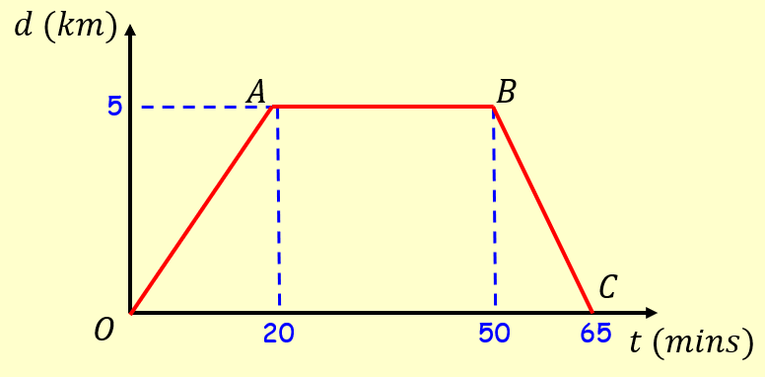
- Work out the average velocity for each stage of her journey, in kmh⁻¹

- Write down the average velocity for the whole journey

- Work out the average speed for the whole journey

9B Time-Speed Graphs

- The diagram below shows a velocity-time graph for the motion of a cyclist moving along a straight road for 12 seconds. For the first 8 seconds, she moves at a constant speed of 6ms⁻¹. She then decelerates at a constant rate, stopping after a further 4 seconds. Find:
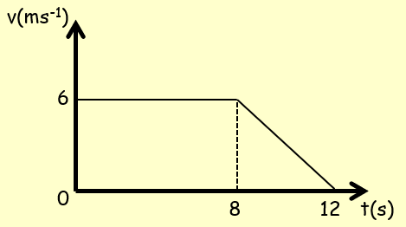
- The distance travelled by the cyclist

- The rate of deceleration of the cyclist

- A particle moves along a straight line. It accelerates uniformly from rest to a speed of 8ms⁻¹ in T seconds. The particle then travels at a constant speed for 5T seconds. It then decelerates to rest uniformly over the next 40 seconds.
- Sketch a velocity-time graph for this motion

- Given that the particle travels 600m, find the value of T

9C First Two SUVAT Equations

- A cyclist is travelling along a straight road. She accelerates at a constant rate from a speed of 4ms⁻¹ to a speed of 7.5ms⁻¹ in 40 seconds. Find:

- The distance travelled over this 40 seconds

- The acceleration over the 40 seconds

- A particle moves in a straight line from a point A to B with constant deceleration of 1.5ms⁻². The speed of the particle at A is 8ms⁻¹ and the speed of the particle at B is 2ms⁻¹. Find:
- The time taken for the particle to get from A to B

- The distance from A to B

After reaching B the particle continues to move along the straight line with the same deceleration. The particle is at point C, 6 seconds after passing through A. Find:
- The velocity of the particle at C

- The distance from A to C

9D Final Three SUVAT Equations

- A particle is moving in a straight line from A to B with constant acceleration 5ms⁻². The velocity of the particle at A is 3ms⁻¹ in the direction AB. The velocity at B is 18ms⁻¹ in the same direction. Find the distance from A to B.

- A particle is moving in a straight horizontal line with constant deceleration 4ms⁻². At time t = 0 the particle passes through a point O with speed 13ms⁻¹, travelling to a point A where OA = 20m. Find:
- The times when the particle passes through A

- The total time the particle is beyond A

- The time taken for the particle to return to O

- A particle is travelling along the x-axis with constant deceleration 2.5ms⁻². At time t = O, the particle passes through the origin, moving in the positive direction with speed 15ms⁻¹. Calculate the distance travelled by the particle by the time it returns to the origin.

9E Movement Under Gravity

- A ball is projected vertically upwards from a point O with a speed of 12ms⁻¹. Find:
- The greatest height reached by the ball

- The total time the ball is in the air

- A book falls off the top shelf of a bookcase. The shelf is 1.4m above the ground. Find:
- The time it takes the book to reach the floor

- The speed with which the book strikes the floor

- A ball is projected upwards from a point X which is 7m above the ground, with initial speed 21ms⁻¹. Find the time of flight of the ball.

- A particle is projected vertically upwards from a point O with initial speed u ms⁻¹. The greatest height reached by the particle is 62.5m above the ground. Find:
- The speed of projection

- The total time for which the ball is 50m or more above the ground

- A ball, A, falls vertically from rest from the top of a tower 63m high. At the same time as A begins to fall, another ball, B, is projected vertically upwards from the bottom of the tower with velocity 21ms⁻¹. The balls collide. Find the height at which this happens.

