A Level Mathematics

Chapter 4 - Statistics
Correlation

Chapter Overview
- Draw and interpret scatter diagrams
- Interpret correlation
- Interpret the coefficients of a regression line equation for bivariate data
- Understand when you can use a regression line to make predications
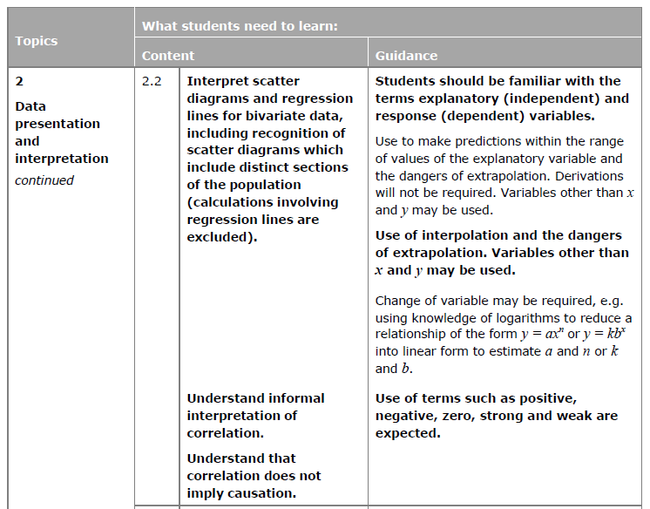

Recap on Correlation

c

c

Important Correlation Concepts

Textbook Exercise 4A Pg 61
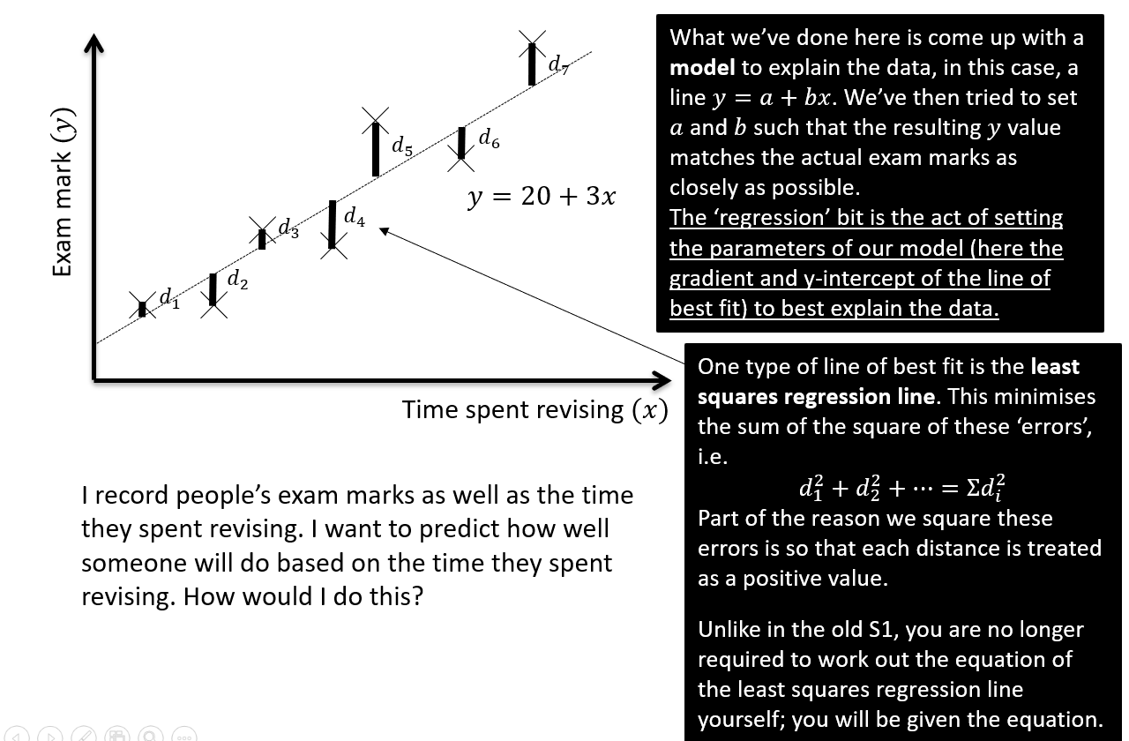
What is Regression?
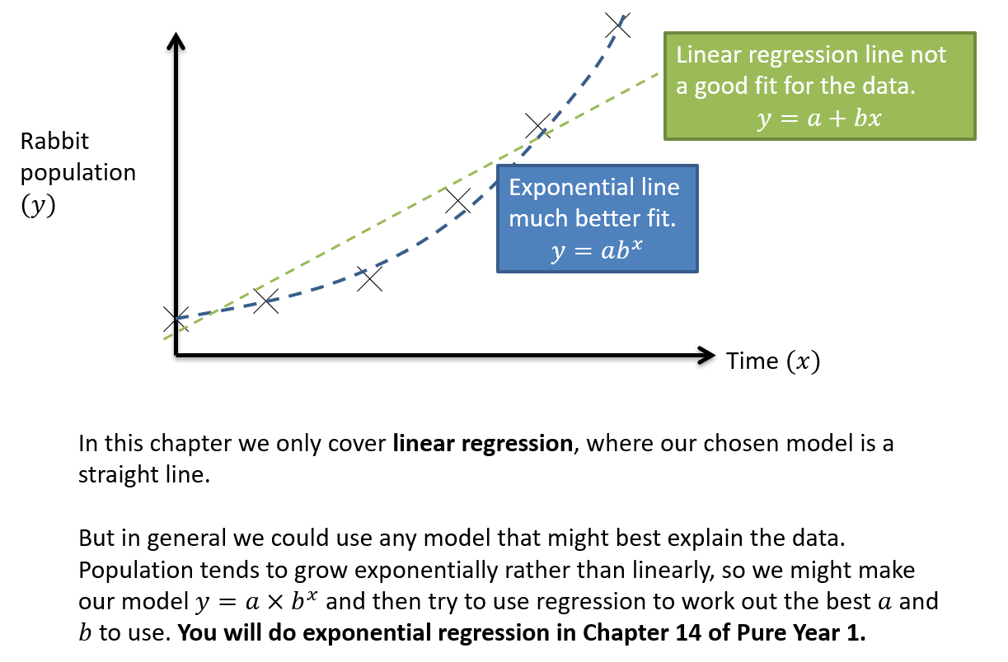
Interpreting a and b.
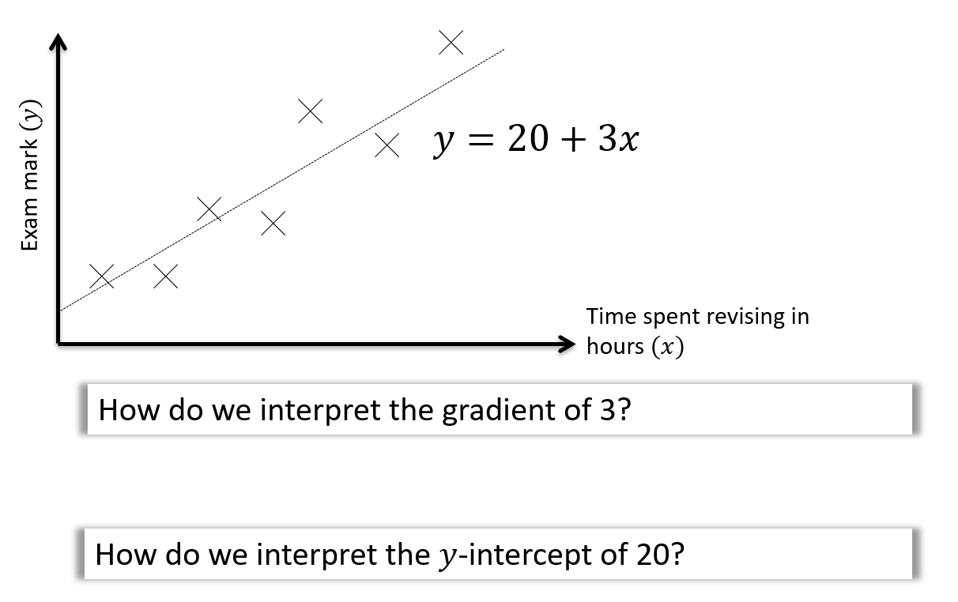
Example
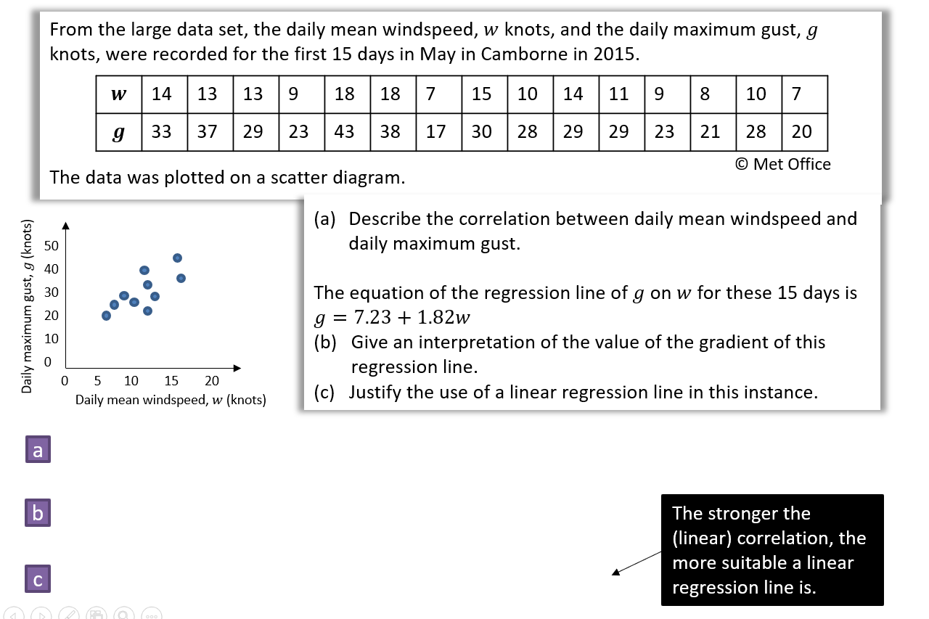

Interpolating and Extrapolating
C

Interpolating =

Extrapolating =

Example

Textbook Exercise 4B Pg 65
Using your Classwiz
Verify the regression line of g on w for the data above has the equation g=7.23 + 1.82w.

