A Level Mathematics

Chapter 3 - Statistics
Representations of data

Chapter Overview
1. Box plots and outliers
2. Cumulative frequency diagrams
3. Histograms
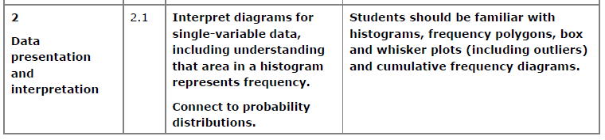
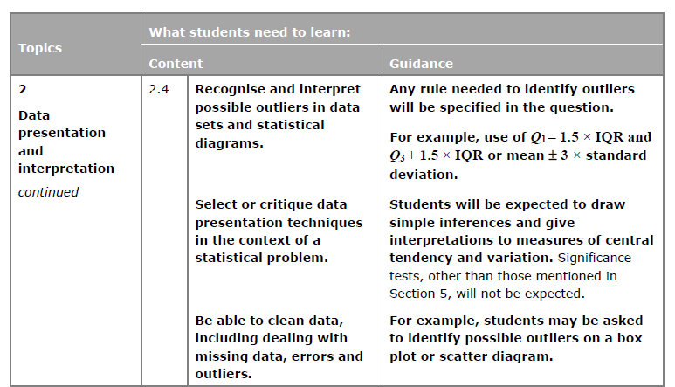

Box Plots
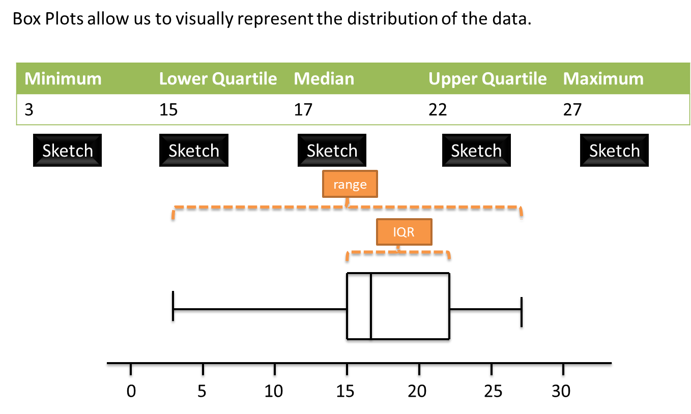
How is the IQR represented in this diagram?

How is the range represented in this diagram?

Outliers
An outlier is an extreme value.
One common definition of an outlier is when we’re 1.5 IQRs beyond the lower and upper quartiles.
Examples
- The diameters of 11 different Roman coins are measured in centimetres:
2.2 2.5 2.7 2.7 2.8 3.0 3.1 3.1 3.2 4.0 4.7
Determine the quartiles and hence any outliers.

- [Textbook] The lengths, in cm, of 12 giant African land snails are given below:
17 18 18 19 20 20 20 20 21 23 24 32
Calculate the mean and standard deviation, given that $Σx=252$ and $Σx^{2}=5468$.
An outlier is an observation which lies $±2$ standard deviations from the mean. Identify any outliers for this data.

Test Your Understanding
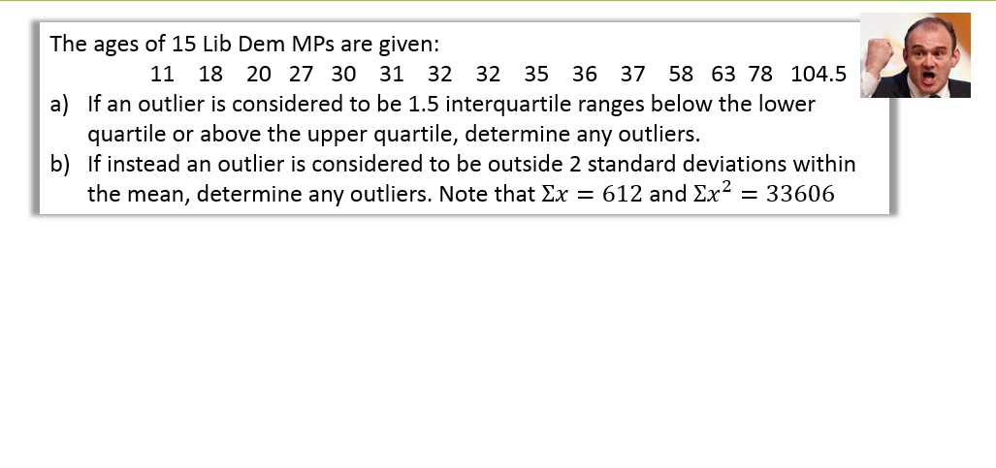

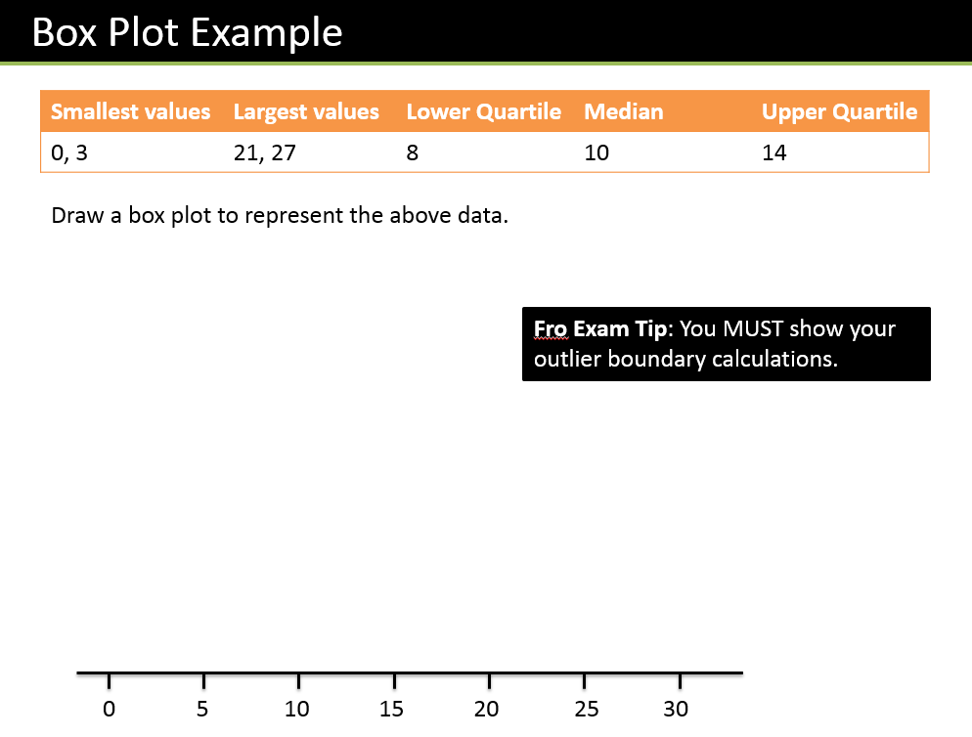

Test Your Understanding
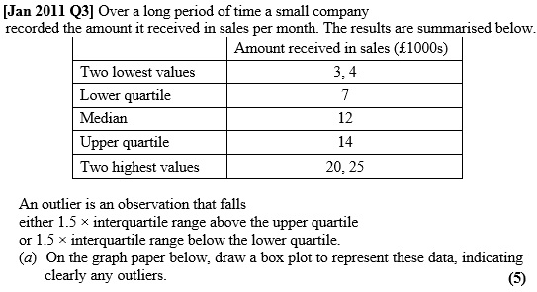
(c) The company claims that for 75% of the months, the amount received per month is greater than £10 000. Comment on this claim, giving a reason for your answer. (2)

Comparing Box Plots
It is important to be able to compare the data that is shown in 2 or more box plots. You should consider the median and quartiles as well as the spread of the data. Always relate the comparison back to the specific situation being analysed.
Examples
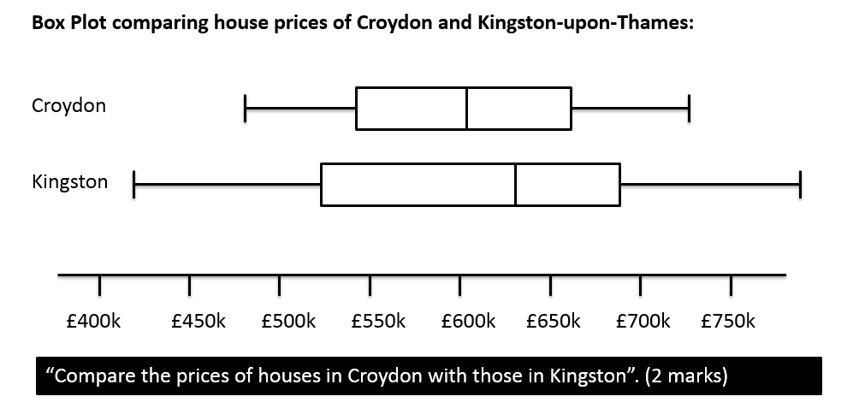

Ex 3A/3B Pg 42-43, 45

Cumulative Frequency Diagrams
We use cumulative frequency diagrams to consider the running totals of / people/ things up to a given value. They are useful for estimating the median and quartiles.
Example: The table below shows the time taken for a group of runners to run 50m. Draw a Cumulative Frequency curve for the data. Use your graph to estimate the median, LQ, UQ and IQR.
Median =

LQ =

UQ =

IQR =
Time (s) | Frequency | C. Freq
9.6 < t ≤ 9.7 | 1 | 1
9.7 < t ≤ 9.9 | 4 | 5
9.9 < t ≤ 10.05 | 10 | 15
10.05 < t ≤ 10.2 | 17 | 32
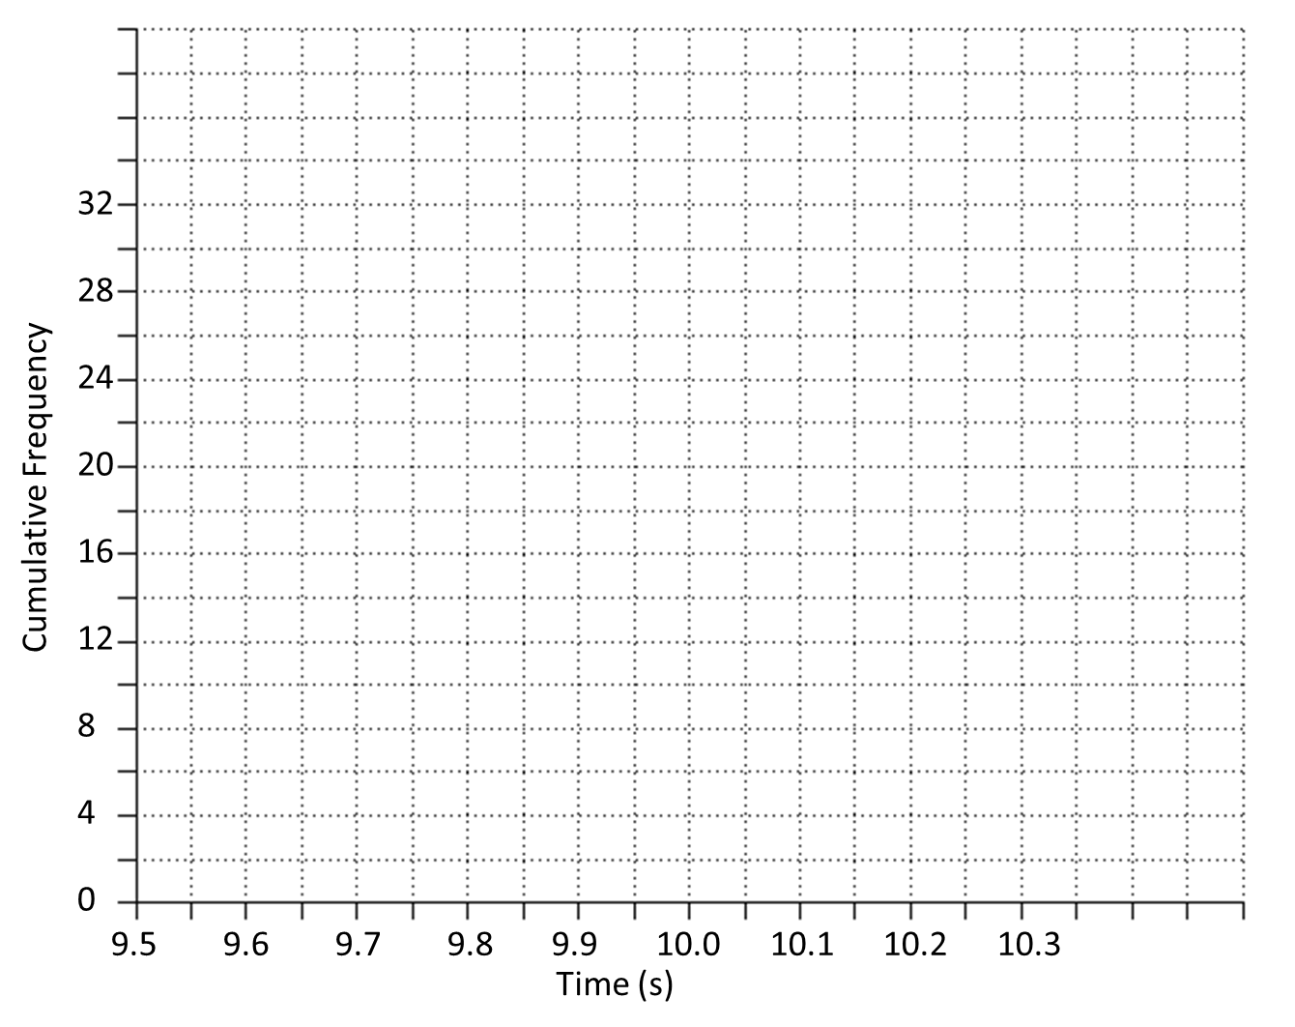
Estimate how many runners had a time less than 10.15s.

Estimate how many runners had a time more than 9.95

Estimate how many runners had a time between 9.8s and 10s
Ex 3C Pg 47/48
Histograms
You should remember from GCSE that there are some important differences between bar charts and histograms. We will consider 4 important skills.
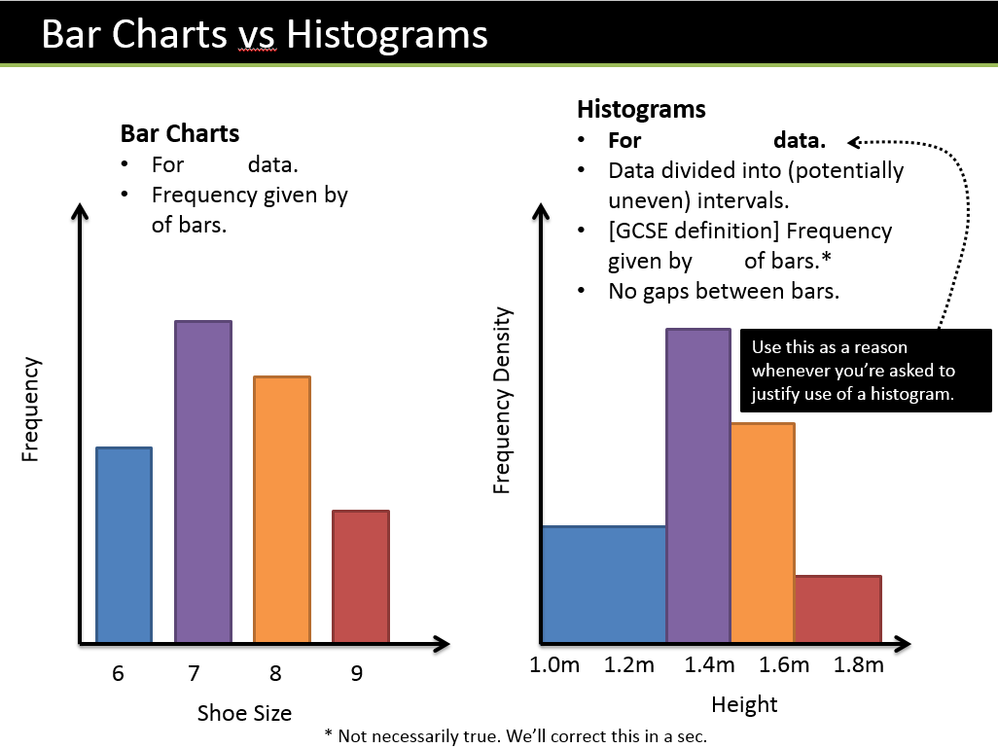

Example
- Calculate the missing values in the table below
Weight (w kg) | Frequency | Frequency Density
0 < w ≤ 10 | 40
10 < w ≤ 15 | 6
15 < w ≤ 35 |  | 2.6
35 < w ≤ 45 |  | 1

- Calculate the frequencies

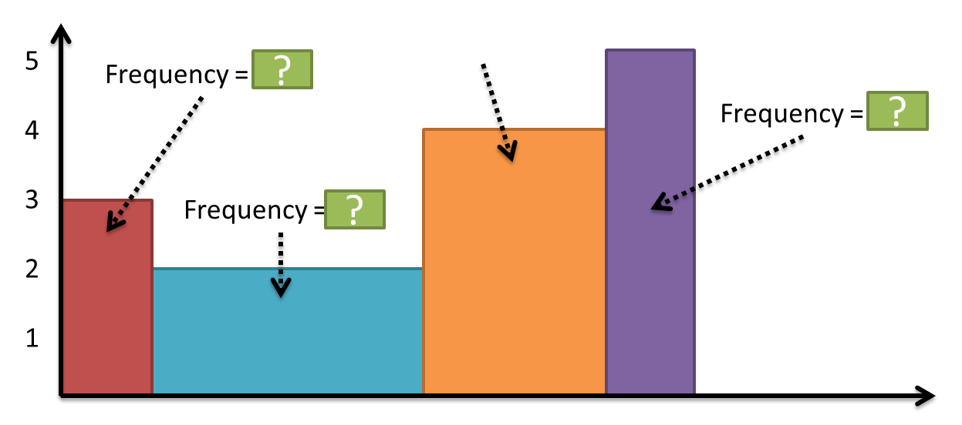

- Let’s consider the area of the bars:

Example
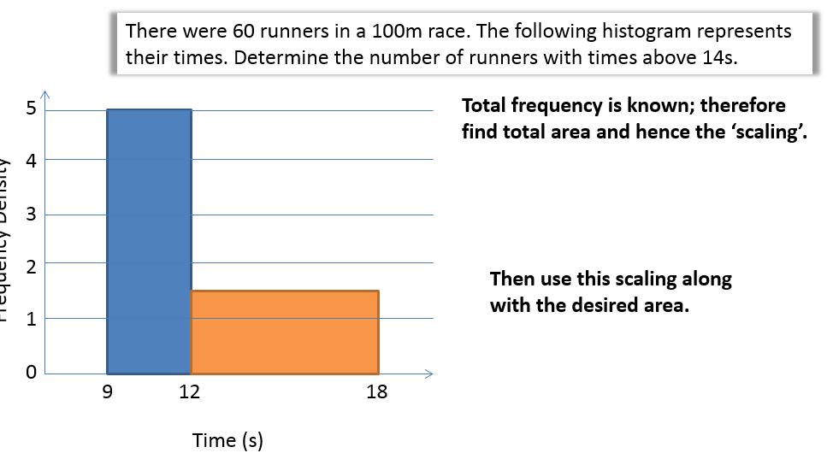
Test Your Understanding
A policeman records the speed of the traffic on a busy road with a 30 mph speed limit. He records the speeds of a sample of 450 cars. The histogram in Figure 2 represents the results.

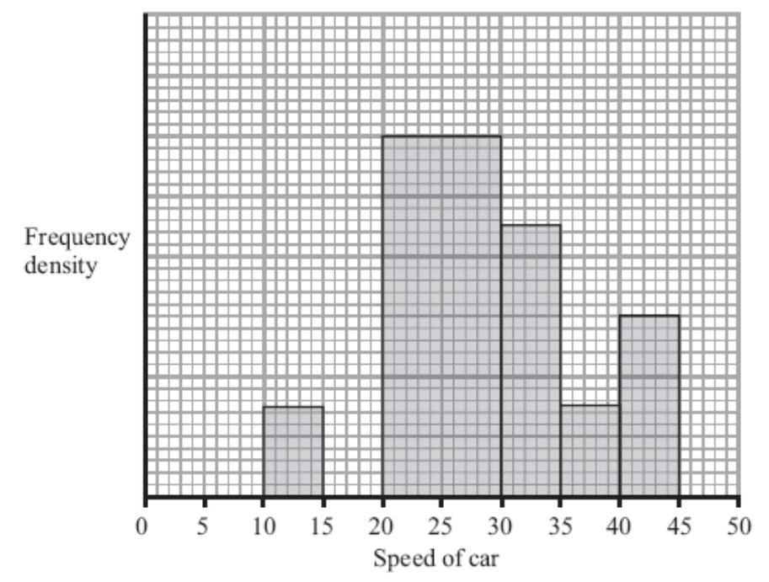
(a) Calculate the number of cars that were exceeding the speed limit by at least 5 mph in the sample. (4 marks)

(b) Estimate the value of the mean speed of the cars in the sample. (3 marks)

(c) Estimate, to 1 decimal place, the value of the median speed of the cars in the sample.(2)

- Let’s Consider the gaps between the classes:

Example
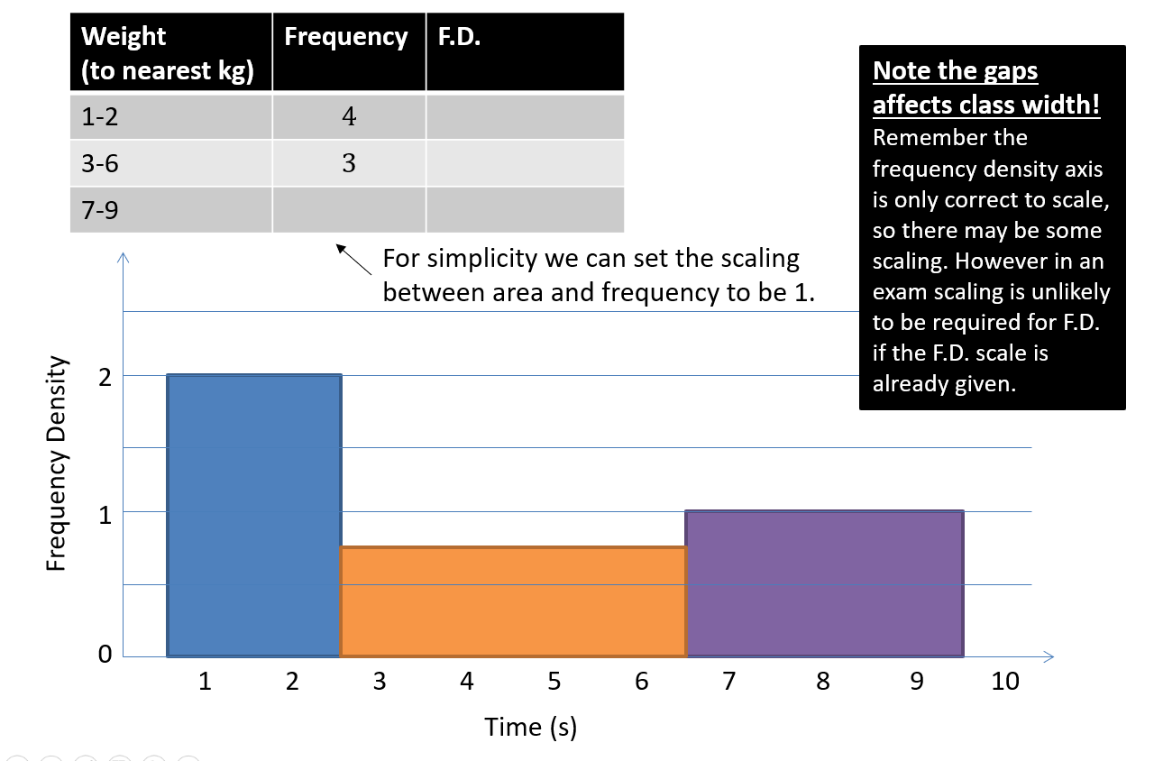

- Let’s consider the width and height on the diagram
An exam favourite is to ask what width and height we’d draw a bar in a drawn histogram.
Example:
The frequency table shows some running times. On a histogram the bar for 0-4 seconds is drawn with width 6cm and height 8cm. Find the width and height of the bar for 4-6 seconds.
Time (seconds) | Frequency
$$0≤t<4$$ | $$8$$
$$4≤t<6$$ | $$9$$

Tip:

0 -4 class
Class width = Drawn width = Scaling =

Frequency Density (height) = Drawn height = Scaling =

4-6 class:

Test Your Understanding

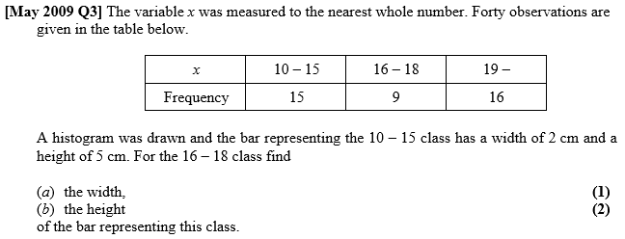

- Forming a frequency polygon

Exercise 3D Pg 50
Supplementary questions on printed sheet
Exercise 3E Pg 53
