A Level Mathematics

Chapter 2 - Statistics
Measures of Location and Spread

Chapter Overview
- Measures of Central Tendency
- Other measures of location
- Measures of Spread
- Variance and Standard Deviation
- Coding
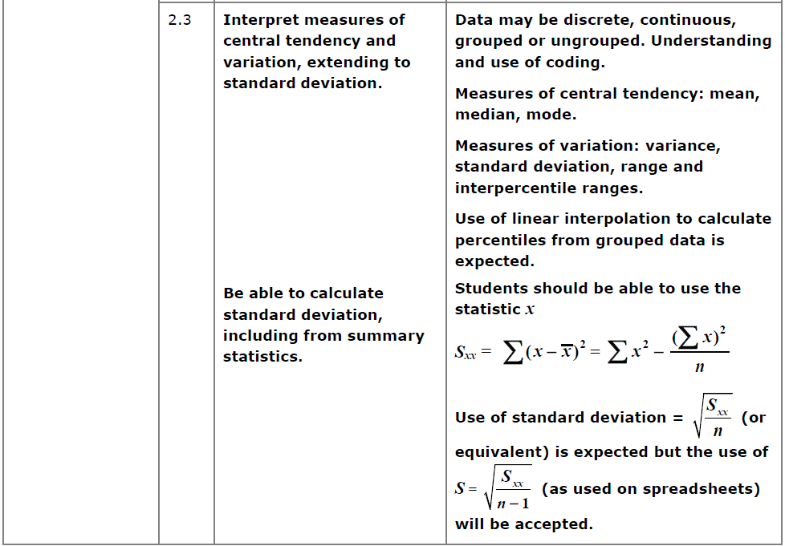

- Measure of Central Tendency

Measures of…

Finding the mean
Using your calculator
On a Classwiz:
- Select 1-Variable.
- Enter each value above, pressing = after each entry.
- Press AC to start a statistical calculation.
- Press the OPTN button. “1-Variable Calc” will calculate all common statistics (including all on the left). Alternatively, you can construct a statistical expression yourself – in the OPTN menu press Down. “Variable” for example contains $\overline{x}$. This will insert it into your calculation; press = when done.

Grouped Data

Mini-Exercise
1.

2.

3.

Exercise 2A/2B Pages 22-23, 24-25

Combined Mean
Example
The mean maths score of 20 pupils in class A is 62.
The mean maths score of 30 pupils in class B is 75.
- What is the overall mean of all the pupils’ marks.
- The teacher realises they mismarked one student’s paper; he should have received 100 instead of 95. Explain the effect on the mean and median.

Question
Archie the Archer competes in a competition with 50 rounds. He scored an average of 35 points in the first 10 rounds and an average of 25 in the remaining rounds. What was his average score per round?

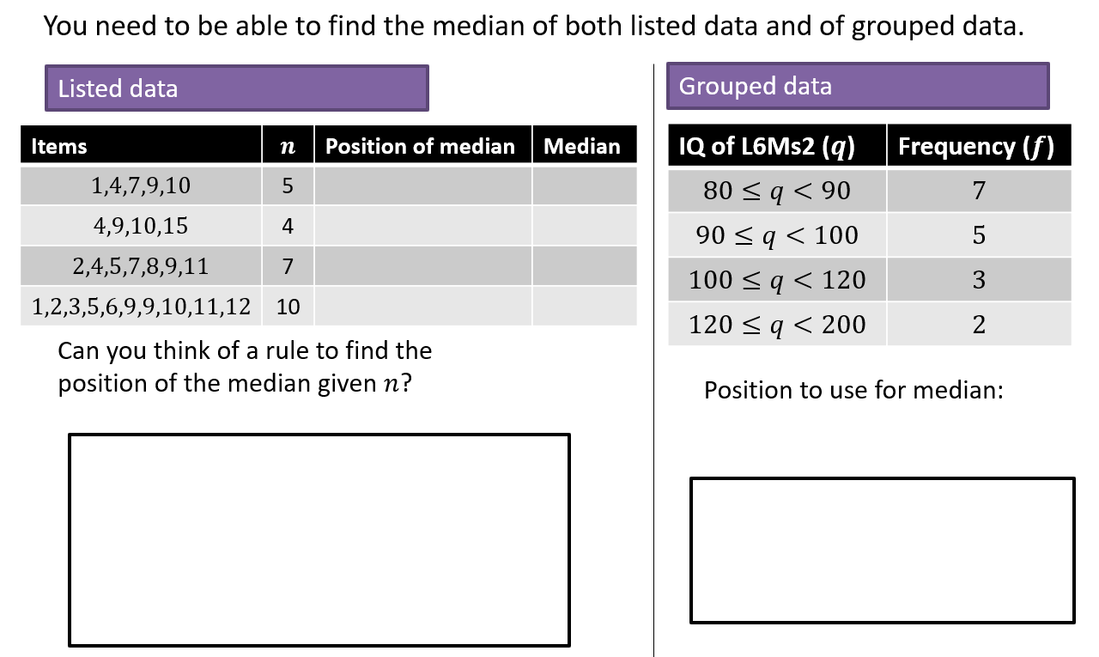
Finding the Median
Linear Interpolation

Formula

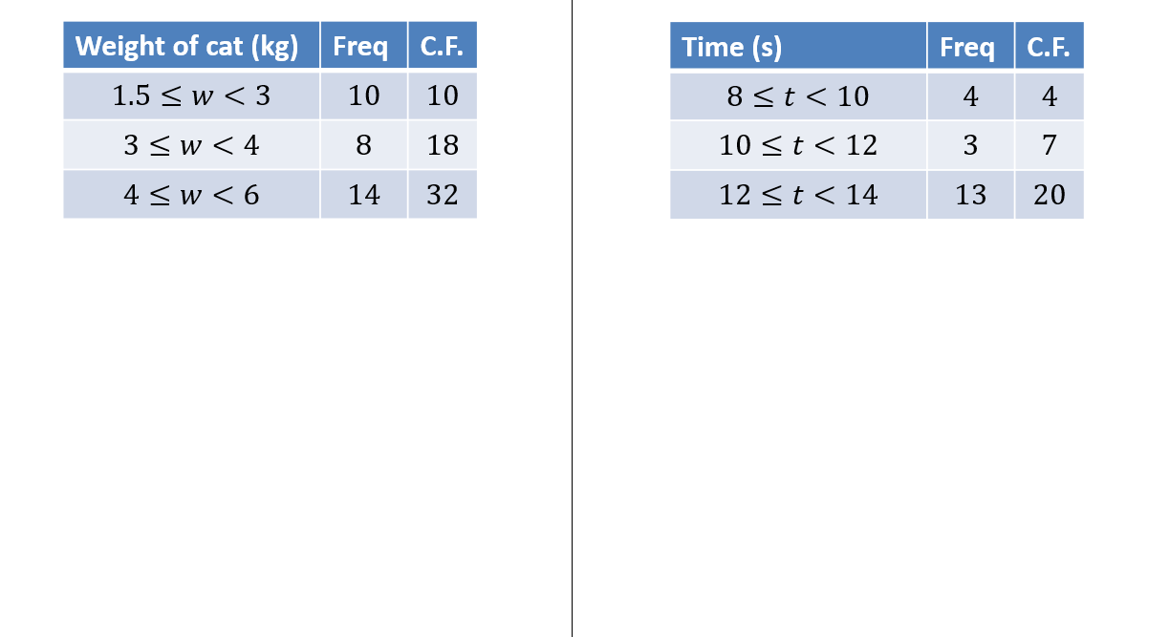
Examples
Class width
Weight of cat to nearest kg | Frequency
$$10-12$$ | $$7$$
$$13-15$$ | $$2$$
$$16-18$$ | $$9$$
$$19-20$$ | $$4$$

Linear Interpolation with gaps
Example
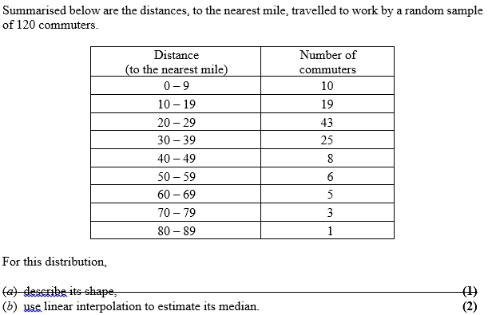
Test Your Understanding
Use linear interpolation to estimate the median of the following:
Age of relic (years) | Frequency
0-1000 | 24
1001-1500 | 29
1501-1700 | 12
1701-2000 | 35
1)

Shark length (cm) | Frequency
$$40≤x<100$$ | 17
$$100≤x<300$$ | 5
$$300≤x<600$$ | 8
$$600≤x<1000$$ | 10
2)

Supplementary Exercise 1
Q1) Solomon Paper A Q5b
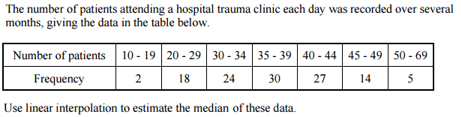

Q2) Solomon Paper E Q4a
The ages of 300 houses in a village are recorded given the following table of results.
Age $a$ (years) | Number of houses
$$0≤a<20$$ | $$36$$
$$20≤a<40$$ | $$92$$
$$40≤a<60$$ | $$74$$
$$60≤a<100$$ | $$39$$
$$100≤a<200$$ | $$14$$
$$200≤a<300$$ | $$27$$
$$300≤a<500$$ | $$18$$
Use linear interpolation to estimate the median.

Q3) Solomon Paper L Q7a
A cyber-café recorded how long each user stayed during one day giving the following results.
Length of stay (minutes) | Number of houses
$$0≤l<30$$ | $$15$$
$$30≤l<60$$ | $$31$$
$$60≤l<90$$ | $$32$$
$$90≤l<120$$ | $$23$$
$$120≤l<240$$ | $$17$$
$$240≤l<360$$ | $$2$$
Use linear interpolation to estimate the median of these data.

Q4) S1 May 2013 Q4
The following table summarises the times, t minutes to the nearest minute, recorded for a group of students to complete an exam.
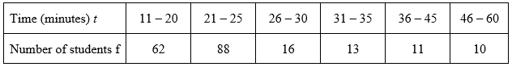
[You may use ∑ft² = 134281.25]

(a) Estimate the mean and standard deviation of these data. (5)

(b) Use linear interpolation to estimate the value of the median. (2)

Exercise 2C Pages 27-28

- Other measures of location
Quartiles
Listed Data
Items | $$n$$ | Position of LQ & UQ | LQ & UQ
$$1,4,7,9,10$$ | 5
$$4,9,10,15$$ | 4
$$2,4,5,7,8,9,11$$ | 7
$$1,2,3,5,6,9,9,10,11,12$$ | 10

Quartiles – Listed Data

Grouped Data
Items | $$n$$ | Position of LQ & UQ | LQ & UQ
$$1,4,7,9,10$$ | 5
$$4,9,10,15$$ | 4
$$2,4,5,7,8,9,11$$ | 7
$$1,2,3,5,6,9,9,10,11,12$$ | 10

Quartiles – Grouped Data

cv
Percentiles

cv
Notation
Lower Quartile: Median:
Upper Quartile: 57th Percentile:
- Measures of Spread

Test your understanding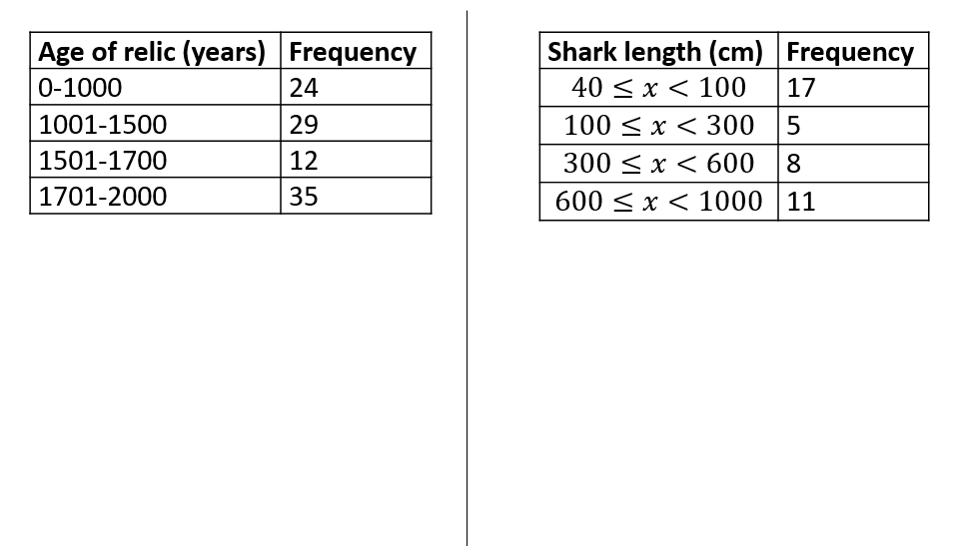

Q1) S1 May 2013 Q4 (continued)
The following table summarises the times, t minutes to the nearest minute, recorded for a group of students to complete an exam.

(c) Show that the estimated value of the lower quartile is 18.6 to 3 significant figures.

(1)
(d) Estimate the interquartile range of this distribution.

(2)

Q2) S1 June 2005 Q2
The following table summarises the distances, to the nearest km, that 134 examiners travelled to attend a meeting in London.
Distance (km) | Number of examiners
41–45 | 4
46–50 | 19
51–60 | 53
61–70 | 37
71–90 | 15
91–150 | 6

(c) Use interpolation to estimate the median Q₂, the lower quartile Q₁, and the upper quartile Q₃ of these data.
Q3) The ages of 300 houses in a village are recorded given the following table of results.
Age $a$ (years) | Number of houses
$$0≤a<20$$ | $$36$$
$$20≤a<40$$ | $$92$$
$$40≤a<60$$ | $$74$$
$$60≤a<100$$ | $$39$$
$$100≤a<200$$ | $$14$$
$$200≤a<300$$ | $$27$$
$$300≤a<500$$ | $$18$$
Use linear interpolation to estimate the lower quartile, upper quartile and hence the interquartile range.

Q4)
A cyber-café recorded how long each user stayed during one day giving the following results.
Length of stay (minutes) | Number of houses
$$0≤l<30$$ | $$15$$
$$30≤l<60$$ | $$31$$
$$60≤l<90$$ | $$32$$
$$90≤l<120$$ | $$23$$
$$120≤l<240$$ | $$17$$
$$240≤l<360$$ | $$2$$

Use linear interpolation to estimate:
- The lower quartile.

- The upper quartile.

- The 90th percentile.

Q5)
Distance  (to the nearest mile) | Number of  commuters
0 – 9 | 10
10 – 19 | 19
20 – 29 | 43
30 – 39 | 25
40 – 49 | 8
50 – 59 | 6
60 – 69 | 5
70 – 79 | 3
80 – 89 | 1

Find the interquartile range for the distance travelled by commuters.

- Variance and Standard Deviation
Variance

cv
Examples

- 3, 11 Variance
Standard Deviation

- 2, 3, 3, 5, 7 Variance
Standard Deviation

- 2, 4, 6 Variance
Standard Deviation

- 1, 2, 3, 4, 5 Variance
Standard Deviation
Variance – frequency tables

cv
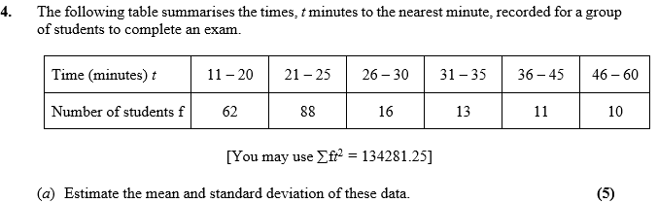
Examples

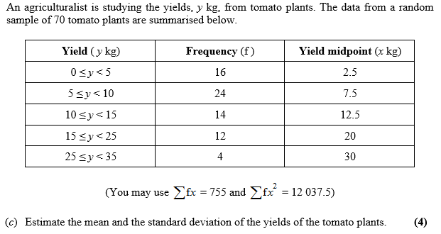

- Coding
