A Level Mathematics

Chapter 1 - Statistics
Data Collection

Chapter Overview
1. Populations and Samples
2. Sampling
3. Non-random Sampling
4. Types of Data
5. The Large Data Set
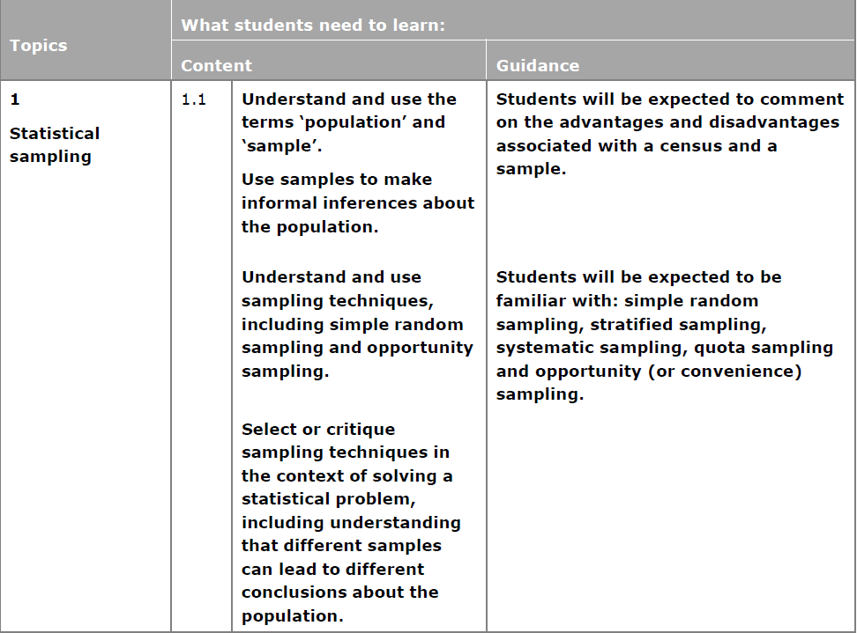
Populations and Samples
A population is –

A sample is –

A census is -

Key words:
Individual units of a population are called _________________. E.g. each individual person/item
Often sampling units of a population are individually named or numbered to form a list called a ________________. E.g. the list of all people/items
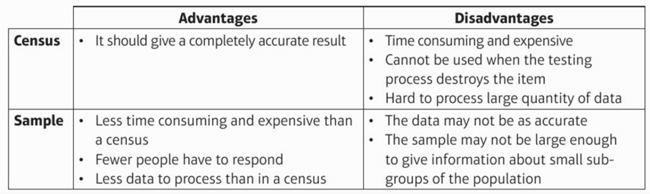
What are the advantages and disadvantages between taking a census and a sample?

Example: A supermarket wants to test a delivery of avocados for ripeness by cutting them in half.
- Suggest a reason why the supermarket should not test all the avocados in the delivery.
- The supermarket tests a sample of 5 avocados and finds that 4 of them are ripe. They estimate that 80% of the avocados in the deliver are ripe. Suggest one way that the supermarket could improve their estimate.

Exercise 1A Page 3

Sampling

Example. There are 64 girls and 56 boys in a school. Explain briefly how you could take a random sample of 15 pupils using a simple random sample. (3)

Example. A telephone directory contains 50 000 names. A researcher wishes to select a systematic sample of 100 names from the directory. Explain in detail how the researcher should obtain such a sample. (2)
Example. A school has 15 classes and a sixth form. In each class there are 30 students. In the sixth form there are 150 students. There are equal numbers of boys and girls in each class. There are equal numbers of boys and girls in the sixth form. The head teacher wishes to obtain the opinions of the students about school uniforms. Explain how the head teacher would take a stratified sample of size 40. (7)

Exercise 1B Page 6

Non-random Sampling
Example.
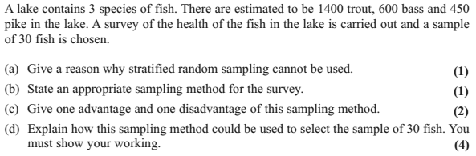

Exercise 1C Page 8
Types of Data
Quantitative Data –

Qualitative Data –

Continuous Data –

Discrete Data –

Key Vocabulary for Grouped Data (presented in a grouped frequency table)
Classes - the groups in a table
Class boundaries - the maximum and minimum values in a class (beware of gaps between the classes)
Midpoint - the average of the class boundaries
Class width - the difference between the upper and lower class boundaries
Exercise 1D Page 10
Test Your Understanding
Name that sampling method
Simple Random Sampling
Systematic Sampling
Stratified Sampling
Quota
Sampling
Opportunity
Sampling

- “You wish to test lightbulbs produced by a factory in a daily batch.”

- “You wish to survey consumer opinion on your new drink FizzGuzz released in the UK.”

- “You wish to determine students’ favourite TV programmes in your school, that is fairly representative of each year group.”

