The Shortest Distance from a Plane to the Origin
If equation of plane is $r⋅\hat{n}=d$, then $d$ is the shortest distance between the origin and a point on the plane.

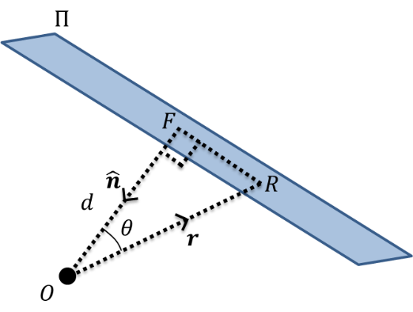
Example
A plane $Π$ has equation $r⋅n=k$.
Suppose $R$ is a generic point on the plane $Π$ and $F$ is the foot of
the perpendicular from the origin $O$ to the plane.
Suppose also that $n$ is of unit length, i.e. $n=\hat{n}$.
What is the distance $d=OF$?

The perpendicular distance from the point with position vector $x$ to the plane with equation $r⋅n=d$ is
$$\frac{x⋅n-d}{\left|n\right|}$$
Example
Find the perpendicular distance from the point with coordinates $\left(3,2,-1\right)$ to the plane with equation $2x-3y+z=5$.

Test Your Understanding
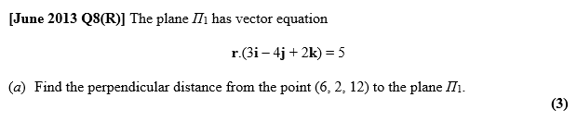

Reflections of Points in Planes

The plane $Π$ has equation $r⋅\left(i+2j+2k\right)=5$. The point $P$ has coordinates $\left(1,3,-2\right)$.
- Find the shortest distance between $P$ and $Π$.
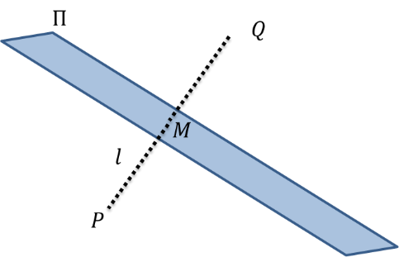
The point $Q$ is the reflection of the point $P$ in $Π$.
- Find the coordinates of point $Q$.

Reflections of Lines in Planes
The key here is that we need to reflect two points on the line through the plane, then find the equation of the line through these new points.

Example
The line $l_{1}$ has equation $\frac{x-2}{2}=\frac{y-4}{-2}=\frac{z+6}{1}$. The plane $Π$ has equation $2x-3y+z=8$.
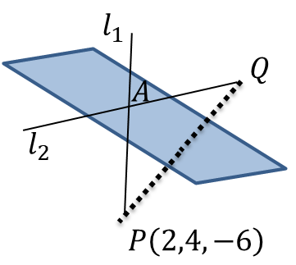
The line $l_{2}$ is the reflection of line $l_{1}$ in the plane $Π$. Find a vector equation of the line $l_{2}$.

Ex 9F Q6,8,10,12

