9F Part 1 Perpendicular Distances with Lines
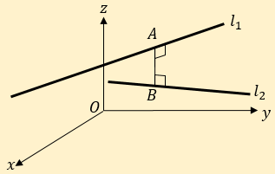
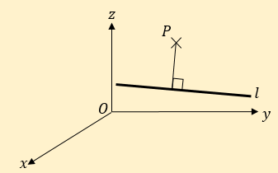
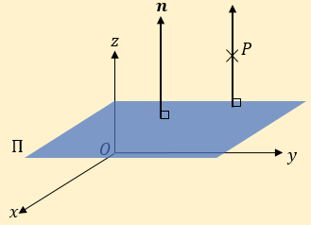

- Show that the shortest distance between the parallel lines with equations:
$$r=i+2j-k+λ(5i+4j+3k)$$
and
$$r=2i+k+μ(5i+4j+3k)$$
is $\frac{21\sqrt{2}}{10}$

- The lines $l_{1}$ and $l_{2}$ have equations:
$$r=\left(\begin{matrix}1 \\ 0 \\ 0\end{matrix}\right)+λ\left(\begin{matrix}0 \\ 1 \\ 1\end{matrix}\right)$$
$$r=\left(\begin{matrix}-1 \\ 3 \\ -1\end{matrix}\right)+μ\left(\begin{matrix}2 \\ -1 \\ -1\end{matrix}\right)$$

Find the shortest distance between these two lines.

- The line $l$ has equation:
$$\frac{x-1}{2}=\frac{y-1}{-2}=\frac{z+3}{-1}$$

The point $A$ has coordinates $(1,2,-1)$
- Find the shortest distance between $A$ and $l$.

- Find a Cartesian equation of the line that is perpendicular to $l$, and passes through $A$.

