The Shortest Distance Between Parallel Lines

The key with such “shortest distance” problems is that the line connecting $l_{1}$ and $l_{2}$ whose distance is shortest, is perpendicular to the two lines.

Example
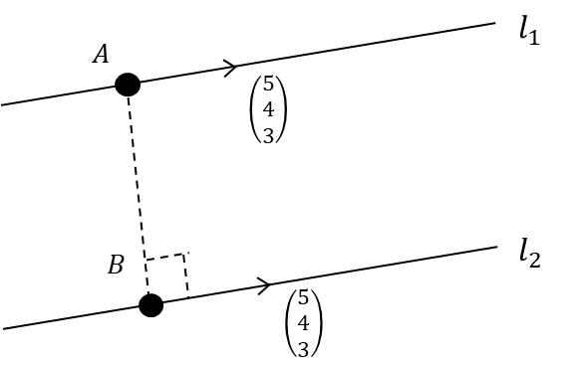
Show that the shortest distance between the parallel lines with equations:
$r=i+2j-k+λ\left(5i+4j+3k\right)$ and $r=2i+k+μ\left(5i+4j+3k\right)$,
Where $λ$ and $μ$ are scalars, is $\frac{21\sqrt{2}}{10}$

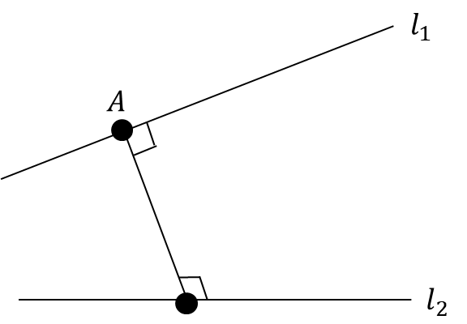
The Shortest Distance Between Any Lines

Again, use same strategy, but this time $\vec{AB}$ is
perpendicular to both $l_{1}$ and $l_{2}$.

Example
The lines $l_{1}$ and $l_{2}$ have equations $r=\left(\begin{matrix}1 \\ 0 \\ 0\end{matrix}\right)+λ\left(\begin{matrix}0 \\ 1 \\ 1\end{matrix}\right)$ and $r=\left(\begin{matrix}-1 \\ 3 \\ -1\end{matrix}\right)+μ\left(\begin{matrix}2 \\ -1 \\ -1\end{matrix}\right)$ respectively, where $λ$ and $μ$ are scalars.
Find the shortest distance between these two lines.

The Shortest Distance Between a Point and a Line
Again, same strategy! If $B$ is a point on the line, $\vec{AB}$ is perpendicular to the direction of the line.

Example
The line $l$ has equation $\frac{x-1}{2}=\frac{y-1}{-2}=\frac{z+3}{-1}$, and the point $A$ has coordinates $\left(1,2,-1\right)$.
- Find the shortest distance between $A$ and $l$.
Find the Cartesian equation of the line that is perpendicular to $l$ and passes through $A$
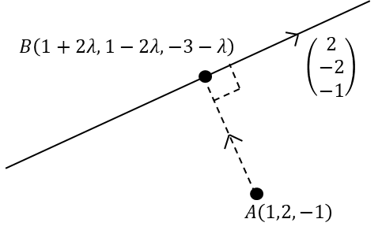
Ex 9F Q 1-5, 7, 9, 11

