Points of Intersection
Example
The lines $l_{1}$ and $l_{2}$ have vector equations $r=3i+j+k+λ(i-2j-k)$ and $r=-2j+3k+μ\left(-5i+j+4k\right)$ respectively. Show that the two lines intersect, and find the position vector of the point of intersection.

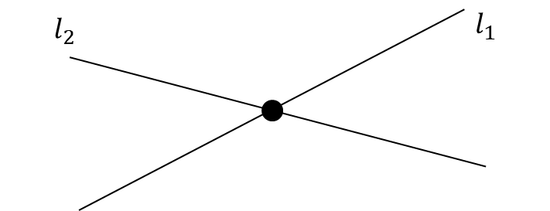

We can represent any point on $l_{1}$ as the position vector $\left(\begin{matrix}3+λ \\ 1-2λ \\ 1-λ\end{matrix}\right)$ and any point line $l_{2}$ as $\left(\begin{matrix}-5μ \\ -2+μ \\ 3+4μ\end{matrix}\right)$ . If the lines intersect, there must be a choice of $λ$ and $μ$ that makes those two points equal,

i.e. $\left(\begin{matrix}3+λ \\ 1-2λ \\ 1-λ\end{matrix}\right)=\left(\begin{matrix}-5μ \\ -2+μ \\ 3+4μ\end{matrix}\right)$

Test Your Understanding
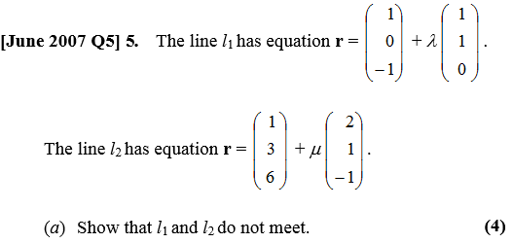

The Intersection of a Line and a Plane
Find the point of intersection of the line $l$ and the plane $Π$ where:
$$l: r=-i+j-5k+λ\left(i+j+2k\right)Π:r⋅\left(i+2j+3k\right)=4$$

The Intersection in Cartesian Form
The lines $l_{1}$ and $l_{2}$ have equations $\frac{x-2}{4}=\frac{y+3}{2}=z-1$ and $\frac{x+1}{5}=\frac{y}{4}=\frac{z-4}{-2}$ respectively. Prove that $l_{1}$ and $l_{2}$ are skew.

Ex 9E Pg 191

