Angles Between Straight Lines

To find angle between two lines………………………………………………………………………..

Example
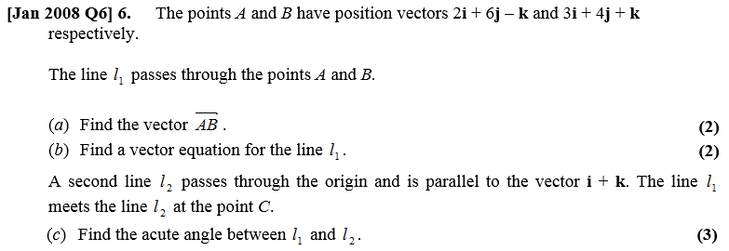

Vector Equations of Planes

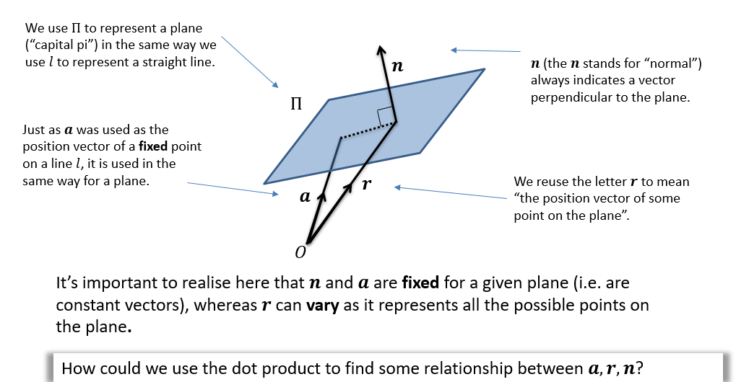

$r-a$ lies on the plane and is therefore perpendicular to $n$, thus $\left(r-a\right)⋅n=0$
$$r⋅n=a⋅n$$
But since $a⋅n$ is a constant, replace with constant scalar $p:$
Hence, the equation of plane is given by:
$$r⋅n=p$$
where $r$ is position vector of some point on the plane, $n$ is normal to plane, $p=a⋅n$ is a scalar constant.

If $r⋅\left(\begin{matrix}n_{1} \\ n_{2} \\ n_{3}\end{matrix}\right)=p$ is the scalar product equation of a plane, then the Cartesian form is:

$$n_{1}x+n_{2}y+n_{3}z-p=0$$

If $r⋅\left(\begin{matrix}n_{1} \\ n_{2} \\ n_{3}\end{matrix}\right)=p$ is the scalar product equation of a plane, then the Cartesian form is:
$$n_{1}x+n_{2}y+n_{3}z-p=0$$

Example
A point with position vector $2i+3j-5k$ lies on the plane and the vector $3i+j-k$ is perpendicular to the plane. Find the equation of the plane in:
- Scalar product form.
- Cartesian form.

The Angle Between a Line and a Plane
We can use the scalar product of the normal and the direction of a line to find the angle between the line and a plane.

Angle $θ$ between line $r=a+λb$ and plane $r⋅n=k$:

$$\cos{α}=\frac{b⋅n}{\left|b\right|\left|n\right|} θ=90°-α$$

Example
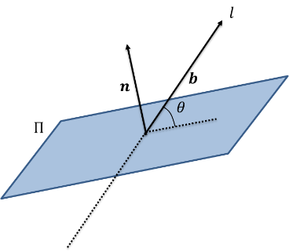
Find the acute angle between the line $l$ with equation
$r=2i+j-5k+λ\left(3i+4j-12k\right)$ and the plane with equation $r⋅\left(2i-2j-k\right)=2$.

Test Your Understanding

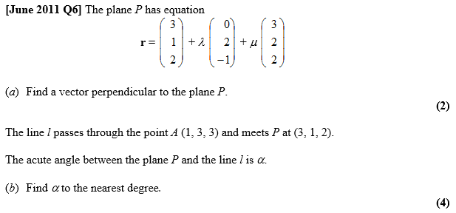

The Angle Between Two Planes
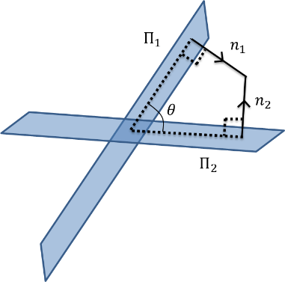

The diagram above shows why the angle between two planes is the complementary angle of the angle between the normal of both planes.

Example
Find the acute angle between the planes:
$$Π_{1}: r⋅\left(4i+4j-7k\right)=13{ Π}_{2}: r⋅\left(7i-4j+4k\right)=6$$

Test Your Understanding
Find the acute angle between the planes:
$$Π_{1}: r⋅\left(3i-j+k\right)=4{ Π}_{2}: r⋅\left(2i+3j\right)=7$$

Ex 9D pg 187

