Scalar Product
The scalar/dot product $a⋅b$ of two vectors is the sum of the products of the components. The result is a scalar, hence the name.
$$a⋅b=\sum{a_{i}b_{i}}$$

Examples

- $\left(\begin{matrix}3 \\ 2 \\ 1\end{matrix}\right)⋅\left(\begin{matrix}4 \\ 0 \\ 1\end{matrix}\right)=$

2. $\left(\begin{matrix}5 \\ -2 \\ 0\end{matrix}\right)⋅\left(\begin{matrix}3 \\ 3 \\ 1\end{matrix}\right)=$

3. $\left(\begin{matrix}a \\ 5 \\ 1\end{matrix}\right)⋅\left(\begin{matrix}3 \\ b \\ 10\end{matrix}\right)=$

Remarkably, if the two vectors are unit vectors, the dot product gives us the cosine of the angle between them.
Angle between vectors:
$$\frac{a}{\left|a\right|}⋅\frac{b}{\left|b\right|}=\cos{θ}$$
or
$$\cos{θ}=\frac{a⋅b}{\left|a\right|\left|b\right|}$$

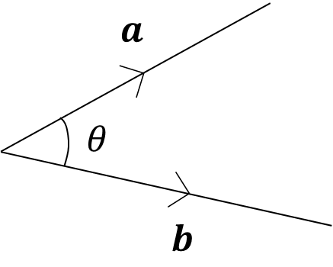
Note the direction if the vectors and the corresponding angle.
Example
Find the acute angle between the vectors $a=\left(\begin{matrix}5 \\ 3 \\ 1 \end{matrix}\right)$ and $b=\left(\begin{matrix}1 \\ 0 \\ 5\end{matrix}\right)$.

Example
Find the angle between the vectors $\left(\begin{matrix}2 \\ 4 \\ -1\end{matrix}\right)$ and $\left(\begin{matrix}0 \\ 1 \\ 8\end{matrix}\right)$.

Example
If $A\left(2,3,5\right), B(5,0,4)$ and $C\left(4,-3,2\right)$, determine the angle $ABC.$
Hence find the area of triangle $ABC$.

Perpendicular Vectors
Given that $$\cos{θ}=\frac{a⋅b}{\left|a\right|\left|b\right|}$$

It follows that if two vectors are perpendicular then ………………………………………
We can use this to prove that two vectors are perpendicular.

Example
- Show that $a=\left(\begin{matrix}2 \\ 3 \\ 1 \end{matrix}\right)$ and $b=\left(\begin{matrix}1 \\ 0 \\ -2\end{matrix}\right)$ are perpendicular.

- Given that $a=-2i+5j-4k$ and $b=4i-8j+5k$, find a vector which is perpendicular to both $a$ and $b$.

Test Your Understanding

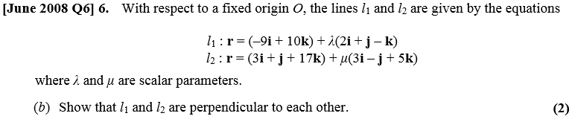

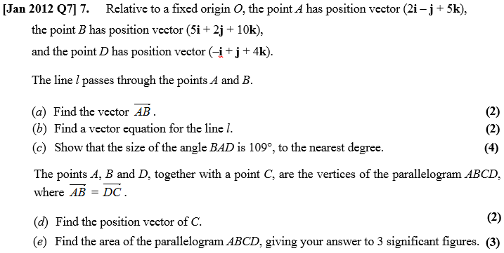

Ex 9C pg 183

