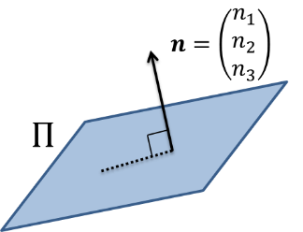
The Cartesian Equation of a Plane

Example
The plane $Π$ is perpendicular to the normal $n=3i-2j+k$ and passes through the point $P$ with position vector $8i+4j-7k$. Find the Cartesian equation of $Π$.

Ex 9B page 177

