8D Intersections

- The diagram shows a curve C with parametric equations:
$x=at^{2}+t$, $y=a\left(t^{3}+8\right)$, $t∈R$
Where a is a non-zero constant. Given that $C$ passes through the point (-4,0):
- Find the value of $a$
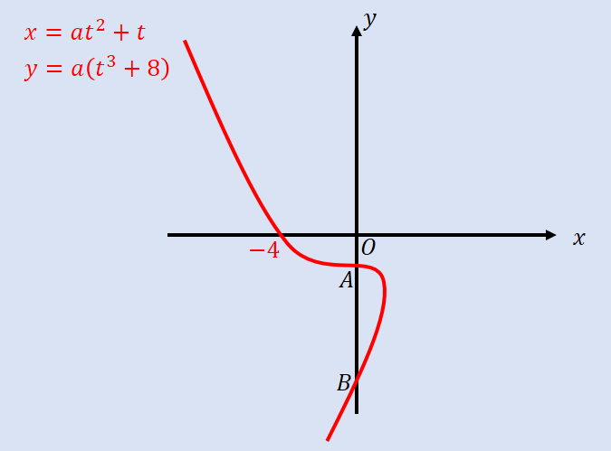

- Find the coordinates of the points $A$ and $B$ where the curve crosses the y-axis

- A curve is given parametrically by the equations:
$x=t^{2}$, $y=4t$
The line $x+y+4=0$ meets the curve at A. Find the coordinates of A.

- The curve in the diagram is given parametrically by the equations:
$x=cost+sint$, $y={\left(t-\frac{π}{6}\right)}^{2}$
$$-\frac{π}{2}<t<\frac{4π}{3}$$
- Find the point where the curve intersects the line $y=π^{2}$

- Find the coordinates of the points A and B where the curve meets the y-axis

