8A Finding Cartesian Equations

- a) Draw the graph of the function:
$$x=2t y=t^{2}$$
$$-3≤t≤3$$

- Find the Cartesian equation of the curve

- A curve has parametric equations:
$x=ln\left(t+3\right)$ $y=\frac{1}{t+5}$
- Find a Cartesian equation of the curve in the form $y=f(x)$, $x>k$, where $k$ is a constant to be found.

- Write down the range of $f(x)$

8B Finding Cartesian Equations with Trig

- A curve has parametric equations:
$x=sint+2$, $y=cost-3$, $t∈R$
- Show that a Cartesian equation of the curve is given by:
$${\left(x-2\right)}^{2}+{\left(y+3\right)}^{2}=1$$

- Hence, sketch the curve…

- A curve has parametric equations:
$x=sint$, $y=sin2t$, $-\frac{π}{2}≤t≤\frac{π}{2}$
- Find a Cartesian equation of the curve in the form $y=f(x)$, $-k≤x≤k$, stating the value of the constant $k$.

- Write down the range of $f(x)$

- A curve has parametric equations:
$x=cot⁡(t)+2$, $y={cosec}^{2}t-2$
$$0<t<π$$
- Find the equation of the curve in the form $y=f(x)$ and state the domain of x for which the curve is defined

b) Hence, sketch the curve

8C Sketching Graphs

- Draw the curve given by the parametric equations:
$x=3cost+4$, $y=2sint$ $0≤t≤2π$

8D Intersections

- The diagram shows a curve C with parametric equations:
$x=at^{2}+t$, $y=a\left(t^{3}+8\right)$, $t∈R$
Where a is a non-zero constant. Given that $C$ passes through the point (-4,0):
- Find the value of $a$
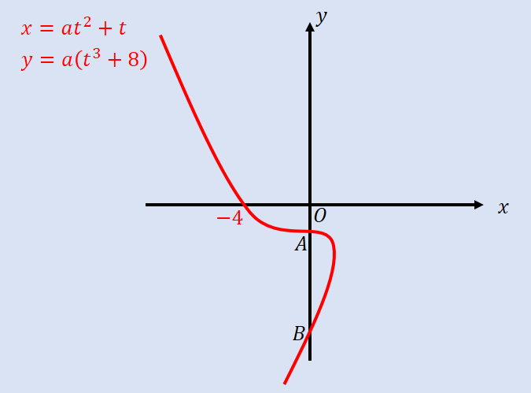

- Find the coordinates of the points $A$ and $B$ where the curve crosses the y-axis

- A curve is given parametrically by the equations:
$x=t^{2}$, $y=4t$
The line $x+y+4=0$ meets the curve at A. Find the coordinates of A.

- The curve in the diagram is given parametrically by the equations:
$x=cost+sint$, $y={\left(t-\frac{π}{6}\right)}^{2}$
$$-\frac{π}{2}<t<\frac{4π}{3}$$
- Find the point where the curve intersects the line $y=π^{2}$

- Find the coordinates of the points A and B where the curve meets the y-axis

8E Modelling

- A plane’s position at time t seconds after take-off can be modelled with the following parametric equations:
$x=\left(vcosθ\right)t,$ $y=\left(vsinθ\right)t$, $t>0$
Where $v$ is the speed of the plane, $θ$ is the angle of elevation of its path, $x$ is the horizontal distance travelled (m) and $y$ is the vertical distance travelled (m), relative to a fixed origin.
When the plane has travelled 600m horizontally, is has climbed 120m.
- Find the angle of elevation, $θ$.

Given that the plane’s speed is $50{ms}^{-1}$.
- Find the parametric equations for the plane’s motion

- Find the vertical height of the plane after 10 seconds

- Show that the plane’s motion is a straight line

- Explain why the domain, $t>0$ is not realistic

- A stone is thrown from the top of a 25m high cliff with an initial speed of $5ms^{-1}$ at an angle of ${45}^{°}$. Its position after $t$ seconds can be described using the following parametric equations:
$x=\frac{5\sqrt{2}}{2}t,$ $y=\left(-4.{9t}^{2}+\frac{5\sqrt{2}}{2}t+25 \right)$
$$0≤t≤k$$
Where $x$ is the horizontal distance (m), $y$ is the vertical distance (m) from the ground, and $k$ is a constant.
- Given that the model is valid from the time the stone is thrown until the time it hits the ground, find the value of $k$.

- Find the horizontal distance travelled by the stone by the time it hits the floor ground

- The motion of a figure skater relative to a fixed origin $O$, at time $t$ minutes is modelled using the parametric equations:
$x=8cos20t,$ $y=12sin\left(10t-\frac{π}{3}\right)$
$$t≥0$$
Where $x$ and $y$ are measured in metres.
- Find the coordinates of the figure skater at the beginning of their motion.

- Find the coordinates of the point where the figure skater intersects their own path, given that it takes place on the x-axis

- Find the coordinates of the points where the curve intersects the y-axis

- Find how long it takes the figure skater to complete on figure of eight motion

