7G Modelling with Trigonometry
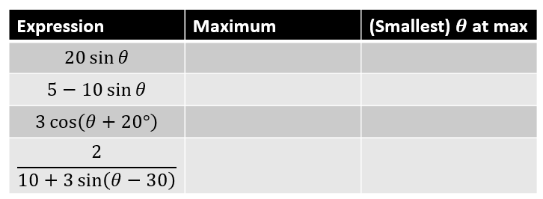

- The cabin pressure, $P$, in pounds per square inch (psi) on an aeroplane at cruising altitude can be modelled by the equation:
$P=11.5-0.5sin\left(t-2\right)$
*note these formulae are often a result of reducing to Rcos(x+a) form
Where $t$ is the time in hours since the cruising altitude was first reached, and all angles are measured in radians
- State the minimum and maximum cabin pressure

- Find the time after reaching cruising altitude that the cabin first reaches a maximum pressure

- Calculate the cabin pressure after 5 hours at a cruising altitude

- Find all the times during the first 8 hours of cruising that the cabin pressure would be exactly 11.3 psi.

