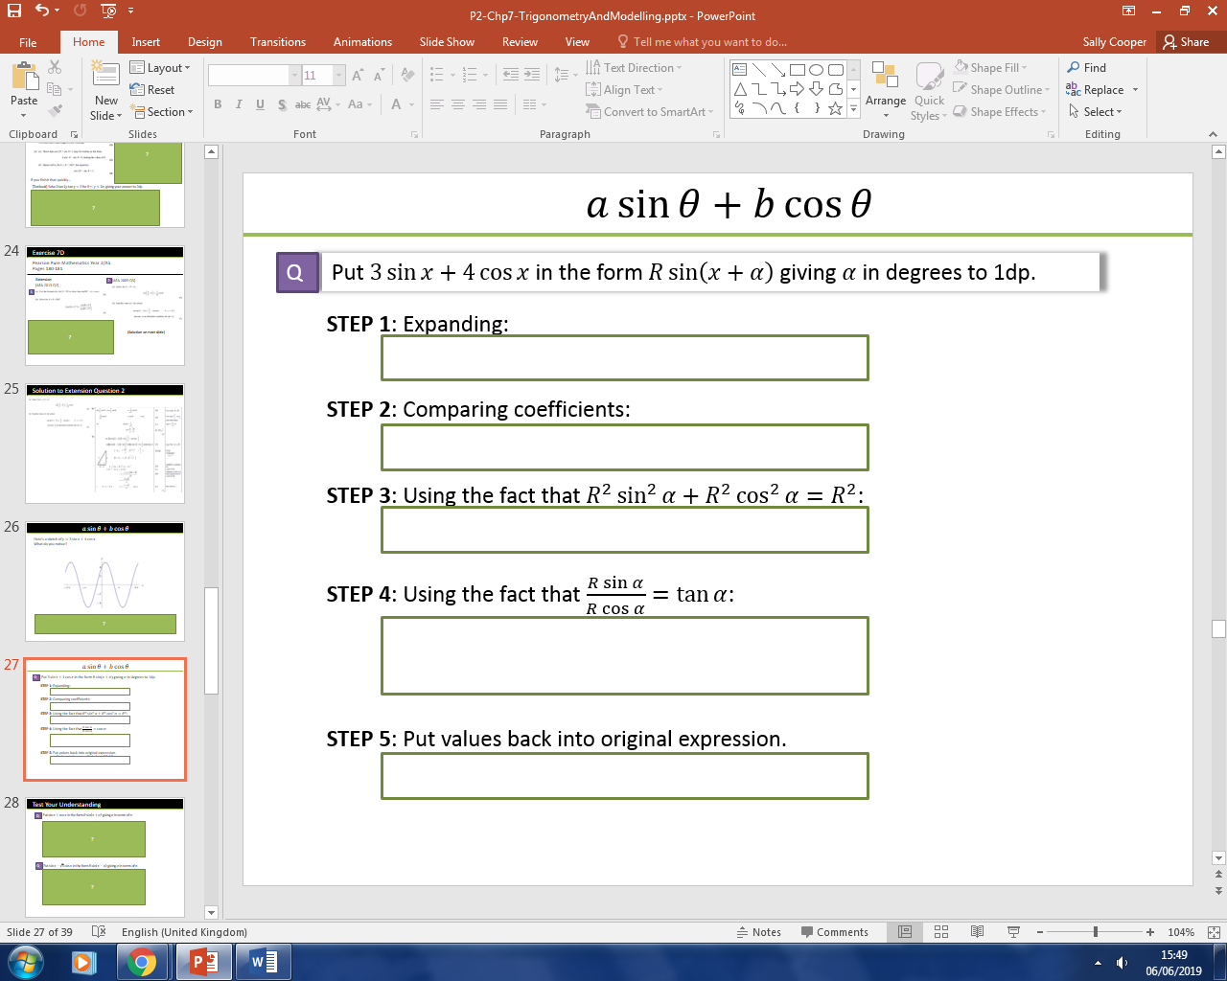

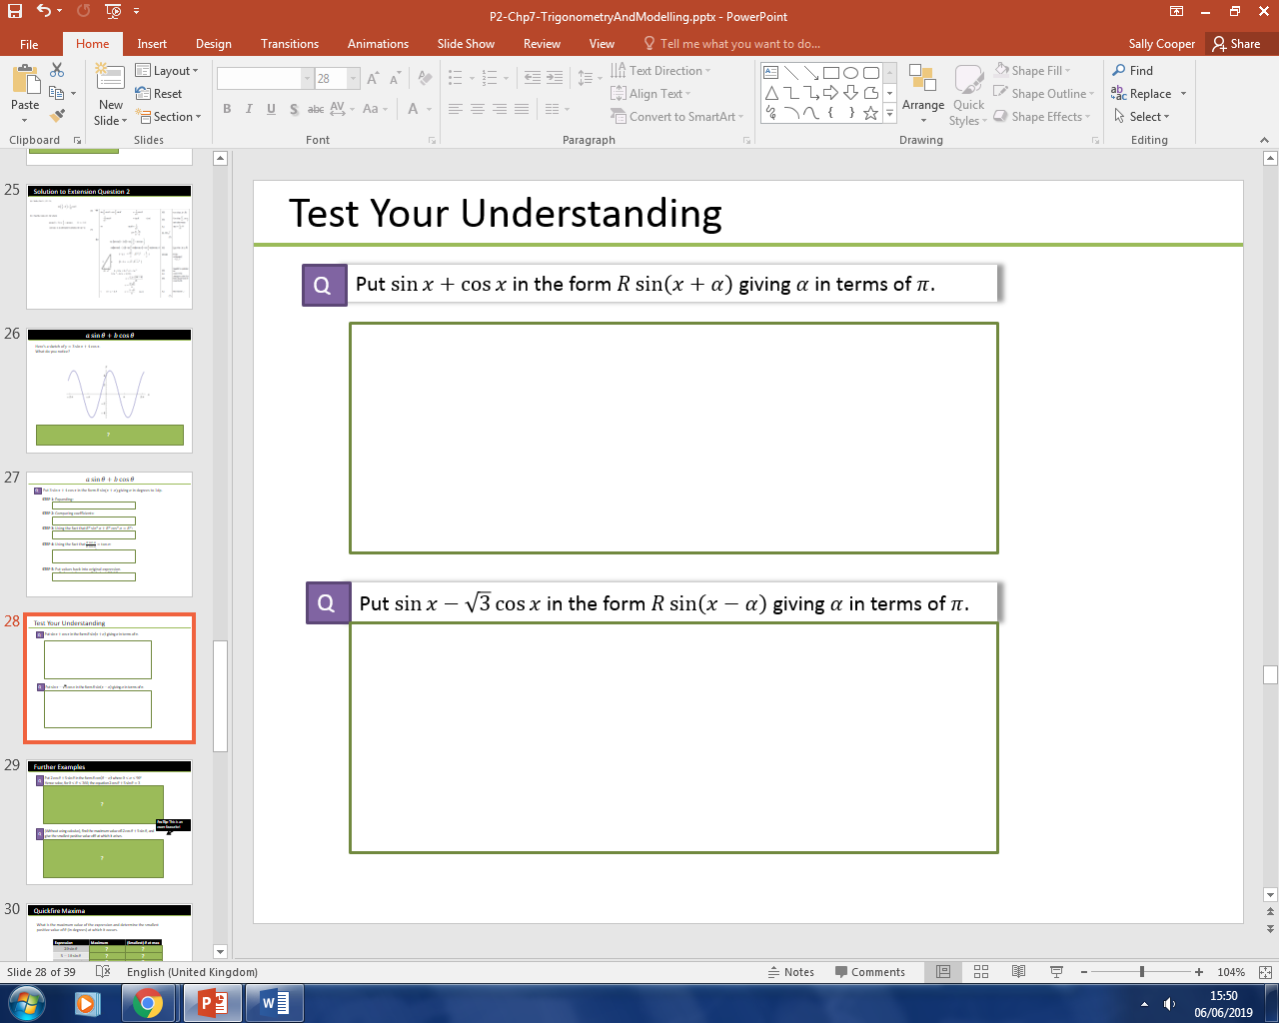



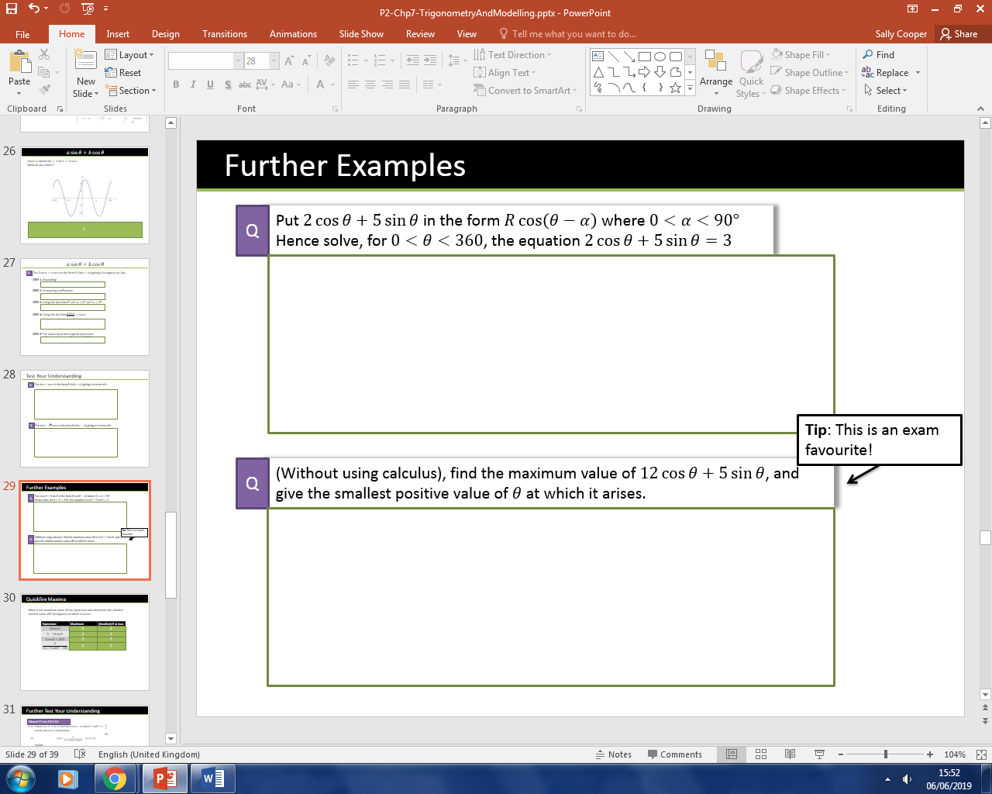



|  |  |  |
| --- | --- | --- |
| **Expression** | **Maximum** | **(Smallest) $θ$ at max** |
| $$20\sin{θ}$$ |  |  |
| $$5-10\sin{θ}$$ |  |  |
| $$3\cos\left(θ+20°\right)$$ |  |  |
| $$\frac{2}{10+3\sin\left(θ-30\right)}$$ |  |  |

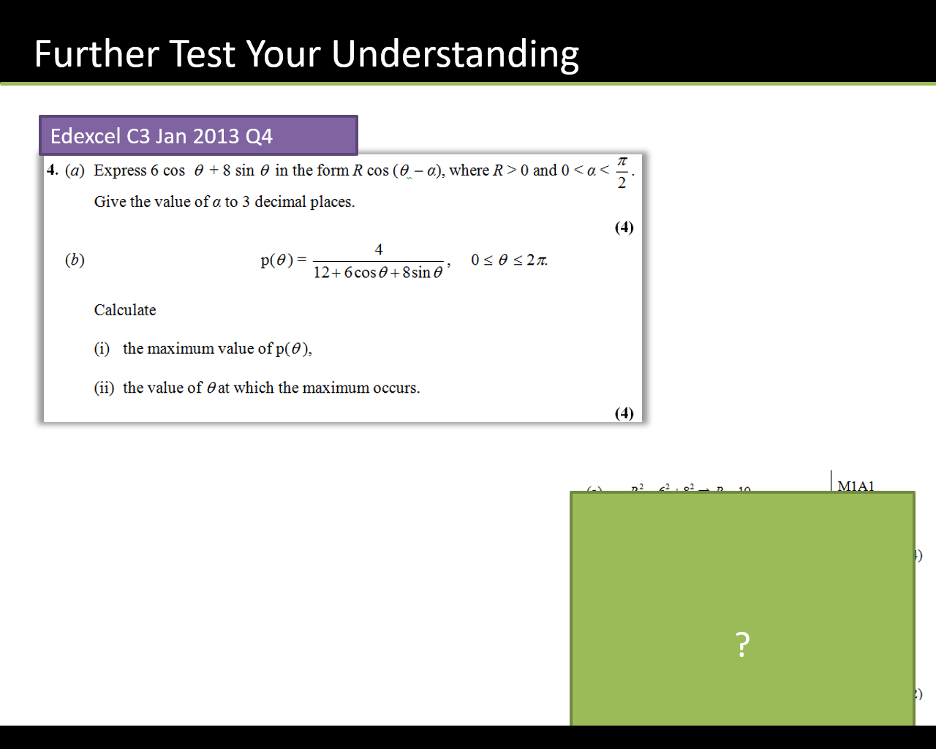

Textbook Exercise 7E Page 184