7A Additional Formulae Identities

- Use $cos\left(α+β\right)=cosαcosβ-sinαsinβ$ to show that:
$$cos\left(A-B\right)=cosAcosB+sinAsinB$$

- Use $sin\left(α+β\right)=sinαcosβ+cosαsinβ$ and $cos\left(α+β\right)=cosαcosβ-sinαsinβ$
To show that
$$tan\left(A+B\right)=\frac{tanA+tanB}{1-tanAtanB}$$

- Prove that
$$\frac{cosA}{sinB}-\frac{sinA}{cosB}≡\frac{cos\left(A+B\right)}{sinBcosB}$$

- Given that:
$2\sin\left(x+y\right)=3cos⁡(x-y)$
Express $tanx$ in terms of $tany$

7B Applying the Addition Formulae

- Given that:

$SinA=-\frac{3}{5} 180˚$ < A < 270˚

Cos$B=-\frac{12}{13} B=Obtuse$

Find the value of:

Tan(A+B)

7C Double Angles Formulae

Sin2A ≡ 2SinACosA

Key points:
If you see sin and cos multiplied together and both have the same angle -> this can be reduced using sin double angle formulae to a single trig function
Examples:
- sinxcosx =

- 6cosxsinx =

- 5sin3xcos3x =

Cos2A ≡ Co$s^{2}A -Sin^{2}A$

Key points:
If you see $Sin^{2}A$ or ${Cos}^{2}A$ this can be reduced using the cos double angle formulae to a single trig function
Examples:
- $Sin^{2}x$ =

- $4{Cos}^{2}x$ =

- $3Sin^{2}4x$ =

Tan 2A $≡\frac{2TanA}{1-Tan^{2}A}$

- Use the double angle formulae to write the following expression as a single trigonometric ratio:
- ${Cos}^{2}50-{Sin}^{2}50$

- $\frac{2tan\frac{π}{6}}{1-\tan^{2}\frac{π}{6}}$

- $\frac{4sin70}{sec70}$

- Given that $x=3sinθ$ and $y=3-4cos2θ$, eliminate $θ$ and express $y$ in terms of $x$.

- Given that:
$$cosx=\frac{3}{4} , 180˚<x<360˚$$

Find the exact value of:
- $sin2x$

- $tan2x$

7F Trig Identities with Double Angles formulae

- Show that:
$$2sin\frac{θ}{2}cos\frac{θ}{2}cosθ≡\frac{1}{2}sin2θ$$

- Show that:
$$1+cos4θ≡2\cos^{2}2θ$$

- Prove the Identity:
$$tan2θ≡\frac{2}{cotθ-tanθ}$$

- Prove the Identity:
$$\sqrt{3}cos4θ+sin4θ≡2cos\left(4θ-\frac{π}{6}\right)$$

7D Solving Equations

- Solve $4cos\left(θ-30\right)=8\sqrt{2}sinθ$ in the range $0≤θ≤360$. Give answers to 1dp.

- Solve $3cos2x-cosx+2=0$ in the range $0≤x≤360$. Give answers to 1dp where appropriate.

- Solve $2tan2ytany=3$ in the range $0≤y≤2π$. Give answers to 2dp.

a) By expanding $sin⁡(2A+A)$, show that:
$$sin3A≡3sinA-{4sin}^{3}A$$

b) Hence, or otherwise, solve:
$16\sin^{3}θ-12sinθ-2\sqrt{3}=0$, in the range $0<θ<2π$

7E $RCos\left(x±α\right) \& RSin\left(x±α\right)$

- Show that:
$$3sinx+4cosx$$
Can be expressed in the form:
$Rsin(x+α)$
$$R>0$$
$$0°<α<90°$$

- Show that you can express:
$$sinx-\sqrt{3}cosx$$
In the form:
$Rsin(x-α)$
$$R>0$$
$$0<α<\frac{π}{2}$$

Quick Shortcuts and patterns:

Key point: This skill helps us reduce two trigonometric functions with the same angle that are being summed together to one single trigonometric function.

Where could this skill be useful?

- Express:
$$2cosθ+5sinθ$$
in the form:
$Rcos(x-α)$
$$R>0$$
$0°<α<90°$

- Hence, solve $2cosθ+5sinθ=3$, $0°<θ<360°$

7G Modelling with Trigonometry
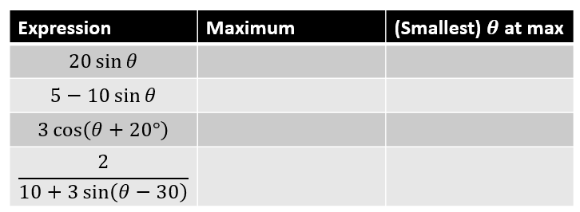

- The cabin pressure, $P$, in pounds per square inch (psi) on an aeroplane at cruising altitude can be modelled by the equation:
$P=11.5-0.5sin\left(t-2\right)$
*note these formulae are often a result of reducing to Rcos(x+a) form
Where $t$ is the time in hours since the cruising altitude was first reached, and all angles are measured in radians
- State the minimum and maximum cabin pressure

- Find the time after reaching cruising altitude that the cabin first reaches a maximum pressure

- Calculate the cabin pressure after 5 hours at a cruising altitude

- Find all the times during the first 8 hours of cruising that the cabin pressure would be exactly 11.3 psi.

