6E Inverse Trigonometric Functions
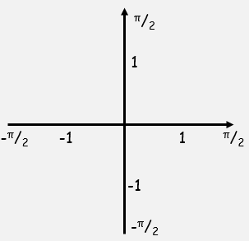
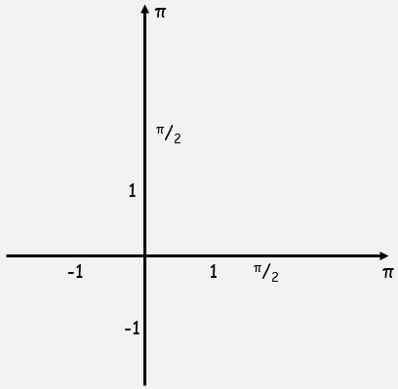

- Work out, in radians, the value of:
- arcsin(0.5)

- arctan($\sqrt{3}$)

- arcsin($-\frac{\sqrt{2}}{2}$)

- cos[arcsin(-1)]

