6B Reciprocal Trigonometric Graphs
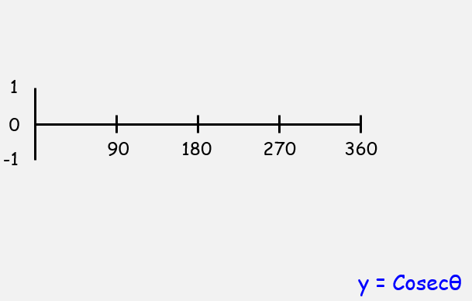
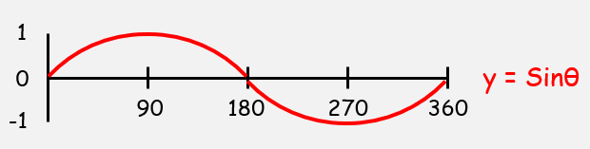

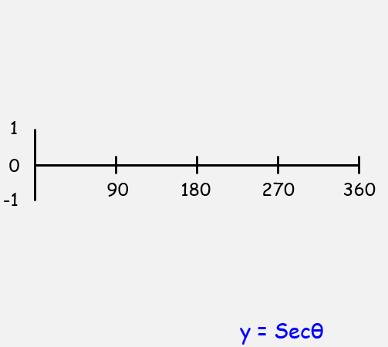

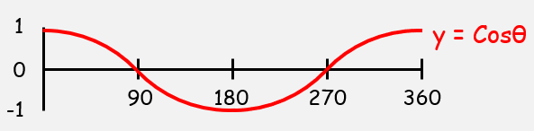

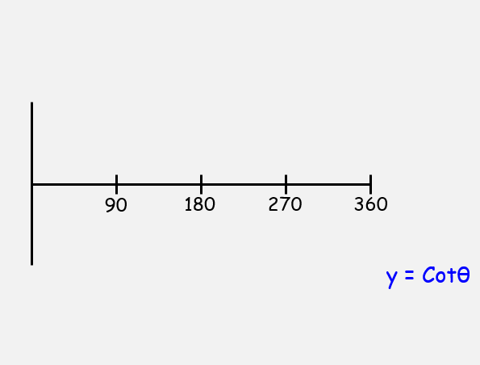
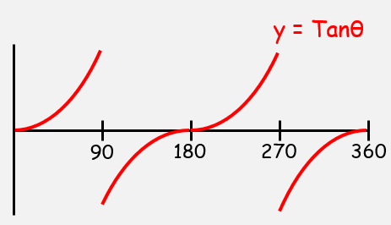

- Sketch, in the interval 0 ≤ θ ≤ 360, the graph of:
$$y=1+sec⁡(2θ)$$

- Sketch the graph of:
- $y=4cosecx,$ $0≤x≤2π$
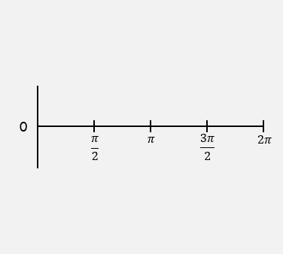
- On the same axes, sketch the line $y=x$

- State the number of solutions to the equation:

$$4cosecx-x=0 0≤x≤2π$$

