6A Reciprocal Trigonometric Functions

- Will cosec(200) be positive or negative?

- Find the value of:
- sec(280)

- cot(115)

- Work out the exact value of:
- sec(210)

- $cosec (\frac{3π}{4})$

6B Reciprocal Trigonometric Graphs
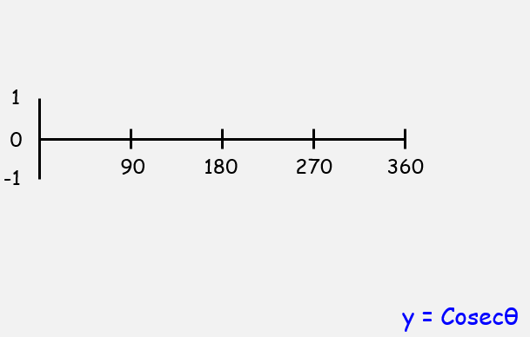
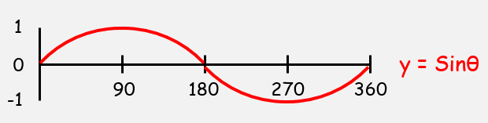

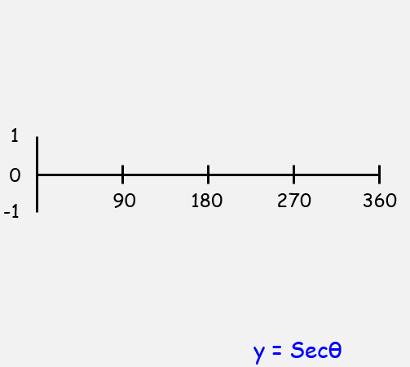

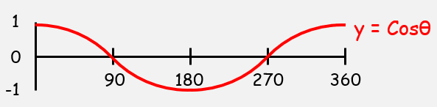

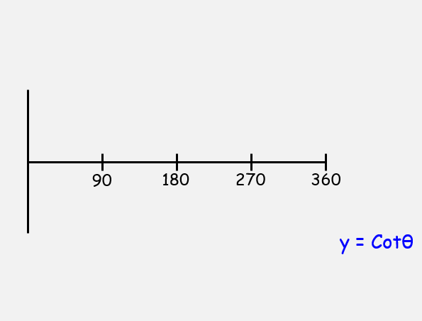
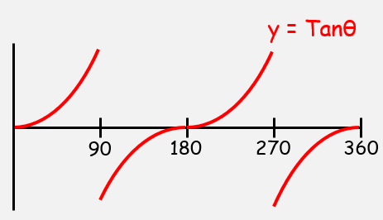

- Sketch, in the interval 0 ≤ θ ≤ 360, the graph of:
$$y=1+sec⁡(2θ)$$

- Sketch the graph of:
- $y=4cosecx,$ $0≤x≤2π$
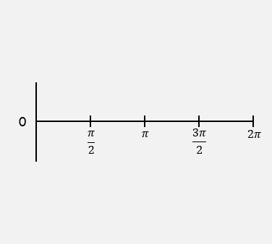
- On the same axes, sketch the line $y=x$

- State the number of solutions to the equation:

$$4cosecx-x=0 0≤x≤2π$$

6C Part 1 Simplifying Expressions
- simplify
- $sinθ cotθ secθ$

- $sinθ cosθ (secθ+cosecθ)$

- $\frac{cotθ cosecθ)}{\sec^{2}θ+{cosec}^{2}θ}≡\cos^{3}θ$

6C Part 2 Solving Equations

- Solve the equation
- $secθ=-2.5 in the range 0≤θ≤360$

- $cot2θ=0.6 in the range 0≤θ≤360$

- $3cosecθ=2secθ in the range 0≤θ≤360$

6D Part 1 Exact Trig Values

- Given that
$$tanA=-\frac{5}{12}$$
and A is obtuse, find the exact value of
- secA

- cosecA

- Given that
$$cotB=\frac{7}{24}$$
and B is reflex, find the exact value of
- secB

- cosecB

6D Part 2 Reciprocal Trigonometric Identities

- Prove that
$${cosec}^{4}θ-\cot^{4}θ≡\frac{1+\cos^{2}θ}{1-\cos^{2}θ}$$

- Prove that
$$\sec^{2}θ-\cos^{2}θ≡\sin^{2}θ(1+\sec^{2}θ)$$

- Solve the equation $$4{cosec}^{2}θ-9≡cotθ$$
in the interval $$0≤θ≤360$$

6E Inverse Trigonometric Functions
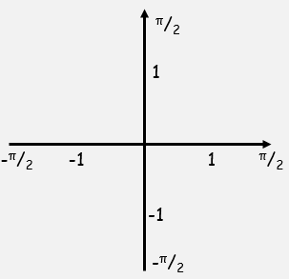
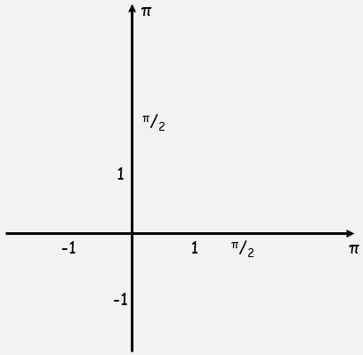

- Work out, in radians, the value of:
- arcsin(0.5)

- arctan($\sqrt{3}$)

- arcsin($-\frac{\sqrt{2}}{2}$)

- cos[arcsin(-1)]

