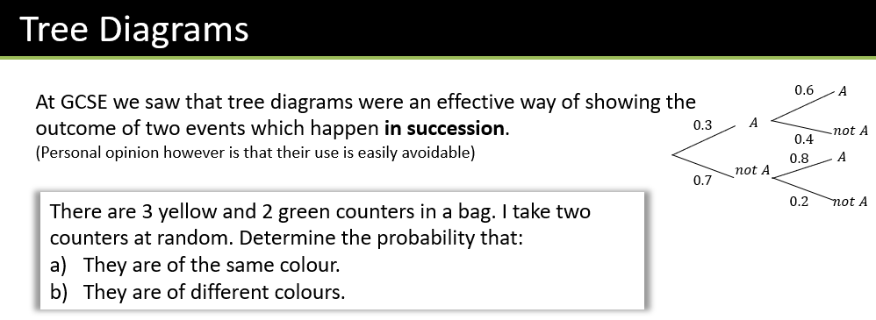

Textbook Exercise 5D Pg 79

