5C Mutually Exclusive & Independent Events
Mutually Exclusive

Independent

- Events A and B are Mutually Exclusive and P(A) = 0.2 and P(B) = 0.4
Calculate:
- $P (A∪B)$

b) $P (A∩B^{'})$

c) $P (A'∩B^{'})$

- Events C and D are Independent and P(C) = ¹/₃ and P(D) = ¹/₅
Calculate:
- $P (A∩B)$

- $P (A∩B')$

- $P (A'∩B')$

- The Venn Diagram shows the number of students in a particular class that watch any of three popular TV programmes, A, B and C.
- Find the probability that a student watches B or C or both.
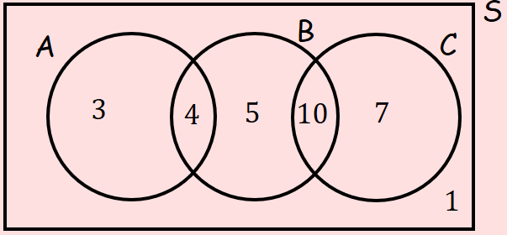

b) Determine whether watching A and watching B are statistically independent.

