**5B Venn Diagrams**

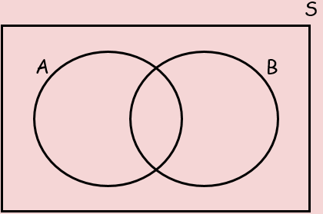

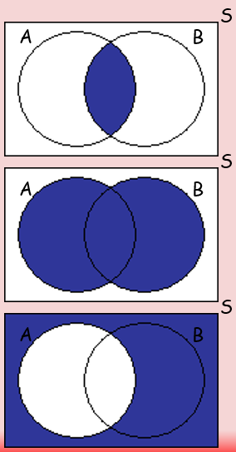

1. A card is selected at random from a pack of 52 playing cards. Let A be the event that the card is an ace, and D be the event that the card is a diamond. Draw a Venn diagram to show this information.
2. In a class of 30 students, 7 are in the choir, 5 are in the school band and 2 are in both the choir and the band. Draw a Venn diagram to show this information.



1. A vet surveys 100 clients. She finds out the following:

25 have dogs 53 have cats 40 have fish

15 have dogs and cats 10 have cats and fish 11 have dogs and fish

7 have dogs, cats and fish





