5A Sample Spaces & Probability from Data

- Two spinners are numbered 1-4. Both are spun and the sum of the numbers (x) is calculated. Find P(x = 5) and P(x > 5)
Draw a sample space to show the outcomes.

- The table shows the time taken, in minutes, for a group of students to complete a number puzzle.
- Estimate the probability that a student completed the puzzle in under 9 minutes
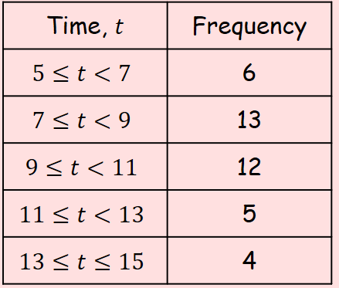

- Estimate the probability that a student completed the puzzle in 10 minutes or more

