A Level Mathematics

Chapter 5 - Statistics
Probability Year 1

Chapter Overview
- Basic probability
- Venn diagrams
- Mutually Exclusive / Independent Events
- Tree diagrams

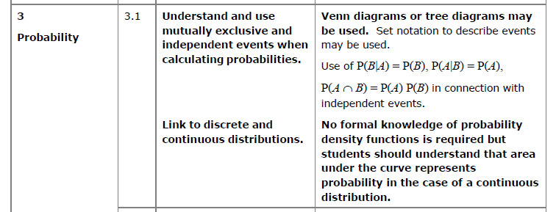

(Set notation may be used in Year 1 – will be seen more commonly in Year 2)

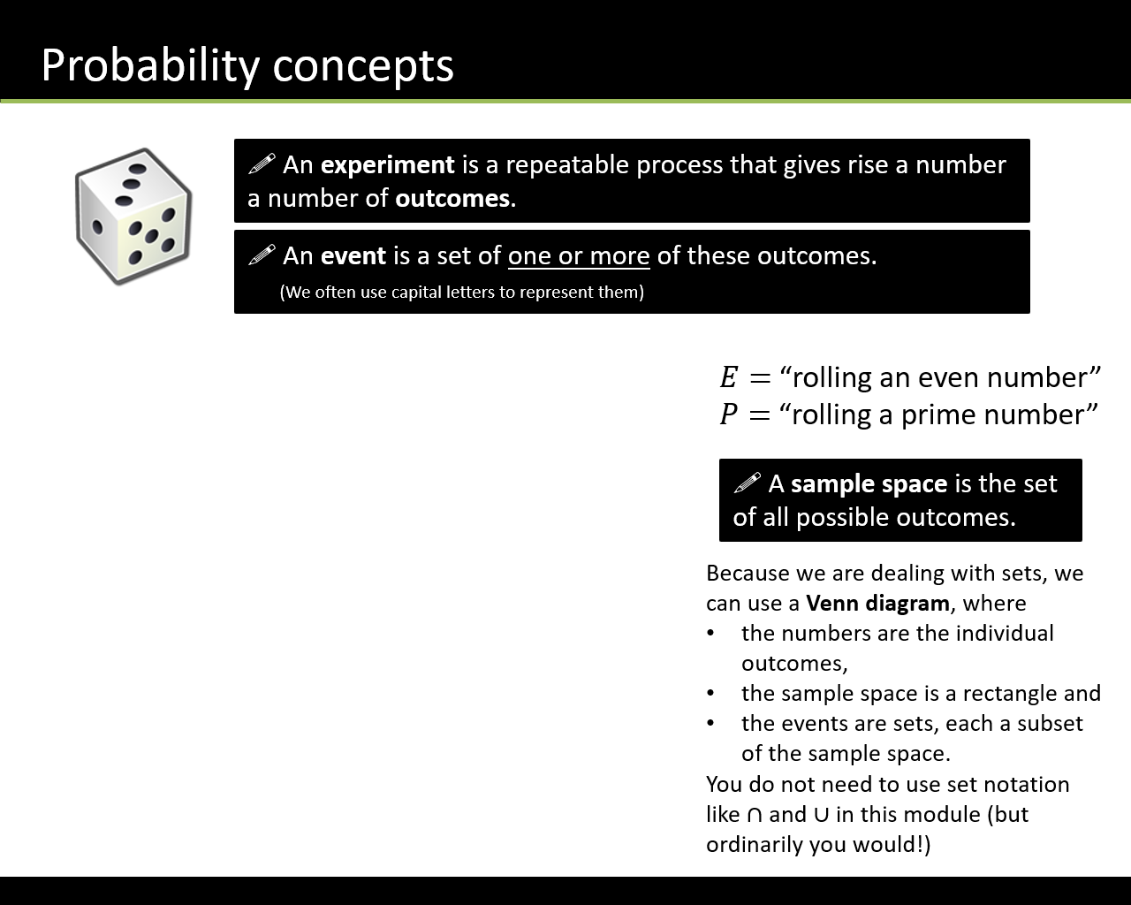

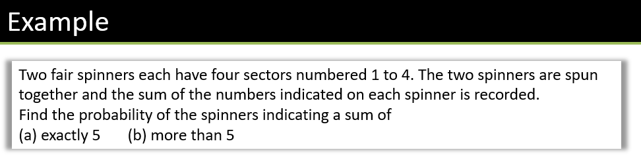
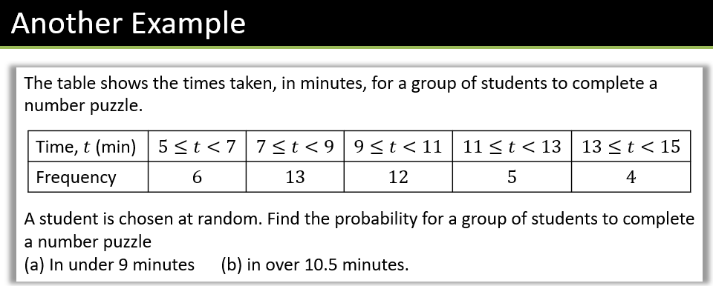

Textbook Exercise 5A Pg 71

