**5A Sample Spaces & Probability from Data**

1. Two spinners are numbered 1-4. Both are spun and the sum of the numbers (x) is calculated. Find P(x = 5) and P(x > 5)

Draw a sample space to show the outcomes.

1. The table shows the time taken, in minutes, for a group of students to complete a number puzzle.
2. Estimate the probability that a student completed the puzzle in under 9 minutes

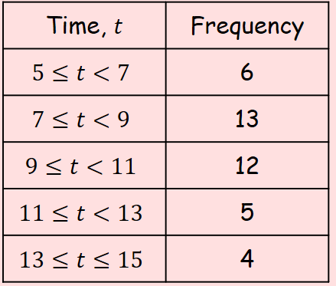

1. Estimate the probability that a student completed the puzzle in 10 minutes or more

**5B Venn Diagrams**

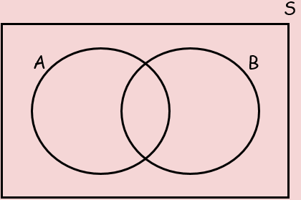

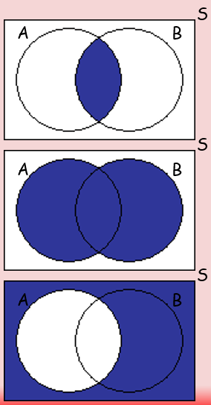

1. A card is selected at random from a pack of 52 playing cards. Let A be the event that the card is an ace, and D be the event that the card is a diamond. Draw a Venn diagram to show this information.
2. In a class of 30 students, 7 are in the choir, 5 are in the school band and 2 are in both the choir and the band. Draw a Venn diagram to show this information.



1. A vet surveys 100 clients. She finds out the following:

25 have dogs 53 have cats 40 have fish

15 have dogs and cats 10 have cats and fish 11 have dogs and fish

7 have dogs, cats and fish







**5C Mutually Exclusive & Independent Events**

Mutually Exclusive

Independent

1. Events A and B are Mutually Exclusive and P(A) = 0.2 and P(B) = 0.4

Calculate:

$P (A∪B)$

b) $P (A∩B^{'})$

c) $P (A'∩B^{'})$

1. Events C and D are Independent and P(C) = 1/3 and P(D) = 1/5

Calculate:

$P (A∩B)$

$P (A∩B')$

$P (A'∩B')$

1. The Venn Diagram shows the number of students in a particular class that watch any of three popular TV programmes, A, B and C.
2. Find the probability that a student watches B or C or both.

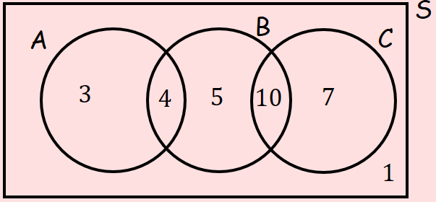

b) Determine whether watching A and watching B are statistically independent.

**5D Tree Diagrams**

1. A bag contains 7 green beads and 5 blue beads. A bead is taken at random, the colour recorded and the bead is not replaced. A second is then taken and the colour recorded. Find P(1 Green and 1 Blue).