4B Linear Regression - Lines of Best Fit

- From the large data set, the daily mean windspeed, $w$ knots, and the daily maximum gust, $g$ knots, were recorded for the first 15 days in May in Camborne in 2015.
The data was plotted on a scatter diagram:
- Describe the correlation between daily mean windspeed and daily maximum gust
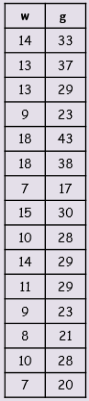
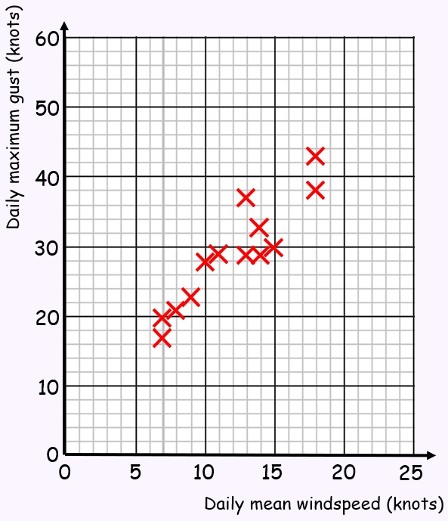

The equation of the regression line of $g$ on $w$ for this data is:
$$g=7.23+1.82w$$
- Give an interpretation of the value of the gradient of this regression line

- Justify the use of a linear regression line in this case.

- The head circumference, $y$ cm, and gestation period, $x$ weeks, for a random sample of newborn babies were recorded, and the scatter graph shows the results.
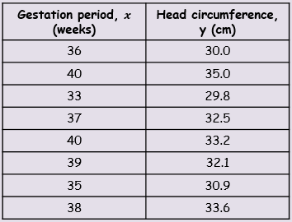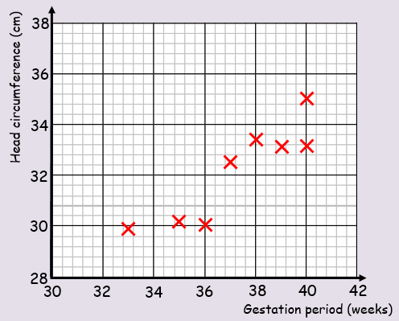

The equation of the regression line of $y$ on $x$ is:
$$y=8.91+0.624x$$
- This equation is used to estimate the head circumference of a baby born after 39 weeks and a baby born after 30 weeks. Comment on the reliability of these estimates.

A nurse wants to estimate the gestation period for a baby born with a head circumference of 31.6cm.
- Explain why the regression equation above is not suitable for this estimate

