4A Correlation & Drawing Scatter Diagrams

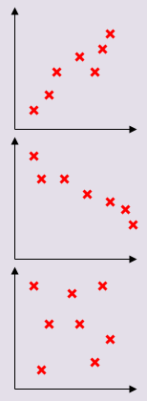

- In the study of a city, the population density, in people/hectare, and the distance from the city centre, in km, was investigated by choosing sample areas. The results are as follows:
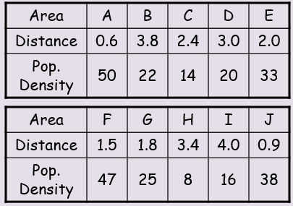
Plot a scatter graph and describe the correlation. Interpret what the correlation means.
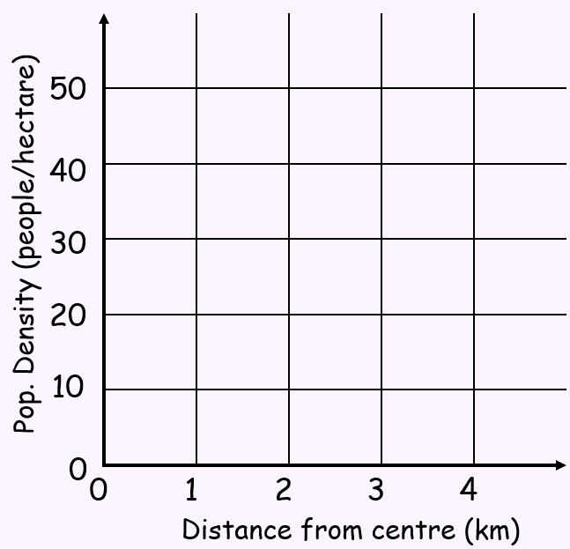
- Hideko was interested to see if there was a relationship between what people earn and the age at which they left education or training. She asked 14 friends to fill in an anonymous questionnaire and recorded her results in a scatter diagram.
- Describe the type of correlation shown
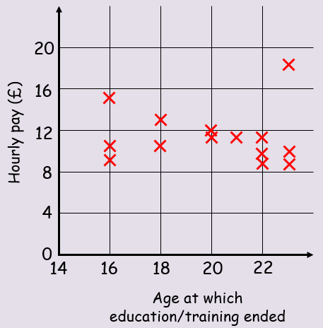
Hideko says that her data supports the conclusion that more education causes people to earn a lower hourly rate of pay
- Give one reason why Hideko’s conclusion might not be valid

