A Level Mathematics

Chapter 4 - Statistics
Correlation

Chapter Overview
- Draw and interpret scatter diagrams
- Interpret correlation
- Interpret the coefficients of a regression line equation for bivariate data
- Understand when you can use a regression line to make predications
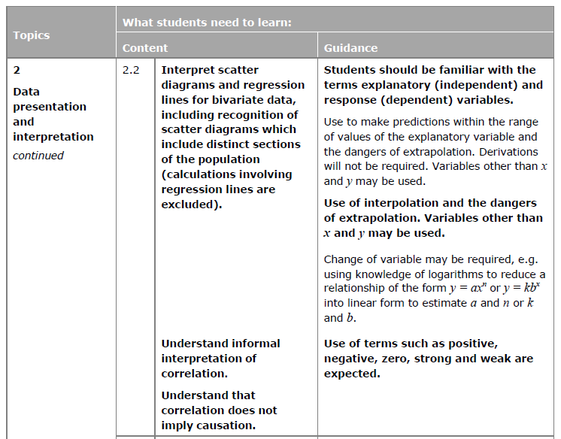

Recap on Correlation

c

c

Important Correlation Concepts

Textbook Exercise 4A Pg 61

