3D Histograms

- A random sample of 200 students was asked how long it took them to complete their homework the previous night. The time was recorded and summarised in the table to the right.
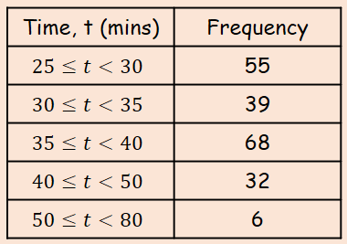
- Draw a Histogram and frequency polygon for this data

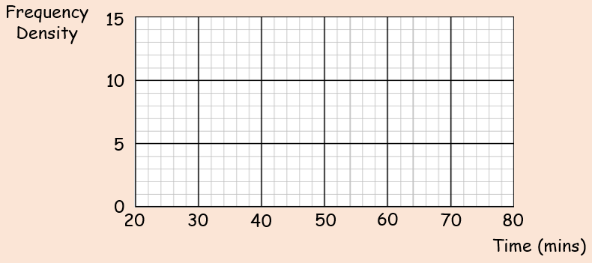
- Estimate how many students took between 36 and 45 minutes to complete their homework

- A random sample of daily mean temperatures $(T,℃)$ was taken from the large data set for Hurn in 2015. The temperatures were summarised in a grouped frequency and represented by a Histogram.
- Give a reason to support the use of a Histogram to represent this data

- Write down the underlying feature associated with each of the bars in a Histogram

On the Histogram, the rectangle representing the $16≤T<18$ class was 3.2cm high and 2cm wide. The frequency for this class was 8.
- Show that each day is represented by an area of 0.8

- Given that the total area of the Histogram was 48cm², find the total number of days in the sample

