Histograms
You should remember from GCSE that there are some important differences between bar charts and histograms. We will consider 4 important skills.
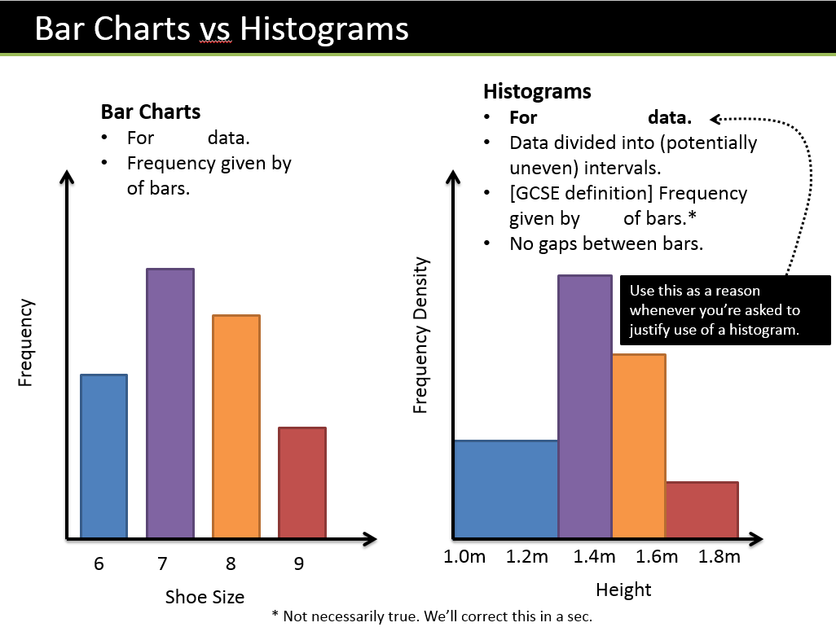

Example
- Calculate the missing values in the table below
Weight (w kg) | Frequency | Frequency Density
0 < w ≤ 10 | 40
10 < w ≤ 15 | 6
15 < w ≤ 35 |  | 2.6
35 < w ≤ 45 |  | 1

- Calculate the frequencies

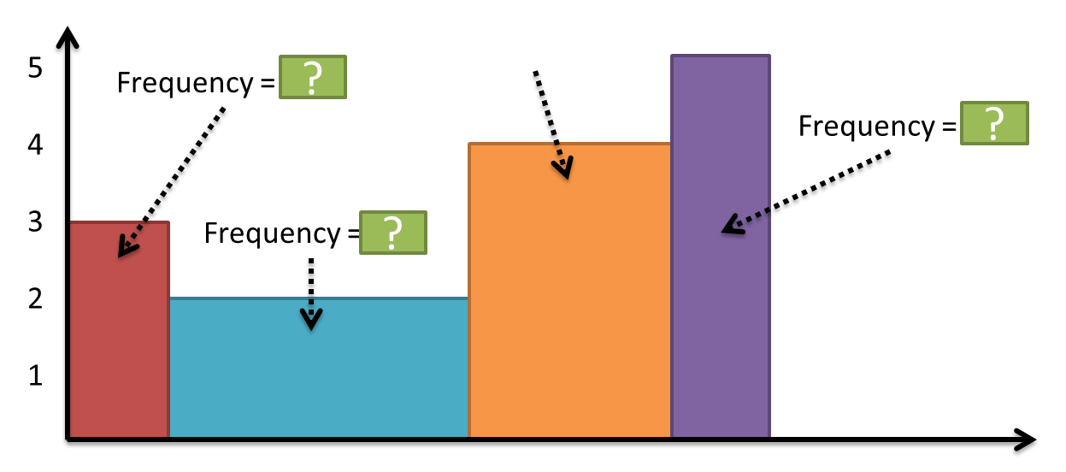

- Let’s consider the area of the bars:

Example
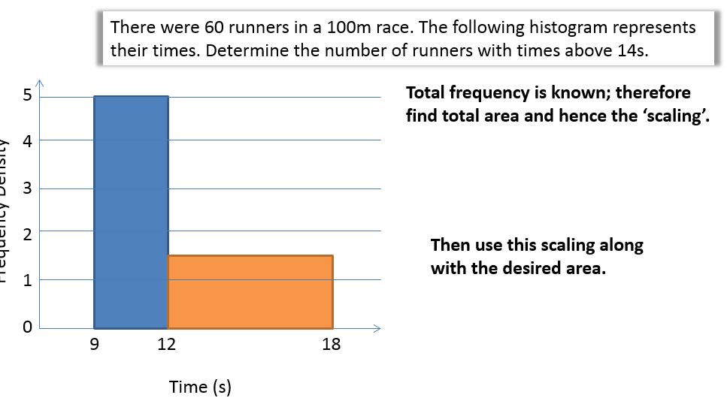
Test Your Understanding
A policeman records the speed of the traffic on a busy road with a 30 mph speed limit. He records the speeds of a sample of 450 cars. The histogram in Figure 2 represents the results.

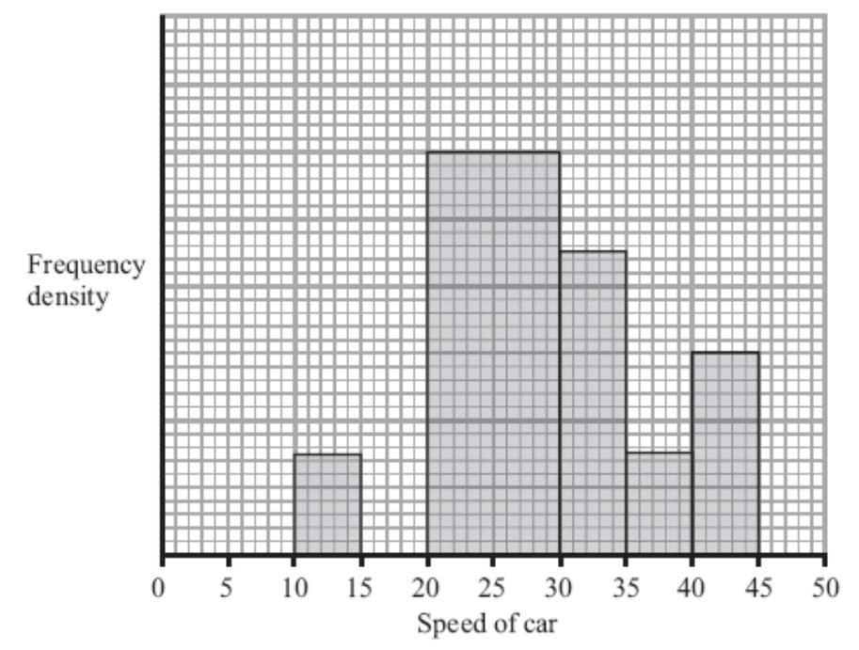
(a) Calculate the number of cars that were exceeding the speed limit by at least 5 mph in the sample. (4 marks)

(b) Estimate the value of the mean speed of the cars in the sample. (3 marks)

(c) Estimate, to 1 decimal place, the value of the median speed of the cars in the sample.(2)

- Let’s Consider the gaps between the classes:

Example
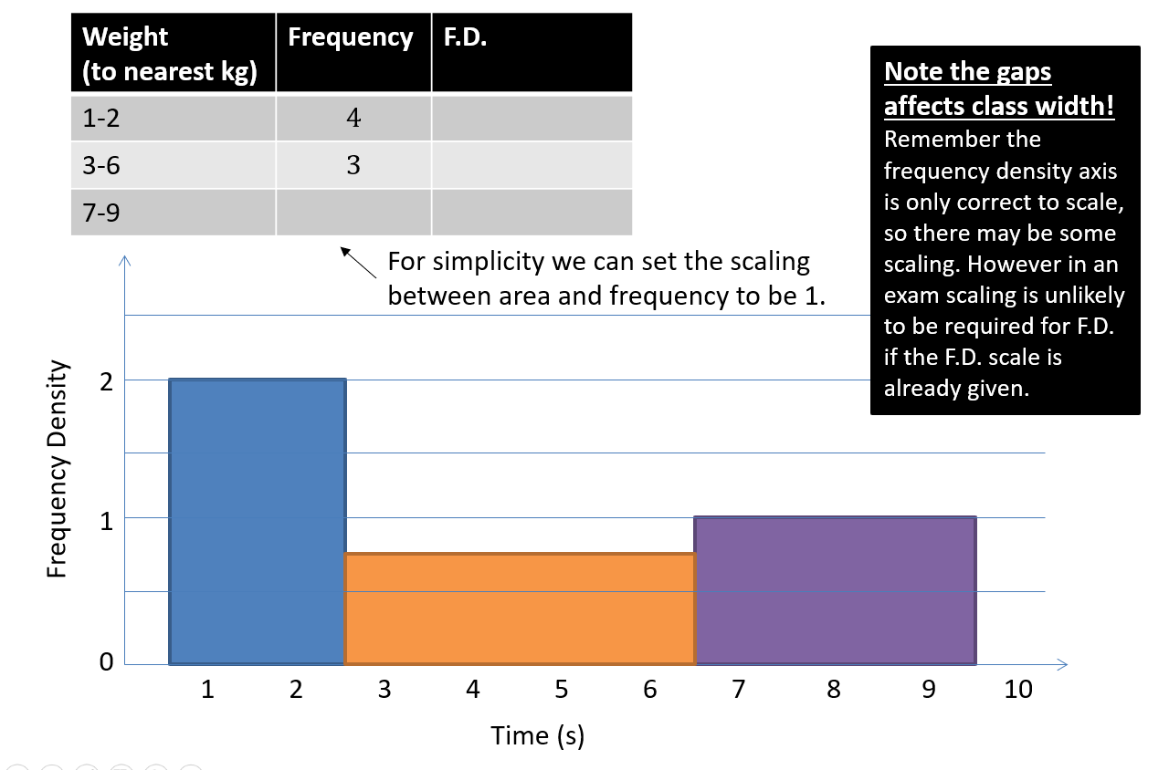

- Let’s consider the width and height on the diagram
An exam favourite is to ask what width and height we’d draw a bar in a drawn histogram.
Example:
The frequency table shows some running times. On a histogram the bar for 0-4 seconds is drawn with width 6cm and height 8cm. Find the width and height of the bar for 4-6 seconds.
Time (seconds) | Frequency
$$0≤t<4$$ | $$8$$
$$4≤t<6$$ | $$9$$

Tip:

0 -4 class
Class width = Drawn width = Scaling =

Frequency Density (height) = Drawn height = Scaling =

4-6 class:

Test Your Understanding

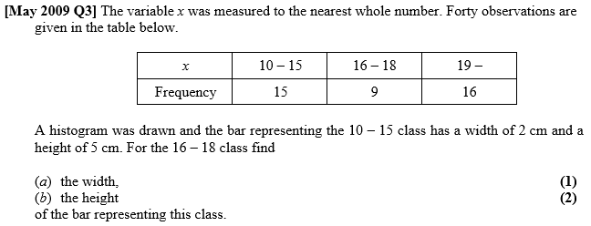

- Forming a frequency polygon

Exercise 3D Pg 50
Supplementary questions on printed sheet
Exercise 3E Pg 53

