3C Cumulative Frequency
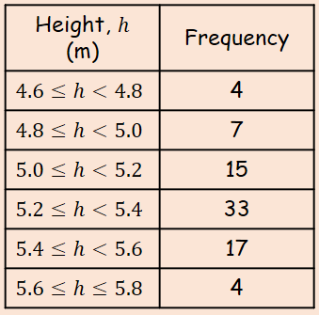
- The data in the table shows the heights in metres, of 80 giraffes.
- Draw a cumulative frequency diagram for the data
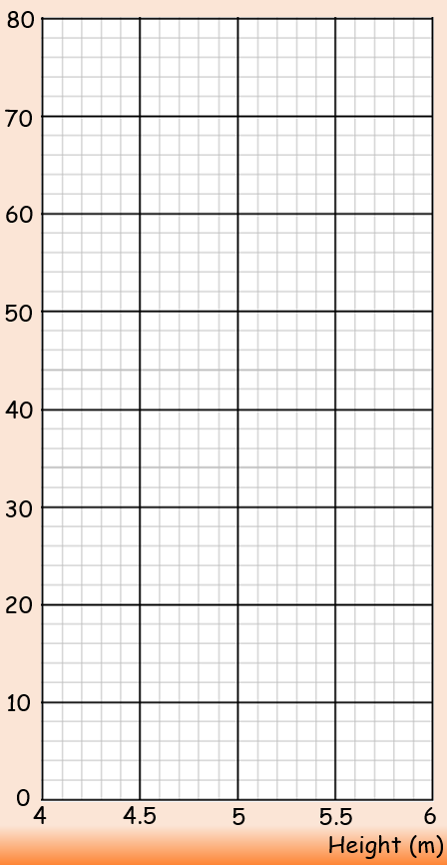
- Using the cumulative frequency diagram, estimate the median and quartiles

- Estimate the 90th percentile

- Draw a box plot to represent the diagram
