Cumulative Frequency Diagrams
We use cumulative frequency diagrams to consider the running totals of / people/ things up to a given value. They are useful for estimating the median and quartiles.
Example: The table below shows the time taken for a group of runners to run 50m. Draw a Cumulative Frequency curve for the data. Use your graph to estimate the median, LQ, UQ and IQR.
Median =

LQ =

UQ =

IQR =
Time (s) | Frequency | C. Freq
9.6 < t ≤ 9.7 | 1 | 1
9.7 < t ≤ 9.9 | 4 | 5
9.9 < t ≤ 10.05 | 10 | 15
10.05 < t ≤ 10.2 | 17 | 32
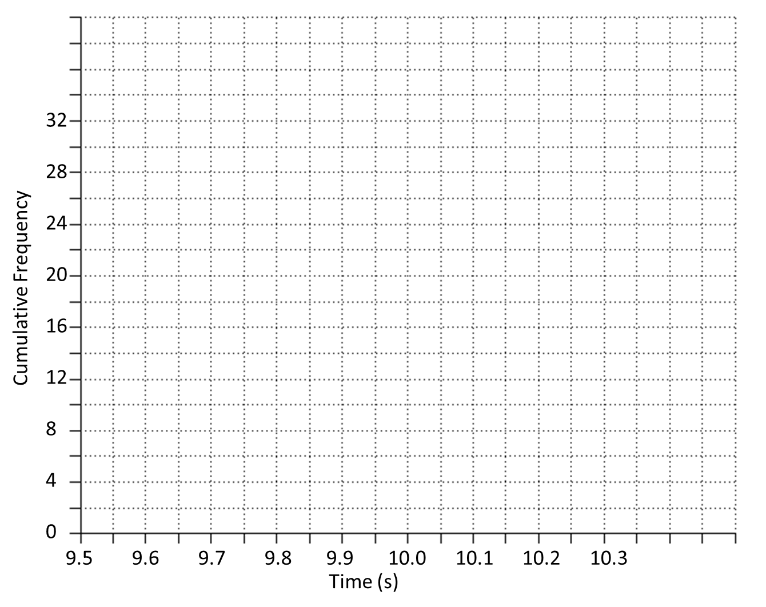
Estimate how many runners had a time less than 10.15s.

Estimate how many runners had a time more than 9.95

Estimate how many runners had a time between 9.8s and 10s
Ex 3C Pg 47/48

