3B Box Plots

- The blood glucose levels of 30 males is recorded. The results, in mmol/litre, are summarized below:
$Q_{1}=3.6$ $Q_{2}=4.0$ $Q_{3}=4.7$
Lowest value = 1.4
Highest value = 5.2
An outlier falls either $1.5×IQR$ above $Q_{3}$, or $1.5×IQR$ below $Q_{1}$.
- Given that there is only 1 outlier for males, plot this information on the same diagram as the females.

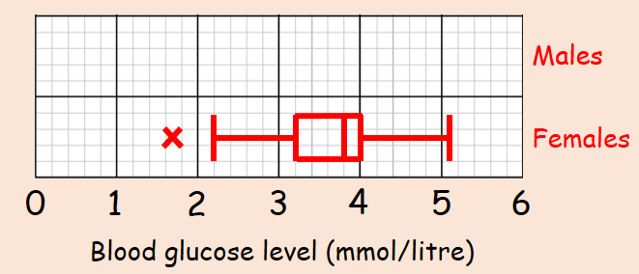
- Compare the blood glucose levels for males and females.

