Box Plots
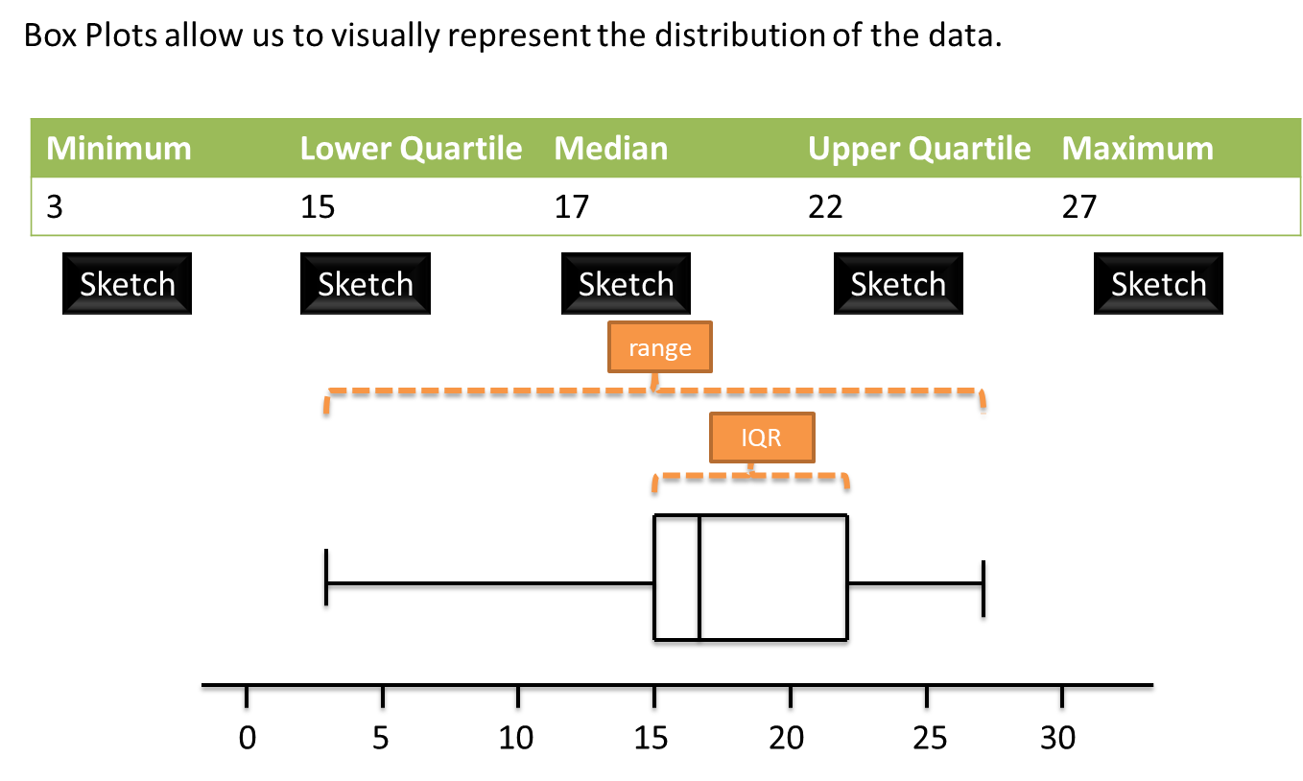
How is the IQR represented in this diagram?

How is the range represented in this diagram?

Outliers
An outlier is an extreme value.
One common definition of an outlier is when we’re 1.5 IQRs beyond the lower and upper quartiles.
Examples
- The diameters of 11 different Roman coins are measured in centimetres:
2.2 2.5 2.7 2.7 2.8 3.0 3.1 3.1 3.2 4.0 4.7
Determine the quartiles and hence any outliers.

- [Textbook] The lengths, in cm, of 12 giant African land snails are given below:
17 18 18 19 20 20 20 20 21 23 24 32
Calculate the mean and standard deviation, given that $Σx=252$ and $Σx^{2}=5468$.
An outlier is an observation which lies $±2$ standard deviations from the mean. Identify any outliers for this data.

Test Your Understanding
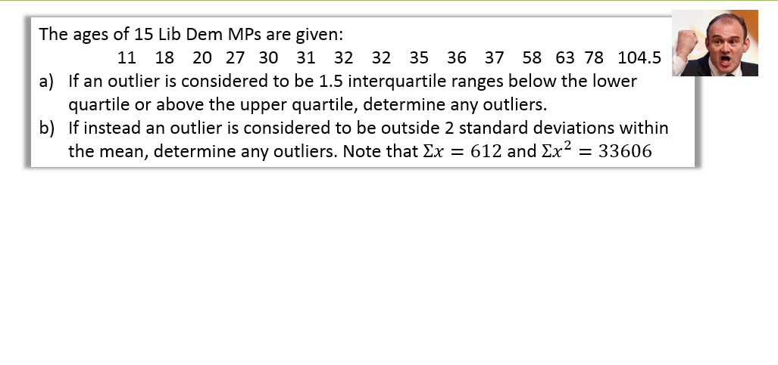

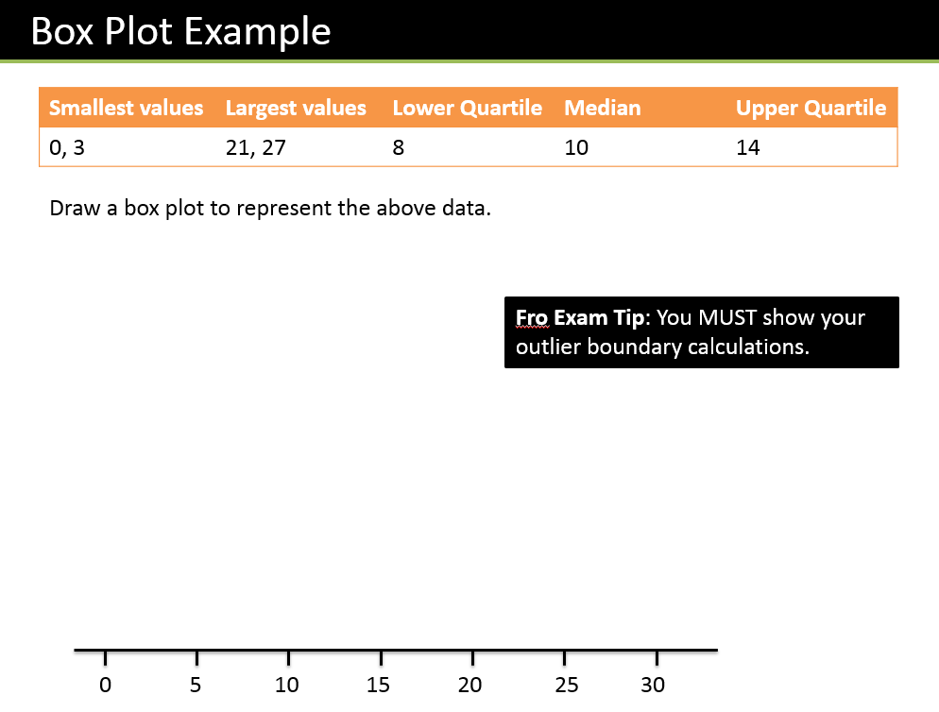

Test Your Understanding
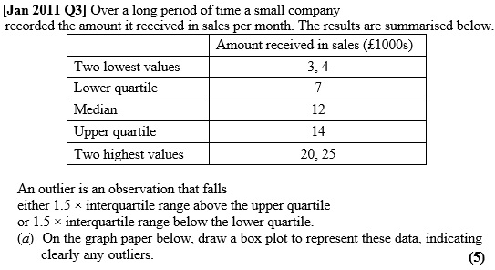
(c) The company claims that for 75% of the months, the amount received per month is greater than £10 000. Comment on this claim, giving a reason for your answer. (2)

Comparing Box Plots
It is important to be able to compare the data that is shown in 2 or more box plots. You should consider the median and quartiles as well as the spread of the data. Always relate the comparison back to the specific situation being analysed.
Examples
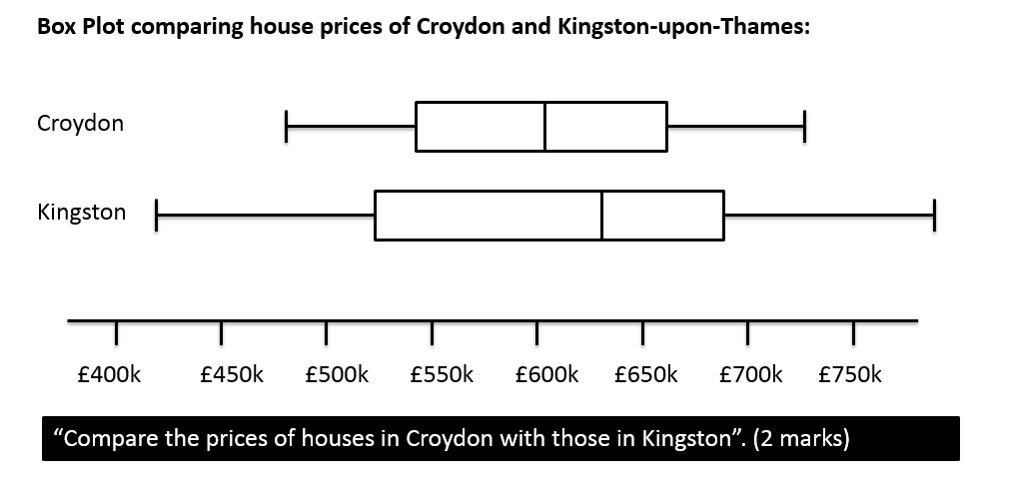

Ex 3A/3B Pg 42-43, 45

