Solving Modulus Problems

Modulus questions are very common in exams. It is important that you are confident with all aspects of questions including sketching graphs, finding the range ad domain and solving equations.

Examples

- Given the function $f\left(x\right)=3\left|x-1\right|-2, x∈R$,
- Sketch the graph of $y=f\left(x\right)$

- State the range of $f$.

- Solve the equation $f\left(x\right)=\frac{1}{2}x+3$

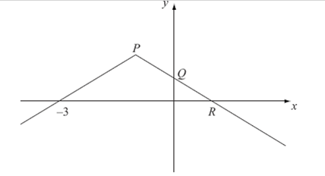
Test Your Understanding

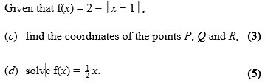

Extension
Ex 2G Pg 51
[MAT 2006 1I]
The equation $\left|x\right|+\left|x-1\right|=0$ has how many solutions?

