2F Multiple Graphical Transformations

- The diagram shows the sketch of $y=f(x)$.
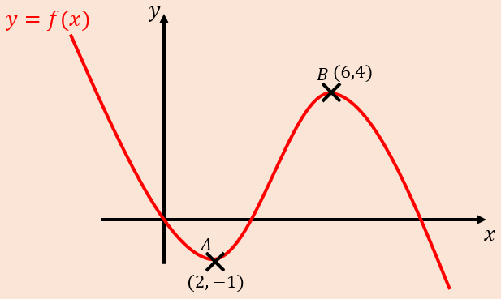
- Sketch the graph of $y=2f\left(x\right)-1$
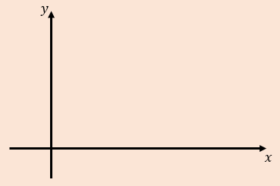
- Sketch the graph of $y=f\left(x+2\right)+2$
- Sketch the graph of $y=\frac{1}{4}f\left(2x\right)$
- Sketch the graph of $y=-f\left(x-1\right)$
- Given that:
$$f\left(x\right)=lnx, x>0$$
Sketch the graphs of:
- $y=2f\left(x\right)-3$
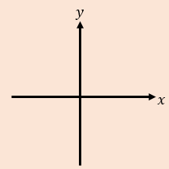
- $y=\left|f(-x)\right|$

