Combining Transformations

 | Affects what axis? | What we expect or opposite?
Change inside f( )
Change outside f( )

In L6 we studied transformations. Here we are asked to combine more than one transformation to a function.
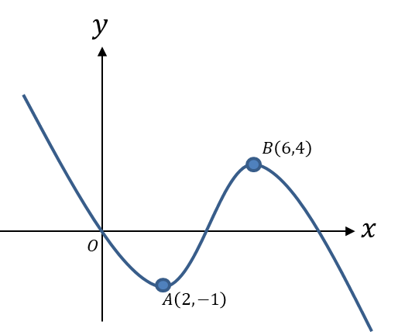
Examples

- Here is a graph of $y=f(x)$.

Sketch the graph of:

a) $y=2f\left(x+2\right)$

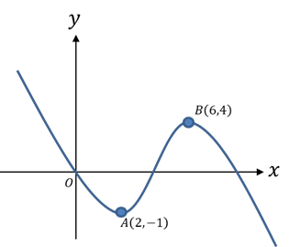

- ) $y=-f\left(2x\right)$
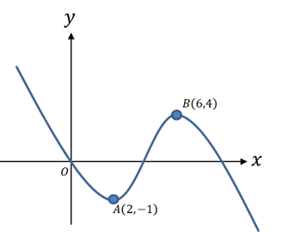

- $y=\left|f\left(-x\right)\right|$

Test Your Understanding
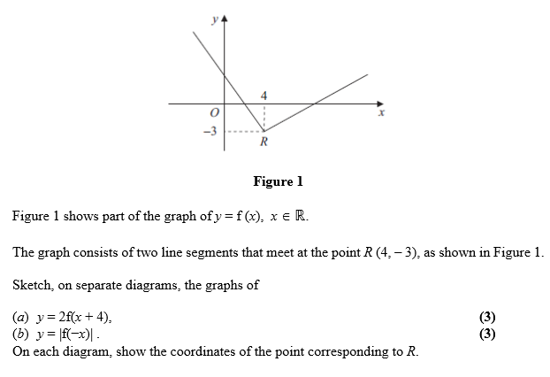
Ex2F Pg 47

