2E Variance & Standard Deviation

- The marks gained in a test by seven randomly selected students are:
x 3 4 6 2 8 8 5

Find the variance and standard deviation of the marks of the seven students.

- Shamsa records the time spent out of school during the lunch hour to the nearest minute, x, of the female students in her year. The results are shown in the table.
Calculate the standard deviation of the time spent out of school.
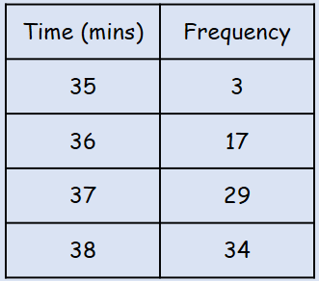

- Andy recorded the length, in minutes, of each telephone call he made for a month. The data is summarized in the table below.
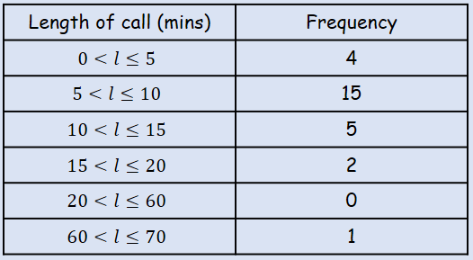
Calculate an estimate of the standard deviation of the length of the phonecalls

