Variance and Standard Deviation
Variance

cv
Examples

- 3, 11 Variance
Standard Deviation

- 2, 3, 3, 5, 7 Variance
Standard Deviation

- 2, 4, 6 Variance
Standard Deviation

- 1, 2, 3, 4, 5 Variance
Standard Deviation
Variance – frequency tables

cv
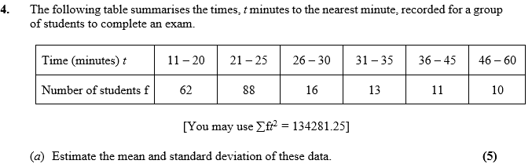
Examples

