2E Modulus Graphs

- Given that:
$$g\left(x\right)=sinx, -360≤x≤360$$
- Sketch $y=g(x)$
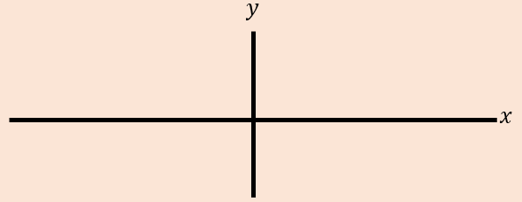
- Sketch $y=\left|g(x)\right|$
- Sketch $y=g\left(\left|x\right|\right)$
- The diagram shows the graph of $y=h(x)$, with five points labelled.
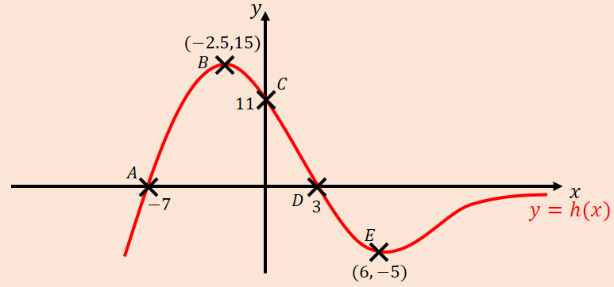
Sketch each of the following graphs, labelling points corresponding to $A$, $B$, $C$, $D$ and $E$, as well as any intersections with the axes.
- $y=\left|h(x)\right|$
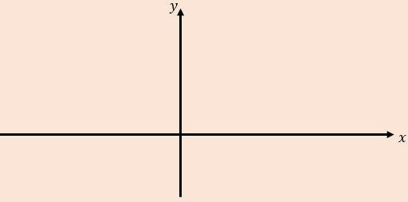

- $y=h\left(\left|x\right|\right)$

