Sketching $y=|f\left(x\right)|$ and $y=f\left(\left|x\right|\right)$
It is important to understand the difference between $y=|f\left(x\right)|$ and $y=f\left(\left|x\right|\right)$ and to be able to graph each of these.

The graph below shows $y=f(x)$ where $f\left(x\right)=(x-3)(x+1)$. Sketch $y=|f\left(x\right)|$ and $y=f\left(\left|x\right|\right)$

$$y=f(x)$$

$$y=|f\left(x\right)|$$

$$y=f\left(\left|x\right|\right)$$

Test your understanding
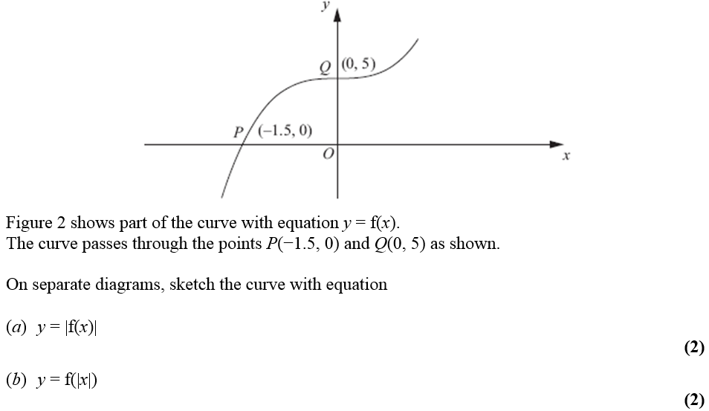

Test your understanding
Sketch for $-2π≤x≤2π$:
a) $y=\left|\sin\left(x\right)\right|$
b) $y=sin⁡(\left|x\right|)$

Extension
Ex 2E Pg 42
[SMC 2008 Q25] What is the area of the polygon forms by all the points $(x,y)$
in the plane satisfying the inequality $\left|\left|x\right|-2\right|+\left|\left|y\right|-2\right|≤4$ ?
A 24 B 32 C 64 D 96 E 112

